Website content:

Site objective is to create leads as opposed to provide information. I want to focus on the value we provide to small / medium business. Present ‘professional’
Target Keywords:
Third-party risk management
cybersecurity
cloud security
cybersecurity assessment
Security Awareness
vCISO
EDR

Homepage meta tag description (proposed):
Pragmatic cybersecurity services protecting your business from cybercrime.
Black Kite Third-Party Risk Management | Cisco Umbrella | vCISO | Endpoint Protection
(160 characters)

Menu (mega menu)
- Logo (links to “home” – hide “home” in the menu)
- Products & Services
  - Third-Party Risk Management
  - Cloud security services
  - Cloud SaaS Backup
  - Endpoint protection
  - Email security
  - Human Risk Management
  - Password Management
  - Vulnerability management
  - vCISO
  - Cybersecurity warrant of fitness
- About Us
- Blog
- Contact Us

Header
Image: (need to find one)
<H1> Protect your business against cybercrime
(demo button) (More info button)
Next section
<body> Cybercrime ranges across a spectrum of activities that involve fundamental breaches of personal or corporate privacy. Assaults on the integrity of information held in digital repositories, the use of illegally obtained digital information, to holding businesses to ransom – cybercrime disrupts your business, putting you and your employees’ livelihoods at risk.
CyberGrape is a 100% kiwi owned and operated cybersecurity firm, designed to help you protect your business from cybercrime. From small businesses without dedicated security professionals to multinational enterprises with complex environments, our combined pragmatic approach and award-winning products and solutions, are designed to provide the cybersecurity protection needed for any business facing cybersecurity challenges.

Solutions We provide – home page introduction

Third-Party Risk Management
Description:
Instantly get a 360° view of all your whole supply chain risk providing technical cyber security ratings, compliance correlations and risk quantification. An award-winning third-party risk management, cloud delivered platform.
Cloud security services
Description:
Flexible, cloud-delivered security combining multiple security functions into one solution, so you can extend data protection to devices, remote users, and distributed locations anywhere.
Cloud SaaS Backups
Description:
Get the market’s best Office 365 backup coverage and a variety of great features with CyberGrape’s cloud backup & recovery service. Also covers Google Workspace, Salesforce, Azure, Dynamics365 and Zendesk.
Endpoint protection
Description:
Cloud-based protection for your business, providing detection and response across email and endpoints - supported by a 24x7 global team of security experts.
Email security
Description:
Detects and blocks ransomware and other types of zero-day malware using pre-execution machine learning, macro analysis, exploit detection, and dynamic sandbox analysis for files and URL’s protecting your business from cybercrime.
Human Risk Management
Description:
Calculate, reduce and monitor human cyber risk with the new-class of user-focused security. Cloud delivered security awareness training, simulated phishing attacks, dark web monitoring and compliance policy management tailored to your business.
Password Management
Description:
Improve your cybersecurity posture with effortless Password Management, improve password hygiene and security, without compromising ease of use for employees or admins.
Qualys Vulnerability management with TruRisk™
Description:
Prioritise vulnerabilities, assets, or groups of assets based on business risk. We can take action to mitigate risk, helping your business measure its true risk and track risk reduction over time.
vCISO
Description:
If a fulltime CISO is too costly for a small business, a virtual CISO (vCISO) can fulfil the need by working part time to provide that same enterprise-calibre expertise. We can help to craft a security program fit for your business.
Cybersecurity warrant of fitness
Description:
Like motor vehicles, an organisation's Cyber Security should be checked on a regular basis by a third party to ensure the security controls in place are relevant and capable of keeping their business and staff cyber safe.
Technologies used for the solutions (for reference):

Third-Party Risk Management | https://blackkite.com
Cloud security services | https://umbrella.cisco.com/products/cloud-security-service
Cloud SaaS Backup | https://www.keepit.com
Endpoint protection | https://www.trendmicro.com/en_nz/small-business/worry-free-services-suites.html
Email security | www.trendmicro.com/en_nz/business/products/user-protection/sps/email-and-collaboration/email-security.html?modal=s9a-btn-read-overview-8291f1
Human Risk Management | https://www.usecure.io/en/
Password Management | https://www.lastpass.com/products/business?utm_medium=cpc&gclid=Cj0KCQiAj4ecBhD3ARIsAM4Q_jH_w9eBKffiQYqB2HXzaAWnShuVbnWX3ewP1HER98T68EFi1JmLPh0aAh9XEALw_wcB&gclsrc=aw.ds
Vulnerability management | https://www.qualys.com/apps/vulnerability-management-detection-response/
vCISO | CyberGrape designed – more info here:  https://cybergrape.co.nz/services/virtual-ciso.html
Cybersecurity warrant of fitness | CyberGrape Designed – More info here: https://cybergrape.co.nz/proposals/cover.php?ProposalID=WYbmExi4jE87KKvC5W6FjhpBUb2a921v6YVii2hTl7k&ContactID=Xd6xQETMNfhtnhTbialPKKyv4nj-5EVXAGciB6Kuu20

I guess for copywrite – you likely have a format that you use ?
I started putting some info together in the next section – but its pretty kak. If you could tell me what info you would expect from me in order to put content together, happy to do the work to provide it – just a little lost as to what is best.

Third-Party Risk Management (black Kite) – Full Page

Black Kite is disrupting traditional third party risk management practices worldwide by providing cybersecurity experts with full visibility they’ve never experienced before. The award-winning intelligence platform continues to push the limits on predictive insights, allowing those liable to make more informed business decisions with straightforward, defensible findings.
Black Kite fills a fundamental security gap by making it simple for businesses to non-invasively quantify and monitor cyber risk across thousands of third parties. We provide intelligence from a technical, financial and compliance perspective, eliminating false positives and ensuring a holistic approach to vendor risk management.

TECHNICAL CYBER RATING
- THE MOST COMPREHENSIVE AND ACCURATE TECHNICAL INTELLIGENCE.
The Black Kite Technical Rating provides easy-to-understand letter grades and defensible data details behind 20 risk categories. The non-intrusive report passively evaluates third parties, and does not touch an organization’s systems or network assets.
- EASY-TO-UNDERSTAND LETTER GRADES CALCULATED BY DEFENSIBLE DATA
Black Kite follows and applies commonly-used frameworks developed by the MITRE Corporation for scoring software weaknesses in a consistent, flexible, and transparent manner, converting highly technical terms into simple letter grades.
- VULNERABILITY PRIORITIZATION
Black Kite provides a graphical distribution in the form of a heat map to determine the status and severity of each finding. Our platform leverages MITRE and NIST to further confirm the criticality of each threat.
- POWERFUL PERFORMANCE BEHIND 20 CATEGORIES
The total score is a weighted average of 20 category components, providing unmatched breadth and insight into detected vulnerabilities.

Benefits: (this needs work)
Receive simple, outlined steps
Multiple formats available for download (PDF, Excel, etc.)
Prioritize tasks based on critically

Some images (kak)
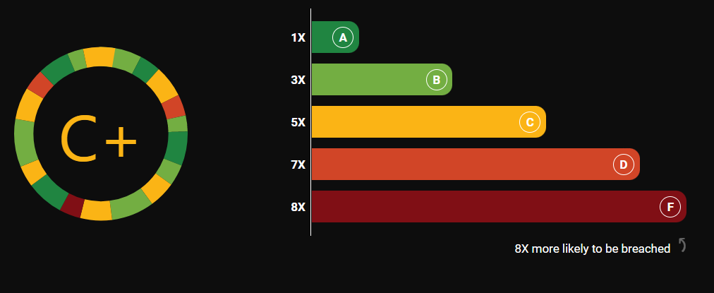
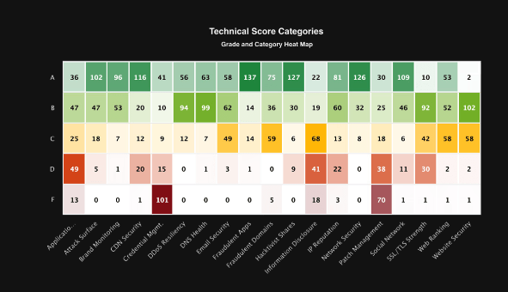
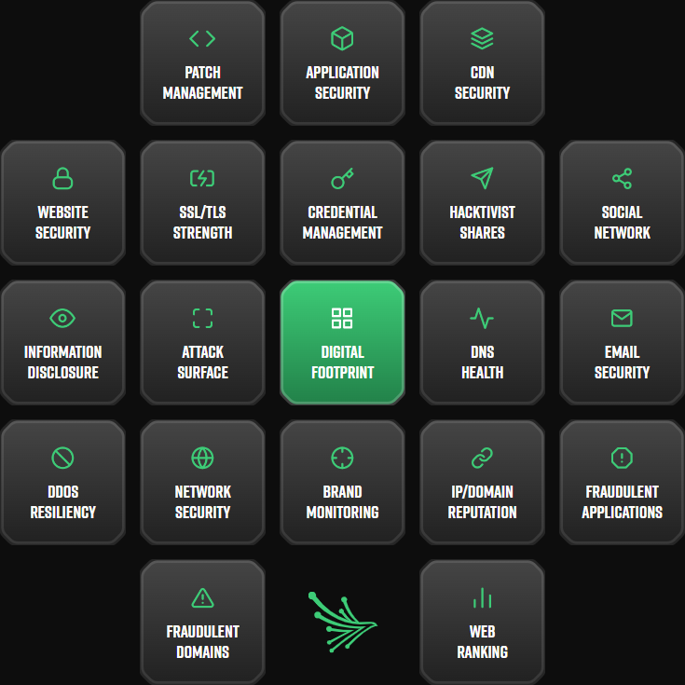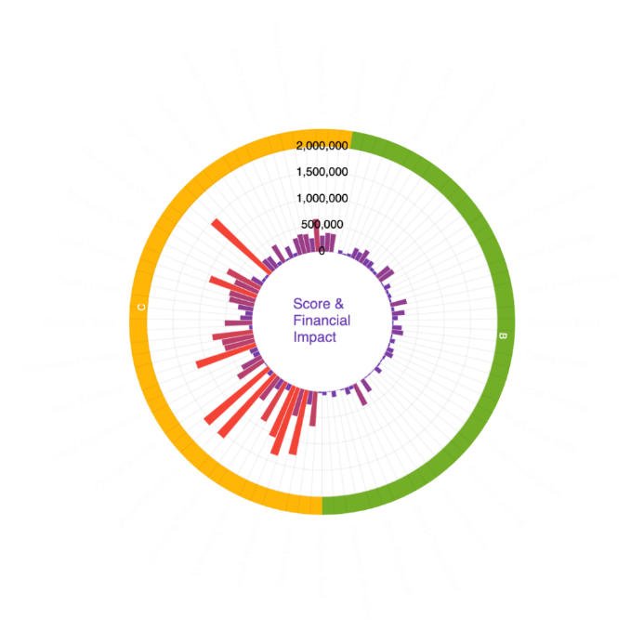

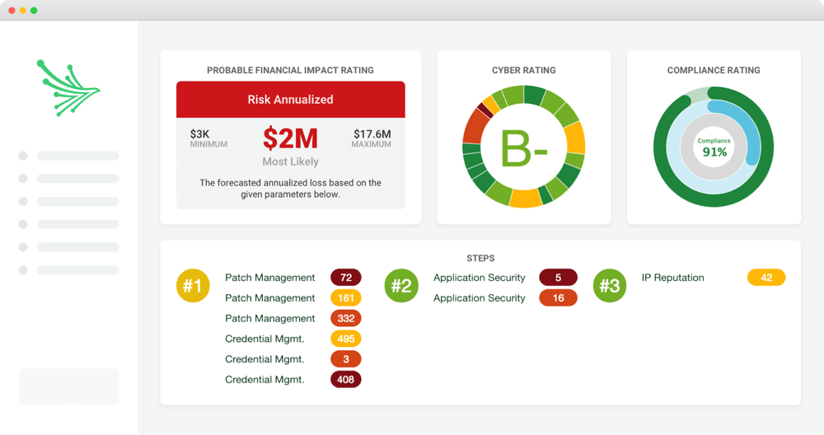

Needs a call to action :
- Form/button : Schedule a free Scan

