Better experts, faster The best developers in our network

“We offer our professionals only if we are convinced of their competences and skills"
We have access to a specialist network of software development professionals carefully built up over a period of 15 years

15

By employing qualitatively suitable candidates, we receive positive customer reviews and score high customer satisfaction.
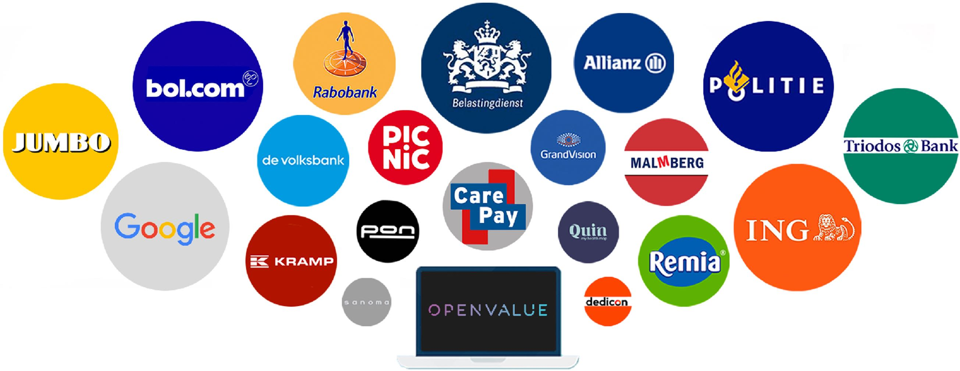√

OpenStaffing helps you solve your IT organisation's capacity problems by offering and deploying high-quality, highly developed candidates.
Our candidates, our professionals, are driven, and they are used to getting the best out of themselves and their project. They bring up-to-date knowledge for you, so they immediately tap the best level for you as a client to help achieve the objectives of the project, and therefore really complement your team. Our professionals are of immediate value and deliver demonstrable results..

OpenStaffing helpt jou met het oplossen van je capaciteitsvraagstuk van je organisatie door het aanbieden en inzetten van kwalitatief hoogstaande kandidaten.
Onze kandidaten, onze professionals, zijn gedreven en zijn gewend het beste uit zichzelf en hun project te halen. Zij nemen up-to-date kennis voor je mee, zodat zij voor jou als klant direct het beste niveau aantikken om de doelstellingen van het project te helpen behalen en daardoor echt een aanvulling zijn voor jouw team. Onze professionals zijn direct van waarde en leveren meetbaar resultaat.

OUR OFFER

TRANSPARANT & OPEN

OpenStaffing stands for transparency and openness, for both client and contractor.
Clear agreements and no unnecessary obligations.
Short lines, and smooth response times. For both the client and the professional.

As part of the OpenValue Group and our partner network, OpenStaffing is able to provide clients with full development teams, complete with test automators, scrum masters, product owners and business analysts and developers..
COOPERATION
ETSAMENWERKING

Java developers Frontend developers (React/Angular/Vue) .Net developers Data engineers Devops (AWS/Azure) PhP developers Testers (automation & functioneel) Mobile developers (Android / iOS) UX/UI developers
OpenStaffing | Savannahweg 71 | 3542 AW Utrecht 0031 30 20 72 690 | info@openstaffing.nl

TEAMS
ETSAMENWERKING

KLANT

Open Value Groep
Netwerk Partijen

ZZP’ers | developers
EXPERTISES
E
Customerrequest
OpenStaffing
Customer request

