

Smarter Reactivation Starts with ListFit
Surgically transform your lapsed subscribers into incremental revenue by leveraging subscriber-level engagement data.

ListFit allows retailers and other high volume email senders to increase revenue by growing the mailable list of existing customers with suppressed subscribers. Using our subscriber-level email activity data, users quickly know which dormant subscribers to reactivate without running into poor inbox placement or deliverability issues.

We are the only data intelligence company that can provide marketers a multi-brand view of customers’ inbox behavior for 90% of the US market.

Customer Reactivation vs. Customer Acquisition
It’s not news that customer acquisition is expensive and time consuming. Customer reactivation is cheaper and easily executed with the right tools. Think of your inactive file like a gold miner thinks of paydirt (that’s where the gold hides!). There are thousands of pieces of gold in paydirt, and your inactive file is no different. ListFit is the premiere tool to sift through your inactive file and find the most valuable lapsed subscribers. By using ListFit you can better understand who is most likely to re-engage and has the highest propensity to buy.

No Fuss. No Muss.
Implementing ListFit is easy. Once you identify your inactives, you are three simple steps away from waking up dormant revenue. We process more than 10 million records per hour, so the time needed to analyze your data is minimal, leaving you time to focus on your strategy.

Here’s the Business case

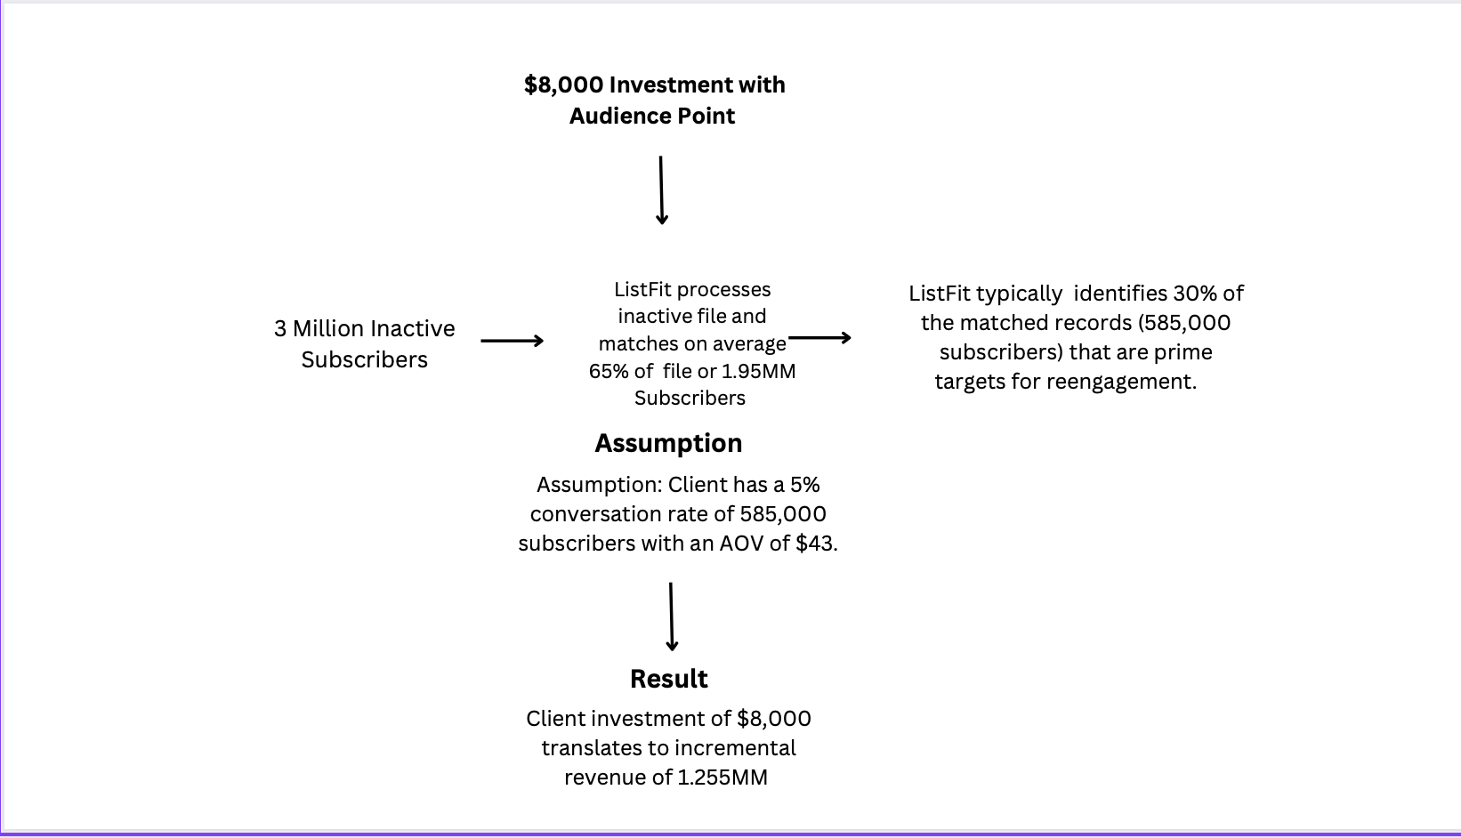

Numbers don’t lie. We invite you to use your conversion rates and AOV to understand how ListFit can impact your email program and bottom line.

ListFit Doesn’t Stop with Reactivation
In addition to reactivation, our clients are using ListFit to:
- Identify Apple MPP opens for A/B testing
- Speed-up IP warming
- Improve sender reputation
- More precise segmentation
- Cull abandoned email addresses and avoid spam traps.
- Optimize send times to increase engagement
- Next-gen validation

The world’s most trusted brands use ListFit to drive revenue.
Logo Logo Logo Logo Logo Logo Logo Logo

Suppressed inactive mail file: 3 million
AudiencePoint Investment: $8,000

ListFit matches at least 65% of those 3MM email addresses or match 1.95MM of the records.
We see customers safely mail approximately 30% of those 1.95MM records or 585,000 subscribers.
Assuming only 5% of those customers or 29,250 subscribers make a one-time online purchase in the year with an AOV of $43, the incremental revenue would be $1.25MM.
The $1.25MM in this example would equate to a 15721% ROI.

