Submission to DesignCrowd
November 3, 2022

©DataFi Consulting Services LLC. All rights reserved. Not for further distribution without the permission of DataFi Consulting Services LLC.

PLEASE READ IMPORTANT INFORMATION IN THE INTRODUCITON, ON HOW THIS DOCUMENT SHOULD BE HANDLED BY THE DESIGNERS AND BY DESIGNCROWD.
Contents
Introduction 1
Section 1: Description of business 1
Section 2: Summary of services 2
Mission Statement 2
Service Line 3
Section 3: Design considerations 5

Introduction

This document is prepared to provide background information to DesignCrowd and all of its contents are confidential and to be used only for the purpose of informing designers engaged in the project. This document is not to be shared with anyone and should be destroyed by anyone who accesses it for the purposes of designing a logo for DataFi Consulting Services LLC (herein “DataFi Consulting”) at the termination of the engagement with DesignCrowd (when the successful designer is chosen, other designers should destroy this document, and when the logo copyright has been transferred to DataFi Consulting Services LLC, the winning designer and employees of DesignCrowd who accessed this document to facilitate the engagement, should destroy this document).

Section 1: Description of business

DataFi Consulting, is a data consulting firm providing professional services to government, private industry, academia, and not-for-profits. We evaluate our clients’ business and where they want to go, and show them how they can get there using data to reach their goals. We then look at their data practices and evaluate their data needs, then support them on their data evolution. We help them scope out what they need to be able to do with data. From there, we help them to navigate through the various solutions available to determine how best to reach those goals. This is not about the technical solutions – it is not an IT consulting firm. This is about supporting them to reach their business strategy goals by using data. This is from a subject matter perspective, and could be through supporting their needs in the areas of:
- Data Strategy:
  - Evidence-based decision-making (EBDM - a priority of the federal government, lower-level governments, and private-sector firms nationally and globally);
  - Data management, governance, literacy, and culture (building blocks for EBDM); and
  - Analytics (supporting EBDM, feedback loops, return on investment, etc.)
- Specialized recruitment: creating a pipeline from colleges/universities to bridge employment in the field, matching data professionals to data jobs.
- Advocacy/advisory services: evaluating regulatory, legal, and ethical data issues, and providing professional input.
The focus of the company will be on data strategy to ensure enterprises are aware and working toward systematically implementing the use of data to remain profitable, efficiently run, and achieving their business goals. This could also ensure they meet the requirements of Environmental, Social and Governance (ESG) initiatives among others, regulatory reporting (BCBS 239, etc.), or their move toward Artificial Intelligence (AI) and Machine Learning (ML). Data governance and strategy initiatives support enhanced reporting and decision-making across various functions not limited to finance, operations, and sales. Many initiatives require the input of coherent and quality data from various sources, which can only be managed through strong data governance practices.

Section 2: Summary of services
DataFi Consulting Services LLC provides consultation services to companies, governments, and not-for-profit organizations. Our services include data strategy, data analytics, data governance and data management; data advocacy and advisory services related to regulation; and, recruitment of data professionals. All services aim to support clients to increase the efficiency of achieving their business strategies and goals.
DataFi Consulting targets business owners, the C-suite and executives of private, public, government and not-for-profit organizations who have a need to increase the efficiency and effectiveness of their business strategy through data. Specifically, we specialize in outlining and supporting organizations to establish the frameworks, practices, and skill sets required to elevate the achievement of business goals with data, and we show organizations how they can demonstrate the returns on investments in data.

Mission Statement
To ensure the most efficient and effective use of data, techniques, and personnel in the achievement of our clients' business goals.

Service Line
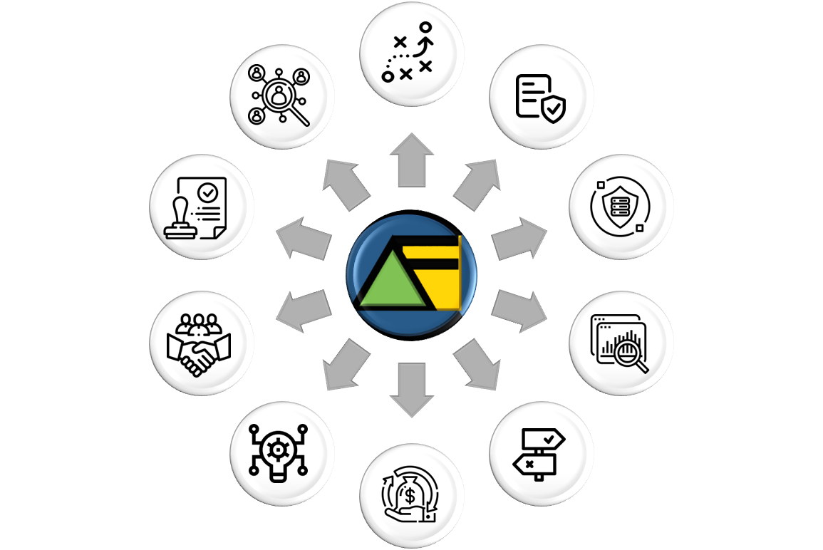
Figure 1: Scope of services to be offered by DataFi Consulting Services LLC (see table below the figure for a description of each service)

 | Data strategy: whether you have a solid business strategy and need a supporting data strategy, have an existing data strategy that can use a brush-up or need help with its implementation, our aim is to understand your business, and to help you map out achievable short-, medium- and long-term goals.
 | Data policy: we help you to understand how you can leverage your existing policies or create new ones to ensure a data-driven enterprise.
 | Data governance: we have firsthand experience in setting up data governance practices in large and small organizations. We can help you determine who the ideal data governors are in your organization, what data governance roles are needed, and advise you on the potential scope of responsibilities and authorities surrounding your data governance office.
 | Data analytics: we evaluate your goals to help you to determine how data, within and outside of your organization, can be used to drive those goals. Through learning how to use your data, to knowing how you can trust your data, we help you to determine and set the parameters necessary to achieve your desired business outcomes.
 | Evidence-based decision-making: ahead of deciding in which initiatives to invest, know that you have the structures and protocols in place to justify those decisions. We have experience in and can help you establish an evidence-based decision-making strategy, which will have the added benefit of providing quality assurance against your analytics.
 | Returns on investments: to report on the outcomes of your investments, a common challenge when justifying investment
 | Synthesis: we show you how a nexus between your data policy and data governance practices will help you to improve your analytics and help you to determine the right solutions, depending on the size and scope of your enterprise and the work needed.
 | Business relations: we help to bridge your business with IT, to define solutions that drive solid business outcomes respecting the parameters of your data capabilities.
 | Regulations: we work with your legal team to help define a data policy and operating structure which meets your regulatory requirements.
 | Recruitment: we bring almost 30 years’ experience building teams to deliver in the areas of data analytics, data management, data policy, data governance, data literacy and data culture. We can either support you in hiring, or provide you with lists of potential candidates. Matching data people to data jobs is a critical service provided by DataFi Consulting.

Section 3: Design considerations

Possible ideas to consider
- Blue circle: Data Governance and Data Management could be viewed as being anchored in the DAMA/DMBOK “wheel” (see https://www.dama.org/cpages/body-of-knowledge).

- Triangle: Data projects are often described through a(n isosceles) triangle which reflects the desire to be at the top tip (advanced analytics), but in order to achieve that you need a solid foundation (data governance and management). Some other triangles demonstrate data as the foundation (bottom of the triangle) with wisdom at the top. Finally, the triangle represents the delta, or the change, which is what organizations which engage DataFi Consuting will be embarking on; cultural and organizational change (leveraging data for better decision-making).

- Square: Data management is often associated with a RACI matrix, which can be depicted by a square.

Some preliminary designs
Although these designs are provided, they should not limit a designer to create something completely unique. We are not designers and are relying on your great ideas to present original works according to what you think is best.

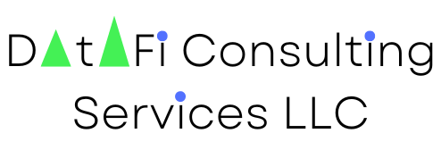
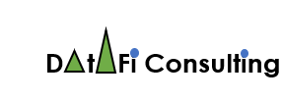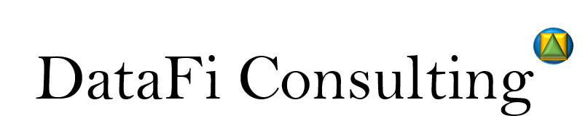



For a list of relevant government initiatives, see Appendix C - Alignment with US and other government priorities.

