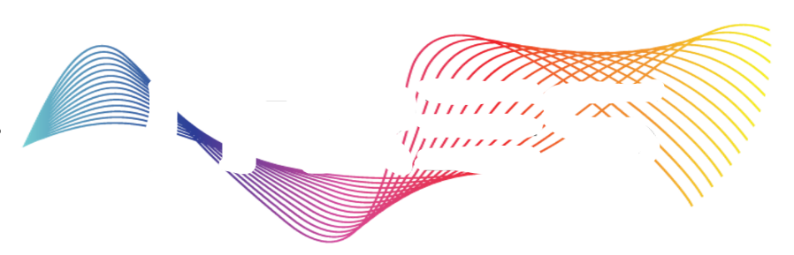

AIRBORNE SENSORS

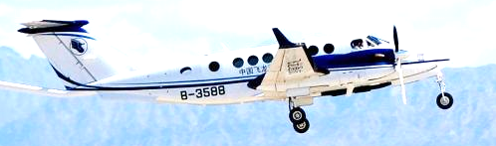
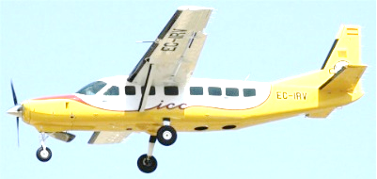
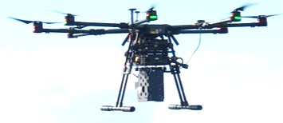

What do you want
to detect and monitor?

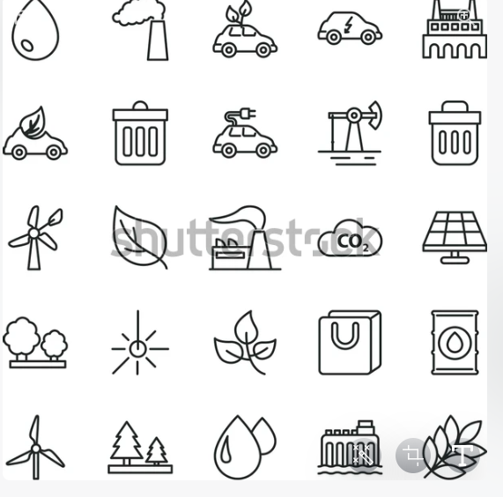
Gas Detection Forestry Water Quality Vegetation Health Precision Ag Species Classification Pollution / Disaster Response

Target Detection Environmental Monitoring Geology / Mineral Exploration Thermal Anomalies Wildfire / Hotspot

