This is the area where the Flag Of Wales should be inputted

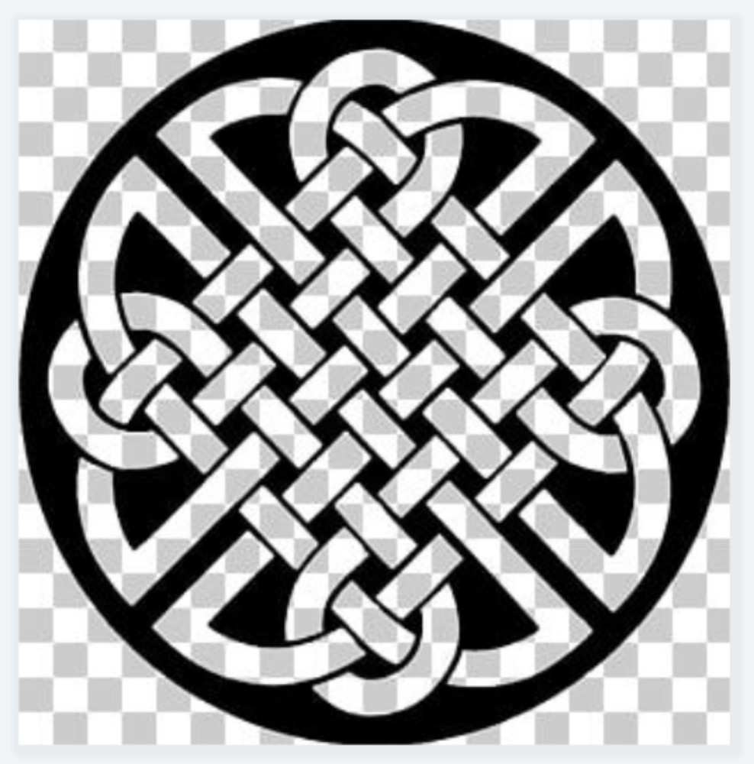

This is the area where the Flag Of Wales should be inputted

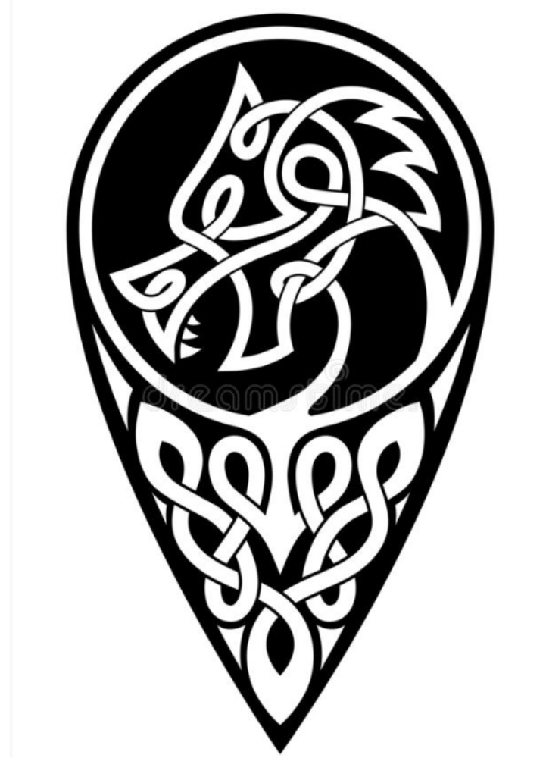



This is the area where the Flag Of Wales should be inputted


FLAG OF WALES
The Red and green colours shouldn’t be too bright. The colours should be a faded / rustic design.

