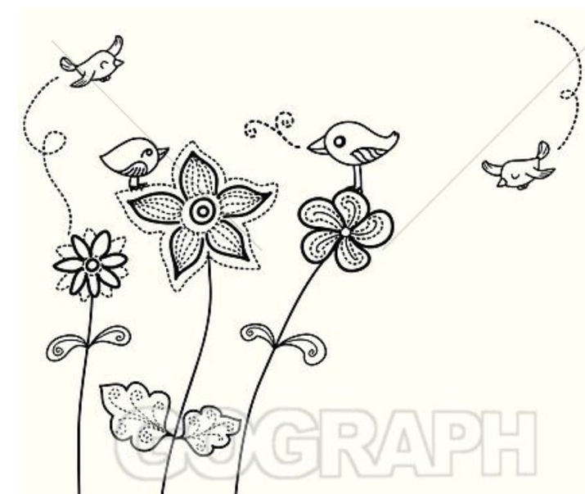
cute cartoon style birds to put in and around the corner floral borders

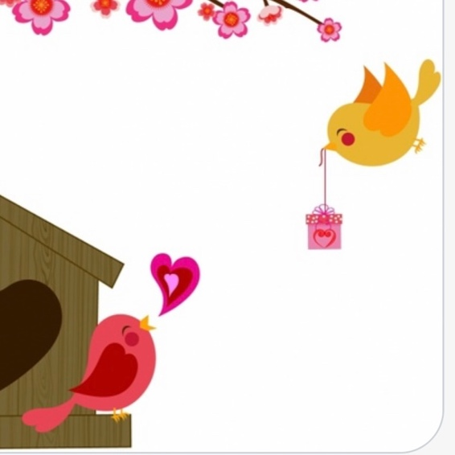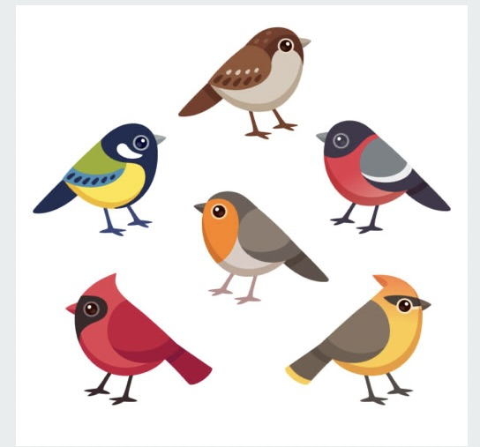

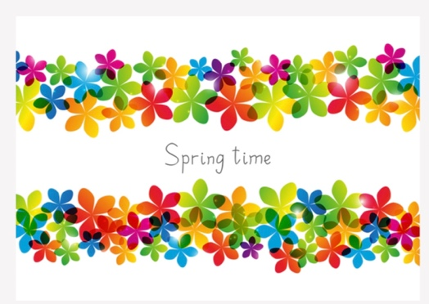
Vibrant bright Colors in the Floral Corner Borders (no pastels)

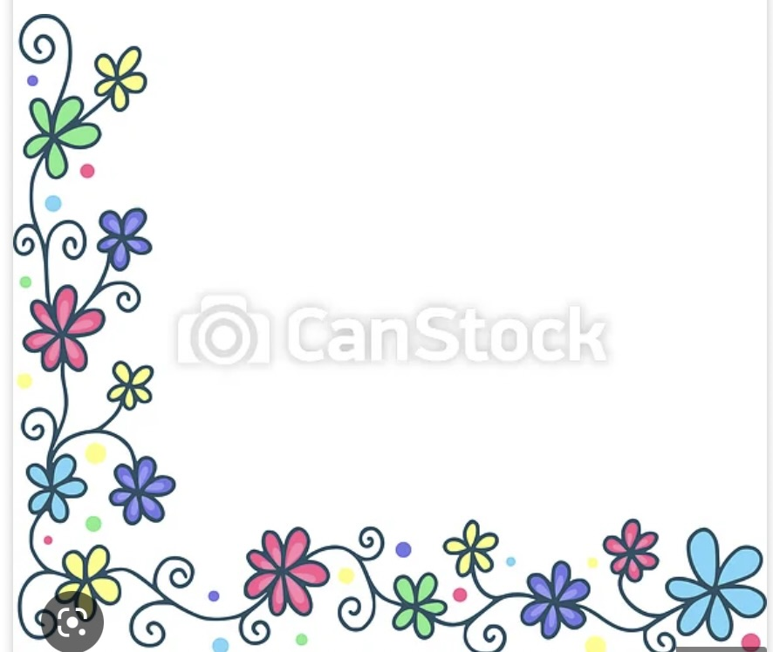
Example of a sample hand drawn style floral border, but needs to be more vibrant, more colors and have cute birds also

The borders would go in opposite corners, top left and bottom right

Rectagular layout of soap box
3.5 x 2.5
White / transparent background

