Residential Interiors &
Property Management Specialists
- Home
ABOUT
- PROPERTIES
- HOW TO LET
- FAQs
- TESTIMONIALS

- Contact Us
Book Now
- Bespoke Design

Industry Leading Returns
Speak to a Host Advisor
- About INTERLETS

Strive for simplicity. Deliver sophistication.

Interlets is a contemporary company focused on a new type of property management. We seek to maximize returns for any landlord through the adaptation of their property and delivery to the correct market. Our wealth of experience and knowledge of Dubai's short-term market is then utilized to proactively market and manage properties as high yield serviced vacation rentals.

Short-Term rental platforms such as, Airbnb, Booking.com and HomeAway are used as vehicles to drive greater returns for our landlords. Property owners can make between 30% - 60% more than traditional long term lets. To get a 12-month forecast for your property BOOK A CONSULTATION
- Our properties are featured on







The INTERLETS Process

We Adapt & Manage


Assessment
During a consultation, your allocated property manager will assess your space. Before sending over a comprehensive proposal.


Adaptation
This is where we transform or tweak the interiors to insure your property is a direct match with its respective target market.


Results
Your property goes live. This marks the beginning of where we begin generating industry leading results for you in terms of occupancy rates and overall turnover.
- Watch Our Video

Take a look and enjoy!

INTERLETS Properties

We pride ourselves in Attention to Detail

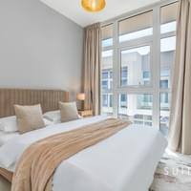

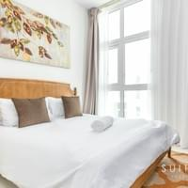

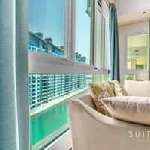

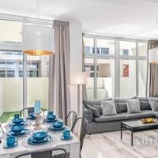

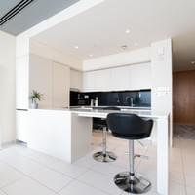

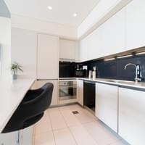

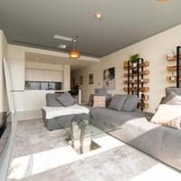

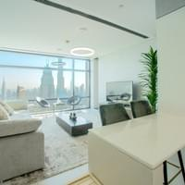

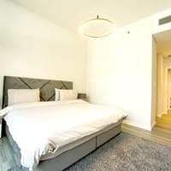

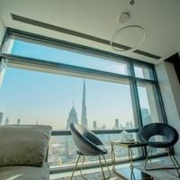

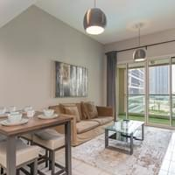

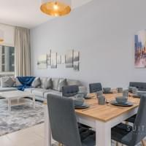

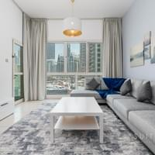

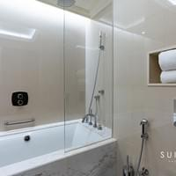

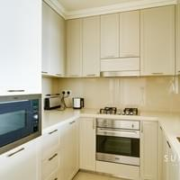

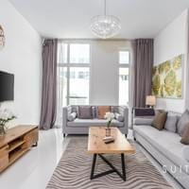

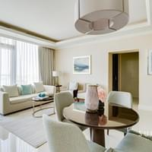

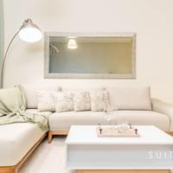

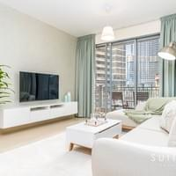

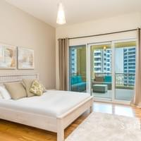

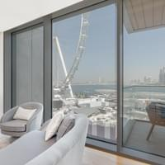

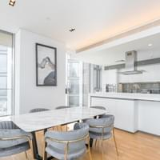

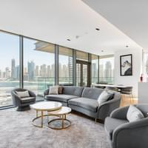

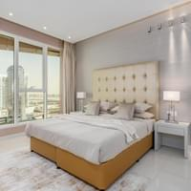

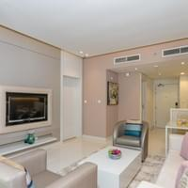

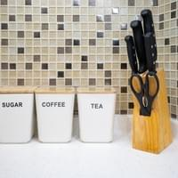

INTERLETS

Industry insights laid out for you by the INTERLETS Team

How to turn your home into a successful Airbnb
- With the growth in popularity of short-term rental platforms like Airbnb, Booking.com, Home and Away and Expedia, homeowners are increasingly taking advantage of the opportunity to gain an extra income. Be it a spare room in your city centre apartment or an entire mansion in the country, these platforms do not discriminate, and chances are if there is space to sleep, someone will be interested in paying you for it. With this it is no longer a question of, can your space be rented? but instead, how much can your space be rented for? While this largely comes down to location, the season and the size and description of the space, it can also be largely influenced by aesthetics. Airbnb’s which make the most money are the ones in highest demand. People need to see your space and immediately feel drawn to it. Every picture must radiate comfort, warmth, cleanliness and functionality. We have put together a list of 5 things you can do to meet these criterium and drastically improve the performance of your Airbnb.
- 1. Furnishings
- At the top of the list is furniture since this is what your guest will be coming into physical contact with, and in many ways distinguish the vibe and functionality of your space. To achieve high occupancy, it is essential that your space appeals to the broadest possible market. The easiest way to do this is by keeping the place minimal and neutral. For some this will mean de-clutter, also people do not feel comfortable constantly being reminded that they are invading someone else’s space so avoid personalizing too much and take down the family pictures.
- Neutral coloured furniture is the best way to go; white, grey, brown and beige. If the furniture is already there and this is not an option, paint the walls a neutral colour which goes with the largest piece of furniture in the room I.e. A red couch can be complimented by grey walls and matching grey cushions. Try to get rid of anything which clashes further and follow this colour scheme with anything else you add.
- Less is more. Minimalism is the key to creating space and compliments functionality and flow. People hate feeling trapped or claustrophobic so in small spaces get rid of unnecessary extras like chest of draws and large decorations which serve no purpose to a short-term tenant. In large empty spaces, consider a tasteful yet neutral wall mural, canvas or painting to add culture and character. A plant or mirror will also suffice to give purpose to the space and bring life to the room.
- 2. Lighting
- Lighting is an integral part of design which is often overlooked. The way a room is lit as well as the added décor of a lamp or pendant tying into the overall theme can make an astonishing impact without hurting your pocket. Updating your lighting solutions may even save you money in the long run.
- Kitchens and bathrooms require more task-oriented lighting. The wrong lighting in these areas can be unflattering and even unsafe. If you have an island in your kitchen, consider installing a pendant 35-40 inches above the surface. This will highlight what is considered a ‘sought for’ feature and provide task lighting to maximize functionality. In the bathroom avoid lights which point directly to the mirror since this will cast unwanted shadows. Instead place fixtures either side of the mirror for balance. Ensure any bathroom pictures listed are bright and clean and do not forget to put down the toilet seat. If for whatever reason this is too difficult to achieve leave these out of your advert.
- Living rooms as well as bedrooms serve multiple purposes so you will want to provide multiple lighting options. For a bedroom simple bedside lamps will suffice as an alternative to the existing ambient (general) lighting. Ensure the bulbs in the lamps are a soft-white colour temperature. This light gives a warm and cosy feel which you can even show off in your listing. Make use of soft white again in the living room through stand-up lamps if you have the space, otherwise tabletop lamps look good too.
- For dining rooms, a pendant or a chandelier can be a statement piece while adding essential illumination to the space. When installing ensure the piece is cantered with the table and hangs 33 inches above the table considering 8-foot-high ceilings. For every foot above 8 feet add 3 inches to the above-table measurement.
- 3. Maintenance
- Before advertising your space make sure everything in the space works. Your guests will be paying a premium for a serviced space, it is paramount that everything advertised is fully functioning and hassle free. There will be mishaps on occasion which can be rectified with fast responses. So, stay on call particularly during check-in and the first 24 hours. During this time, broken furniture and non-functioning appliances are grounds for Airbnb to cancel the reservation and issue the guest a full refund if not resolved.
- Further, studies show that reviews are increasingly a determining factor as to whether a booking is completed or not. Without the reputation of a 5* Hotel, reviews become the only basis through which guests can determine their trust for what you have advertised. With this you can genuinely appreciate the importance of the customer experience. Do not give anyone any reason to complain, respond to complaints in an effective and timely manner and ensuring each guest review pushes you in the right direction.
- 4. Cleanliness
- It is no secret that cleanliness is important. But as a host welcoming guests into your home even more so. Everyone’s standards are different which is why the cleaning of your space must consistently be held to the highest of these standards. From the utensils they will be using to cook to the doormat at the front door, guests will continuously be conscious of their hygiene and safety. And they are not the only ones. Writing this during the COVID 19 crisis, health authorities worldwide are focusing on cleaning practicing like never before and will continue to protect their community’s once businesses open and travel resumes. With this it is a strong recommendation that you hire a professional. No matter how well you think you can clean, a trained eye and a checklist system will eliminate the risk of you missing something.
- While guests will not experience the true cleanliness of your space until they arrive, it is equally important to project cleanliness through the pictures in your listing. Clutter and poorly placed cushions and furniture reflect disorganisation which will also raise question as to whether the place is cleaned properly. Look at some Airbnb listings yourself and be mindful that you are competing with luxury hotels and brand name properties. Minimalism as mentioned above gives for a cleaner look, ensure furniture is not warn out or damaged, and if pets have been kept in the space make sure none of their toys, hair or cages feature in the listing. For bedding, White is the way to go. White sheets reflect a confidence in your cleanliness and are both neutral and inviting for whoever will be sleeping in them.
- 5. Photography
- Much like your furniture and lighting, photography is a one-time investment which will have a continuous impact on how your property performs once listed online. The pictures you choose to advertise with will be the sole reference point, other than reviews, your guest will use to justify parting with their hard-earned cash. So, make sure they are the best they can possibly be, particularly if you intend on charging more than similar properties in the same location.
- Hire a professional. Listings with professional photos earn 40% more, get booked 24% more often and can charge 26% higher nightly price. Aside from using a high-resolution camera, a photographer can distinguish the most flattering angles, provide styling tips for each room and will capture key features from their specialist experience. Photos are then edited and vetted before being sent to you ready to go live. The process is more extensive than taking the photos yourself and uploading them from your smart phone, but worth gaining a competitive edge over your competition.
- Conclusion
- The role of a successful Airbnb Host is fun and exceptionally rewarding. Once your space is up to spec and you systemize your check-in, responsiveness and turnovers into a smooth process, there really isn’t much left to do other than sit back and watch the handsome returns and 5*reviews roll in. You become part of a community who offer safe and comfortable stays to holiday goers and business travellers alike, and with this a sense of pride in your successfully transformed space and its well-deserved reputation. The 5 points above will not get you to this point over night, but if followed will certainly give your space the key foundations necessary to be a successful Airbnb.
- FAQs

Commonly asked questions.

What is a Short-Term Rental property?
The term refers to an apartment, villa or house which is made available for lease for shorter periods of time than conventional 3–12-month minimum term rental commitments. To cater to the short-term market, the accommodation is advertised as serviced; including essential utilities and furniture as you would expect in a hotel. The unit is managed closely according to the high turnover of guests and payment for each stay is paid in advance on a nightly basis inclusive of all taxes and charges.

Why do Short-Term Rentals see greater returns than Long-Term Rentals?
Traditional long-term rentals are too common. The oversupply of accommodation has left long term tenants with multiple options of the same unit to choose from. The competition pushes rent prices down and returns for landlords down with them. Short-Term rentals on the other hand are in far lesser supply. The emerging concept is seeing significant demand as Dubai remains a tourism and business hub. Additionally, a premium is charged on all the utilities which go towards making it hassle-free, serviced accommodation.

Why do people choose Short-Term Rentals over Hotels?
People want Privacy. A short-term rental in a residential space makes people feel more at home. Affordability is also essential here; as an individually managed short-term let, longer stays are welcomed at a reduced price as they require less management and a larger amount paid upfront. Not to mention, a 3-bedroom apartment in JBR is far more economical for a family-of-6 than 3 separate hotel rooms on the walk! Further, health authorities worldwide are appealing for social distancing and limited contact to strangers. People want to be able to do everything in one place and with the option of isolation should it be required. Gone are the days of crowded hotel lobbies and claustrophobic hotel rooms with public facilities and no kitchens.

Who are the DTCM?
DTCM stands for, Department of Tourism and Commerce Marketing. They are a government department dedicated to the growth and development of Dubai’s tourism industry. The DTCM portal allows companies like ours to apply for permits, classify and manage all properties in one place. All the above is required to operate any residential unit as a short-term rental property.

How much can I make?
How much our landlords make is relative to the type of unit and its location. Demand in the Short-Term market varies according to these staple factors. Although returns of any property will be superior to those rented long term, the above factors will distinguish exactly how broad those margins are. For instance, a Burj Khalifa facing 2 bed in Downtown may return between 80-100% more than its long-term counterpart. Whereas a 3 bedroom + maids villa in JVC may return between 30-50% more. Should you wish to find out how well your property will perform, feel free to book a consultation with one of our trusted property managers.

What is required from me should I wish to proceed?
Absolutely nothing. Once the property is ready and the documentation is signed giving us permission to market and manage the property, INTERLETS will manage the entire process. Simply sit back and wait for your monthly pay-out. Your allocated property manager will be on call to you daily should you have any questions or concerns, and we will keep you up to date regarding performance and market trends. Since we specialise in this space, our landlords enjoy the peace of mind of knowing they are dealing with well-versed professionals. We provide a management solution specifically tailored to each landlord and their property.
- Testimonials

Our guests love the INTERLETS experience


Fatima ★★★★★

Luxury Burj Khalifa facing Suite in the Sky
"This. was an amazing apartment. Everything was perfect. The location is 2mins from The Dubai Mall, the view from the apartment is breathtaking (especially at night). It has all we needed for a 2 weeks stay."


Daritza ★★★★★

Luxurious Contemporary Suite
"Had an amazing and relaxing stay at Christopher's Airbnb! Would definitely book again."


James ★★★★★

Luxurious Contemporary Suite
"Fantastic alternative to hotel of you plan on being out and about during your stay in Dubai. Complex is hotel like in its standard, apartment is like a large one bed room suite, pool and gym facilities excellent. Supermarket next door for everything you need. Great value"

- Contact us Today

Speak to our team to learn more
Dubai, UAE
+971 525 863 475

Info@

FIRST NAME
LAST NAME
PHONE NUMBER
Email
Message
Submit

INTERLETS © 2022 Info@

