Auslan Flyer Brief
This brief is to instruct the design of a 2-page flyer advertising our Auslan + Braille educational plates/signs. Auslan is the name given to the Australian Sign Language system, used by people who are deaf.
Braille Tactile Signs (Aust) are Australia’s premier manufacturers of Braille amenities signage. Please take a look at our website and Instagram to get an idea of what we do and to understand our Brand elements.
https://www.brailletactilesigns.com.au/
https://www.instagram.com/brailletactilesigns/
In this brief, you’ll find the sections/subheadings we require on this flyer with relevant images for those sections. Please use your creative abilities to set this flyer out to be neat, fresh and modern looking.
See attached an example of how we might want this flyer laid out (Auslan – Range Options). That document contains the same copy as found in the subheadings of this document. This attachment is by no means how we actually want this to look. It’s simply a very rough example.
Please note that notes are in italics.

Section 1 - Auslan Braille Tactile Signs – Range Options
Auslan Braille Tactile Signs – Range Options
BTS (Aust) are excited to showcase our exclusive, Auslan Braille Tactile Signs; an interactive learning Alphabet Range.

This exciting range of 26 or 52 signs offers a durable, fun, educational and interactive set of Alphabetical signs comprising Braille & Tactile lettering and matched with images of the Auslan sign language. Featuring each letter of the alphabet along with a word that identifies activities or landmarks around park and nature environments. Each word is nationally recognised in Auslan and suitable Australia Wide!

Section 2 – Where & Why?

Where & Why?
If your school, library, council or organisation is interested in the inclusion and education of languages used by people who are blind or have low vision levels (Braille & Tactile) as well as people who are deaf or have low hearing levels (Auslan), well this fun and interactive set of signs are your education solution for children and adults alike!

Endless Customisations:
Get creative and make this range suited to your school, community, and environment; with colours, digital graphics, shapes and backing options; suitable for internal or external interaction.
Designing and Ordering:
Contact the friendly Sales Team at BTS (Aust) today on 03 9876 0898 to order your standard set of Auslan Braille Tactile Signs or work with our creative Design Team to create your unique set, suited to your application and requirements.

BTS (Aust) Product Technology:
Premium Continuous Surface Encapsulated Polycarbonate Membrane.

Product Quality:
Able to be kept hygienically clean
(STOP GERMS image to be used)


Section 3 – Standard Finishes
Standard External Finish:
Colour: Black on Silver
Backing: 1mm Aluminium backing (1.5mm thick overall)
External Finish: Complete with an Anti-Graffiti and UV Stabilising Coating
Fixings: holes (option)

…. Endless Customisations…
NOTE: use any images titled External

Standard Internal Finish:
Colour: Black on Silver
Backing: 1mm flexible HIPS backing (1.5mm thick overall)
- Lightweight and smooth to touch.

…. Endless Customisations…
NOTE: use any images titled “Internal”

Section 4 – Nillumbik & Ringwood Heights Primary School
In this section, we detail an installation of these signs that we’ve made previously. We did this as a collaboration with Nillumbik Shire and Deaf Children Australia. Think of it as a very brief case study. We’ve also installed these recently at a school. We should have some images soon. Please use place-holders for the school.
Inspired by:
Signage produced for Eltham Lower Park, Eltham Victoria

A Collaboration of:
Nillumbik, BTS (Aust) and Deaf Children Australia
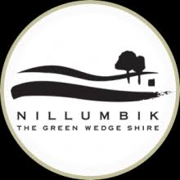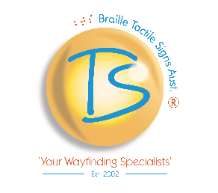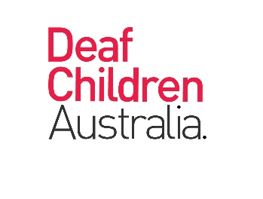
Education and inclusion for all is at the core of BTS (Aust)’s Mission, Vision and Values and we are proud of the successful collaboration between Braille Tactile Signs (Aust), Nillumbik Shire Council and Deaf Children Australia.
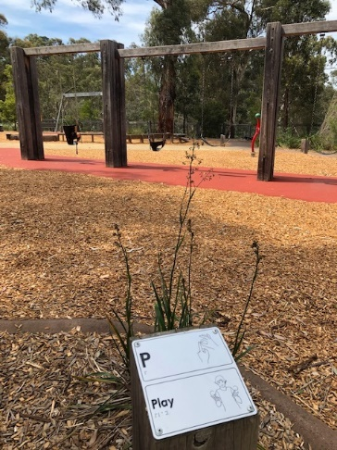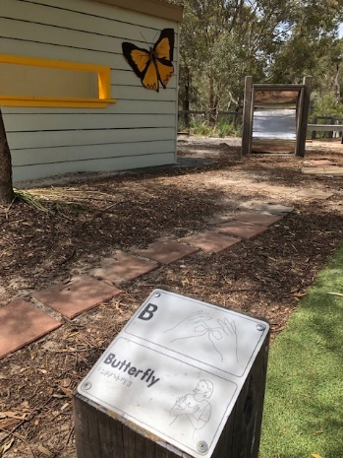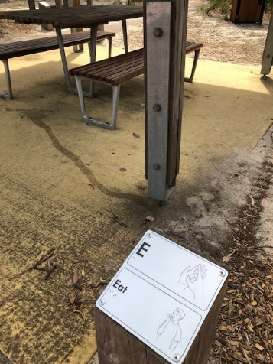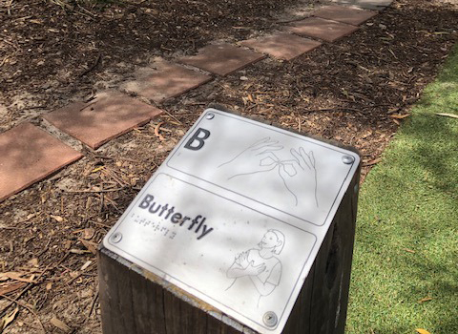

Image: Ringwood Heights Primary School – image to come.

