Auslan Braille Tactile Signs – Range Options

BTS (Aust) are excited to showcase our exclusive, Auslan Braille Tactile Signs; an interactive learning Alphabet Range.

This exciting range of 26 or 52 signs offers a durable, fun, educational and interactive set of Alphabetical signs comprising Braille & Tactile lettering and matched with images of the Auslan sign language. Featuring each letter of the alphabet along with a word that identifies activities or landmarks around park and nature environments. Each word is nationally recognised in Auslan and suitable Australia Wide!

Where & Why?
If your school, library, council or organisation is interested in the inclusion and education of languages used by people who are blind or have low vision levels (Braille & Tactile) as well as people who are deaf or have low hearing levels (Auslan), well this fun and interactive set of signs are your education solution for children and adults alike!

Endless Customisations:
Get creative and make this range suited to your school, community, and environment; with colours, digital graphics, shapes and backing options; suitable for internal or external interaction.

Examples:

Designing and Ordering:
Contact the friendly Sales Team at BTS (Aust) today on 03 9876 0898 to order your standard set of Auslan Braille Tactile Signs or work with our creative Design Team to create your unique set, suited to your application and requirements.


BTS (Aust) Product Technology:
Premium Continuous Surface Encapsulated Polycarbonate Membrane.

Product Quality:
Able to be kept hygienically clean

Standard External Finish:
Colour: Black on Silver
Backing: 1mm Aluminium backing (1.5mm thick overall)
External Finish: Complete with an Anti-Graffiti and UV Stabilising Coating
Fixings: holes (option)

…. Endless Customisations…

Standard Internal Finish:
Colour: Black on Silver
Backing: 1mm flexible HIPS backing (1.5mm thick overall)
- Lightweight and smooth to touch.

…. Endless Customisations…

Inspired by:
Signage produced for Eltham Lower Park, Eltham Victoria

A Collaboration of:
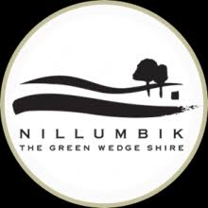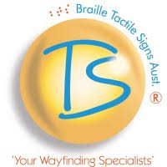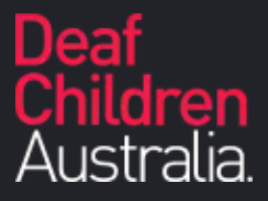

Illustrated by:
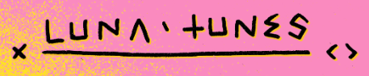

Education and inclusion for all is at the core of BTS (Aust)’s Mission, Vision and Values and we are proud of the successful collaboration between Braille Tactile Signs (Aust), Nillumbik Shire Council and Deaf Children Australia.

Image: Eltham Lower Park Image: Ringwood Heights Primary School

