The All in One Captain  Presents Concierge for high end clientele assets and effects.  List of Services  - Full Luxury Concierge  - Absentee Owner Assistance  - Yacht Asset Assistance  - Estate Asset Assistance  - Preventative Maintenance and Repairs for Assets  - Property and Yacht Inspection assistance  - Project Management  - Shipyard Management  - Class and Flag State Assistance  - Assistance/ Consulting with Flag State Surveys  - Assistance/ Consulting with Class Surveys  - Assistance/ Consulting in Charter Crew Training  - Charter Program Consulting  - Assistance and Consulting with Newly Purchased Yachts  - Consultation for the purchase of Yachts  - Consultation for Chartering Yachts  - Assistance and Consulting for Hiring of new Employees. | 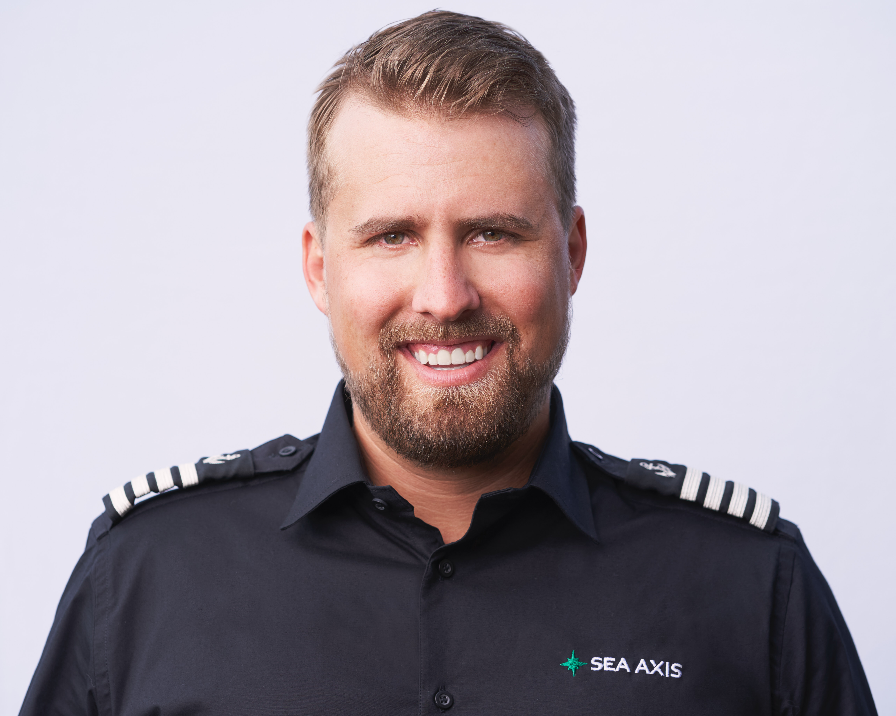

The Management Master
16089 Poppyseed Circle #2007
Delray Beach FL, 33484
1-219-588-9971
Shipyardcaptain@gmail.com

