Main Page Concept. We will be designing multiple verticals. Residential, Commercial, Hospitality, Transportation and Medical Facilities.

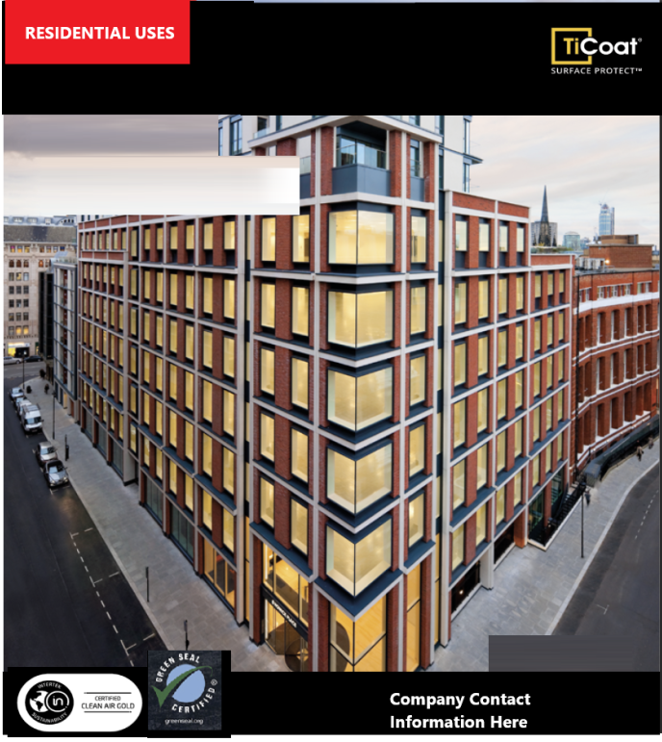

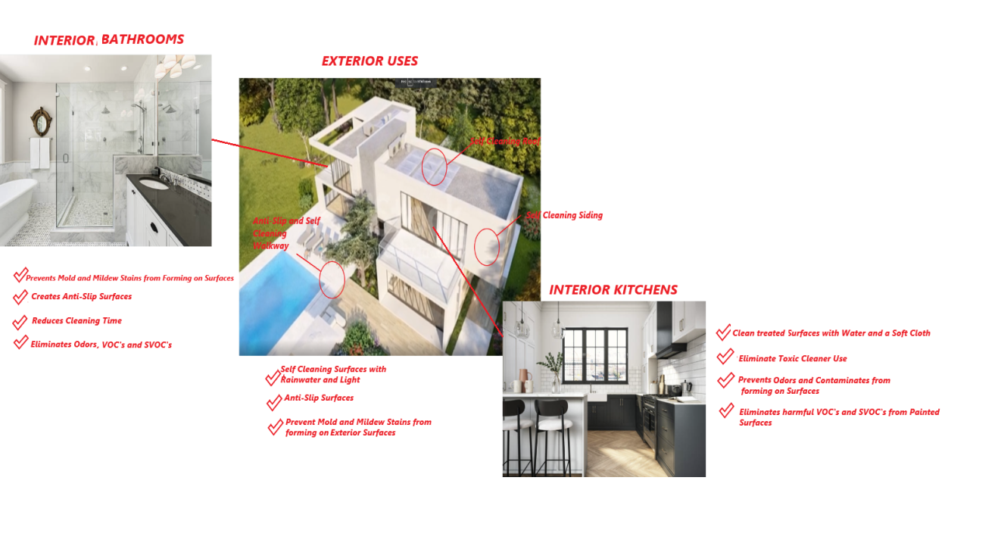
Use a good image to show interior and exterior uses using these bullet points for bathroom, kitchen, exterior. We need a creative front cover to illustrate these points.

The back of the flyer will use this
