Start A New Chapter In Your Mental Wellbeing & Unleash The Real You!

Ketamine Assisted Therapy Packages To Address Treatment-Resistant Depression, Anxiety, Addiction, Trauma, And Other Mental Health Concerns.
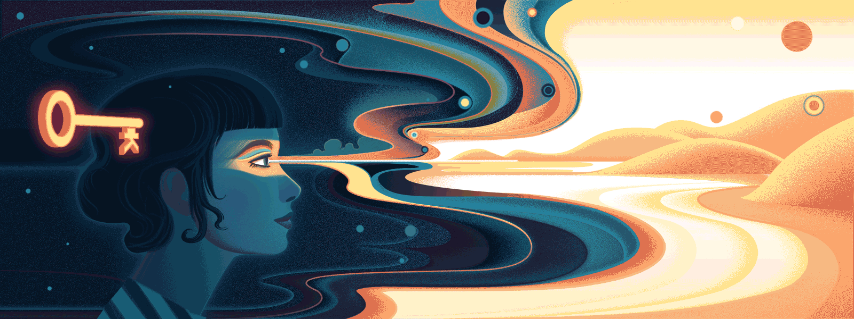

- Do you always feel listless, restless, or lethargic?
- Do those feelings of depression constantly evade all your attempts to control it?
- Are you having trouble focusing on daily tasks and falling asleep?
- Do you feel like you’re on a dead-end path or that you are not worthy of finding success in life or relationships?
- Has repeated therapy failed to help you get a handle on your motivation?
A lot of people go through expensive and drawn-out therapy sessions without finding success in getting their lives back on track. Traditional counseling and treatments may not prove effective in all cases of depression. When you are struggling with the ordeals of depression or other mental health issues, the last thing you need is a treatment program that leaves you feeling more exasperated than well. You need a treatment that hits at the root of your problems, not put a Band-Aid on them.
We may have the answer.
When other forms of therapies have failed to address depression, anxiety and trauma, Ketamine Depression Therapy can often provide a beacon of hope to help you get energized and motivated to take on your daily challenges. Ketamine is a safe, natural remedy that, when coupled with professional therapy, can greatly enhance your body’s resistance to depression and anxiety.
Let us show you how Ketamine Assisted Therapy can help you feel like the YOU that you know you can be.

What Is Ketamine?
Ketamine is a prescription medication that has shown tremendous results in combatting depression, anxiety, chronic pain, PTSD, and a myriad of other mental health conditions. At a safe dose, ketamine can propel you beyond the limits of your day-to-day consciousness, allowing you to target and remediate symptoms of trauma and mental illness in a more direct and productive manner.
How Does Ketamine Work?
Ketamine increases the neuroplasticity of your brain by ramping up the production of a crucial brain hormone called the “Brain-Derived Neurotrophic Factor.” This hormone has been proven to revitalize the connections of neurons that may have been damaged as a result of chronic depression or other conditions.
In addition to increased neuroplasticity, ketamine can also reduce inflammation and excitotoxicity by blocking NMDA receptors in your brain.
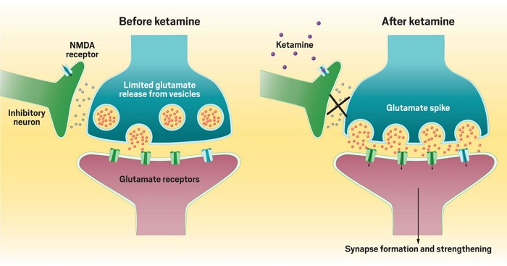

Ketamine-Assisted Therapy in Boulder, CO
Ketamine-Assisted Therapy utilizes the psychedelic nature of Ketamine to produce positive mind-altering effects such as broadening your perspective on life and developing critical insights into negative behavioral patterns. Our treatment method allows patients to experience the antidepressant qualities of ketamine in a streamlined and highly effective method that delivers results much quicker than conventional treatment.
At lower doses, patients often experience a trance-like state, while patients who receive higher doses report a transformative psychedelic experience.

Rapid Results
The majority of antidepressants currently on the market may take weeks, and in some cases months, before any results can be measured. Ketamine outshines all of these conventional antidepressants, producing positive results within hours to days. According to clinical trials, ketamine patients experienced peak mood elevation in about 24-36 hours following their initial treatment, with this mood boost persisting for the remainder of the week.
Reduced Frequency
While many other psychiatric medications are typically administered daily, ketamine treatments are far less frequent, which results in less stress on the patient’s life, fewer doses required for maintenance, and decreased probability of side effects.
Powerful, Lasting Change
Undertaking a guided ketamine experience can allow patients to enter an enhanced state of consciousness in which they can develop life-altering insights.
Our patients’ improvements in motivation, mood, and outlook on life as a result of these professionally-guided experiences can be much longer-lasting than the other antidepressants or counseling treatments.
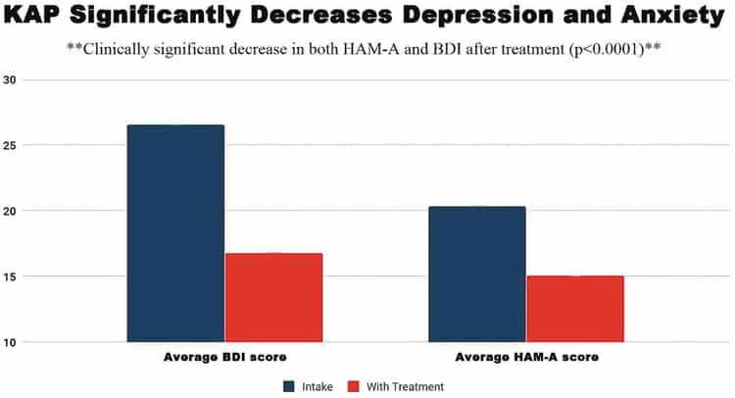

We Don’t Treat Patients, We Treat People.
We are dedicated to helping you achieve your ideal lifestyle.
With our treatment, you don’t just receive counseling, you become a part of our supportive, healing-centric community.
We stay with you along every step of your journey, developing a personalized healing plan based on proven methodologies to help you break free of the mental chains keeping you from reaching your full potential. Our priority is providing readily-available support throughout the entire process, ensuring everyone being treated has access to a qualified, positive, and passionate support system.
Our world-class Ketamine Assisted Therapy program collaborates with industry-leading therapists to create positive transformations in the lives of each and every one of our patients.
While each plan is customized for our patients’ unique goals, there are key guidelines we follow with every treatment plan:
- Introductory Evaluation: The first step for any potential patient involves a comprehensive psychiatric evaluation. Following the evaluation, a personalized plan is formed to help you attain your goals within an achievable timeframe.
- Consistent Counseling: We understand that our patients may be struggling with severe trauma or illness, and as a result, we provide counseling sessions before and after your ketamine treatment to keep an accurate account of your mental well-being.
We believe maintaining safe spaces for our patients is critical to ensure their comfort, as healing cannot be completed if the patient feels they are in a hostile or unfamiliar environment. Our spaces are safe, calming, and supervised by a professionally-trained therapist.
- Safety: As an FDA-approved anesthetic since 1970, Ketamine has been safely used as an alternative to traditional antidepressants and treatments for mental illnesses such as anxiety, PTSD, OCD, and a variety of other conditions. Our treatment programs are formulated based on years of expertly-conducted research and a comprehensive history of positive results.
- Proven Results: Ketamine is currently the only psychedelic medicine that can be prescribed by a healthcare professional. Our treatment programs are so effective that within only a few sessions, the majority of our clients report improvement in their condition. Our life-changing treatment plans transform the lives and perspectives of our patients in a way that counseling or medication could not do on their own.
- Affordable Solutions: Combatting mental illness is a challenge in itself, which is why we believe that you should never have to compromise your health due to limited finances. We are dedicated to minimizing our operating costs, allowing us to remain as affordable as possible while still upholding a superior standard of patient care.

Imagine opening your eyes on another beautiful morning, ready to see your family and friends, work toward your goals, and jump head first into what the day has to offer. Having the energy you need to exercise, tackle a new project at work, or simply find a fulfilling new hobby.
Does this sound like a dream? It doesn’t have to.

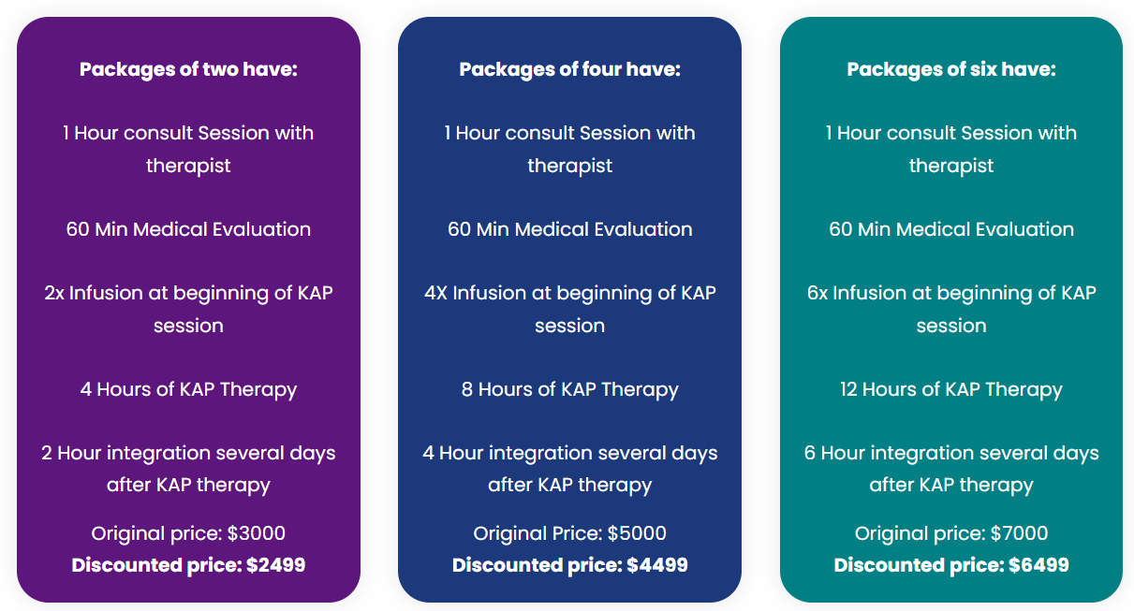

We assist patients in rediscovering their higher purpose, placing the tools of our patients’ success back into their own hands. Our patients have reported these transformative results after undergoing our Ketamine-Assisted Therapy. We ensure each of our patients leaves our facility feeling energized, refreshed, and more engaged in the present than when they arrived.
Living a consistently productive life may seem unattainable, but with our Ketamine Assisted Therapy administered by trained professionals, we transform these dreams into your reality. Individual results may vary.
Get In Touch With Us Now!
We understand that seeking help can be a challenge, and we want to congratulate you for taking the first step towards wellness. By skillfully utilizing ketamine to treat your depression, we allow you to reconnect with the person you were before your depression, restoring your ability to feel compassion and motivating you to pursue the goals you hope to accomplish.
If you or someone you know is struggling to deal with depression alone, we are here to help.
Allow us to help you get back on course to creating the most fulfilling life possible.
We combine our years of medical expertise to help:
- Alleviate feelings of severe anxiety.
- Increase your motivation and overall attitude about life.
- Rejuvenate your overworked mind, helping you increase the overall quality of life in both personal and professional capacities.
It is time to reclaim control over your life, directly addressing the issue damaging your quality of living with positive solutions for a sustainable lifestyle. With our therapy, we can eliminate even the most stubborn negative thoughts, including feelings of self-doubt, hopelessness, and worthlessness.
Getting started with us is simple, either schedule an appointment online or arrange a call and we’ll be glad to see how we can help. We are conveniently located at 2501 Walnut St. Suite 204 Boulder, CO 80302.
We are eager for the opportunity to help change your life, contact us today!

