~ Item Change Management (ICM) ~
Managing closeout, replacement, and reinstated items can be a complex, time-consuming activity, resulting in lost sales and frustrated customers. Item Change Management (ICM) addresses these issues at its core. Simply stated, ICM is an application that serves as your one stop destination to identify and take action against discontinued products and items that have been reinstated you previously carried. The program bridges communication and execution between ACENET and Eagle saving you time, improves accuracy, and ultimately ensures you have a proactive plan for products that are no longer available (temporarily and permanently).

Get Real Results:
- Labor Savings: 8-12 hours per month
- Improved IRA : 5% Increase
- Improved In-Stock Position: 10% healthier

Key Item Status Terms:

Term | Definition
Cancelled | Item status when Ace stops carrying the SKU and its inventory at your RSC falls to zero.
Closeout | Item status when Ace stops carrying the SKU and it still has inventory in your RSC. Closeouts first appear in ICM upon having less than 30 days of supply
Direct Replacement | An item having the same performance, features, benefits, color/finish as the discontinued SKU.
Discontinued | A generic term for an item no longer being stocked by the RSC. Depending on whether there is inventory left, this term is synonymous with the SKU being Cancelled or a Closeout.
Temporary Closeout | An item expected to be out of stock at the RSC for more than 30 days.
Suggested Replacement | Though similar to the discontinued SKU its replacing, performance, features, benefits, color/finish may vary from it.

Before Implementing ICM:
- Be on level 30.1 Eagle software
- Set up security access in ACENET for individuals responsible for managing the ICM. For instructions, see ACENET > Help > Item Change Management.
- Confirm ESOA (communication tunnel between ACENET and Eagle) has been setup for your store. Verify this by ensuring you have a ‘Refresh’ icon displaying in the Item Detail application in ACENET, per the illustration below. If the Refresh button does not appear, contact the Epicor Advice Line for setup assistance.
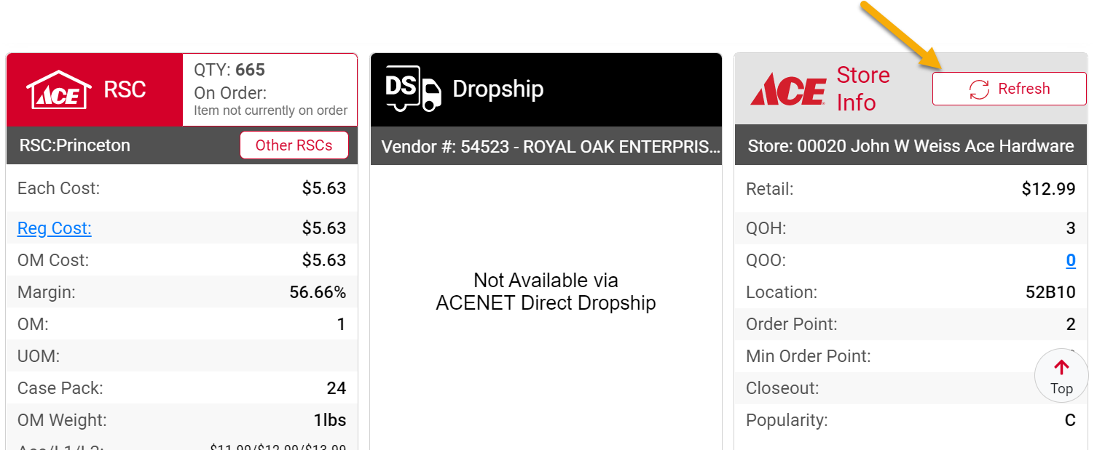

- Contact the Ace Care Center to setup ICM Access.
 Frequently Asked Questions:
  - Why do I even need to do Item Change Management (ICM)?
ICM simplifies and reduces the amount time and effort to manage the process of identifying and taking action against canceled, replacement, and reinstated items. Without ICM, the process of doing so is manual and laborious, error prone, and ultimately can result in taking lost sales. Contrarily, leveraging ICM (versus other manual approaches) typically saves stores between 8-12 hours per month, increase inventory accurateness, and improves operational effectiveness on the sales floor.

  - How frequently should I be working ICM?
Weekly. This keeps the execution manageable and steady. Aim for consistency by performing ICM the same day each week.

  - My computer is ordering the replacement SKU when I’m not out of stock on the discontinued product. Why?
Confirm option configuration setting 9972 is set to option ‘2’ . Doing so tells the system to order the new product only when the discontinued item falls to zero on hand.

  - I heard ICM merges product information. I’ve been using RCIN in Eagle for years to do that. Do I still need to use RCIN?
Managing items via ICM renders the need to do RCIN obsolete. ICM doesn’t technically ‘merge’ items because doing so creates inventory issues as well as a loss of visibility to discontinued SKUs . ICM, on the other hand, copies over certain key information from the discontinued item to the new item, keeping the discontinued item intact to retain visibility and minimize long-term inventory accuracy issues.

- I’m in on ICM. How do I get started?
Great! Start by reviewing the Ace Way of Retailing Practice titled Item Change Management (Cancelled, Replacement, Temporary Closeout, and Reinstated Items) – Setup. Path: ACENET > About Ace – Ace Way of Retailing > AWOR Search: ICM.

- What in the world is the RICR report, and how does it relate to ICM?
RICR stands for ‘Item Change Report’ and prints after finalizing your work in ICM. Review it in the back office and on the sales floor as a means to update location codes and bin labels.

- Does ICM have any effect on my in-stock percentage measurement?
Undoubtably. Stores regularly leveraging ICM weekly have shown to have a higher in-stock percentage than those that don’t. ICM allows retailers to react faster and more effectively to items going away ensuring an effective plan is in place. Also, taking action against temporary out of stocks using ICM doesn’t negatively impact your in-stock percentage.

- If I don’t stock the SKU, will it appear in ICM?
No. Your ICM list is store specific, not a report of everything carried in the RSC. In other words, items you have not sold or purchased from the RSC in the last three years do not appear in the program for you to action.

- I have five stores in my chain. Can I review and execute ICM for all of them in one fell swoop?
Sure. The reporting in ICM can be reviewed and executed centrally creating greater efficiencies when executing. Upon entering the ACENET application, simply click the multi-store icon to select the stores you want to work on.

- I don’t know if my SKUs are updating properly – How do I confirm?
Compare the ACENET PDF (available upon finalizing your work) to the Eagle RICR report to ensure all information has transmitted properly. If need be, you can also run the RICR report manually to serve as an audit tool. Within the ICM application, there is also an option to review previously finalized items for further investigation.

- When I replace an item with another, what information is exactly ‘copied’ over to the replacement SKU?

- Date Added | - Sales History | - PO Season Code | - Tally | - Discountable
- ROP Protect | - Max Stock Level | - Tax Status | - Loading Required | - User codes
- Order Point | - Special Fees | - # of Labels | - Ace MSU's | - Promo History
- Location code(s) | - Signature Required | - Expanded Sales History | - CPP Discounts | - Sells with SKU
- Expanded Promo History | - Popularity Code

- Who do I contact with any further questions and support?
Your field representative is always available to help answer questions. For further details about the program, you can also contact the Store Systems and Operations team.

Contact Information for Brochure: P: 630.472.4784 E: storeoperations@acehardware.com

Key Options Settings:

Option ID | Description | Value to Set | Comments
9971 | Use Ace Replacement Item Maintenance process? | Y | This option initiates ICM in Eagle.
9972 | Ace Closeout Items – when should the replacement SKU be ordered? | 2 | Order replacement item when inventory falls to zero.
9973 | RICR-Printer | Enter the printer to the store | Defines the printer to use for ICM, printing the decisions made in ACENET.
9974 | RICR-Print To | A | Indicates to print and spool the report.
9975 | RICR-Copies | 1 | The number of copies of the RICR to print.
9976 | RICR-Channel | Enter spooler channel | Indicates the Channel used for the spooled report (i.e. 91).
9977 | RICR-Print Pre-Page | N | Print the RICR pre-page.
9978 | RICR – Double Space | N | Print the RICR double-spaced.
9980 | Ace New Item RRP print Closeout Info? | Y | Prints information on the RRP report for the item being replaced as a reference when putting away new items. This makes the Store Associate aware of which cancelled items are going away and new SKUs being stocked in their place.
​5810 | ​Default bin label format used for Windows label printing | ​Your normal label | ​Bin labels may be printed on delivery day for all new items via Eagle’s RBL program created via Ace best practices. Ensure the label in this option is your current label.
My Team:


ICM Application Screen Shots:

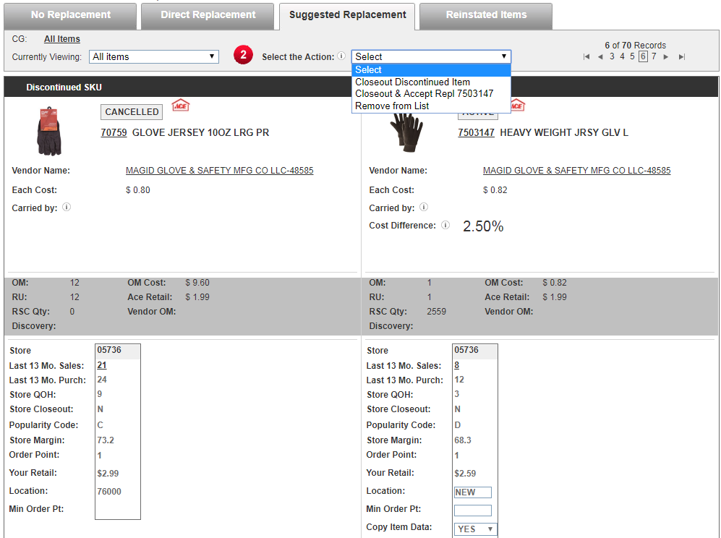

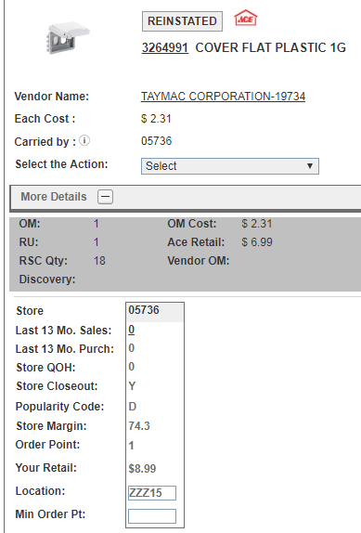
Products handled by ICM:





