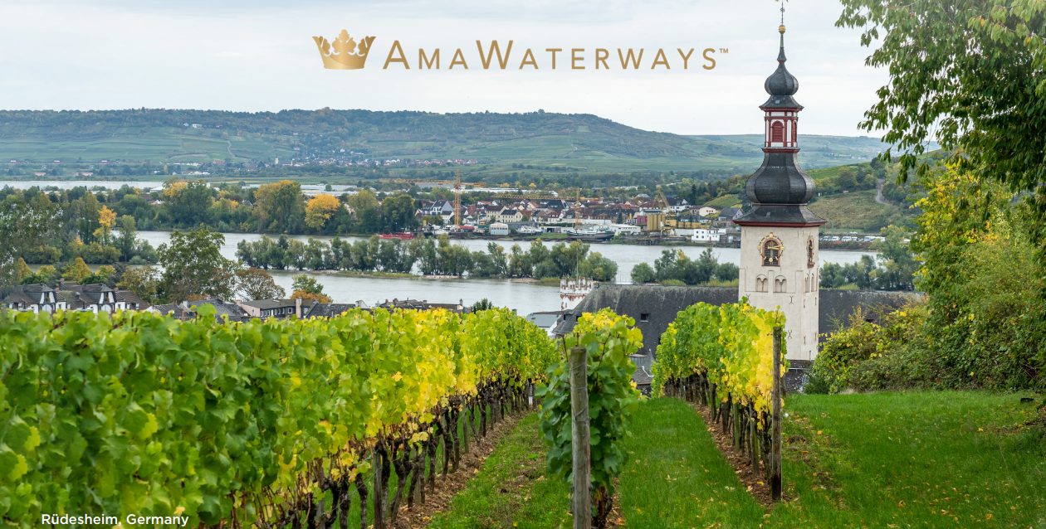
Step aboard a world of unparalleled experiences, where your journey is our passion. Aboard our award-winning ships, you will be delighted in the luxury of space, breathtaking views, exquisite cuisine, and impeccable service - providing the ultimate river cruise experience for you and your members.

Why Host a Wine Club Group on a River Cruise?
WINE AND RIVER CRUISING:
THE PERFECT BLEND TO BOOST YOUR BRAND AND CREATE A WONDERFUL MEMBERSHIP EXPERIENCE
Imagine the members of your wine club toasting life’s sweetest moments with your most celebrated bottles while cruising through one of Europe’s most renowned wine regions. When you join us on one of our river cruises, you’ll discover iconic vineyards and historic cellars in breathtaking destinations. Discover France’s Bordeaux region, Portugal’s storied Douro Valley, Austria’s Wachau Valley, and beyond, all while inspiring your followers with your finest wines.
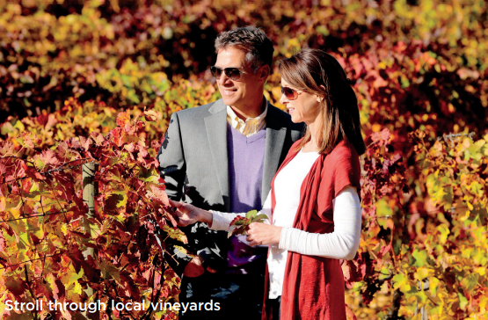

WHAT’S INCLUDED:
- 7, 10,11, or 14-night cruise in elegantly appointed accommodations (optional pre and post land packages available).
- Fine dining at The Chef’s Table and Main Restaurant (four dining venues on AmaMagna)
- Hand selected complimentary red and white wines from Europe’s great wine regions, beer and soft drinks served with lunch and dinner onboard
- Daily “Sip & Sail” cocktail hour with complimentary wine, beer and spirits
- Complimentary Wi-Fi onboard
- Small group guided shore excursion with a variety of choices and activity levels
- Adventurous guided bicycle and hiking tours
- Complimentary bicycles and helmets to explore on your own
- Professionally trained Wellness Host leading a variety of exercises classes
- Experienced and dedicated Cruise Manager who accompanies you throughout your entire journey, both on land and on your cruise
- AmaWaterways will assist with personalized marketing materials for your wine club members and followers
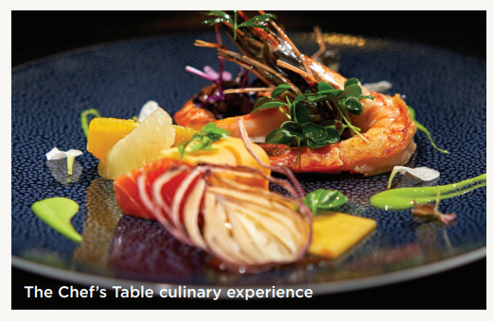
With a minimum of only 20 passengers (10 cabins), your group will also receive:
- 1 private excursion
- 1 private wine tasting event in The Chef’s Table
- Discount towards each cabin
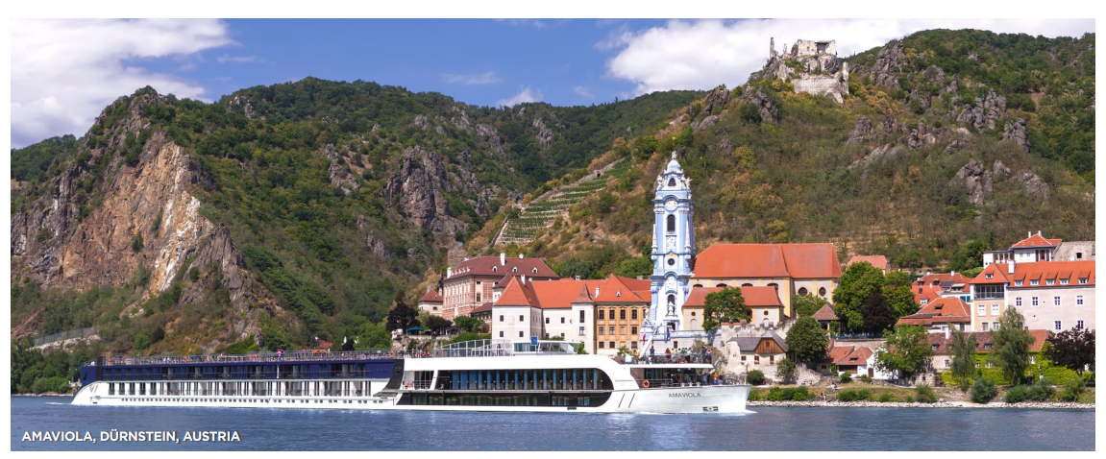

THE LUXURY OF MORE
AmaWaterways’ focus is continually finding ways to give their guests more – more memorable experiences, more space, and more choices. Offering the luxury of space, elegant accommodations and a wealth of innovative amenities, our award-winning ships are designed to maximize every aspect of the onboard experience for an average of just 150 guests. Whether guests are relaxing within the modern comforts of their stateroom, taking a dip in the sun-deck pool or enjoying complimentary drinks at our “Sip & Sail” cocktail hour, their 5-star floating hotel provides them everything they need for an unforgettable journey. Multiple dining venues are also available, including a multi-course tasting menu at The Chef’s Table specialty restaurant and four unique restaurants on board the AmaMagna.

THE AMAWATERWAYS EXPERIENCE
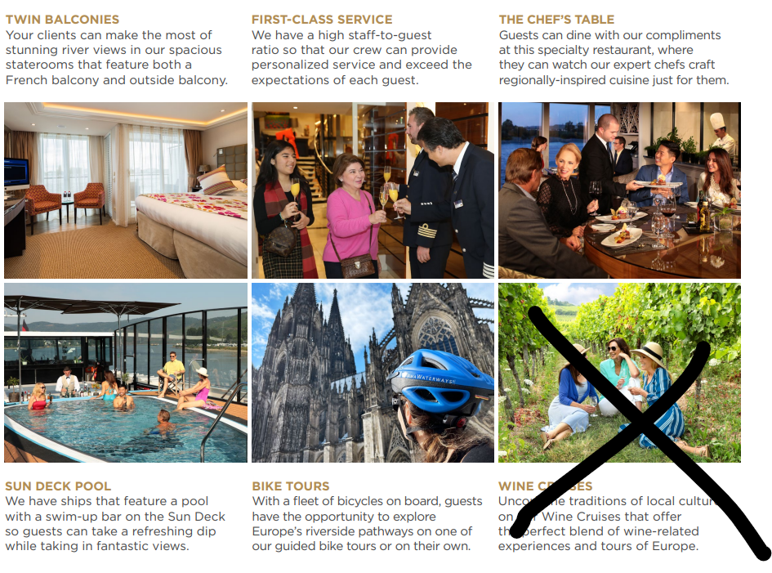
(instead of the crossed off box above, please include this…)
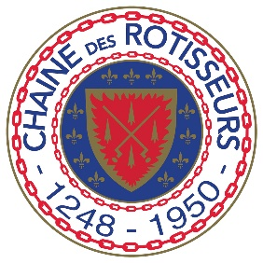
AmaWaterways and President Rudi Schreiner were inducted into La Confrérie de la Chaîne des Rôtisseurs, a prestigious international gastronomic society dedicated to fine cuisine. Founded in Paris in 1950 to honor the royal Guild of Goose Roasters (whose origins date back to the 13th century), it is the oldest and largest food and wine society in the world. Membership to La Chaîne des Rôtisseurs is by invitation only and is extended to those possessing world-class culinary acumen. All of our ships in Europe are members and our onboard culinary team is united by a desire to share their expert knowledge of wine and fine dining with you.

For group inquiries, contact:
Steffy Blasdell
E: steffy@silverleaftravel.com
Tel: (623) 826-8776

Or

Kim Covert
Email: kim@silverleaftravel.com
Tel: (480) 704-4022

