I need design for the Canadian clothing line Big Woof Apparel.

Big Woof Apparel or short version - Big Woof is an apparel line targeting Great Dane lovers and owners. Designs on the apparel are inspired by the majestic size and goofiness of the gentle giants. Some designs are humorous, some show Great Danes as an elegant and powerful dog.
Big Woof is an apparel line supporting non-for-profit organization called My pet and ME (Mega Esophagus). ME is a condition that is very difficult to manage and shortens pets’ life drastically. My pet and ME is dedicated to bringing awareness through education and research to the public around ME illness in dogs and cats and providing support and services to the owners of pets born with ME to prevent sending them to the shelter or for euthanization.
ABOUT THE DESIGN:
I am looking for funny design to be used on an adult unisex navy heather color hoodie as on the picture below:
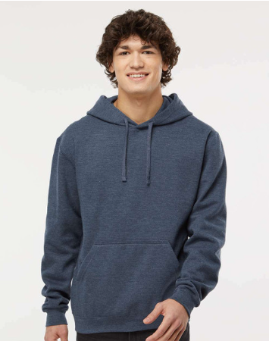
Design:
I would like the design to be one or two colors. The overall feel should be rustic, funny and cool looking.
Incorporate saying such as: I love my car rides or I love my sunwoof or If you don’t have one you’ll never understand (similar to the style on the picture below but instead of a Great Dane portrait use design with the Dane in the car) Use pictures below as an inspiration for the car rides with Great Danes.
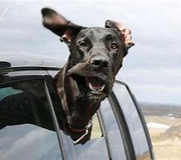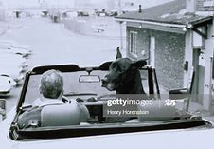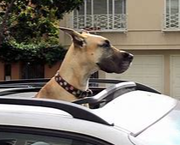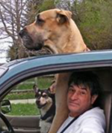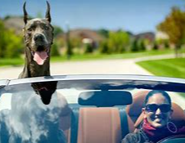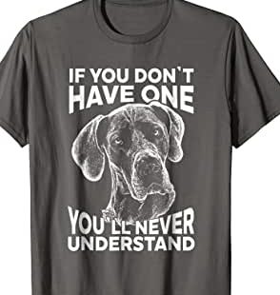
If possible, try to incorporate some design on the sleeve or back of the hoodie. Use your imaginary. Sleeve or the back, or both, could have text, graphic or anything you feel like it will look good. Could be small or big.
Target market: Great Dane owners and dog lovers with the sense of humor.
Industry: Clothing brand
Colors: Designer to choose colors to be used in the design.

