Sell Sheet Outline
Please check out www.ventboards.com for more info on this product.

Front:
- Address problem it solves – “Enhanced Protection Against Infectious Airborne Particles”
- Big rendered image of VentBoard system in a room with a visual aid (arrows) showing airflow into the board. (We are looking for a updated image that shows air coming into to the headboard (dirty red arrows) and coming out of the HEPA filter with (clean Green arrows). We also want to remove the 2 black items on the bottom and replace them with a rough image of the attached white HEPA machine on the bottom (No labeling required)
- With the image is our 2-3 sentence overview of what the system does.
  - “The VentBoard is an air filtration system that reduces the exposure to airborne infectious particles for healthcare workers, patients, and visitors by utilizing a source-focused technology that captures airborne infectious particles at the source. The VentBoard utilizes a patent-pending headboard design that pulls air from the head area of the patient through a HEPA filtration system and exhausts filtered air back into the room.”

Back:
TOP:
Rendering of the different types of protections similar to below. Give people a visual aid of “source-focused” filtration. For spacing, we could do the 4 graphs next to each other rather than 2 on top, 2 on bottom like below. We want this image recreated.
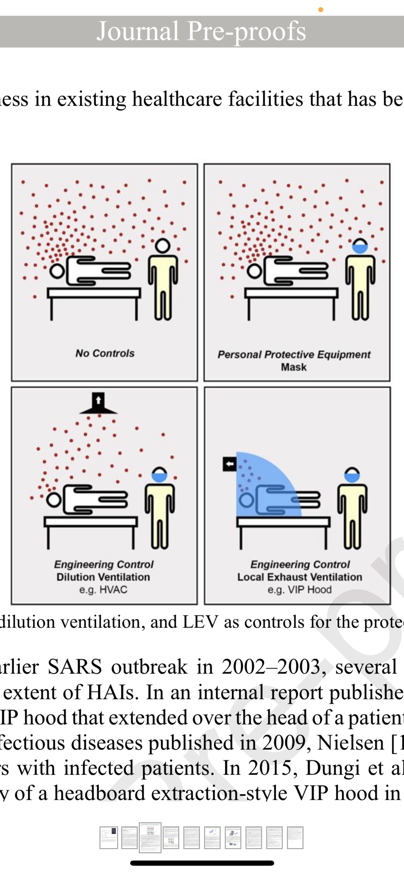

MIDDLE:
Graph of our internal data using the NIOSH Droplet Testing Protocol.
Blank Page | VentBoards LLC

Ventboards Internal testing. The VentBoards System has been shown to drastically reduce the number of airborne particles in a room within minutes of being powered up.

BOTTOM:
Item numbers:
SKU | Description
VB100SYS | VENTBOARD SYSTEM (VENTBOARD, HEPA FILTER SYSTEM, HOSE)
VB100 | VENTBOARD
VB100FAN | HEPA FILTER SYSTEM
VB100FIL | REPLACEMENT HEPA FILTERS
VB100HOSE | HOSE
VB100CP | CANOPY POLE (SET OF 2)
VB100C | CANOPY
VBBASE | FREESTANDING BASE

Contact info: hello@ventboards.com, 302-305-9559

Extra Images:

To be used in photo render on the top.

