LTC PROPERTIES, INC.
HUMAN CAPITAL POLICY

At LTC, we strive to cultivate a cohesive company culture based upon ethical standards. We recognize and value our employees and are committed to being a workplace that encourages respect, collaboration, communication, transparency, and integrity. We seek to hire talented employees with diverse backgrounds and perspectives.

The development and maintenance of this policy is a company-wide effort overseen by LTC’s Board of Directors through its Environmental, Social and Governance (ESG) Committee. We will review and evaluate this policy at least annually. All employees will receive a copy of this policy. This policy is accessible on our website at www.ltcreit.com.

While crafting this policy, we referenced multiple third-party international and national organizations. Whenever possible, we have aligned our approach in this policy with the following:
- International Labour Organization Conventions
- United Nations Sustainability Development Goals (UN SDGs)
- United Nations Guiding Principles on Business and Human Rights
- Sustainability Accounting Standards Board (SASB) Human Capital Bulletin
- Bloomberg Gender Equality Index

WORKFORCE OVERVIEW
We endeavor to provide a working environment where all employees can have fulfilling careers that enhance our company and community.
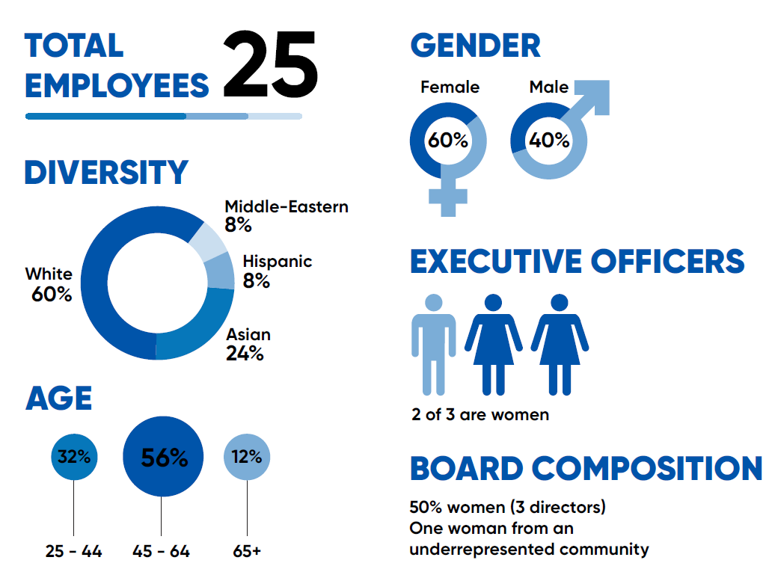

As a result of our company culture and commitment to attract, motivate, reward, and retain our employees, we believe our workforce is strong and stable. The average tenure of our employees is 10 years or more.

Annually, we monitor employee satisfaction by requesting all employees to participate in an engagement survey. Our executive team analyzes the results and makes incremental changes based on employee feedback. In 2021, we received 21 completed surveys. Employee satisfaction averages 90%.

ANTI-HARASSMENT AND NON-DISCRIMINATION
LTC is committed to maintaining a work environment that is free from unlawful discrimination, harassment, and retaliation. In keeping with this commitment, our company does not tolerate unlawful discrimination against, or harassment of, an applicant, employee, client, customer, or vendor based on any protected characteristic. LTC prohibits retaliation of any kind against an individual who complains of suspected harassment or discrimination, or who otherwise engages in protected activity.

In accordance with California law, all employees are required to complete anti-harassment and anti-abusive conduct training courses on a bi-annual basis.

ANTI-CORRUPTION
LTC expects our employees and persons with whom we do business, including lessees, borrowers, and financing sources, to act ethically and with integrity. LTC does not tolerate corruption in any form. LTC will not engage in any form of corrupt practices including, without limitation, extortion, fraud, impersonation, false declarations, bribery, money laundering, supporting or involvement with terrorist or organized crime organizations or activities. LTC will not offer, and LTC personnel will not solicit or accept, bribes or kickbacks involving any government official or third party with the intention of obtaining or retaining a business advantage. We do not permit improper or excessive payments in dealing with the government or private sector. Our employees are prohibited from making payments or promises to influence acts or decisions. Our employees also are prohibited from receiving payments from our lessees, borrowers, and financing sources. Our employees are expected to observe all government rules, regulations and restrictions on gifts and entertainment.

COMPENSATION AND BENEFITS
LTC recognizes the importance of committing to ensuring a living wage for all employees by complying with the national wage regulations, such as the minimum wage and overtime payments. LTC compensates employees at competitive rates, in all cases at or above applicable minimum wage levels including overtime for eligible employees.

We believe the employee health care and other benefits we offer meet or exceed market standards. For qualified employees, we offer a 401(k)-retirement plan with an employer contribution matching program and an opportunity to earn discretionary bonuses, restricted stock awards and performance-based unit awards. We offer flexible working locations for certain job functions.

We are committed to the health, safety, and wellness of our employees. We pay 100% of the heath care premiums for employees and all eligible dependents. The benefits we offer include medical, dental, and vision coverage, paid time off, paid holidays, bereavement leave, and employer-funded life and disability insurance. We also offer an employee assistance program to support our employees’ mental health and well-being. Additionally, we provide disability and medical leave, family and pregnancy leave, and organ and bone marrow donation leave.

DIVERSITY, EQUITY & INCLUSION
As an equal opportunity employer, LTC values the diversity of the unique individuals who comprise our team from workforce level to senior level and extending to our Board of Directors. LTC does not discriminate based on an individual’s race, gender, age, color, religion, national origin, mental or physical disability, sexual orientation, ancestry, genetic information, military or veteran status, creed, pregnancy, marital status, citizenship, gender identity, gender expression or any other status protected by applicable law. This statement extends to specifically respect and protect minority groups and women’s rights under the internationally endorsed UN Guiding Principles on Business and Human Rights.

Our company will provide reasonable accommodations for qualified individuals with disabilities and medical conditions. Employment decisions at our company are based on merit, qualifications, and abilities.

EMPLOYEE SAFETY AND HEALTH
Employee safety and health is an important element of LTC’s working environment, and we are dedicated to creating and maintaining a safe and healthy working environment.

We discourage employees from lifting heavy objects and we encourage good nutrition by providing healthy snacks for employees. We also make adjustable stand-up desks available and encourage their use by employees. Smoking is prohibited in our offices. Hand sanitizer stations are located throughout the office.

A safe and healthy environment includes access to clean sanitary facilities and drinking water as a fundamental human right. LTC’s corporate headquarters provides employees with tri-temp purified water from reverse osmosis water systems. These water systems are plumbed into the wall, eliminating the need for plastic or glass refill bottles found in other water systems.

Over the past 30 years, LTC has incurred one incidence of workman’s compensation settlement for an injury, and zero occupational diseases or workplace-related fatalities.

FREEDOM OF ASSOCIATION
We recognize and do not interfere with our employees’ right to self-organization, to form, join, or assist labor organizations, to bargain collectively through representatives of their own choosing, and to engage in other concerted activities for the purpose of collective bargaining or other mutual aid protection.

PHILANTHROPIC SUPPORT
LTC supports charitable initiatives ultimately benefitting our operating partners, their residents and employees, and the seniors housing and care industry. This support includes industry associations on various levels (national, state and local) and customer employee assistance funds.

Many employees support our local community through voluntary contributions to annual company-wide holiday season philanthropies. LTC sponsors and organizes a team to participate in the Walk to End Alzheimer’s.

POLITICAL CONTRIBUTIONS
LTC’s Code of Business Conduct and Ethics prohibits contributions of LTC assets to any political candidate, political action committees, political party, or ballot measure without the permission of our Chief Executive Officer or Board of Directors.

STAKEHOLDER CONSULTATION AND ENGAGEMENT
LTC distributes a proxy statement and holds an annual meeting to provide stockholders the opportunity to engage with the company. Other stakeholders may contact LTC online at www.ltcreit.com/contact.

TRAINING AND EDUCATION
LTC invests in employee development and training by providing access to in-class and online learning and by promoting participation in professional seminars and continuing education. We encourage attendance at industry conferences where employees can choose from various presentations, seminars, and workshops. LTC reimburses employees who attend these industry conferences.

For employees with at least one year of service, we grant up to three days leave to take professional licensing examinations. We pay for the annual renewal fee for registration for a professional license. We encourage membership in professional societies.

COMPLAINTS
LTC has implemented a whistleblower hotline and dedicated email address to enable all interested parties, including employees, to submit confidential complaints, concerns, unethical business practices, violations or suspected violations for all matters pertaining to accounting, internal control, or auditing. Our company will not tolerate retaliation for whistleblower reports made in good faith.

Please direct questions and input about this policy to Mandi Hogan mandi.hogan@ltcreit.com.

Adopted , 2022

