A Year with Narrative 4

About Narrative 4
Narrative 4 (N4) equips educators and artists to help young people learn and lead with curiosity, deep listening, and imagination. We envision a world where community and civic engagement replace loneliness and isolation. We are creating this world student by student, school by school, story by story. Join us at narrative.com.

Outcomes
A Narrative 4 school partnership ensures that every student and teacher understands:
- Who I am matters.
- I already know many things.
- I belong to a community who cares about me.
- I can pay attention to my feelings and make choices in how to behave.
- I know when to stop and take care of myself.
- When challenges arise, I know I can handle them, either on my own or with the help of others.
- I can sustain attention to other people’s experience.
- I understand my responsibility for the well-being of others.
- I can learn from and teach other people.
- I can find joy and purpose in a variety of ways.
- I understand that discovering my strengths sometimes involves hard work.
- I can improve my life and the lives of others.

N4 supports the growth of the whole individual: as learners and as human beings. We do this work in three phases over the course of a yearlong engagement. N4 customizes your plan to address the specific needs and interests of your school community.

Phase 1: N4 Community Skills | Phase 2: N4 Story Exchange | Phase 3: N4 Arts & Civic Engagement

Phase 1: N4 Community Skills

The work of Phase 1 is to create the necessary conditions for student risk-taking and growth. Students develop a positive sense of self and community through hands-on N4 activities, videos, readings, and journaling. Experts in education and psychology offer strategies in deep listening, self-awareness, self-management, social awareness, relationship skills, and responsible decision-making.

Skill 1: Know yourself.

- Practice self-care
- Know how to self-monitor and self-calm.
- Recognize your own strengths and needs.

Skill 2: Commit to positive relationships.

- Practice deep listening. Self-monitor for a loss of focus. Use techniques to bring your attention back.
- Be accountable to learning about different experiences and making connections with people who are different from you.
- Create space for all emotions in constructive ways. Embrace discomfort.
- Self-monitor for unconscious biases.

Skill 3: Define how you want your community to treat one another.

- Recognize neurodiverse ways of engagement
- Practice neutrality to what’s being discussed but not to how people treat one another.

Skill 4: Reflect with the goal of continuous improvement.

Sample Resources
Day 1 of School: Building Community, Liz Prather
Cultural Wealth Survey, Tyrone Howard
Self-Awareness Activities, David Yusem
Relationship Skills, David Yusem
Story of Self, Story of Community, Limarys Caraballo
Phase 2: N4 Story Exchange
In phase 2, students experience the N4 Story Exchange and learn how they can create and receive the benefits of a positive community. N4 scaffolds the experience based on your community – ensuring a successful exchange for elementary students, multilingual students, etc.

Story Exchange Participants Learn That: | These Practices Go Beyond the Story Exchange:
Showing up is an act of curiosity and courage when the commit to hearing someone else’s story. | 1: CURIOSITY  You learn from others’ knowledge and experience.  How can I cultivate curiosity?
Other people need and deserve to feel heard when they let their partner tell their story without interruption. | 2: LISTENING  You seek to understand before speaking.  How can I focus on hearing others?
We can grow by learning about other people’s experiences when theyretell their partner’s story to the larger group and imagine themselves as their partner. | 3: IMAGINATION  You consider new possibilities.  How can I imagine possibilities beyond what I already know?
Reflection is necessary component of growth when they debriefon the process and offer their partner a hope for the future, using the prompt, “My hope for you is....” | 4: POSITIVE ACTION  You show your words and actions matter.  How can I bring positive action to my life and community?

Four Key Practices Embbeded in Our Work
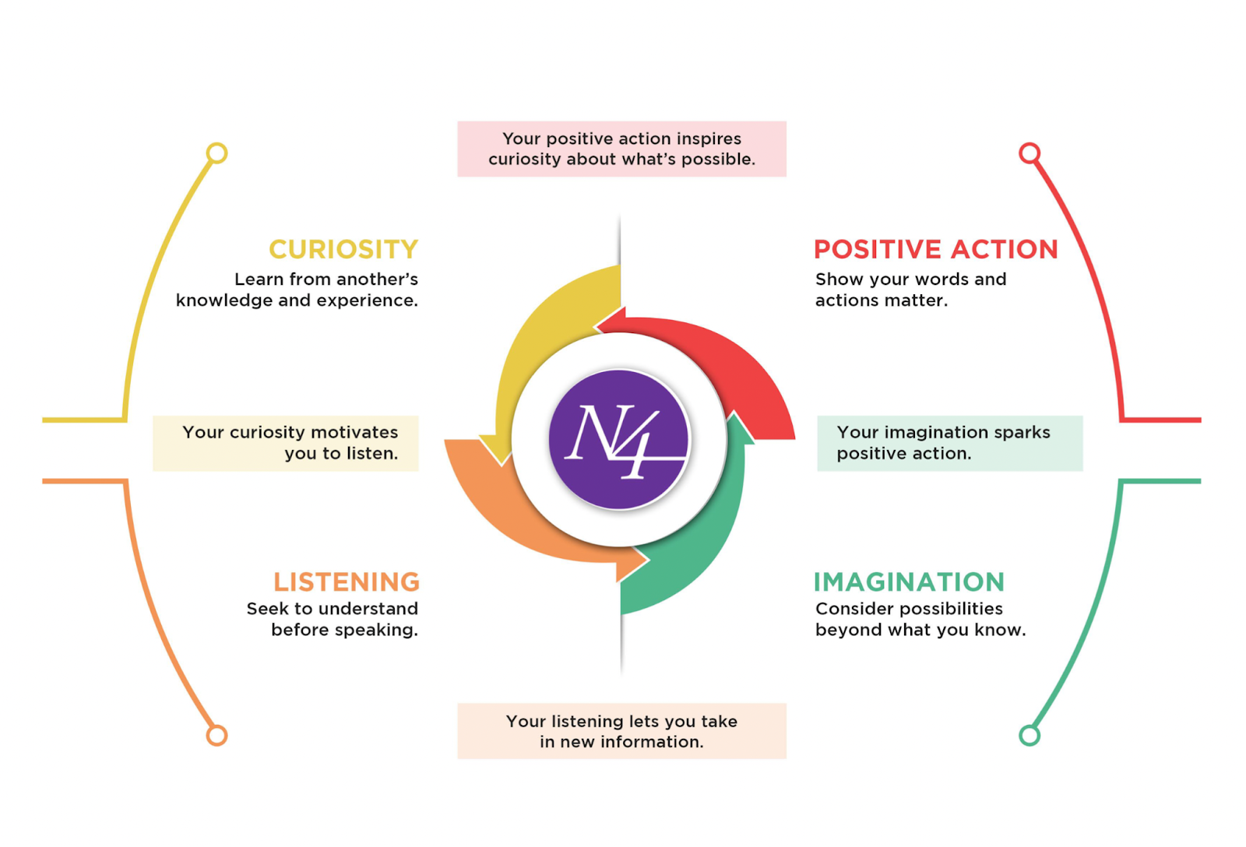
After learning the practice in your school setting, N4 can support other kinds of Story Exchanges such as:
- Story Exchanges with public service organizations to show students the real tools and adults doing this work every day
- Formal long-term collaboration with another school (N4 Field Exchange)
- Letter writing exchanges with students across the country and globe

Sample Resources
Story Exchange in the Content Areas: From Prompt to Project
STEM Storytelling: “Dear Data”, Tanya LaMar
Storytelling is Searching, Natalie Handal

Phase 3: N4 Arts & Civic Engagement
After the Story Exchange, your students will know they can support one another and take constructive risks. In Phase 3 we’ll explore how students can bring N4’s Essential Practices into their community/ies
N4 Arts
We have a vibrant community of global artists who embody N4’s Essential Practices of curiosity, listening, imagination, and positive action. Students can interact with these artists in print, video, and live hands-on workshops where they recognize their own identity as artists and explore how the arts can be a tool for positive change in their community/ies.

N4 Civic Engagement
N4 Civic Engagement invites students to recognize the ways they are already helping their community/ies and to choose what else they would like to do. Students learn how their existing strengths can help them identify and collaborate on solving community problems. This is a proven path for further growth supported by N4’s Learning Resources and experts on youth civic engagement. As students participate, they become part of the larger N4 community of civically engaged students and adults around the world and grow their expertise through workshops on civic engagement, emotional intelligence, and the arts.

Sample Resources
Gathering Observations to Create Art, Colm Mac Con Iomaire
Research for Change, Ernest Morrell
How to Invite in Local Experts Based on Students’ Questions, Nicole Walker
How to Help Students Create a First-Person Advocacy Proposal, Nicole Walker
Civic Engagement Profiles (Real Student Models)
Ezzaddin and Revolt: Hearing Other People’s Stories Changes Us
Tricked Out Trash Cans, Chris Rasheed and Students

