ONE IS NOT ENOUGH! HEALTHY ADDICTION

ABOUT THE COMPANY:
Big Woof Apparel or short version - Big Woof is an apparel line targeting Great Dane lovers and owners. Designs on the apparel are inspired by the majestic size and goofiness of the gentle giants. Some designs are humorous, some show Great Danes as an elegant and powerful dogs.
Big Woof is an apparel line supporting non-for-profit organization called My pet and ME (Mega Esophagus). ME is a condition that is very difficult to manage and shortens pets’ life drastically. My pet and ME is dedicated to bringing awareness through education and research to the public around ME illness in dogs and cats and providing support and services to the owners of pets born with ME to prevent sending them to the shelter or for euthanization.
ABOUT DESIGN:
I am looking for design to be used on dark T-shirts and hoodies.
Front of the T-shirt should have graphic of multiple Great Danes. Pictures below are just for an inspiration. Please do NOT use them in your design. Feel free to use your own imagination as long as there is more than one Great Danes in the graphic. Graphic can look like drawing, watercolor, art print or just gray scale design style similar to the black t-shirt on the picture below:
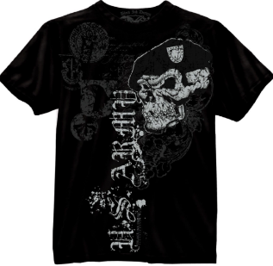
Multiple Great Danes for an inspiration.
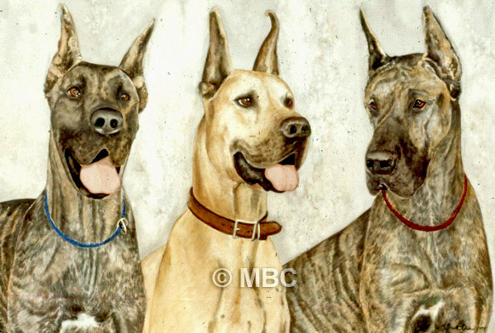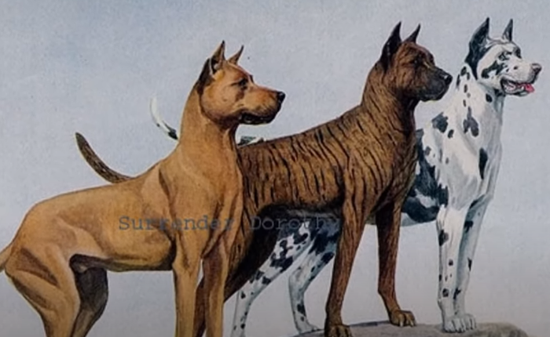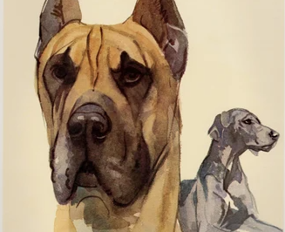

The back of the T-shirt will have sign: ONE IS NOT ENOUGH! HEALTHY ADDICTION
The sign at the back can be placed on the top back of the t-shirt or at the bottom of the t-shirt.

Additional comment: As this design will be one of multiple designs in the apparel line I would like to use the same style and most likely same designer to design few more T-shirts.
I appreciate your time taken to design my t-shirts.

