ABOUT THE COMPANY:
Big Woof Apparel or short version - Big Woof is an apparel line targeting Great Dane supporters and owners. Designs on the apparel are inspired by the majestic size and goofiness of the gentle giants. Some designs are humorous, some show Great Danes as an elegant and powerful dogs.
Big Woof is an apparel line supporting non-for-profit organization called My pet and ME (Mega Esophagus). ME is a condition that is very difficult to manage and shortens pets’ life drastically. My pet and ME is dedicated to bringing awareness through education and research to the public around ME illness in dogs and cats and providing support and services to the owners of pets born with ME to prevent sending them to the shelter or for euthanization.
ABOUT DESIGN:
I am looking for design to be used on T-shirts and hoodies.
Portrait of the Great Dane with cropped ears will be placed on the front of the t-shirt or hoodie.
Back of the t-shirt will have sign – Born to be great

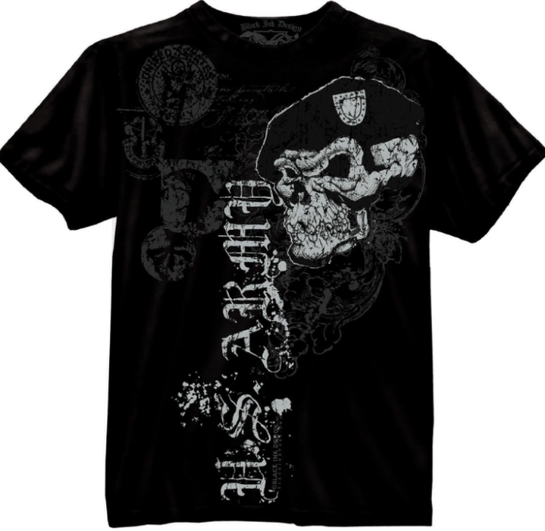
I like this style of the artwork. Light and dark gray, or almost black on the black t-shirt.

Please use portrait of a Great Dane with cropped ears. Pictures below are just for a reference.

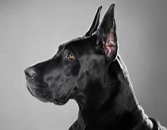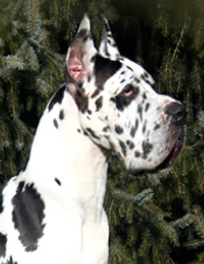

The front of the T-shirt will have a Great Dane portrait.
The back of the T-shirt will have sign: BORN TO BE GREAT
The sign at the back can be placed on the top back of the t-shirt or at the bottom of the t-shirt.

