
RAISE HL-48 UAS with SABRE SKY-3D payload

Introduction

The RAISE HL-48 is an Unmanned Air System specifically built for a diverse range of applications and payloads including geospatial, security, defence, law enforcement, coast guard, construction, maintenance of existing infrastructure.

The RAISE HL-48 supports SABRE SKY-3D™ integrated with a FARO high precision laser scanners, enabling the LiDAR system to capture high-resolution data of up to 1 million points per second. The system is complemented with high-resolution imagery using an optional FLI R camera system to deliver the best in market airborne mobile mapping solutions.

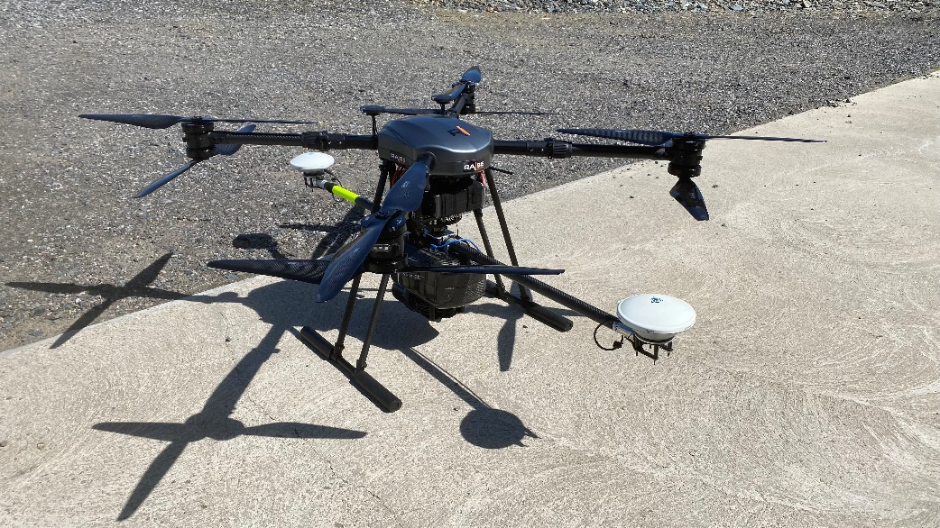

Features

- GTOW 25kg
- Useful Load 8kg
- HD FPV Camera
- Dual GPS
- 100m Laser Alt
- 360 Collision Detection
- 16KM Line of Sight Transmission
- Removable Quick Connect Props



Specifications:

Item | RIL HL - 48 |  | Electrical Power Provision & Distribution | RIL HL-48
Dimensions: Airframe | Width: 1060.0mm |  | Battery Weight: | 1350g
Dimensions: Airframe | Length: 1060.0mm |  | Cell Chemistry: | Lithium Polymer (LiPo)
Dimensions: Airframe | Height: 400 – 700mm |  | Battery Design: | Standard Lithium Polymer
Power Source: | 4 x Lithium Polymer (Li-Po) Battery – 6S - 12S |  | Battery Connectors: | Tatu Independent Balance and Power - 2 pin
Motor Type: | 8 x Electric Brushless Motor
Propulsion Layout: | Quadcopter design with corner positioned puller rotors.
Battery Weight: | 4 x 1350g |  | Propulsion System RIL HL-48
Internal Components: | Flight Controller / Herelink  Controller |  | Motors: | 8 x Motors (Coaxial)
Control Data Link (master)  Gimbal Control Data Link (slave)  Video Data Downlink | 2.4GHz ISM Receive sensitivity: -99dBm@20MHz BW Interference recovery: < 1s |  | Props: | 8 x 28” Carbon Fibre Propeller (Quick Release)
Transmitter Power (EIRP): | -99dBm
Video data down link: | 2.4GHz ISM
Antennas:  Control Data Link:  Video Data Downlink: | Circular (5dBi) × 1, detachable, omnidirectional (2dBi) × 1, detachable,built-in wifi antenna, built-in GPS antenna, external GPS antenna interface x 1  MMCX antenna jack x 2: used for signal transmission and ground communication

Failsafe Features
Return to home function on loss of transmitter signal.
Failsafe works to protect the aircraft if TX signal is lost. In the FailSafe mode, the flight controller will automatically control the aircraft to hover or fly to the home point and land.
Manually switched Failsafe return to home function.
Manual Failsafe works to protect the aircraft in any event the operator is unable to carry on flying. In the manual Failsafe mode, the flight controller will automatically control the aircraft to hover or fly to the home point and land.
Low Voltage Protection
In order to prevent the aircraft from crashing or other harmful consequences caused by low battery voltage, two levels of low voltage protection are available.

Transit Case
Width | Depth | Height | Weight
1200 mm | 800 mm | 510mm | 28kg

