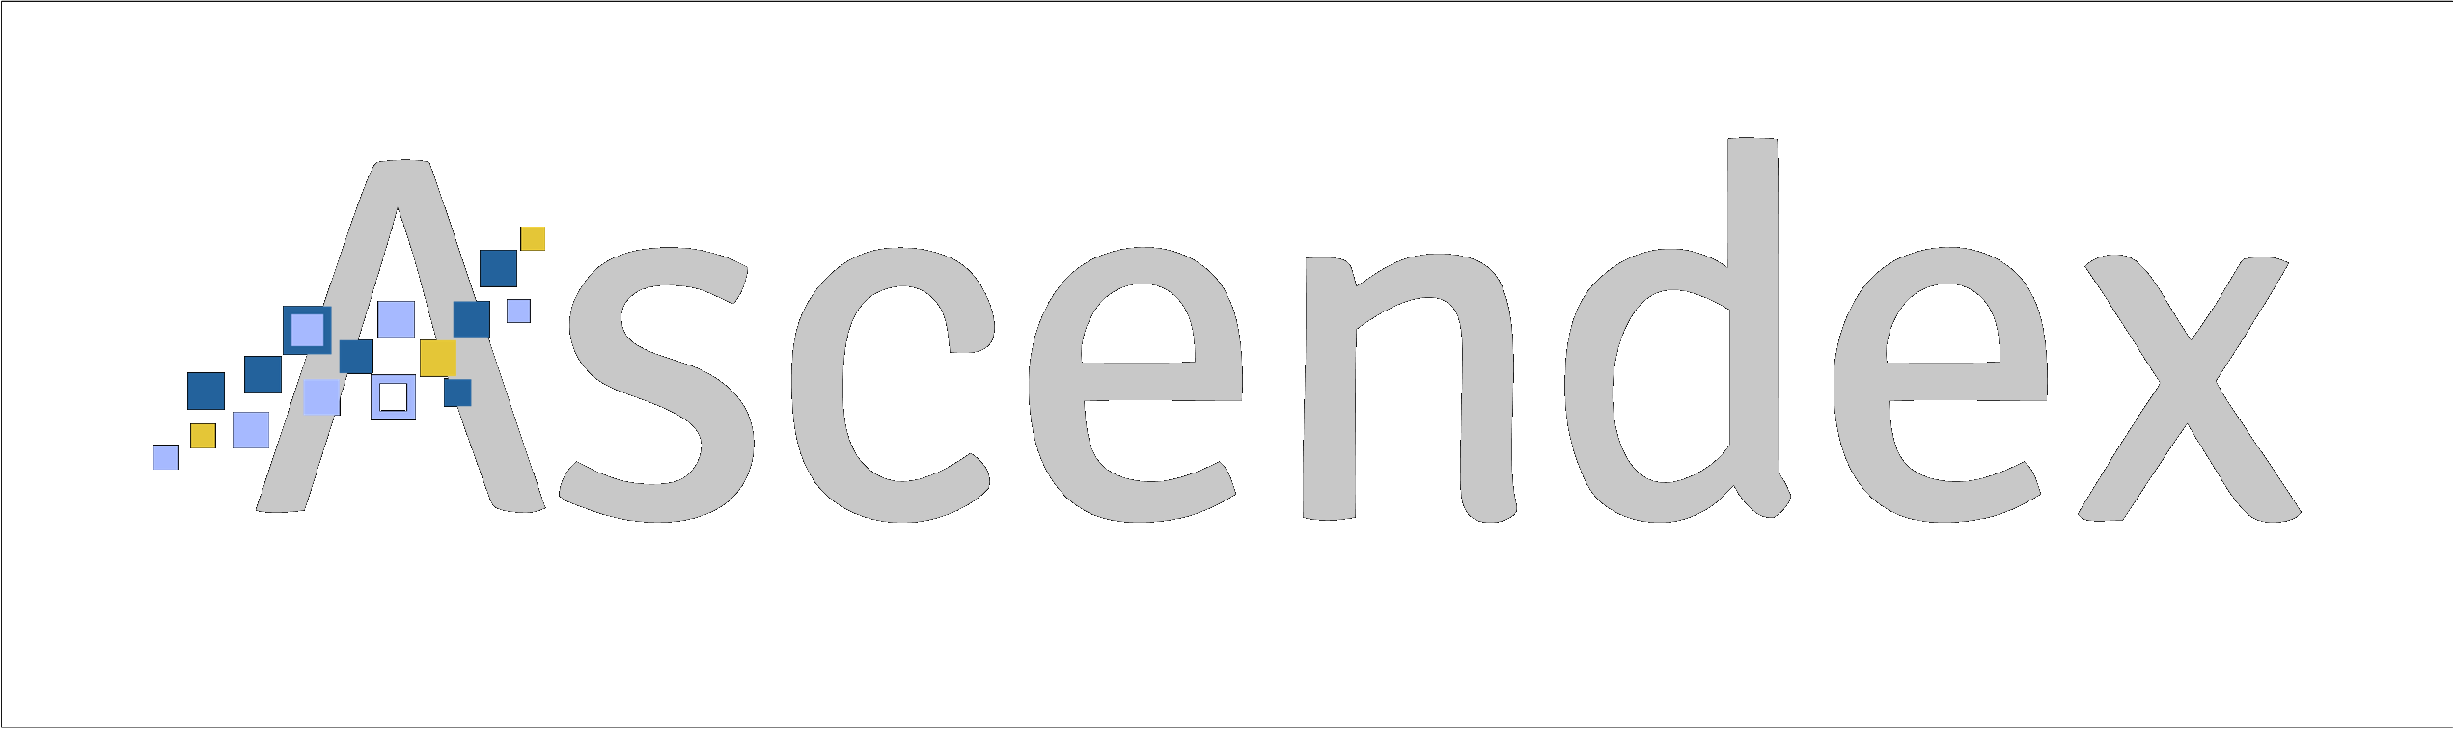

Transformation delivered.
Our approach is to give you what you need to get the most from your ERP implementation.  If you know what that is, we can leverage a resource base of over 200 ERP consultants, both onshore and off, to provide the expertise that will fit seamlessly into your team.  If you don’t know what you need, we have a process to help you figure that out. Our eight-point assessment starts with strategy and covers the other seven essential elements that ensure implementation success.  Bringing the Most Value to Your ERP Implementation  - Emphasis on Process Improvement and Adoption  You want to improve processes and ensure adoption. We can help you do both. Ascendex evaluates current processes, identifying process streamlining opportunities along with providing process insight to the ERP implementations. This enables an ERP implementation tailored to your business resulting in increased adoption.  - Bringing Down Costs with the Right Resources  If you’re looking for one resource or twenty, working on-site or remote, onshore or off, we can provide them.  - Need to Add Value to Your Current Installation?  If you need help to drive the most value from a system already in production, whether it is business intelligence, Power Platform applications, integrations, or new features, we can help.  - Not Sure What You Need?  If you sense something is wrong with your implementation but don’t know what it is, we can help. Our eight-point assessment starts with strategy and continues with the seven things that ensure success.  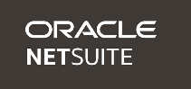  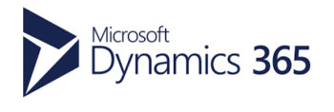  Platforms |  | Services


ERP
Implementations
Select and implement the right ERP platform for your needs and objectives
- Start to Finish Implementations
- Project Turnarounds
- Hard to Find Resources
- Value Add Solutions


ERP Leadership & Staffing
Secure top match talent from interim CIOs to software engineers and project managers.
- Strategy Focused Leadership and Expertise
- Right-sized for Your Business
- Maximize ROI
- Lead from Experience

 |  | ERP Transformation & Strategy
Define and execute your transformation strategy and clarify technologies to make it real.
- Strategy and Innovation
- Digital and Technology Prioritization & Roadmap
- Executive Coaching
- Process Adoption & Optimization

200 Southdale Center Suite 158, Minneapolis, MN 55435 Tel 651.470.3209
www.ascendexconsulting.com

