INFORMATION ON THIS PROJECT

We are looking for a report to visual workers compensation claim data and the impact claims have on premium. I’m looking for something that is very visually NEW, appealing, easy to understand, and cutting edge.

Right now we are looking for 6 pages to be designed: a cover page, an informative page, and 4 reports. The key data for the last 3 reports are listed in the other document attached named “Key Data for Report”. These should be designed in a 8.5 x 11 page layout.

I would prefer a way where things can be combined without looking too crowded. You can play around with the background, for printing purposes try to leave white space.

Attached in file “inspiration” are a few things I found that I like the look of. Please design when YOU think is best. The information below & the comments on the side are just to help you visualize.

We are a mod analysis company that is always developing new reports. We are hoping to find a designer we can work with in the future as well – think of this as a trial run!

Disclaimer & Logo

- Please leave room for a disclaimer at the bottom of every page besides the cover page. “Proprietary and Confidential. Mod Advisor provides for an ESTIMATE of an experience modification factor. Your official experience modification factor is issued solely by the applicable workers' compensation rating bureau. Mod Advisor Inc. All Rights Reserved.”
- There should be a small logo somewhere on each page that is consistently in the same spot. For the cover page, you can put the logo wherever you see fit.

Name of Business

WORKERS COMPENSATION EXECUTIVE SUMMARY

Mod Effective 10-08-2022

This document uses proposed rating values that are not yet final.

Agent information
Name of agent
Phone #
Email

LOGO

Workers compensation claims can have a significant impact on a business. In addition to the direct
claim costs, there are many other costs associated with a workers compensation claim that can impact a business.

They are:
- Work Comp Premium Costs
- Overtime
- Administrative time spent on claim after an injury
- Lost Opportunities due to staffing
- Lost Productivity
- Clean up or repair of damaged equipment

OSHA estimates that depending upon the size of the claim indirect costs range from 1 to 4 times the
direct costs.

The following report explains in detail how a workers compensation claim affects the premium that
your business pays for workers compensation. Most business have an experience mod that is
reflective of their past claims experience and every claim has an impact on the experience mod. It is
important to note that some claims affect the mod differently.
- A medical only claim is reduced by 70% in the mod calculation.
- A medical/indemnity claim has no reduction.
- All claims are also limited by a primary threshold value where claims are grouped into primary claims and excess claims.

The following report will analyze the types of claims that are occurring in your business and will group
them together for ease of identifying trends and areas of opportunity to improve.

By identifying the types and causes of losses many times a cost/benefit analysis can be performed to
allow for safety training, additional equipment or building or process improvements.

For the premium cost analysis in this report we have used a manual premium of $XXX,XXX. A manual
premium is the premium derived by the carrier before any credits, debits, or experience rating.

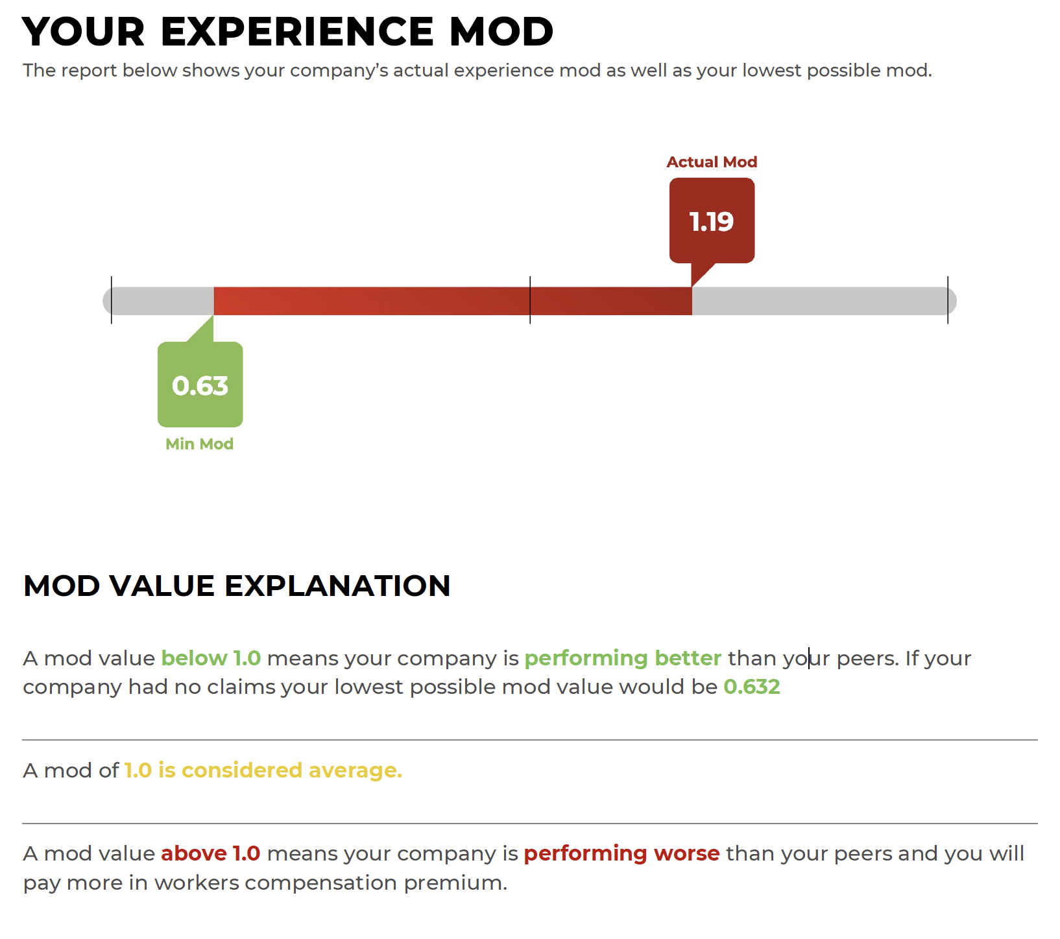

SUMMARY:

The incurred claims reported have a claim impact of .56 on your mod value. This is increasing your premium annually by $112,000.

In the following pages we’ll dig into the types of claims your business is having and look for areas of opportunity to reduce or eliminate claims and lower your mod value.

MEDICAL VS MEDICAL/INDEMNITY CLAIMS

The type of claims your business is having can have a significant impact on your mod value as not all claims are valued equally. Medical only claims have their value reduced by 70% in the mod calculation and any claim with an indemnity payment is not reduced. This is one of the reasons an effective return to work program can help reduce your premium costs.

Here’s your company’s breakdown.

The total losses for the period reviewed are $284,623.
Medical only claims accounted for $85,719 in losses.
Medical/Indemnity claims accounts for $198,904 in losses.

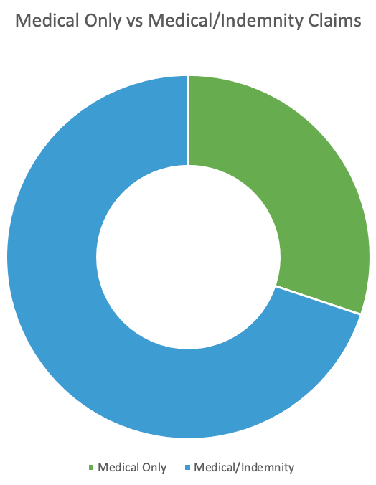
MEDICAL ONLY CLAIMS

$85,719 incurred losses
0.127 mod impact
$76,200 3 yr premium impact
MEDICAL/INDEMNITY CLAIMS

$198,904 incurred losses
0.446 mod impact
$267,600 3 yr premium impact

22
claims

CLAIMS BY CAUSE OF INJURY

Visually grouping the claims together can help with identifying trends and areas to focus on for improvement and future risk management. The following groupings identify the top losses incurred by your company.

CLAIMS BY NATURE OF INJURY

(information on other document)

