Research for Change (Youth Participatory Action Research)

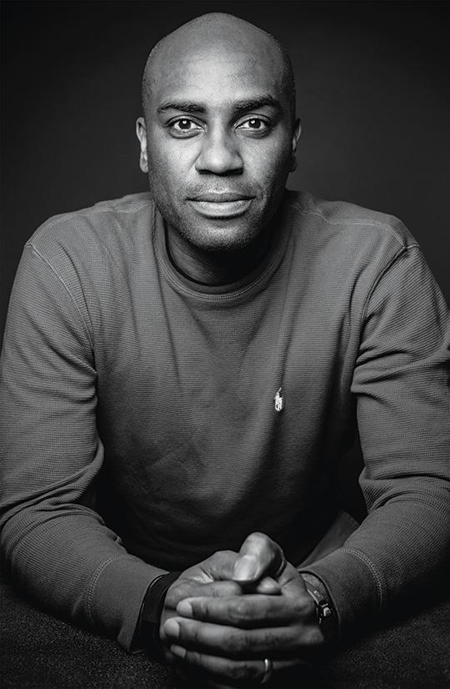 | Ernest Morrell is the Coyle Professor, a member of the faculty in the English, and Africana Studies Departments and Director of the Center for Literacy Education at the University of Notre Dame. Ernest is also director of the National Council of Teachers of English (NCTE) James R. Squire Office for Policy Research in the English Language Arts. His scholarly interests include: Critical Pedagogy, English Education, Literacy Studies, Postcolonial Studies, popular culture and education across the African Diaspora.

When we talk about transformational learning, we must talk of engagement, voice, agency, and love.

Rather than try to “figure out what’s wrong” with our beautiful and brilliant young people, we should be thinking about how to better harness their talents in making the world a better place. Such a process engages their creative genius and develops the academic and creative skills they require for active participation in the world.

How better to engage young people than to ask them to conduct transformational research in schools, neighborhoods, and communities? Who, more than they, are most invested in and impacted by the quality of life in these places?

Since the early 1990s, I have been working with students across the country to engage in Youth Participatory Action Research (YPAR). YPAR is at once a methodology, a pedagogical practice, and an ethic of love manifest through righteous action. When given the opportunity to identify a problem or concern, gather and study data, and generate possible solutions, YPAR becomes a powerful and empowering learning experience for students. Students develop their understanding of research and hone their academic and critical literacy skills while engaging in personal and meaningful work toward neighborhood, community, and social change. Estafania describes YPAR’s internal and external power: “I learned how to get my point across and sharing my message has helped me see that the problems just don’t happen here but in many places.”

The collective voice and agency of young people is a wisdom our society cannot do without. YPAR has given students a structure to do powerful and life-changing work. Students create art, music, poetry, social media sites, videos, policy briefs, podcasts, legislation, to powerfully change the way we all think, act, and believe.

To be true to its purpose, YPAR must be about student purpose, voice, and agency. Students must be the ones who choose how to answer the three essential questions that define this work.

YPAR’s 3 Essential Questions

Who is most impacted by this problem or issue?
How can everyone invested in this issue (who wants to) collaborate so that there are no sidelines?
Why are we doing this? How can this work make life better?

These questions help clarify students’ goals, both before and during the YPAR process. YPAR is about the mindset of a true ethical researcher, one who is focused on finding truth and making that truth useful to others.

YPAR 10-Step Process

Historians, scientists, artists, teachers, and mathematicians have defined processes to pass their learning onto future people who want to do the same work. YPAR is a common process I’ve collaboratively defined with students and teachers to help carry this work forward.

#1: Identify a Problem: Students identify a problem in their school, neighborhood or the wider community that they would like to study.

Encourage students to talk with their family members, community members, and one another about what they want to see changed and improved. Students can also write about their lives, specifically what they do in a day (A Day in My Life) and identify elements of their lives that could be improved through research.

#2: Develop a Question: Once students have identified a general problem, brainstormed possible elements of the problem, they then hone in on a specific focus and develop a researchable question. As they proceed through their research, they may revisit their question(s) to consider if it is too narrow or broad and amend as needed.

For example, if they are concerned about a broader topic, such as access to high quality afterschool programs, they might hone in on sports or music and research ways to create and offer these programs within their own schools and district.

#3: Design a Study: To answer or address their question, students need to develop a plan for what type of data they will collect, how they will collect the various forms of data, and how they will analyze the data. This serves as their roadmap. However, rather than thinking about this as a non-negotiable linear process, they should design their study and recognize that they may need to revise their “roadmap” as they learn more about their problem, the type of data that is most helpful, and better ways to proceed. In other words, research is often a circular or spiraling process so that as we learn, we may need to take a few steps back, amend, and then continue to move forward.

If students are interested in a topic such as how to improve after school programs for students’ overall health and safety, they can determine the type of data they need to gather and the necessary steps. For example, they might generate a list of data sources (e.g. interviews, focus groups, existing programs, list of stakeholders) and create a timeline and plan for how they will gather the data and who they should involve.

#4: Collect Data: Once students have designed their study and generated a list of potential data sources, they begin collecting data, both qualitative and quantitative.

Qualitative: interviews, fieldnotes, observations, focus groups, analyzing sources such as books, photographs, newspaper articles

Quantitative: surveys, school and community demographics, graduation rates

As students collect data, they may discover sources of data they had not considered when designing their study and may choose to add new sources if it helps to answer their research question(s). Instead of research being done to a specific group, YPAR is about attempting to engage everyone invested in the issue, so students think broadly about diverse types of data.

As students are gathering their data, it helps to organize the various sources to keep track of what they have already found, identify areas where data may be light, and prepare for the next step.

Following their interest in improving after school programs, students might research the benefits of extracurricular activities such as sports, music or art and the overall social emotional well being of individuals by collecting the following kinds of data:
- interview peers who participate in these types of programs to learn more about how sports or music help them to develop valuable characteristics and traits such as persistence and discipline
- interview people in the medical field to learn about the health benefits of young people in sports
- search for articles, testimonies, and examples of people who have benefitted from participating in extracurricular activities.

#5: Analyze Data: During this process, students are looking at and determining the best way to sort and organize all of their data.

They are also determining which data is most useful for answering their research question(s). They may discover that some of the data they gathered was interesting or helped them to gather more insightful data, but it does not clearly address their question. They should never throw it away; rather, set it aside and see if it may still offer insights through this process or for future steps.

Once they have sorted the data, which may be by theme or how it addresses subquestions, they can begin analysis. With qualitative data they can develop a coding system. This may be abbreviations (e.g. access to healthcare could be “HC”) or by color (e.g. any data related to healthcare is highlighted in yellow) so when they revisit the data, they can quickly see the various topics, categories or themes, and begin to develop claims.

As with prior steps, they may find they need to expand or combine their categories. While this is a labor intensive process, it allows students to continue to revisit the data and think about how it is helping to answer their question(s).

Once students have gathered data on the benefits of afterschool and extracurricular programs, they would analyze the data and search for themes such as health benefits, psychological well being, social skills, stress management, and so on.

#6: Produce Claims: Based on findings from the previous step, students make data-informed claims with the goal of producing an outward facing product to share and make concrete change. Each claim should be supported by a robust amount of data and thorough analysis.

In the after school program example, they might make strong connections between sports/arts and well-being, which influences academic performance and engagement. These claims help them to think about their audience, how they want to convey their findings, and what type of change they want to see.

#7: Provide Evidence: As students develop as participatory action researchers, they should constantly ask themselves how the data informs their claims and what evidence they can provide to support their claims. In other words, does the data provide robust “evidence” and how can they clearly present this to their audience?

If students wanted to propose to the School Board that they should provide funding for afterschool sports and arts programs, they need to have evidence that this type of investment would yield positive and significant results.

#8: Create Products: Multimedia has become a staple in many students' lives yet they are not always able to demonstrate their knowledge and expertise in these various ways during the typical school day.

YPAR creates space and opportunities for young people to create products both “traditional” (e.g. written paper or report) and new, innovative and multimedia (e.g. videos, commercials, a movie script, a play, a grant proposal for funding, a blog, a documentary film).

Students should be encouraged to consider their audience to make their products accessible and “user-friendly”. They may create multiple products that appeal to various audiences to share their findings as widely as possible.

To inform and convince stakeholders that investing in afterschool programs would be beneficial to students, the student researchers might produce a video that splices together interviews, voice overs describing images or data, and implications or suggestions for investing in afterschool programs. They could create a PowerPoint presentation for School Board and community members to share at the next School Board meeting. They could produce a report to share with investors who would want to fund afterschool programs to promote arts and sports.

#9: Share Products: Products can be disseminated in person and digitally. The process of sharing elevates students’ experience. As one student explains, “Let us teach so that we can become better learners.” Depending on the focus of their research and their audience, students can determine the most effective ways to share their products to maximize the size of their audience.
School-based problem?
Likely share with the students, families, and faculty.
In-person dissemination?
An assembly, presenting to the School Board, or a mini-conference led by the YPAR students during the school day
Problem concerning the neighborhood and wider community?
Host a conference at a community center and/or reach out to political representatives in their community and seek their support and a space to share their work (e.g. the mayor’s office).
Digital dissemination?
Students can capitalize on their knowledge and experience with social media and use many platforms to share their research and disseminate their products.

Anyone who might be interested and have the power to bring afterschool programs to local schools would need to be part of the audience of students’ outreach, including those at the school, in their community, possible funders. Students would need to be very focused about what they want to teach about the benefits of sports and art for social emotional well being in order to garner support.

#10: Take Social Action: Once students have experienced the prior steps, their knowledge can be the key to making them feel agency for change. They have invested significant time and energy to gather and analyze valuable data, produce a tangible product and disseminate findings. While these are all critical components of YPAR, enacting informed and positive change is at the heart.

After students learned about the benefits of afterschool programs - to develop as artists and athletes - they demanded opportunities to grow in these areas and to advocate for their family and friends. Each of the 55 million children in American public schools should have access to a quality education and activities that help them to be physically and emotionally healthy. With a wealth of data and products to disseminate, youth researchers are in an ideal position to advocate for real, concrete change to improve the lives of those around them.

Here’s one profile of students living through the YPAR process.

Dropout/”Push Out” Rates in LA Public Schools

#1: Identify a Problem: Eleventh and 12th grade high school students in Los Angeles public schools who were participating in a six week summer seminar were concerned about the four-year completion rates in their Los Angeles public high schools, which ranged between 25 - 40%. During the summer seminar, they engaged in YPAR which led to significant changes in their schools and their district.

#2: Develop a Question: Rather than asking a general or broad question such as how to decrease drop out or “push out” rates (Morris, 2016), students in the summer seminar were divided into five teams (4 - 5 students each) and each group studied a particular neighborhood with specific questions to guide their work.

#3: Design a Study: In the summer seminar, students researching high school completion rates sought a wide range of data including interviews, surveys, photographs, participant observations, digital videos, and descriptive statistics. They developed a timeline, scheduled interviews, and identified online databases and websites to help address their questions.

#4: Collect Data: Students researching graduation completion in their neighborhoods collected data sources (listed in step #3) over the six week seminar and throughout the process, continued to inventory the data to understand what they already had and what they still needed to know or search for. They often spread out their data on long tables in the classroom, mined through interviews, fieldnotes, transcriptions and other sources, to keep track of their data.

#5: Analyze Data:It was not uncommon to see pages and pages of data covering large tables in the classrooms, students discussing how to organize the various sources, insightful debates on which data sources belonged together, and how they were going to synthesize their data to make it accessible and clear for their audience. Given the giant mounds of artifacts, students often lost track of time and were the last ones to leave the classroom. As they discovered through the process, each data source is precious and when combined with other sources, allows a researcher to make informed claims.

#6: Produce Claims: After analyzing their vast amount of data including fieldnotes, interview transcripts, research reports, and personal essays, students were able to make claims about factors that influence and impact high school completion.

#7: Provide Evidence: Students in the summer seminar were able to draw on a substantial amount of data as evidence to make claims. Knowing they would be presenting their work to political leaders in the school district, local, and state government, they needed to provide indisputable evidence that change was critical to ensuring more students graduated from high school.

#8: Create Products: PowerPoints and written reports were the most common works created by the students in the summer seminars. They shared these products with a wide range of audience members including a presentation at the end of the seminar that included family members, local media, and members of the university where the seminar was held. They also shared these products at formal presentations in the Los Angeles Mayor’s office, at international conferences including the American Educational Research Association, and at the California State Capitol where they spoke to State legislators about issues of educational injustice.

#9: Share Products: As stated in the prior section, students in the summer seminar reached a wide audience - from local families, community members and the local media, to the Mayor of one of America’s largest cities, State legislators, and conference attendees at an international conference. Their work was viewed as legitimate, well-designed research that demanded to be taken seriously.

#10: Take Social Action: At the culmination of the research process we encourage the students to consider what actions they may want to take. This larger question of “what next” is woven throughout the process, but we generally use the sharing phase as a platform for more sustained social action. In one of our partner schools, the student researchers created a social justice club which served as a permanent and accessible space for the larger student community to share their school-related concerns with one another. This club became a central component of the school culture. After two years, they began working with the administration to improve the campus climate. A member of this club began working with a newly appointed dean as a liaison between students and administration.
Every young person has the right and potential to become empowered changemakers in their school, neighborhood, and/or community and YPAR is the means to make it happen. Students decide what is most disconcerting in their lives, develop as researchers, and use their intellect and passion to address real-world problems to change the lived experiences of those they care about. Since the youth researchers are deciding on the topic of research, they are automatically more invested than if an adult was telling them what to research. The role of the adult is to guide the students to become highly competent researchers, support their intellectual growth, nurture their interests and ideas, and help them to develop the critical literacy skills that are transformational and transferable to other aspects in their lives. While the work of the research has the potential for real-world change, the most powerful aspect of YPAR is the impact it has on the overall growth of youth researchers.
Not all growth can be documented but here is some further testimony to the power of students as change makers from my twenty+ years of YPAR in Oakland, LA, Arizona, and New York. As one student explains, “You don’t get to a place where youth have power if when you say your opinion people say, ‘Ok, back to the subject.’' In each of these examples, you’ll see how educators and students followed a YPAR process to connect the wealth of their lived experience and their unresolved questions and concerns with the tools of research.
https://www.youthhistorians.com
The Youth Historians in Harlem (YHH) project involves students in the practice of "doing" history through guided projects, programs, and participatory action research of ‘their’ Harlem community via the historical process.

PRODUCT Flipping the Script on Historical Knowledge: A Youth-Led Walking Tour
Local high school students in Harlem led an informational tour around their neighborhood to help Teachers College graduate students link their readings to the specific spaces where history happened. Students discussed elements of a walking tour, made decisions on how to design the tour as a history of young people in Harlem, and chose seven spots or areas in Harlem (one for each student) to present during the walk.
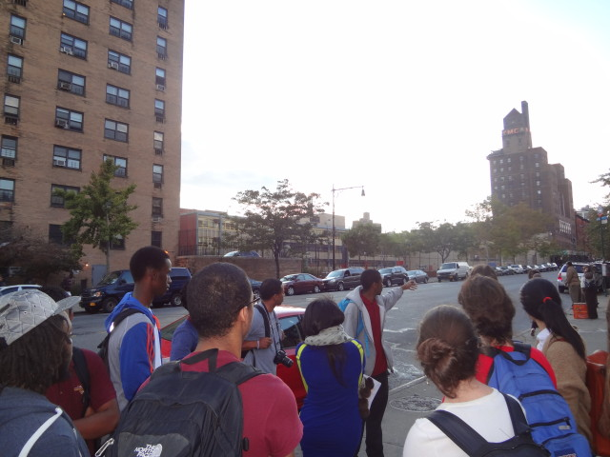
Youth Historian pointing to the corner on 135th Street and Lenox Avenue, nicknamed “The Campus,” because it served as an iconic speaking location for African-Americans leaders such as Malcolm X and Marcus Garvey.
Photograph and caption by Barry M. Goldenberg.

https://hiphoped.com/science-genius/

HipHopEd Science Genius meets urban youth who are traditionally disengaged in science classrooms on their cultural turf, and provides them with the opportunity to express the same passion they have for hip-hop culture for science. The project aims to display the interests of science enthusiasts who have a passion for hip-hop and introduce both hip-hop and science to a wider audience.
PRODUCT DNA Music Video
A student-produced rap video about science and their realities as immigrant English language learners in New York City Public Schools.
https://www.youtube.com/watch?v=1-5aQQ5SriE

https://idea.gseis.ucla.edu/projects/the-council-of-youth-research
The Council of Youth Research (2009-2011) was a partnership between UCLA IDEA and Los Angeles high school students. Los Angeles Unified School District high school students combined their personal life experiences with graduate-level research techniques to examine central questions impacting the lives of district students. The youth researchers worked closely with LAUSD administrators, as well as the office of the Los Angeles mayor, reporting their findings to officials and the broader public throughout the year.

PRODUCT “unLOCKE’n the Crisis”

A student-created public service announcement (PSA) on the impact of the economic crisis on education at their school.

