Fabric pattern design request

The theme:

In this project we our inspiration will be the old traditional Arabic face cover “Burqa”.

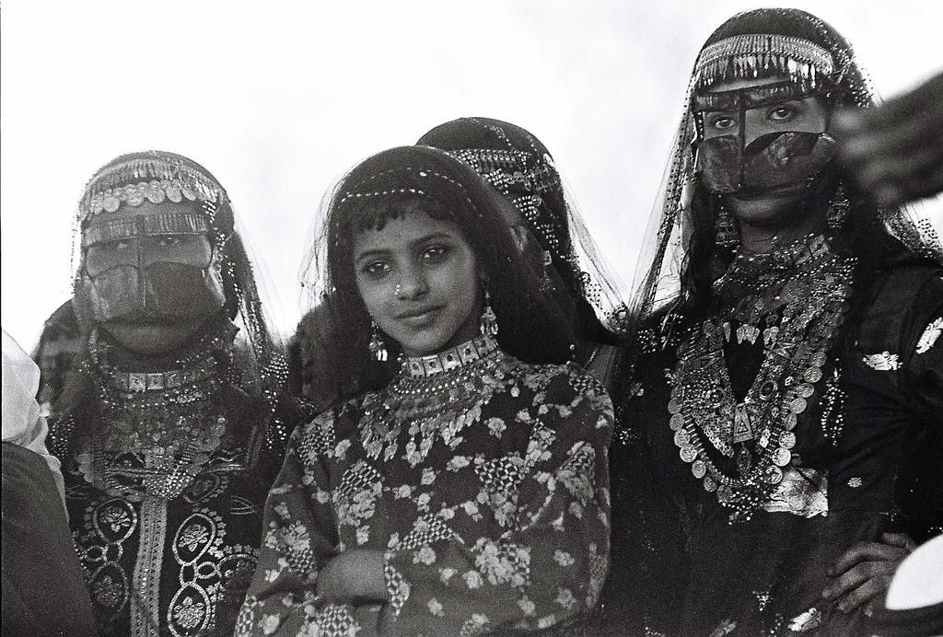

Pic.1

This Material + fabric sample will be our guideline:
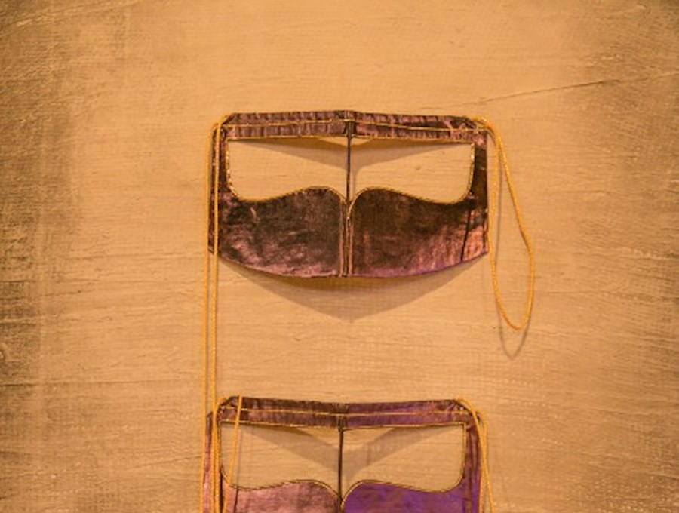

pic.2

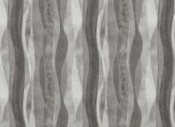
kindly use the provided material: pic.2 +pic.3 to support you in your designing journey.
you will be advised to use the hole technique in the pic.2 to achieve a unique fabric design.
Combine that with the wave-like lines see picture.3 to create soft repetitive waves effect design.
Thank you.

SUMMARY:

pic.3

Designer sketches for the pattern:

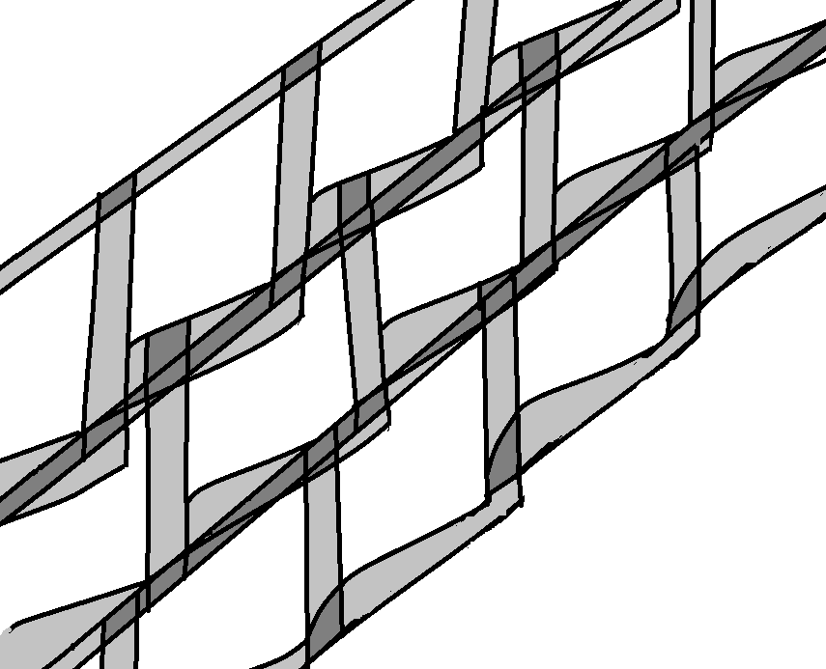

Desired color combination:

Option1 Option2 Option3
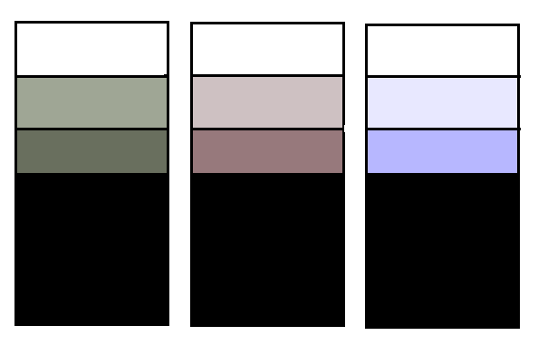

Done by: Fatima alketbi
Date: 31/07/2022

