
 | 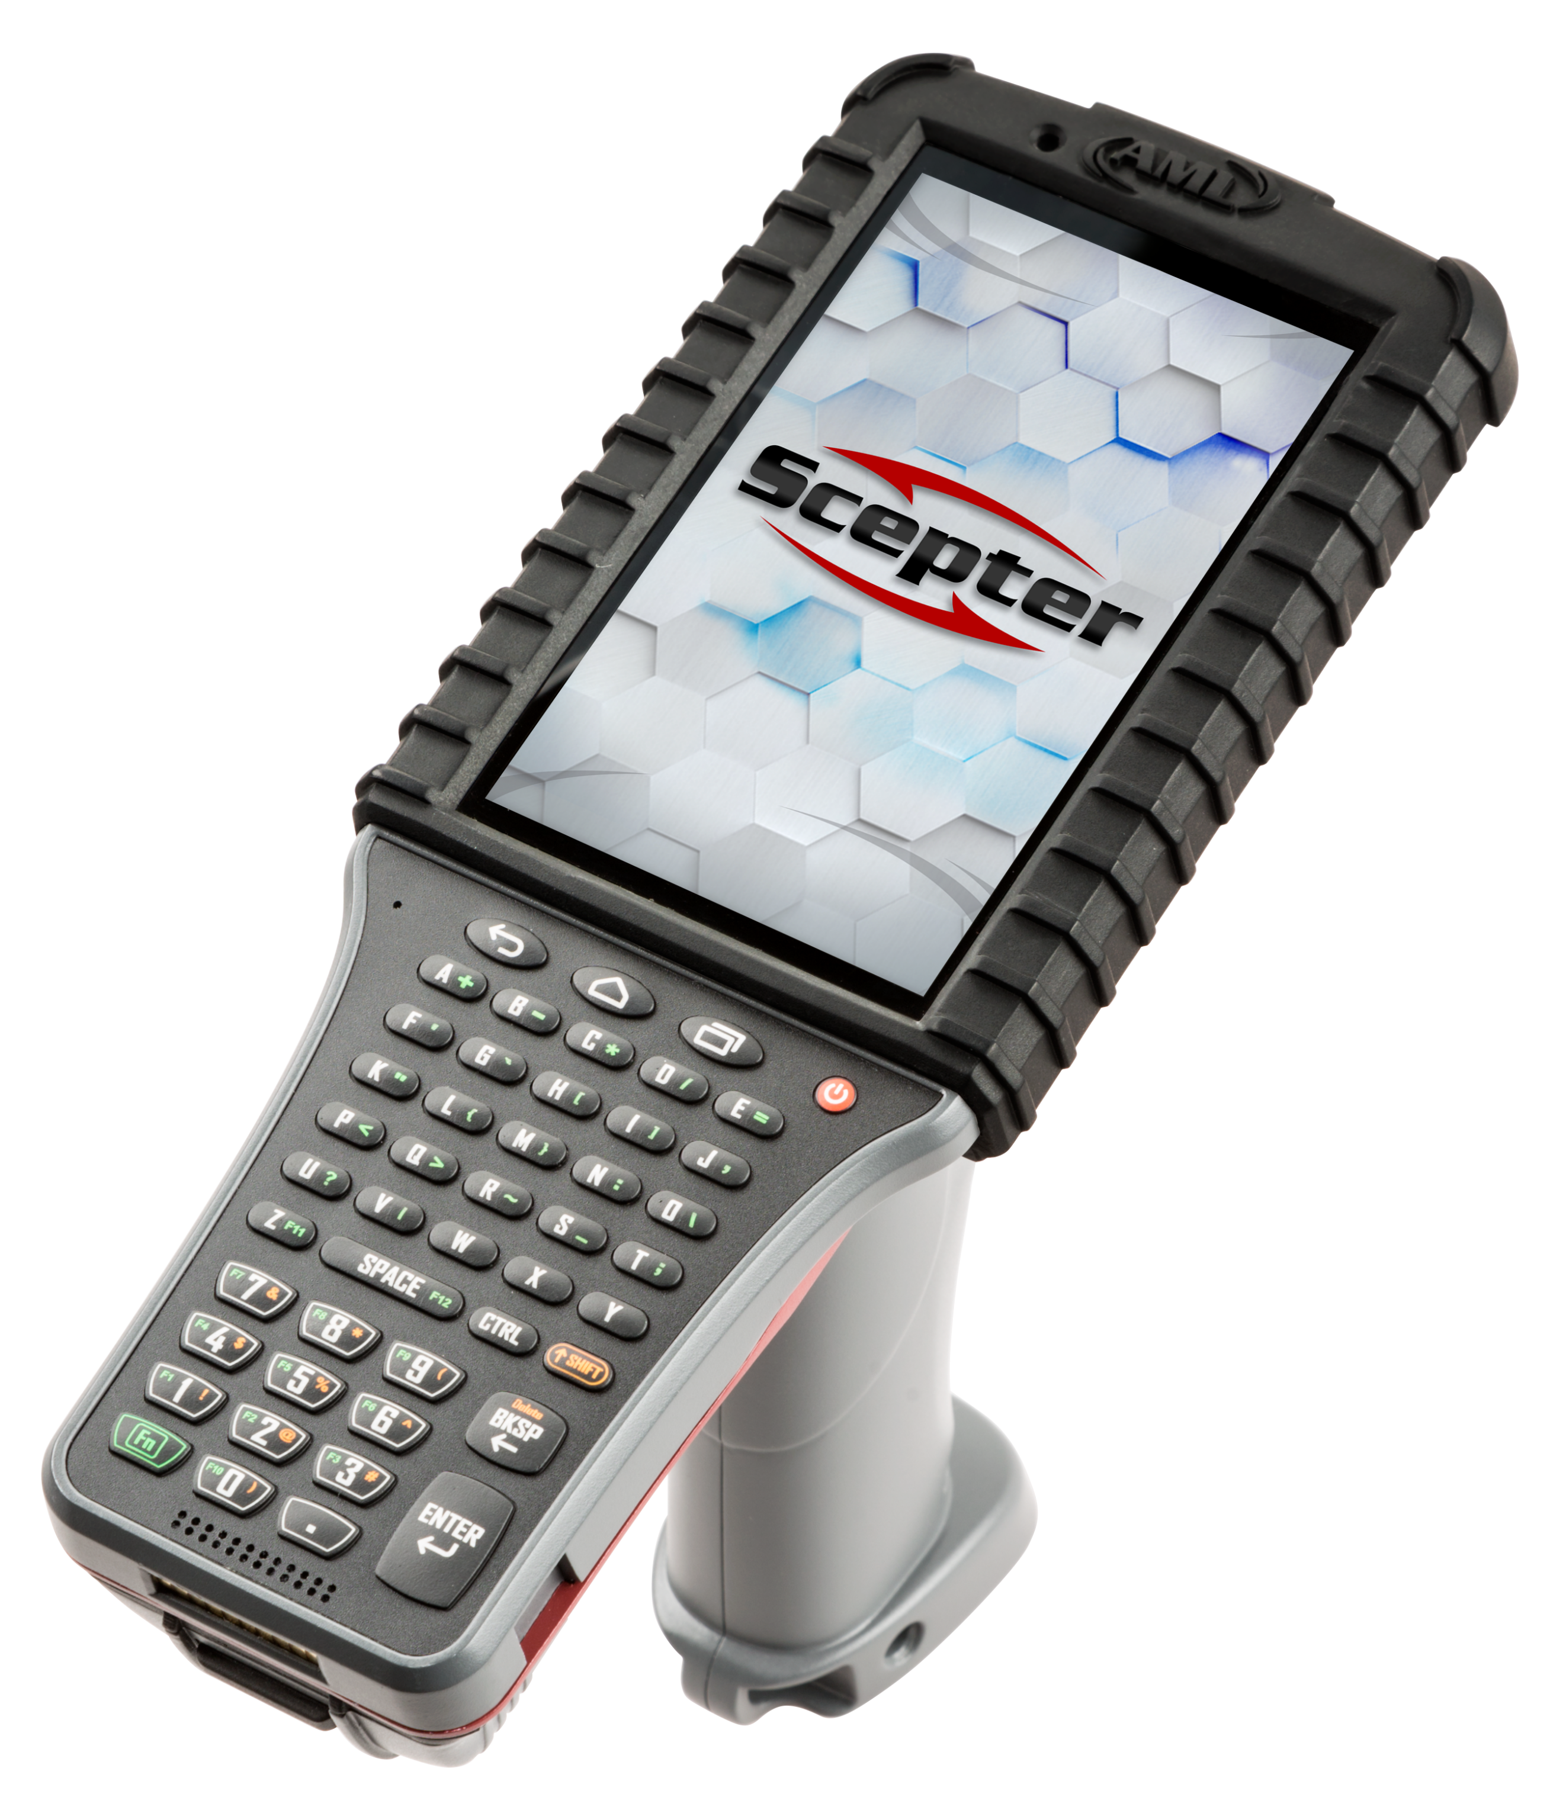 | - Android™ 7.1  - 5” LCD with capacitive touchscreen.  - 47-key and 41-key tactile keypads.  - 802.11abgn, BT 4.0  - With or without pistol grip handle.  - 24.8 watt-hour battery.  - Multiple barcode scanning options  - IP65, 6’ drop rating. | The Scepter was engineered for industrial applications such as manufacturing or warehousing, where a rugged device is necessary and the larger 5” display is desirable.
 | Starts at $2,270 MSRP
 | 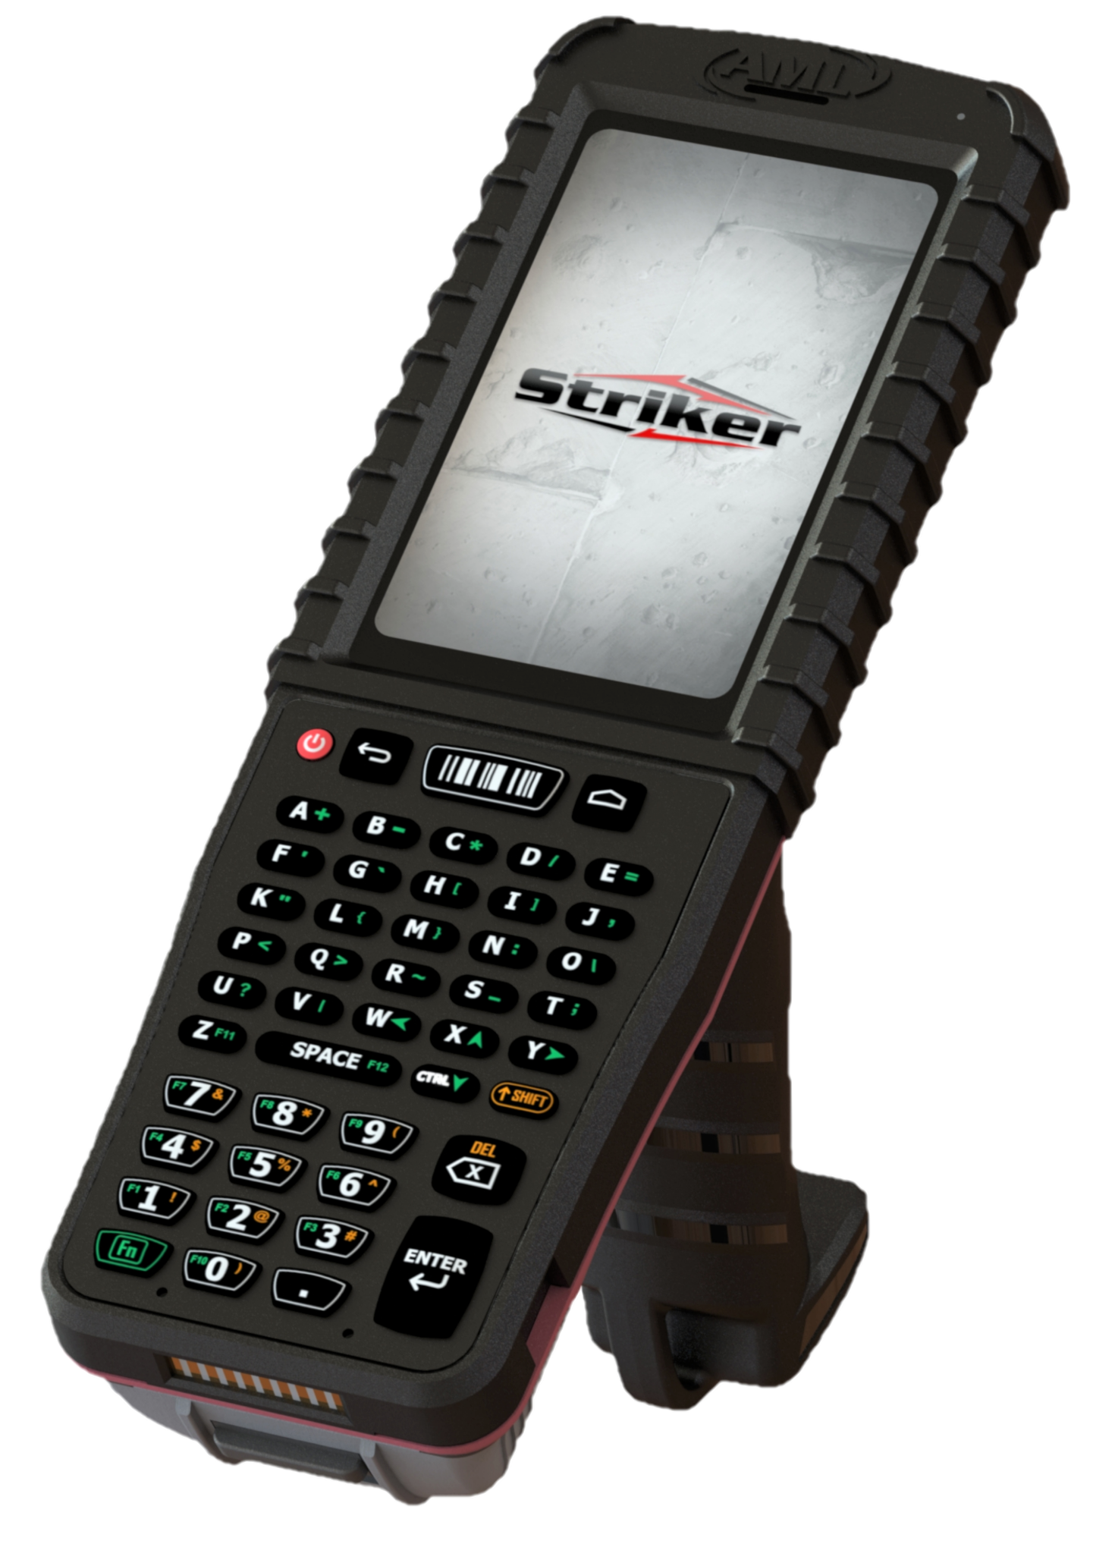 | - Android 8.1  - 4" LCD with capacitive touchscreen.  - 47-key tactile keypad.  - 802.11abgnac BT 4.2  - With or without pistol grip handle.  - 24.8 watt-hour battery.  - Multiple barcode scanning options  - IP65, 6’ drop rating. | Striker is a smaller, lighter device, but durable enough for harsh environments. It comes preloaded with an assortment of software making it out-of-the-box ready for most applications.
 | Starts at $1,895 MSRP
 | 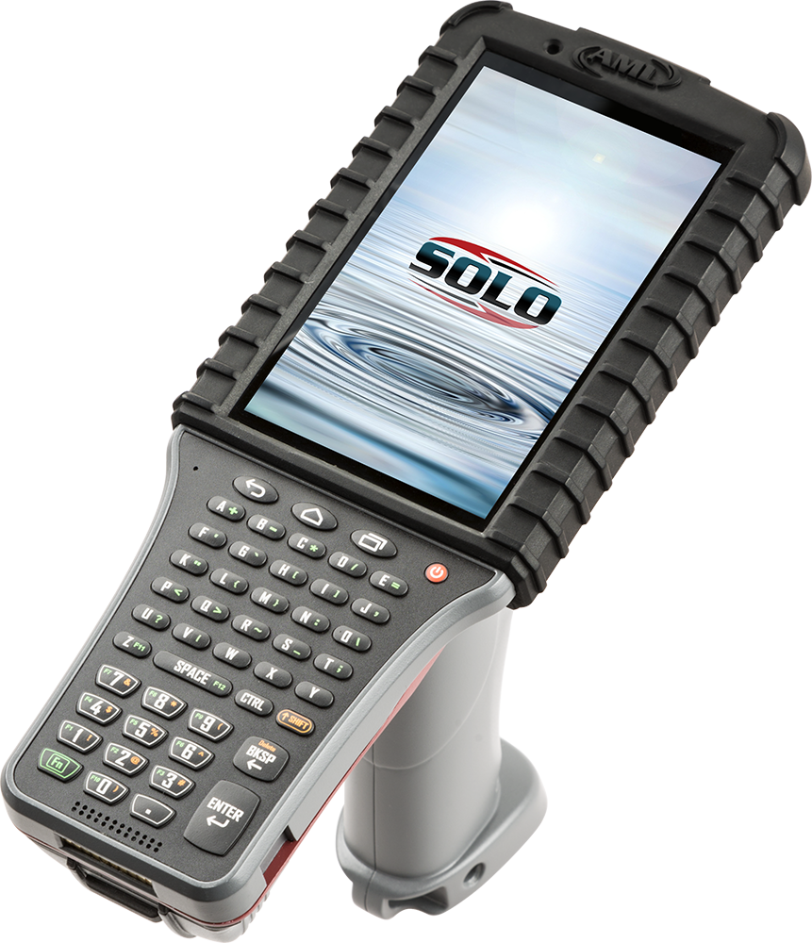 | - Radio-free device.  - Android 7.1  - 5" LCD with capacitive touchscreen.  - 47-key and 41-key tactile keypads.  - With or without pistol grip handle.  - DC Suite data collection software.  - 24.8 watt-hour battery.  - Multiple barcode scanning options  - IP65, 6' drop rating to concrete. | Solo is specifically for use in secure environments where the presence of radios, or even radio components, are strictly forbidden. Striker is Ideal for military bases and defense contractors.
 | Starts at $2,170 MSRP
 | 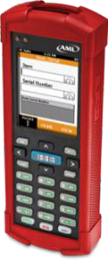 | - Windows® CE  - 2.8” LCD with resistive touchscreen.  - 24-key tactile keypad.  - 13.4 watt-hour battery.  - Barcode Scanner: 1D CCD, 2D Imager  - USB data transfer.  - Includes DC Suite applications as well as DC Console Program Generator. | The LDX10 and TDX20 are perfect when real time data transfer is not required and an affordable solution is a priority.  Pre-loaded DC Suite software includes pre- loaded apps for common data collection tasks.  Customize your own apps using the DC Console program generator.  Exports data into Excel or CSV formats for easy import into host applications.
 | Starts at $795 MSRP
 | 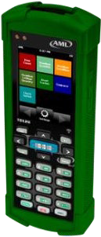 | - Windows® CE  - 2.8” LCD with resistive touchscreen.  - 24-key tactile keypad.  - 802.11bgn radio.  - 13.4 watt-hour battery.  - Barcode Scanner: 1D CCD, 2D Imager  - Includes DC Suite applications as well as DC Console Program Generator.
 | Starts at $995 MSRP

AML Quick Reference Guide

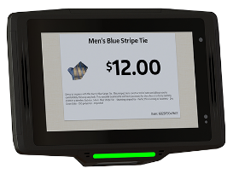    Starts at $1,695 MSRP | - Self-Service Kiosk.  - Android™ 8.1  - 7" Color LCD with capacitive touch.  - 1.8 GHz octa-core processor.  - Landscape or portrait mode.  - Dual 2W speaker in landscape mode.  - 2D omnidirectional barcode scanner.  - Optional 13MP camera.  - Power: PoE, 5VDC. | The Firebird self-service kiosk is equipped with a 2D barcode scanner and can be powered over PoE equipped networks.  The Firebird is also capable of running AML's StoreScan price verification software for retail applications.
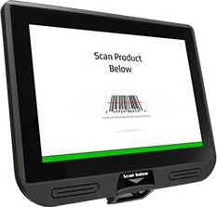   | - Self-Service Kiosk.  - Windows® 10, Android™ 6.1.  - 10.1” LCD with capacitive touchscreen.  - 2D omnidirectional barcode scanner.  - USB, Ethernet, HDMI  - Optional 802.11bgn with BT 4.0.  - Power: PoE, 5VDC. | The Monarch’s powerful architecture provides the performance of a desktop in user-facing applications.  Integrated barcode scanning, printer, mag-stripe reader and EMV reader are all available options, as is our StoreScan price verification software.
Starts at $2,095 MSRP
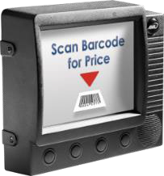 | - Self-Service Kiosk/Data Terminal  - Windows® CE  - 5.6” VGA display with resistive touch.  - 2D omnidirectional barcode scanner.  - USB x 3, RS-232 x 2, Wiegand HID, Isolated I/O x 2.  - Optional 802.11bgn.  - Power: PoE, 12VDC. | The Phoenix is a versatile and cost-effective platform for:  - Retail Price Checking  - Access Control  - Time Clock  - Shop Floor Data Collection  - WIP/Labor Tracking  Use AML’s StoreScan software for retail price verification.
Starts at $1,360 MSRP

