
Face of bull
Please rotate horns so they appear upside down

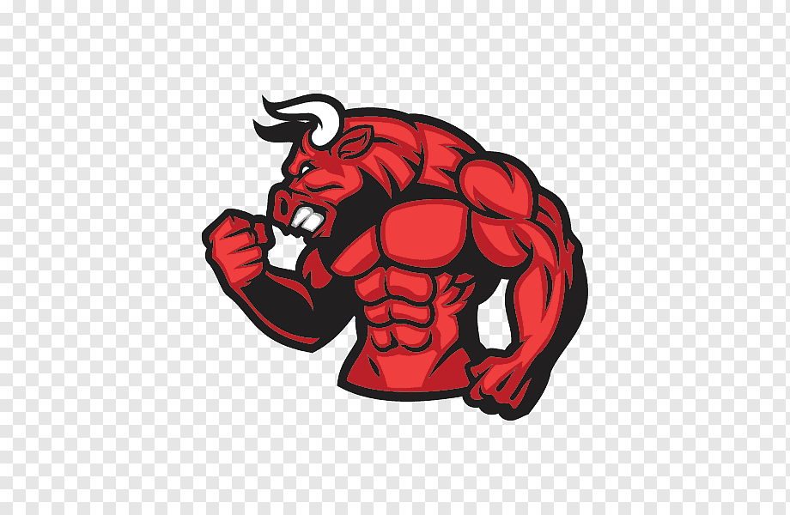
Body of the bull

In the logo can you please show the bull using a floor scrapper and scraping up concrete. The business name Profound Flooring can appear to be scrapped up by the bull.

