Live website domain: avgantivirus.com.sg
Staging domain to test website templates: avastsingapore.com
A) Project details
Responsive & Raw Multi-Purpose Multi-Page HTML5 Website (Template).
Corporate web site – Singapore AVAST and AVG Distributor - Antivirus endpoint
- Current website – www.avgantivirus.com.sg
- Staging Website – avastsingapore.com
All materials can check from AVAST.com and AVG.com
B) Requirements
- Bootstrap4
- Revolution Slider
- Retina Ready
- RTL Support
- SASS Support
- Mobile Version
- Headers Layout Sliders
- Optimized for Speed

Please follow the following for Site Navigation
C) Menu Pages (Updated on 20 July 2022)
#Home
#AVG BUSINESS
#-- AVG Antivirus Business Edition
#-- AVG Internet Security Business Edition
#-- AVG Email Server Business Edition
#-- AVG File Server Business Edition
#-- AVG Patch Management Business Edition
#-- AVG Business Management Console
#AVG HOME
#--AVG Ultimate (Multi-Device)
#--AVG Internet Security (Multi-Device)
#-- AVG Mobile Ultimate
#--AVG Secure VPN (Multi-Device)
#--AVG TuneUp (Multi-Device)
#--AVG BreachGuard
#--AVG AntiVirus PRO for Android
#AVAST BUSINESS
#-- AVAST Essential Business Security
#-- AVAST Premium Business Security
#-- AVAST Ultimate Business Security
#-- AVAST Business Antivirus
#-- AVAST Business Antivirus Pro
#-- AVAST Business Antivirus Pro Plus
#-- AVAST Business Patch Management
#-- AVAST Business Management Console

#AVAST HOME
#--AVAST Premium Security (Multi-Device)
#--AVAST Ultimate (Multi-Device)

#- Services
#-- IT Services
#-- Data Backup
#-- Data Recovery
#- SMB Grant Subsidies
#- About
-- Company
-- Partner
-- Contact
#- Store
#- Support

LIST OF MISSING URL

MAIN HEADER

- http://avastsingapore.com/IT-Services.html
- http://avastsingapore.com/Data-Backup.html
- http://avastsingapore.com/Data-Recovery.html
- http://avastsingapore.com/SMB-Grant-Subsidies.html
- http://avastsingapore.com/Company.html
- http://avastsingapore.com/Partner.html
- http://avastsingapore.com/Contact.html
- http://avastsingapore.com/Store.html
- http://avastsingapore.com/Support.html

FOOTER

+ AVG PC
- http://avastsingapore.com/AVG-Driver-Updater.html
- http://avastsingapore.com/AVG-Secure-VPN-for-PC.html
- http://avastsingapore.com/AVG-AntiTrack.html
- http://avastsingapore.com/AVG-Breach-Guard.html
- http://avastsingapore.com/All-AVG-PC-product.html

+ AVG FOR MOBILE

- http://avastsingapore.com/AVG-Cleaner-for-Mac.html (BLANK PAGE)
+ CUSTOMER AREA
- http://avastsingapore.com/Request-for-Quotation.html
- http://avastsingapore.com/Support-Centre.html --> Support.html
- http://avastsingapore.com/Shop-Online.html -->Store.html

+ AVG BUSINESS SECURITY
- http://avastsingapore.com/AVG-Email-Server-Edition.html --> http://avastsingapore.com/AVG-Email-Server-Business-Edition.html
- http://avastsingapore.com/AVG-File-Server-Edition.html --> http://avastsingapore.com/AVG-File-Server-Business-Edition.html

+ AVG CLOUD CARE
- http://avastsingapore.com/What-is-AVAST-CloudCare.html
- http://avastsingapore.com/What-is-AVG-CloudCare.html
- http://avastsingapore.com/Key-Benefits.html

+ PROMOTION AND OFFERS
- http://avastsingapore.com/Promotion.html
- http://avastsingapore.com/SITIEX.html
- http://avastsingapore.com/IT-Show.html
- http://avastsingapore.com/Singapore-PC-Show.html
- http://avastsingapore.com/COMEX-SHOW.html

+ AVAST PC
- http://avastsingapore.com/AVAST-SecureLine-VPN.html
- http://avastsingapore.com/AVAST-SecureLine-VPN.html
- http://avastsingapore.com/AVAST-AntiTrack.html
- http://avastsingapore.com/AVAST-CleanUp-Premium.html
- http://avastsingapore.com/ll-AVAST-PC-product.html

+ AVAST BUSINESS
- http://avastsingapore.com/AVAST-Patch-Management.html ---> http://avastsingapore.com/AVAST-Business-Patch-Management.html
- http://avastsingapore.com/Compare-AVAST-Business-Products.html
- http://avastsingapore.com/AVAST-Patch-Management.html
E) FOOTER (Updated 19 July 2022)
(Can refer to avastsingapore.com)
AVG PC  - AVG Ultimate (Multi-Device)  - AVG Internet Security (Multi-Device)  - AVG Mobile & Tablets  AVAST Home  - AVAST Premium Security (Multi-Device)  - AVAST Ultimate (Multi-Device) | AVG Business Security  - AVG AntiVirus Business Edition  - AVG Internet Security Business Edition  - AVG Email Server Edition  - AVG File Server Edition  - Compare AVG Business Products  AVAST Business Security  - AVAST Essential Business Security  - AVAST Premium Business Security  - AVAST Ultimate Business Security  - AVAST Business Antivirus  - AVAST Business Antivirus Pro  - AVAST Business Antivirus Pro Plus  - AVAST Patch Management  - Compare AVAST Business Products  CloudCare  - What is AVAST CloudCare?  - What is AVG CloudCare?  - Key Benefits  Promotions and Offer  - Promotion | Avast Home Security  - Avast Internet Security  - Avast Premier  Avast Business Endpoint Protection  - Avast Business Antivirus  - Avast Business Antivirus Pro  - Avast Business Antivirus Pro Plus  - Avast Business Patch Management
Total Pages :  Created:  Need to create: | Customer Area  - Upgrade to latest version  - Renew my AVG protection  - ​Request for Quotation  - ​Support Centre **  - ﻿Shop Online﻿ ** | Company  - About  - ​Careers  - Partner Application  - AVG Partner  - ​Contact  - Blog

** External website links
IN MAIN HEADER MENU BAR (UNDER AVG HOME)

Number of pages (Updated 2022-07-20 2:20PM)
- AVG BUSINESS
- AVG Antivirus Business Edition
- AVG Internet Security Business Edition
- AVG Email Server Business Edition
- AVG File Server Business Edition
- AVG Business AntiVirus for Linux
- AVG Patch Management Business Edition
- AVG Business Management Console
- Compare AVG Business Products
- AVG HOME
- AVG Ultimate (Multi-Device)
- AVG Internet Security (Multi-Device)
- AVG Mobile Ultimate
- AVG Secure VPN (Multi-Device)
- AVG AntiTrack
- AVG TuneUp (Multi-Device)
- AVG BreachGuard
- AVG Internet Security for Mac
- AVG TuneUp for Mac
- AVG Secure VPN for Mac
- AVG AntiTrack for Mac
- AVG Secure Browser for Mac
- AVG BreachGuard for Mac
- AVG AntiVirus for Android
- AVG Cleaner for Android
- AVG Secure VPN for Android
- AVG SecureBrowser for Android
- AVG Mobile Security for iPhone/iPad
- AVG Secure VPN for iPhone/iPad
- AVG SecureBrowser for iPhone/iPad
- AVAST BUSINESS
- AVAST Essential Business Security
- AVAST Premium Business Security
- AVAST Ultimate Business Security
- AVAST Business Antivirus
- AVAST Business Antivirus Pro
- AVAST Business Antivirus Pro Plus
- AVAST Business Patch Management
- AVAST Business Management Console
- Compare AVAST Business Product
- AVAST HOME
- AVAVAST Premium Security (Multi-Device)
- AVAST Ultimate (Multi-Device)
- AVAST SecureLine VPN (Multi-Device)
- AVAST BreachGuard
- AVAST AntiTrack
- AVAST SecureBrowserPRO
- AVAST Cleanup Premium
- AVAST Driver Updater
- Services
- IT Services
- Data Backup
- Data Recovery
SMB Grant Subsidies (External Link)
- Company
- Partner
- Contact
Store (External link)
Support (External link)
- Promotion
- Customer Area
- Request for Quotation
- Renew

(PLEASE USE THIS UPDATED LIST OF PAGES)
- AVG BUSINESS
- AVG Antivirus Business Edition
- AVG Internet Security Business Edition
- AVG Email Server Business Edition
- AVG File Server Business Edition
- AVG Business AntiVirus for Linux
- AVG Patch Management Business Edition
- AVG Business Management Console
- Compare AVG Business Products
- AVG HOME
- AVG Ultimate (Multi-Device)
- AVG Internet Security (Multi-Device)
- AVG Mobile Ultimate
- AVG Secure VPN (Multi-Device)
- AVG TuneUp (Multi-Device)
- AVG BreachGuard
- AVG AntiVirus PRO for Android
- AVAST BUSINESS
- AVAST Essential Business Security
- AVAST Premium Business Security
- AVAST Ultimate Business Security
- AVAST Business Antivirus
- AVAST Business Antivirus Pro
- AVAST Business Antivirus Pro Plus
- AVAST Business Patch Management
- AVAST Business Management Console
- Compare AVAST Business Product
- AVAST HOME
- AVAVAST Premium Security (Multi-Device)
- AVAST Ultimate (Multi-Device)
- AVAST SecureLine VPN (Multi-Device)
- AVAST BreachGuard
- Services
- IT Services
- Data Backup
- Data Recovery
SMB Grant Subsidies (External Link)
- Company
- Partner
- Contact
Store (External link)
Support (External link)
- Promotion
- Customer Area
- Request for Quotation
- Renew

AVG Internet Security (Multi-Device)

AVG Ultimate (Multi-Device)

AVG Internet Security (Windows, Mac, Android, iOS)
AVG Tuneup (Windows, Mac, Android)
AVG Secure VPN (Windows, Mac, Android, iOS)
AVG AntiTrack (Windows, Mac)
NOTE: AVG Ultimate (Multi-Device) can be activated on up to 10 devices simultaneously, on the platforms
of your choice. On each device, you can choose to activate all or some of the available products for
the relevant platform.

AVG Mobile

AVG AntiVirus Pro for Android | AVG Mobile Security Pro for iOS
Advanced security: Block online threats such as viruses and other forms of malware.  Web Shield: Avoid unsafe and fake websites that could try to steal your data.  Wi-Fi Security: Make sure Wi-Fi networks are safe before you connect to them.  Anti-Theft: Use the location feature to track your lost or stolen device.  Camera Trap: Secretly take photos and audio of the thief if your phone is stolen.  Last Known Location: Recover your phone by checking its last known location.  Photo Vault: Hide personal photos in an encrypted vault so only you can access them.  App Lock: Protect your apps with a PIN code,pattern, or fingerprint password.  RAM Boost: Free up RAM to speed up your phone or tablet.  Junk Cleaner: Clean out unnecessary junk files to free up precious storage space.  Wi-Fi Speed Test: Check the download and upload speeds on any Wi-Fi network.  App Insights: See how much time you use each of your apps and how much data they use.  VPN Protection: Secure your online privacy. | Identity Protection  We´ll send you a notification right away if any account passwords linked to your email are leaked online, so you can change them as soon as possible.  Photo Vault  Hide your photos in an encrypted vault, accessible via PIN, Touch ID, or Face ID — so your private photos stay truly private.  Wi-Fi Security  Automatically scans your current wireless connection to ensure it’s safe and uncompromised — and if any trouble is detected, we’ll let you know right away.  Secure Browsing - available in Premium version  A built-in VPN will ensure that your browsing remains safe and private, no matter where you are or what you’re doing.

CHANGES / CORRECTIONS
AVAST BUSINESS
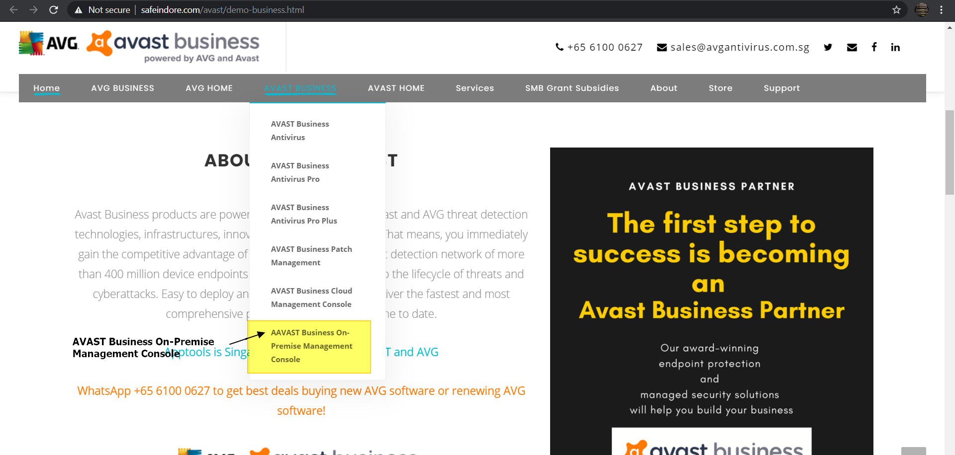

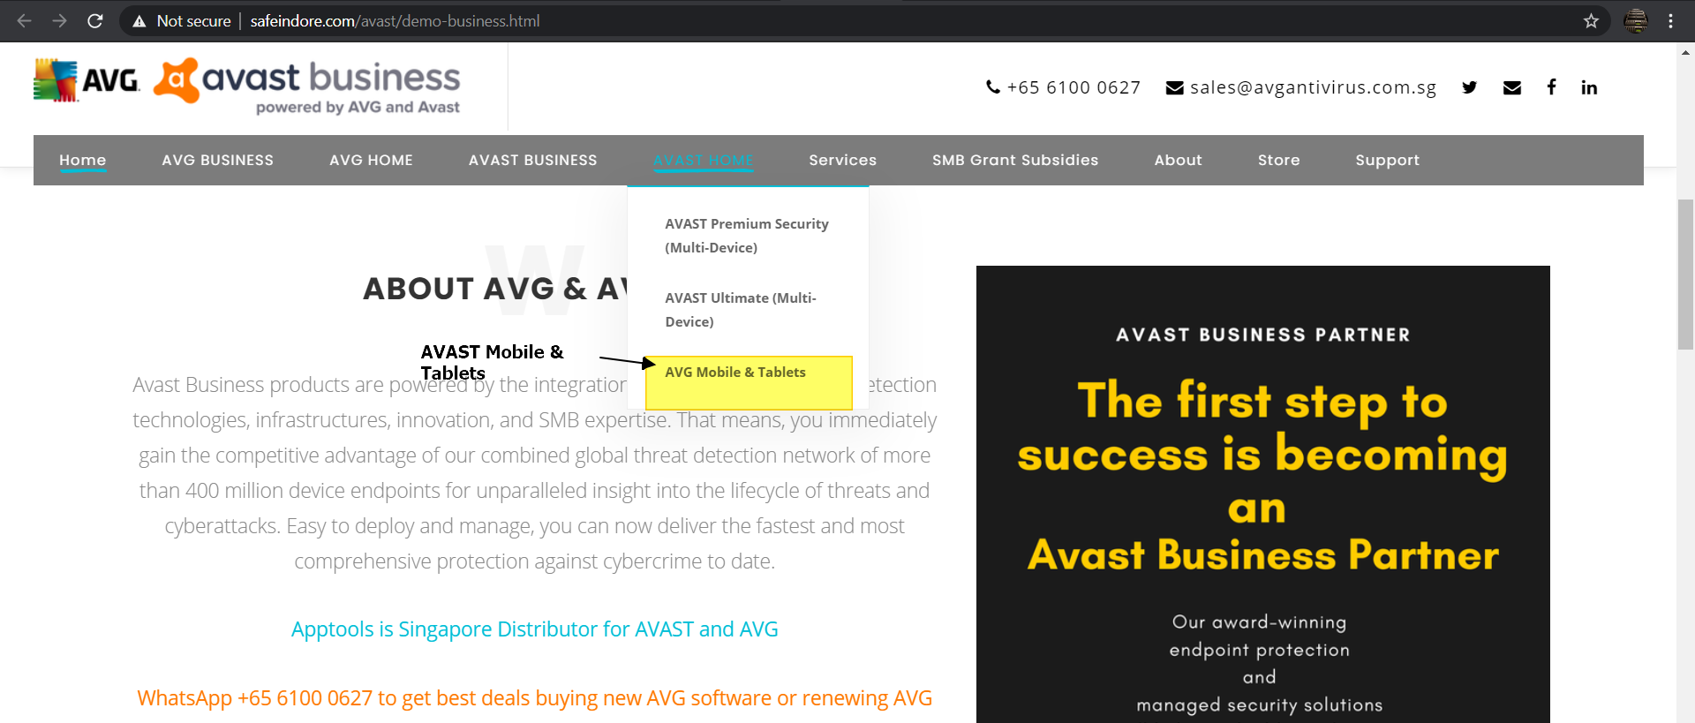

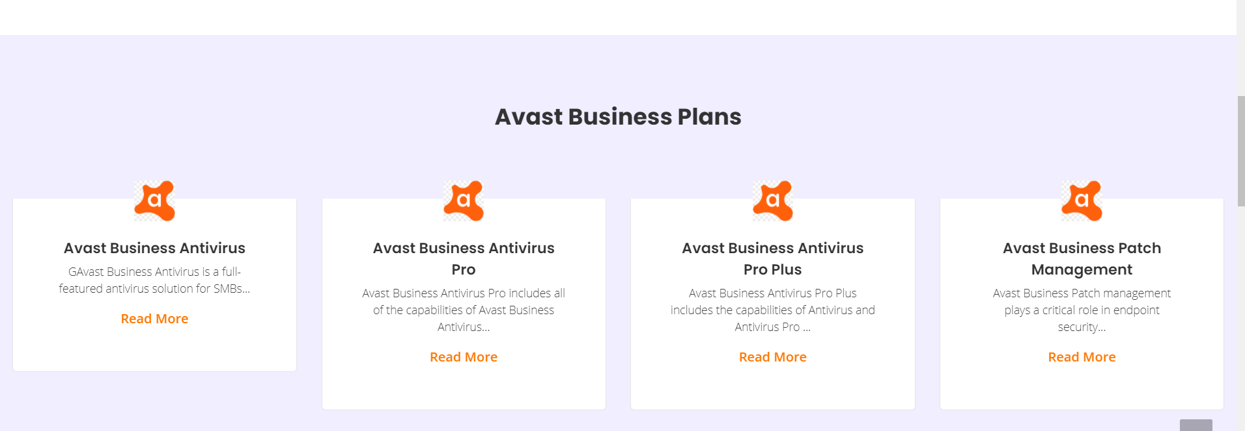

ANOTHER NEW SECTION UNDER – AVAST BUSINESS
  - AVAST Essential Business Security
  - AVAST Premium Business Security
  - AVAST Ultimate Business Security

ANOTHER NEW SECTION UNDER – AVG BUSINESS
- Replaced AVAST logo with AVG
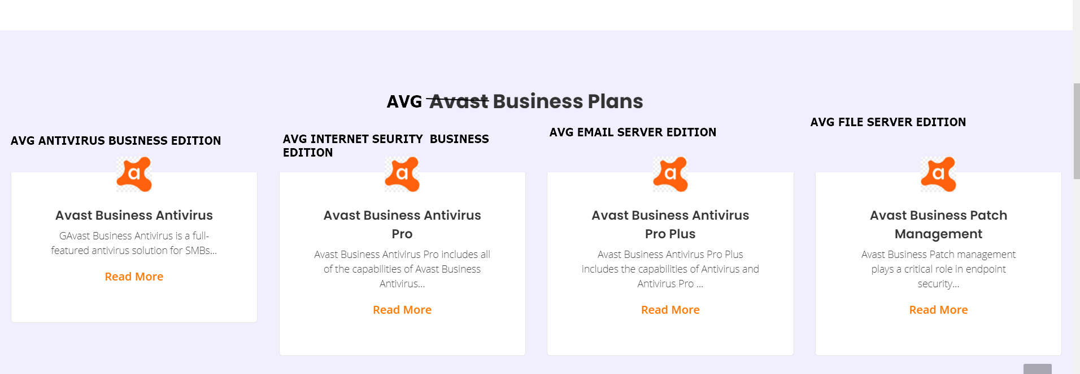

AVG ANTIVIRUS BUSINESS EDITION
- Protect your business Endpoints today against ransomware, malware, hackers and much more
AVG INTERNET SECURITY BUSINESS EDITION
- Protect your business Endpoints, email & network from ransomware, spam, phishing and much more
AVG EMAIL SERVER BUSINESS EDITION
- Keep your emails safe and running fast from server to inboxes.
AVG FILE SERVER BUSINESS EDITION
- Windows server security software to protect your small business

F) Slider Images / Writeup
(Please choose one of the image , included is also the .html pages naming)
#-AVG BUSINESS PRODUCTS
#--AVG AntiVirus Business Edition
Protect your business Endpoints today against ransomware, malware, hackers and much more
#-- AVG Internet Security Business Edition

#-- AVG Email Server Business Edition

#-- AVG File Server Business Edition

#-- AVAST Business Antivirus
Avast Business Antivirus
Avast Business Antivirus is a full-featured antivirus solution for SMBs that keeps any end-user device connected to the network safe from sophisticated online threats -- whether it's a known ransomware variant or a never-seen-before, zero day attack.
With Avast Business Antivirus, customers receive comprehensive device protection. Our hundreds of millions active users provide a continual stream of data that helps us quickly identify and destroy any threat and predict future ones. Day and night, across the globe, our immense cloud-based machine-learning engine is evolving and learning, make our solutions smarter, faster, and more powerful than ever.

Avast Business Antivirus Pro
Avast Business Antivirus Pro includes all of the capabilities of Avast Business Antivirus plus automatic software updates, data shredding to permanently delete files, and extra security for servers.
With Avast Business Antivirus Pro, customers receive the most comprehensive device and data protection. Our hundreds of millions active users provide a continual stream of data that helps us quickly identify and destroy any threat-and predict future ones. Day and night, across the globe, our immense cloud-based machine-learning engine is evolving and learning, make our solutions smarter, faster, and more powerful than ever.

Avast Business Antivirus Pro Plus
Avast Business Antivirus Pro Plus includes the capabilities of Antivirus and Antivirus Pro with additional data and identity protection to secure users and connections in open and public networks.
With Avast Business Antivirus Pro Plus, customers receives the most comprehensive device, data, and employees’ protection. Our hundreds of millions active users provide a continual stream of data that helps us quickly identify and destroy any threat-and predict future ones. Day and night, across the globe, our immense cloud-based machine-learning engine is evolving and learning, make our solutions smarter, faster, and more powerful than ever.

Avast Business Patch Management
Avast Business Patch management plays a critical role in endpoint security, but many businesses are reluctant to patch because there are too many patches, patching often interrupts operations, and they can cause problems with other systems. Avast Business Patch Management takes the guesswork out of patching by identifying critical vulnerabilities and making it easy to deploy patches across all endpoints from one central dashboard.

-

- Refer to
- PNG / 2000 x 1583

F) Slider Content
AVAST BUSINESS
AVAST Business antivirus

AVG BUSINESS

3. A.I Data Disaster Reconstruction (A.I DDR)

Since 2006, we are the only datacentre group in the world with the only A.I. Data Disaster Reconstruction (A.I.DDR).

During 2017's global Wannacry ransomware attack, the A.I. Data Disaster Reconstruction (A.I.DDR) helped 35,000 organisations across the globe reconstruct infected files.

These 35,000 organisations never paid any ransom to the attackers.

Saving them over USD 3.5 Billion in ransoms.

