THE EFFECTIVE LEADER Creative Brief: Logo Design

Overview:
Our goal is to elevate THE EFFECTIVE LEADER into an iconic brand.
We want to attract individuals seeking to make the greatest impact in the world.
To reflect this, the EL logo and brand need to have an elegant, high-end feel with a creative edge. We are looking for both a logo icon and THE EFFECTIVE LEADER as a type font. Often, they will be paired together.

Our intention is to do work that is constantly pushing the envelope. As a result, that icon will be associated with the best brand design and story work in the industry.

Our new logo needs to be bold, simple, and unique.

THE EFFECTIVE LEADER - WHAT WE DO AND WHY:
What we do:
We accelerate the growth of your leaders so they can intentionally
create a positive & profitable workplace culture.

Keynote Speaking | Leadership Development | Coaching
Why:
No matter how senior the leader is, they quickly see that doing what they know how to do is less effective than what they need to do in this new role. The question then becomes, how can you quickly move from inexperienced to effective?

This requires each leader to move through three stages of growth:

Awareness: Moving from a problem awareness (something isn’t working) to a solution awareness: I know what needs to change to be effective in this new role.

Beliefs: Challenging the beliefs they had in their previous role and building the beliefs that will serve them in their new role.

Behaviors: Daily living out the behaviors that shape their team and the organizational culture around them.

CHANGE MODEL

Awareness | Beliefs | Behaviors
Moving from a problem awareness (something isn’t working) to a solution awareness: I know what needs to change to be effective in this new role. | Challenging the beliefs and assumptions leaders had in their previous role to discover more reliable beliefs that will serve them in their new role. | Choosing and living out more productive behaviors daily to improve interactions and create an exceptional culture around them.

Once leaders move through these stages of growth, they become far more effective at building winning teams and exceptional work cultures.

Our OLD LOGOS:

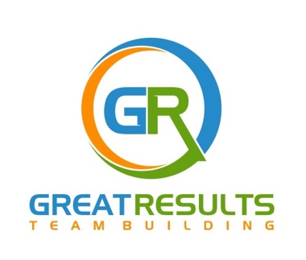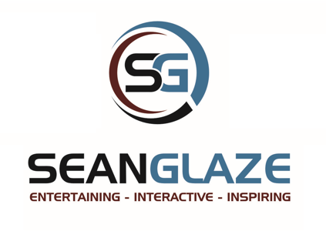
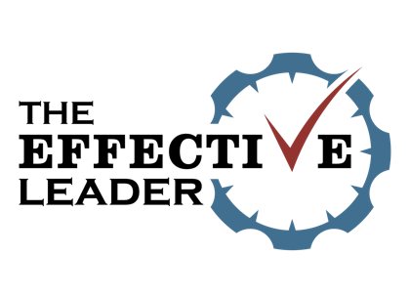

The following is the LOGO we would most like to emulate:
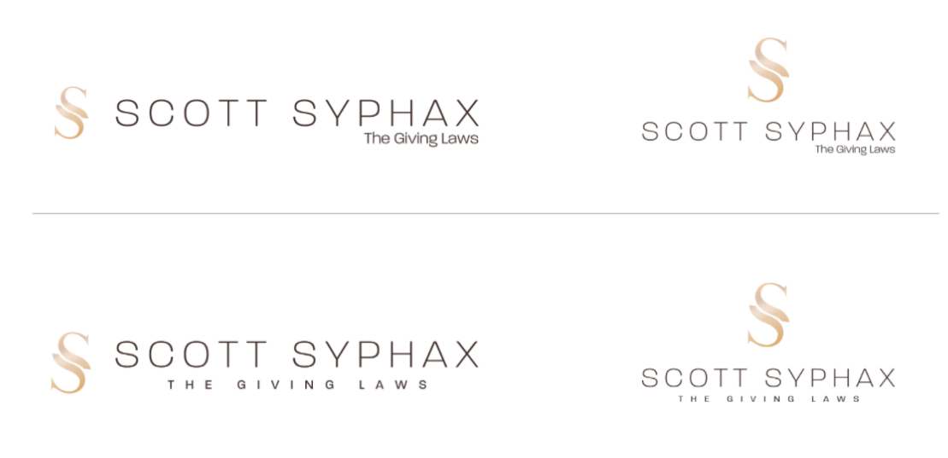
What we love:
- It has an icon and unique type font.
Both can stand individually and together.
- The icon are the initials of the brand (this is not essential to our brand, but a good start)

- The icon alone is visually appealing, could be an art piece in a gallery, and looks stunning when it is repeated as a pattern on a box. We would do this for future labeling.
- It mixes black, white, and one logo color (exchange gold for our burgundy or blue.)

Here are other logos we loved:

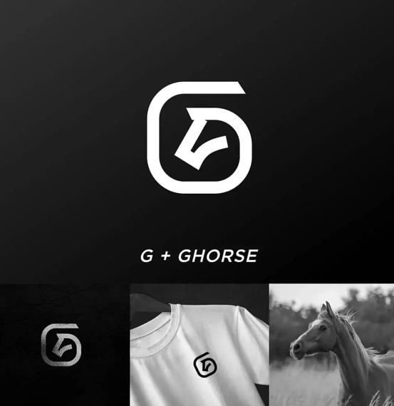
What we loved:

- The truth about this logo is that we love the simplicity and the use of letters with a meaningful image that communicates the company purpose / focus.
- I would like an icon that can be used at the start of a video and makes for a great icon for our products (shirts, gear, etc.) This is the kind of imagery we want to have over the next 5-7 years in the leadership development and speaking industry.

Another logo we loved:

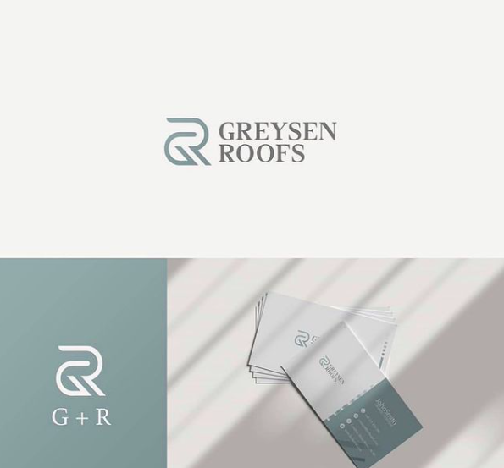

What we loved:

- It is an icon and font type. Both can stand alone, but also work together.

- The initials are the icon.

- There is MEANING in the way it’s designed. As a collective, people should feel connected. All the lines run together and are connected.

Another logo we loved:

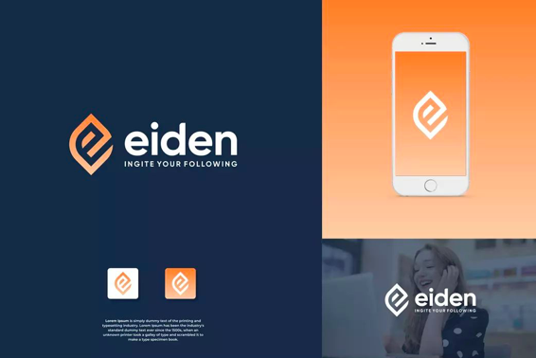

What we loved:

- It is an icon and font type. Both can stand alone, but also work together.

- The initials are the icon, and the color is unique and memorable.

- - - - -

We like Copperplate and Superclarendon fonts – looking for something professional and strong.

These are the colors we would love to keep in our brand:
Mostly, we will focus on white, black, and burgundy and blue…
