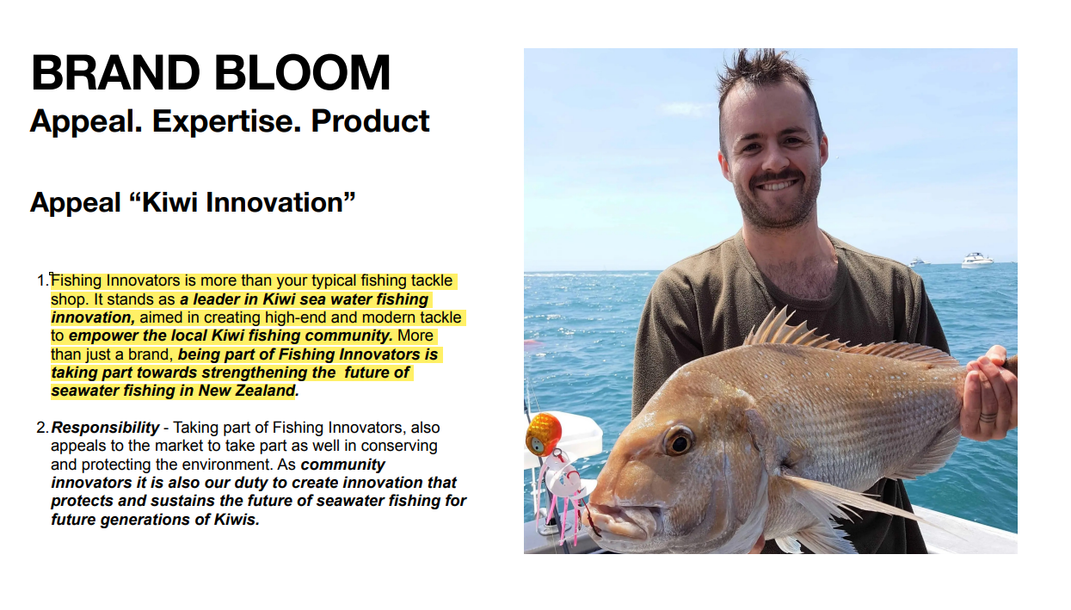
Sustainability
At Fishing Innovators we believe that time spent on the water fishing with family and friends is priceless. We want happy memories of fishing to be part of our children’s identity, and the same for the generations that follow.
To achieve this we work together to protect our environment and to care for the fish stocks that we cherish. Fishing sustainably is a key tenant in the Fishing Innovators brand.
Ingenuity
Fishing Innovators are passionate for New Zealand to be recognised as the premier designers of fishing tackle – globally.
We do this through innovation and continuous improvement to create quality, technically advanced tackle that empowers the local Kiwi fishing community.
More than just a brand, being part of Fishing Innovators is joining a community of individuals who are strengthening the future of fishing in
New Zealand.
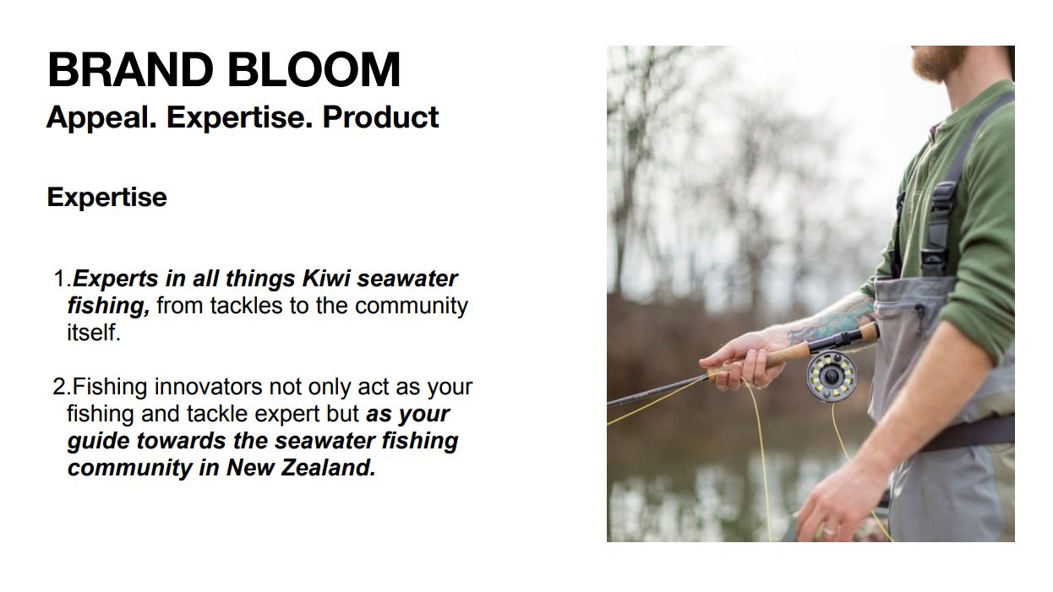
Expertise
The strength of Fishing Innovators is community. Within our vast network of fishing men and women from all over New Zealand, we have experts who have tackled every fishing style and species available in our waters. Fishing Innovators draws on this wealth of expertise when developing and refining new products by NZ fisho’s for NZ conditions and NZ fish.
As a community, we also offer you support and expertise whenever you are ready for your next fishing adventure
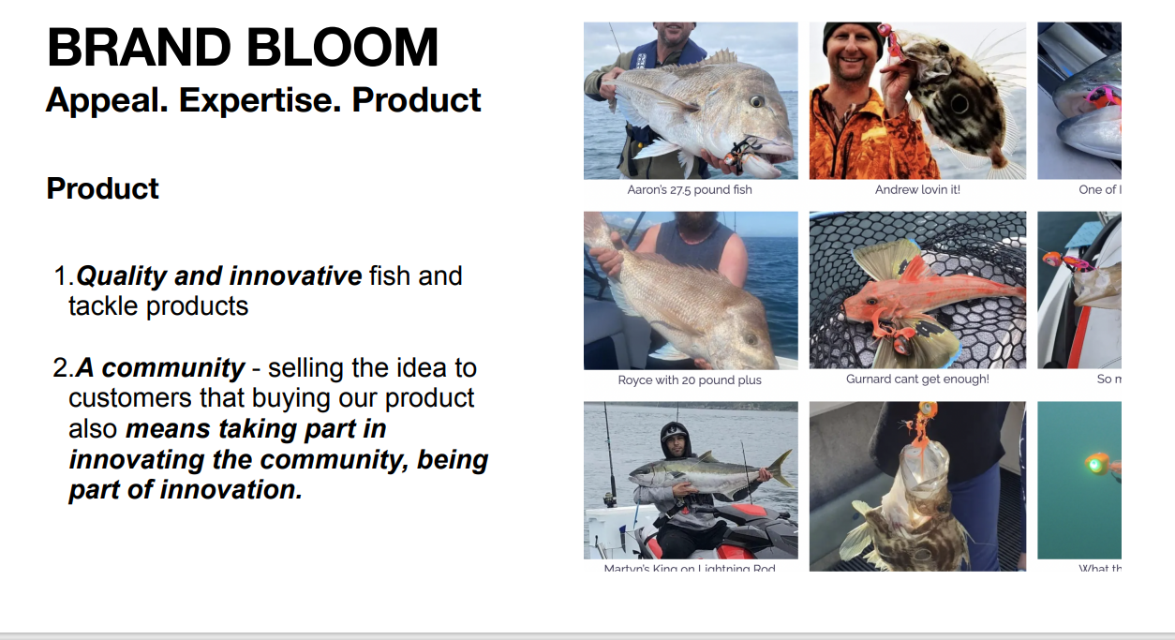
Product
If it catches fish and it fits our sustainability guidelines then we’ll try it…
…if it can be scientifically proven to catch way-more fish then we’ll make it!
And we won’t compromise on quality.
Our products are unique in the market. They have fish catching features that far surpass other tackle. We will never sacrifice the opportunity to catch the fish of a lifetime by cutting corners with costs!
Better ideas
Better products
Better features
Better results
Throwing out the rule book
Not copying the crowd

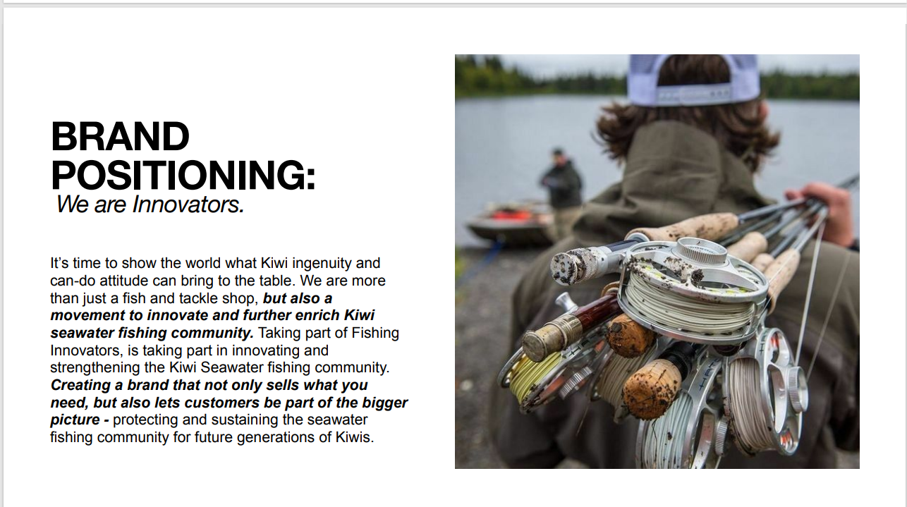
It’s time to show the world what Kiwi ingenuity and can-do attitude can bring to the table. We are more than just a tackle provider, we are a movement to innovate and enrich the NZ saltwater fishing community.
Creating a brand that not only gives you what you need, but also lets you be part of the bigger picture - protecting and sustaining saltwater fishing for future generations.

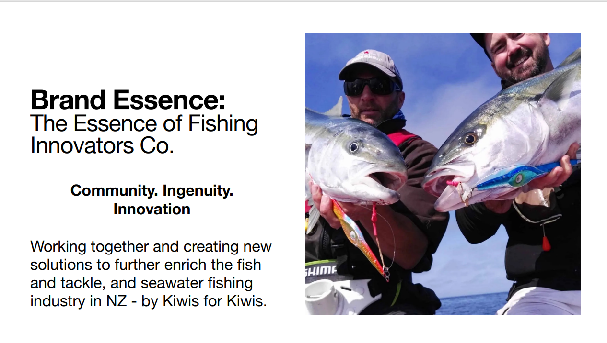
Brand Essence:
The Essence of Fishing Innovators Co.
Ingenuity. Quality. Sustainability. Community
Working together to innovate new technologies that enrich the fishing experience in New Zealand
- designs by Kiwis for Kiwi fish
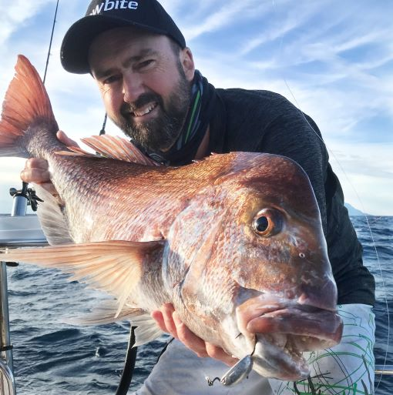
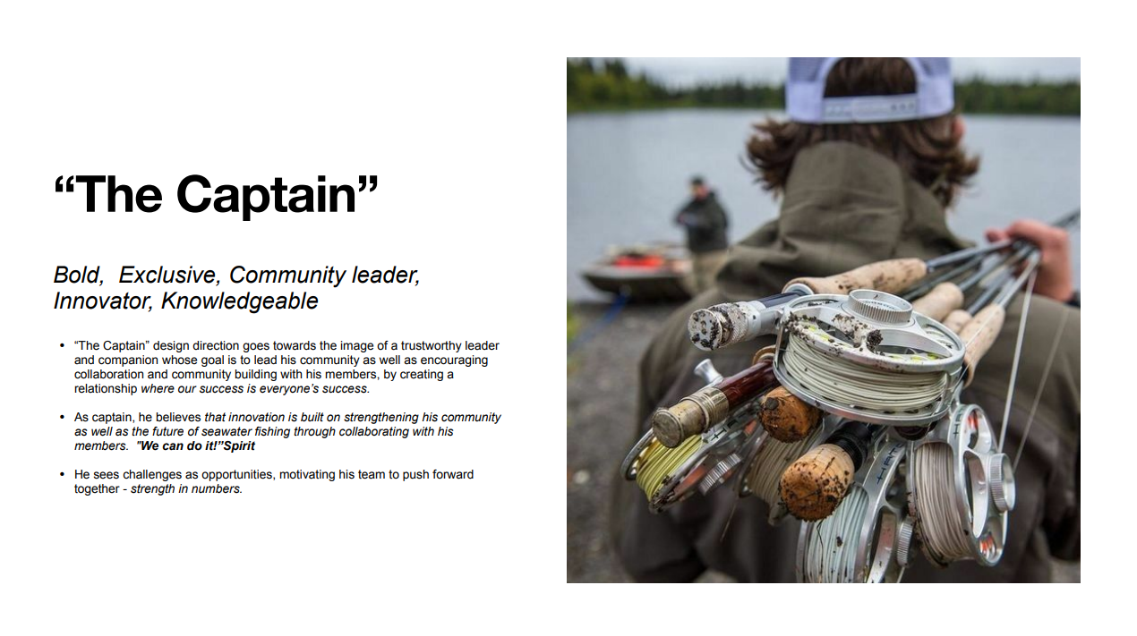

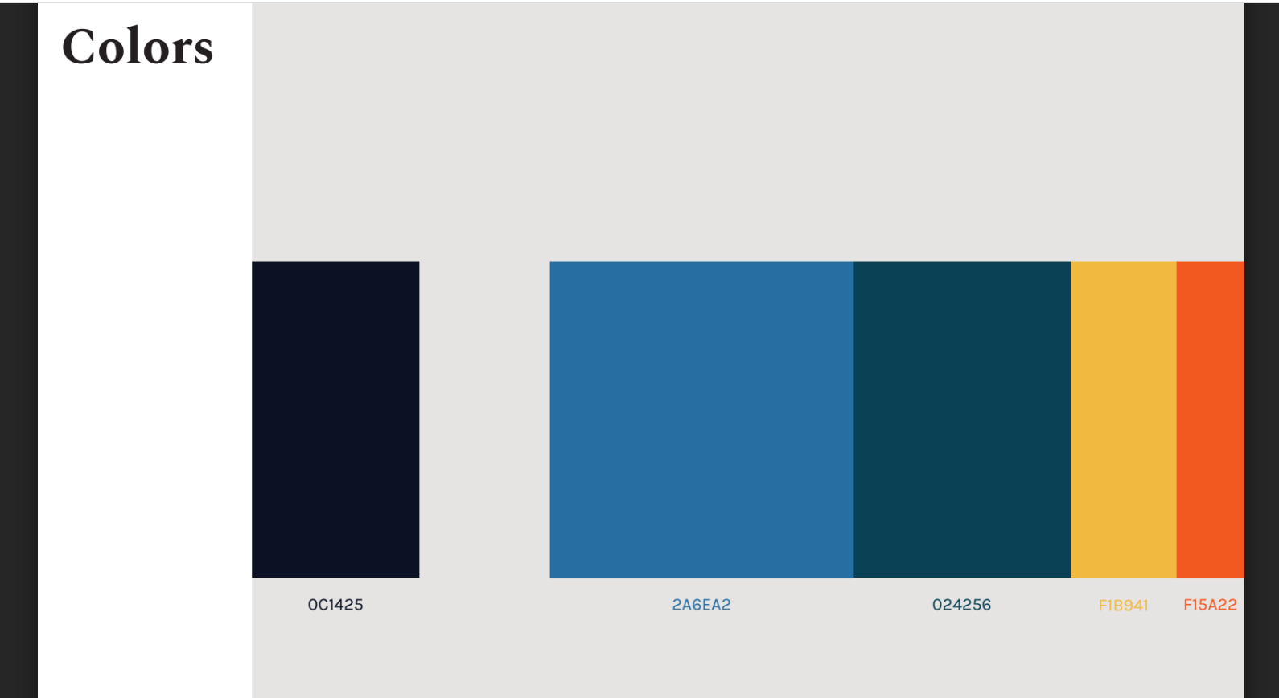
Colour Palette
The Coloured Bars show the colours that will be used on our new website.
The size of each bar represents the proportion of that colour used.

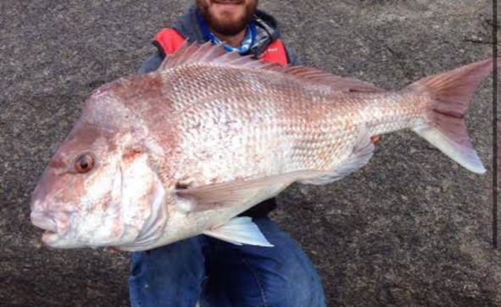
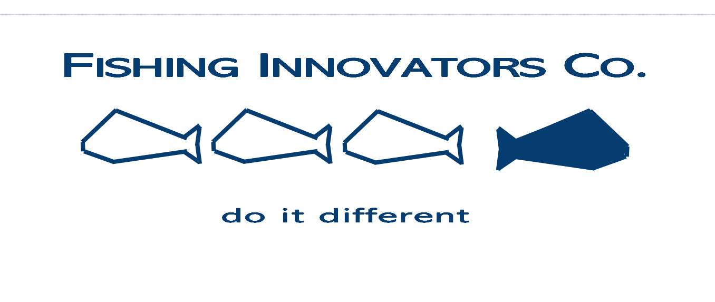
Possible logo ideas:
These are the result of a quick brainstorm. They are not finalised designs.
The fish shown are just a “place holder”. The actual fish would be based on the fish photo below.
The three fish swimming left are hollow outlines. The fish Swimming right has more detail.

