Slick Fire System® for Well Stimulation
& Scale Removal Services

Overview:
The origin of this service started in the DJ Basin when we discovered a need to increase production on older producing Plunger Lift wells. We found that after multiple rig workovers the issue was not in the wellbore itself, rather the Perf or Slotted Sub had become either scaled or sanded off choking the well down to very little or no flow. Realizing the issue was fixable without performing an expensive traditional Workover, we utilized our Slick Fire System®; a device that allows us to perform basic ballistic procedures safely off of our Slickline units. This system provides a ballistic solution by removing scale or other well choking build up utilizing our Scale Shot® or by perforating new holes using an RTG. There are no other standard mechanical or hydraulic slickline perforating tools available that can accomplish this service.

The main benefits are:

- For a small investment, we can provide helpful information to determine if the well needs to be worked over or not. I.e., if we perform this service and nothing changes, you know you have wellbore issues NOT production tubing issues.
- This service is “greener” than a traditional workover by producing far less emissions. There is no need to kill the well or to flare any gas.
- When the service is successful, the data has shown an increase of 100%-600% in production! For example, wells that were making 2-3BBL/day before we performed this service are now producing 50-70BBL/day!
- This service is cost effective enough that in most cases, the “free” increased production will pay for this service in 24-48 hours.

Work Summary:
This service can be done in a few hours if no unexpected well conditions are encountered. A typical job would look something like this.

- MIRU Slickline, RIH and pull plunger noting tight spots
- RIH and pull BSSV-note depth of nipple to correlate to tubing tally and wellbore diagram
- RIH with “dummy run” (Spang Jars, Weight bars, Blind Box and Temperature Probe) drift through Profile Nipples to determine Perf Sub depth, establish bottom hole temperature and to locate fluid level.
- Once depths, fluid level and temperature have been confirmed and we know we are deep enough to get into the Perf Sub, RIHW Slick Fire System® and either perforate new holes using a RTG (Retrievable Tubing Gun) or remove scale utilizing our Scale Shot®.
- Free flow well to determine if new or more communication has been established.
- RIHW broach to production nipple. Reset production tools and turn well back to the client

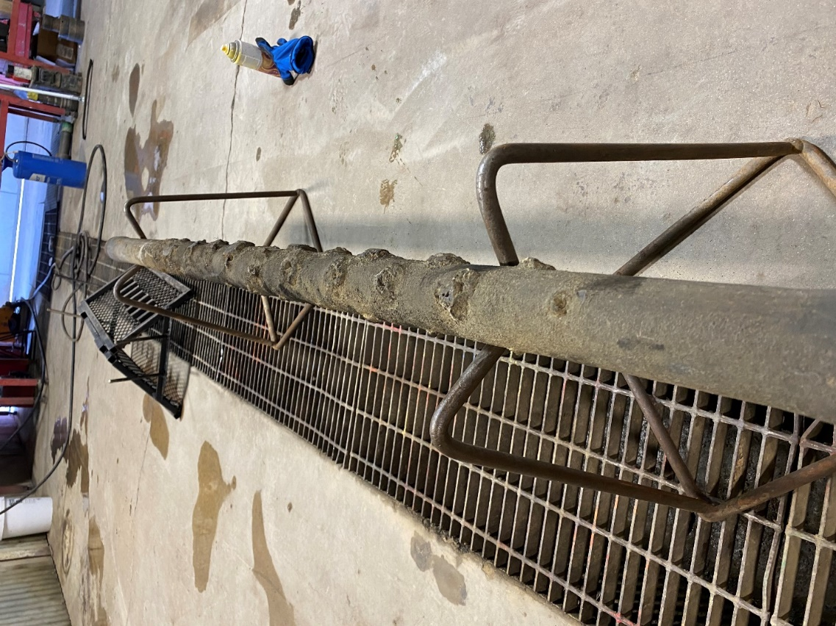
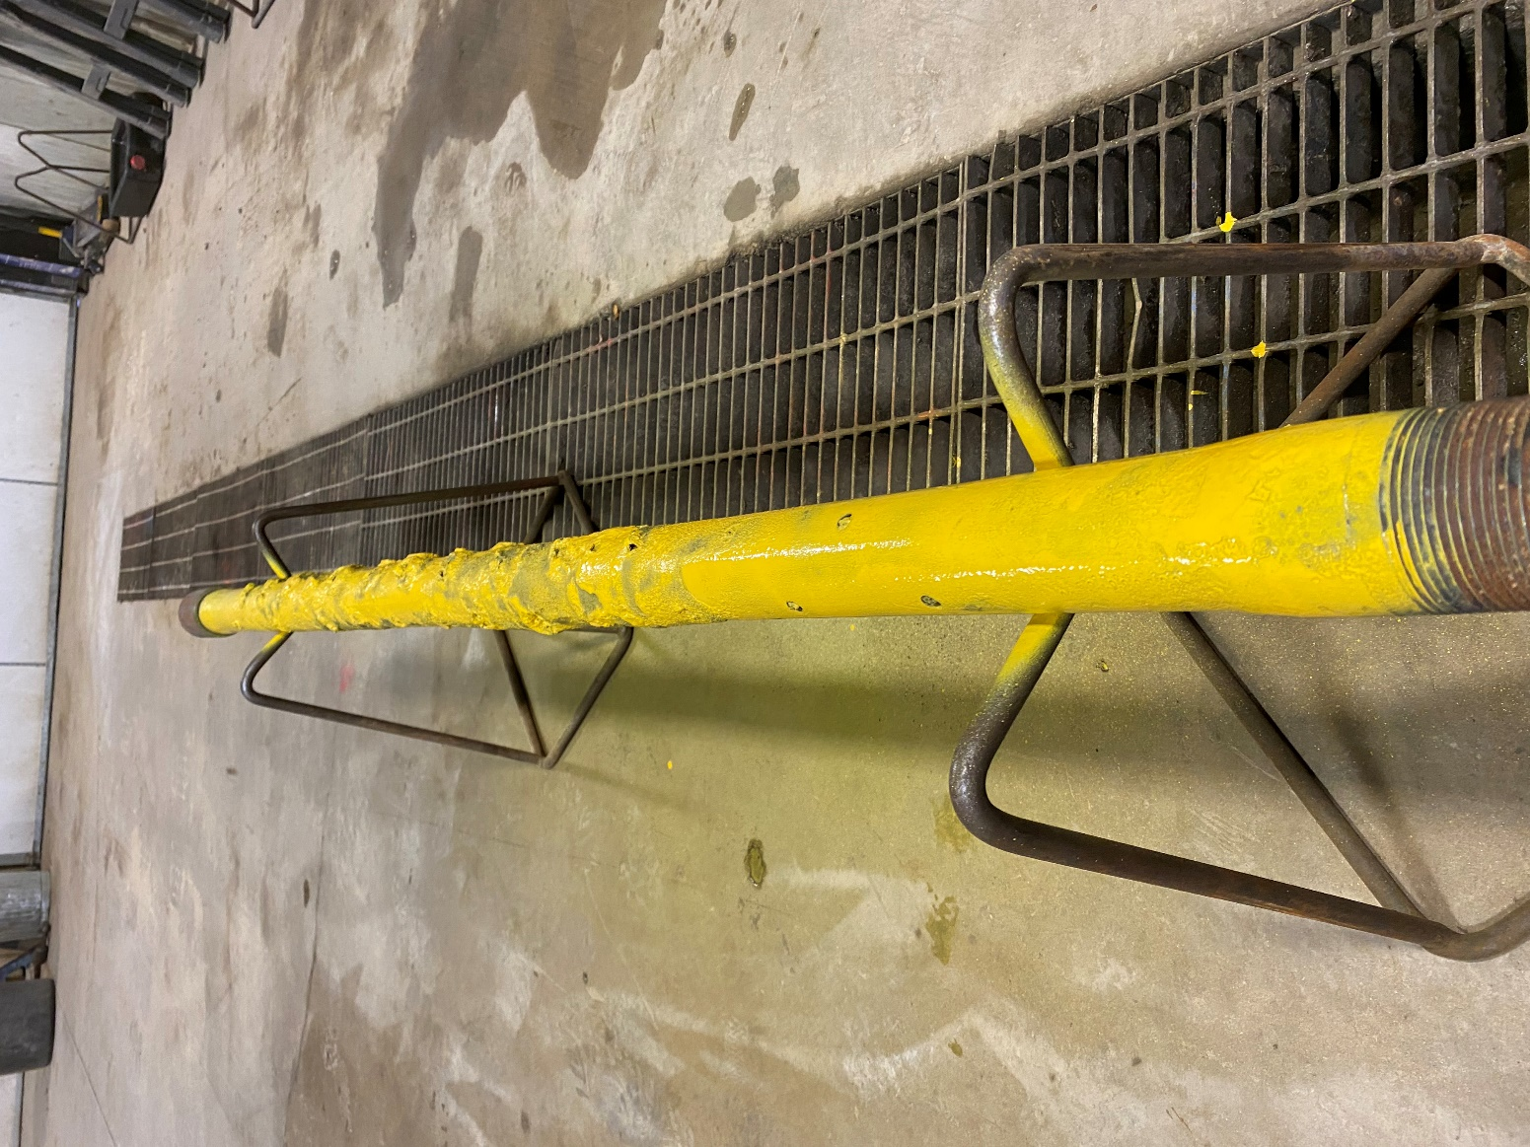

Images 1-2: Perforated Sub recovered from a Workover rig that was completely scaled off. It was painted yellow before the test to see how much scale came off when it was stimulated using our Scale Shot®.

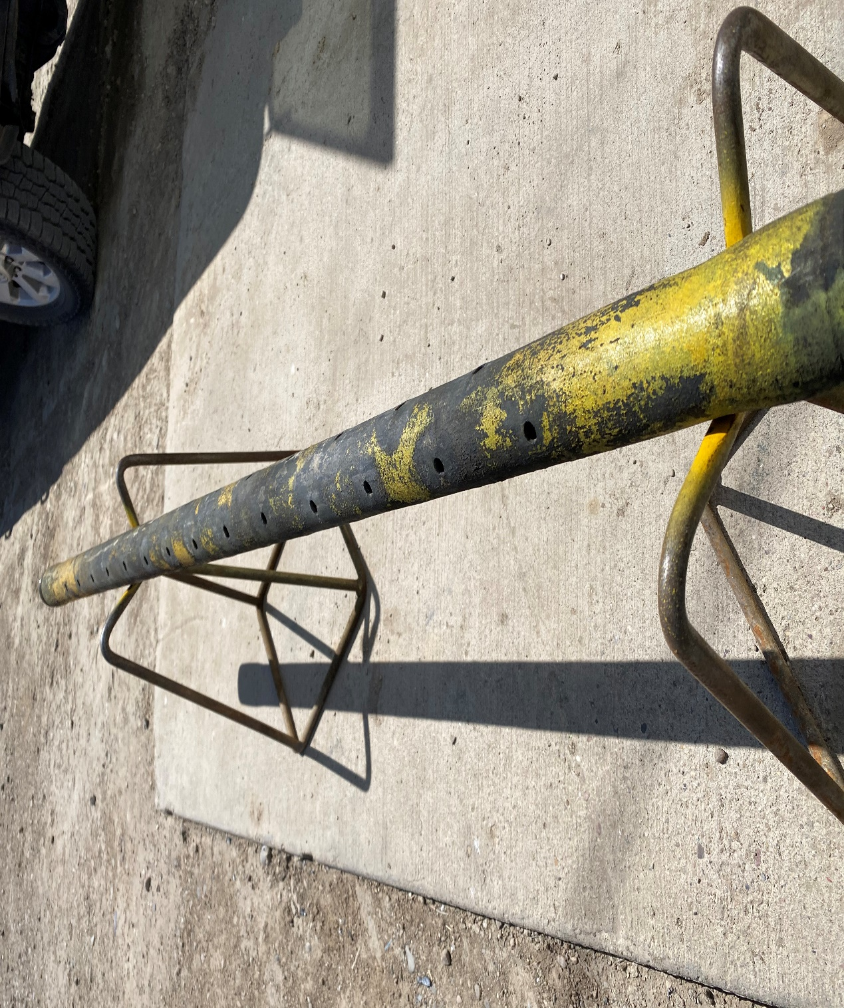

Perforated Sub after utilizing Scale Shot®: ALL scale was removed from the sub opening the original 56 holes.

