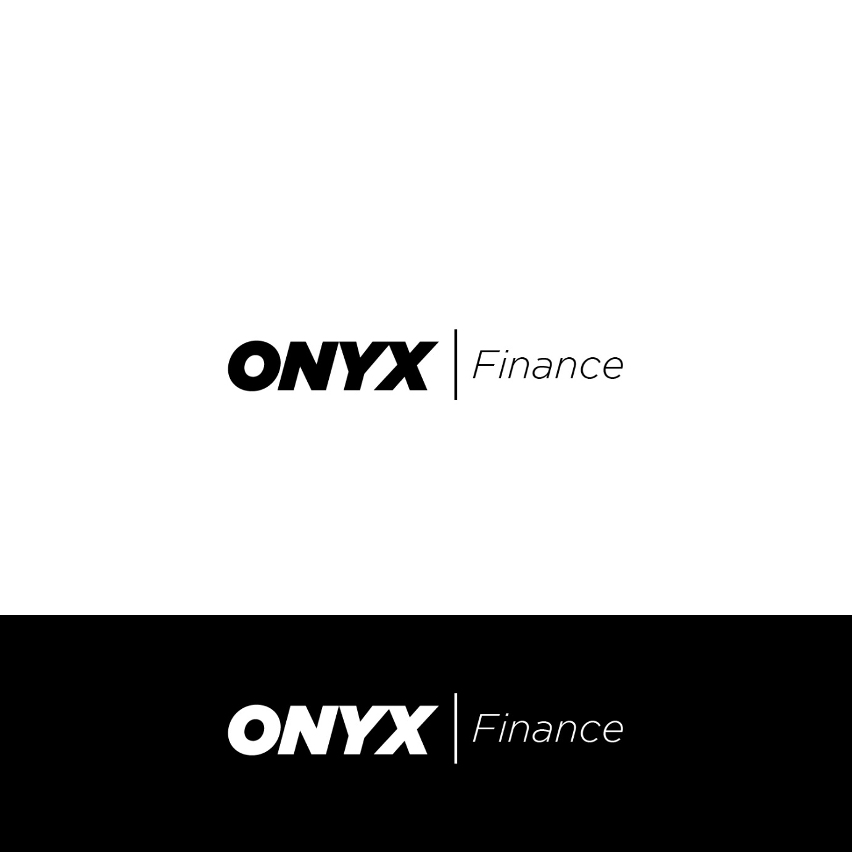

Makers of possible
ONYX Finance has nearly 20 years industry experience, so we certainly understand personal and business lending. We are committed to providing individuals and businesses with tailored financial services that enable them to reach and then exceed their financial goals. We have a vast list of lenders to suit along with an online team ready to help you, so we're easily accessible and here when you need us. Our friendly team of experienced and approachable staff that will listen, understand your situation and lend responsibly.

ONYX Finance - Makers of Possible.

WHY CHOOSE US?

Well, because we're here to help you! We care about outcomes AND helping you achieve a stress and enjoyable lending experience.

Vehicle Loan
While you focus on getting the right car, we will focus on getting you the right finance.

APPLY NOW

Whether you’re interested in purchasing a used or new car for yourself or a fleet of vehicles through your business, ONYX’s team are well equipped to help you find the car finance that’s right for you.

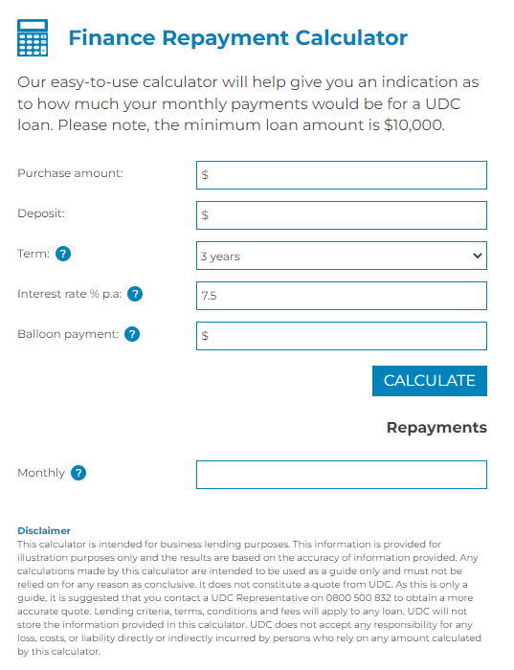

Equipment
At ONYX, we help businesses of all sizes to secure funding in the form of a business loan for asset purchases from either a bank or private lender.
Our dedicated Equipment Finance specialists have extensive industry experience across the agricultural, construction and earthmoving sectors. We’ll work with you to understand the specific needs that face your business to keep your equipment up to date.

APPLY NOW

The types of items we finance are:
- Transport & Logistics: Trucks, vans, trailers, ships, forklifts, conveyors, conveyance robots etc.
- Construction, Earthmoving, Forestry and Farming: Scaffolding tower, digger, shovel loggers, harvesters etc.
- Healthcare: dental machinery, medical imaging machines, Veterinary equipment etc.
- Automotive: Cars, utes, motorbikes etc.
- Technology: computers, laptops, printers/copiers, servers, upgrading to new system software, etc.
- Manufacturing: Industrial machinery, textile machinery, cosmetics machinery, cable making machinery etc.

Who We Are
The goal of ONYX Finance is to build on the track record of the ONYX business and to create a new benchmark in the Australia’s Asset Finance industry, providing good old fashioned localised service that delivers the assets you want when you need them and structured to recognise asset useful life while being sensitive to cashflow.
providing second to none asset finance support to business owners and individuals alike.
A healthy appetite exists to help our customers with finance for a broad range of motor vehicles (from cars to heavy commercial vehicles), mobile and fixed plant, and business equipment…for more detail you can contact us today.

Contact Us
To find out how to get ONYX Finance working for you helping with your funding needs.
Please call 13 66 99 ( 13 ONYX)
Or Contact us now: Alternatively send us a message with your questions.