Front page:
Replace image home to exterior back yard
Remove Wilson Care Group WELCOMES YOU TO OUR HOME
-Replace with Wilson Senior Living Welcomes you home!
-move up the title and make words a little bigger
Remove under monthly fees Monthly RN visits-if possible make words a little bigger
Both pages-Remove flowers in the back ground
Both pages-Remove-Complimentary care consultaion that is above contact info and make contact information bigger
Both pages-remove call for initial consultation
Both pages-above phone number it should say only SCHEDULE A TOUR TODAY and make
Both pages-QR code should go to www.wilsoncare.com and remove scan for opportunities

LOGO SHOULD BE THE SAME SIZE AND SAME PLACEMENT ON BOTH SIDES TO FILL SPACE
Back page: Remove (7-day min stay and 3-day min stay)
Change image of girl buttoning mans shirt and lady with flowers-image of kitchen and hallway
Remove Wilson Senior living opened in 2013 in the aikahi neighborhood of kailua paragraph
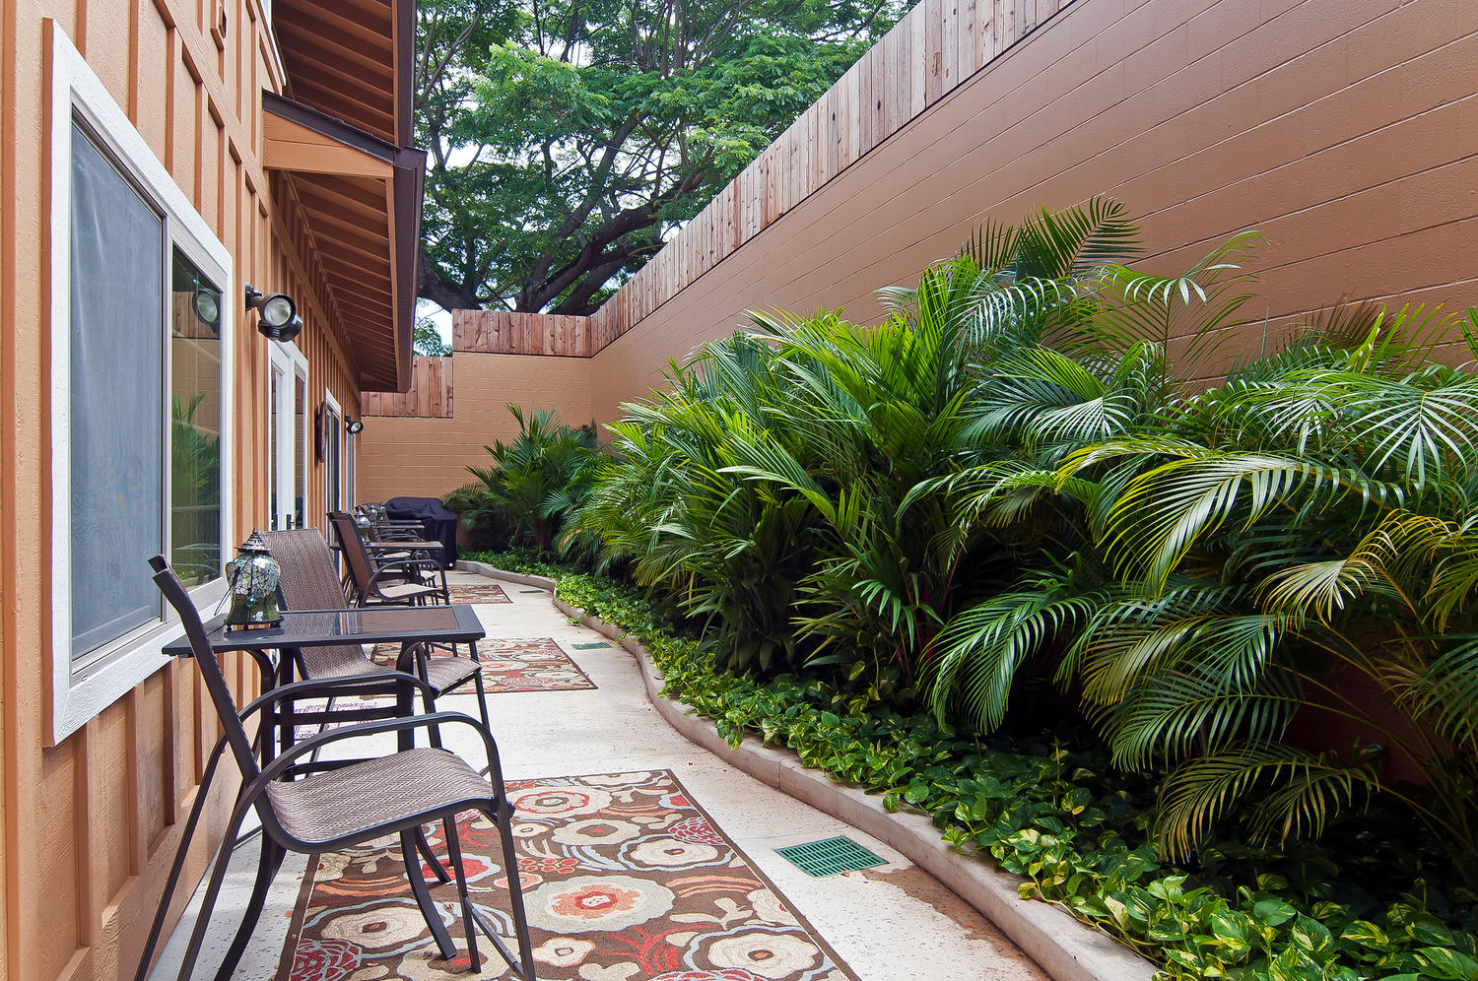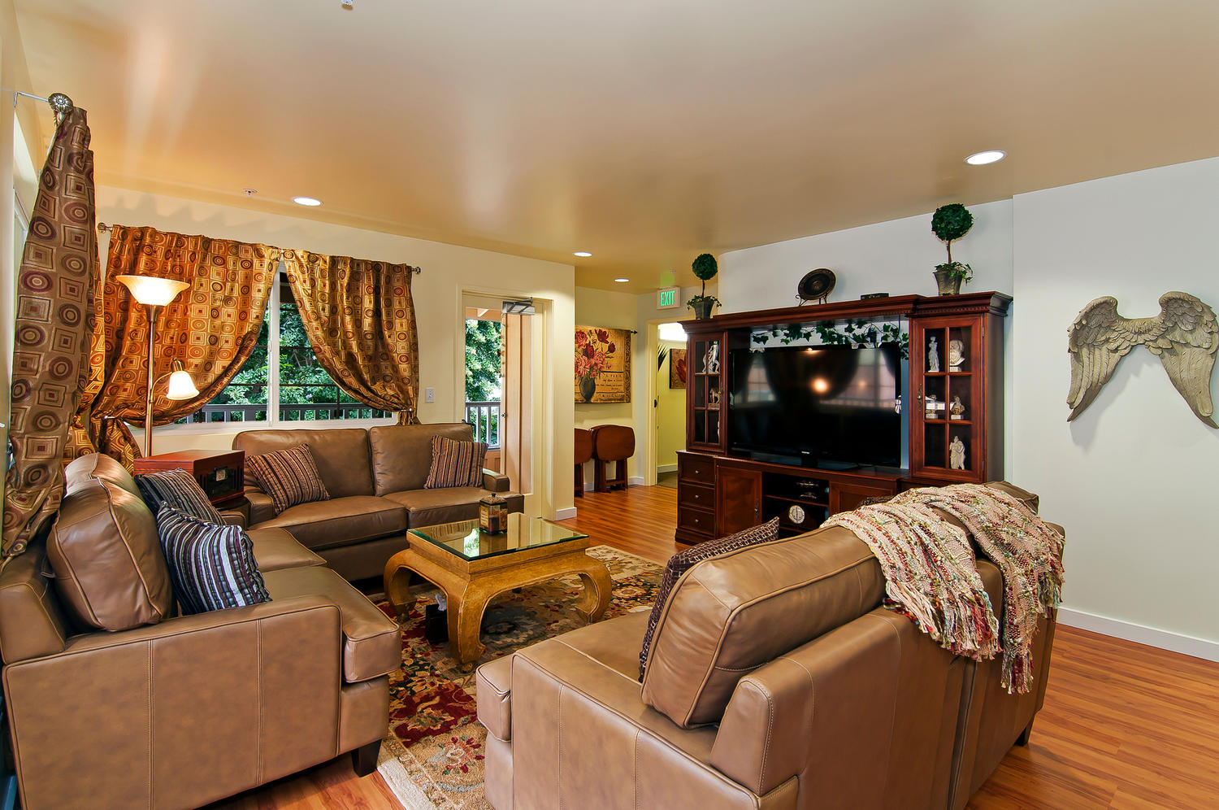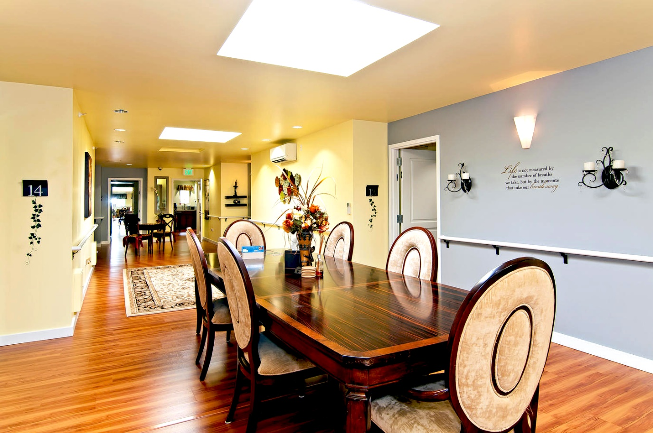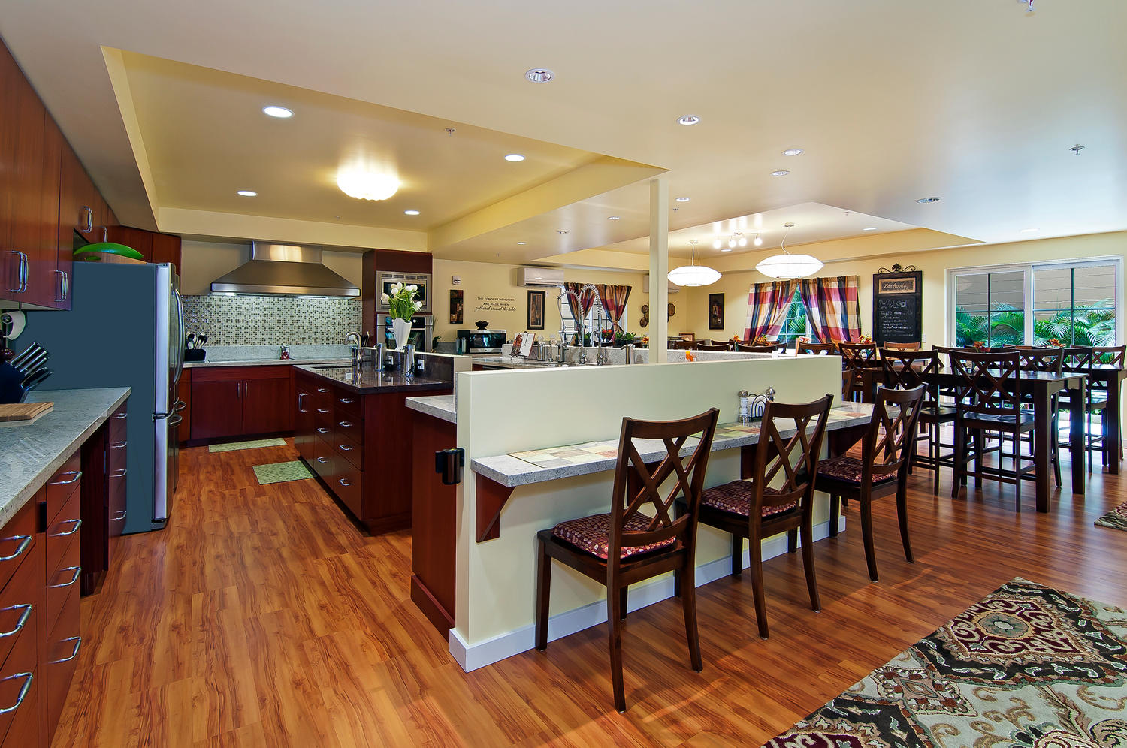
Are you able to make rectangle images into bubble images to makes the ones on the top?

