Please use Kay Bahd design as an inspiration. I like the style of this design. Design can be one or two colors, possibly with the distressed pattern. Screen printing will be used for the design to be applied to the fabric.
Replace goose with the Great Dane graphic similar to one of those below. If possible, please incorporate the white smudge mark on the dog’s nose same to one on the picture. (Maya – dog on the picture is the reason how the apparel line started)
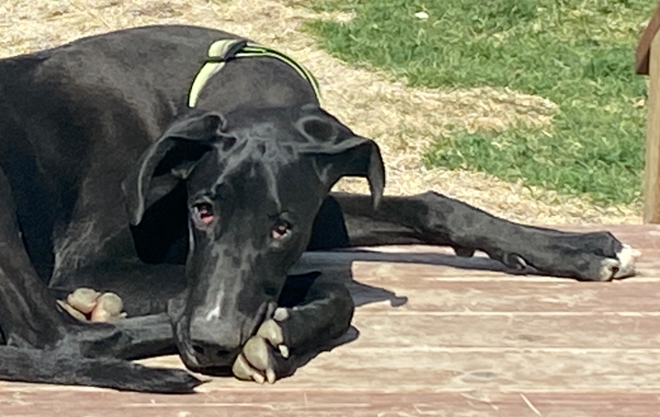
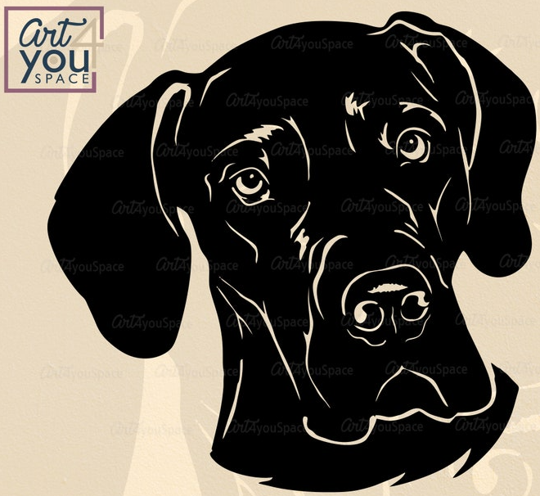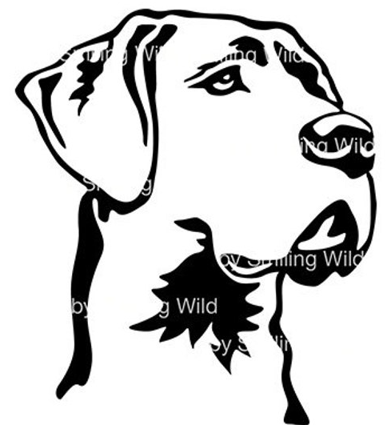

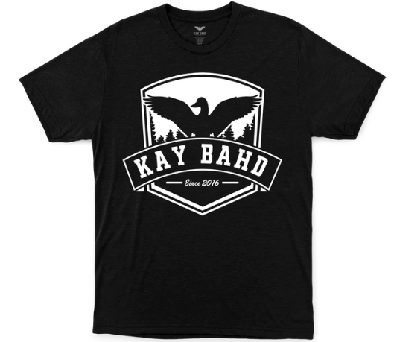
I am looking for the logo design that can be used on T-shirts, hoodies and hats.

About the company: Big Woof Apparel or short version - Big Woof is an apparel line targeting Great Dane owners.
Other designs on the apparel will be humorous, inspired by the life with the ‘goofy gentle giant’. Only the Great Dane owner understand good and bad, funny and serious challenges of life dedicated to the dog up to 180 lbs heavy that behaves as a lap dog or small puppy.
The Great Dane graphic used in the design is inspired by Maya – Black Great Dane who will never reach her full size and life span as she was born with very serious health condition.
Big Woof is an apparel line supporting non-for-profit organization called My pet and ME (Mega Esophagus). ME is a condition that is very difficult to manage and shortens pets’ life drastically. My pet and ME is dedicated to bringing awareness through education and research to the public around ME illness in dogs and cats and providing support and services to the owners of pets born with ME to prevent sending them to the shelter or for euthanization.

