Tribal Law and Policy: Alzheimer’s Disease and

Related Dementia Issues

Prepared by Splaine Consulting
October 27, 2021
For
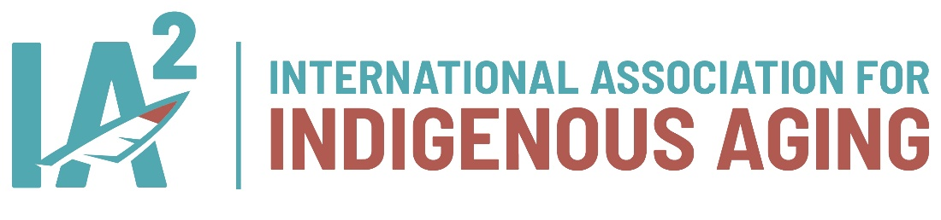
Contents
Executive Summary 3
Background 4
Road Map for Indian Country 5
Tribal Sovereignty 5
Process 6
Primary Sources 6
Secondary Sources 7
Road Map Development and Subsequent Activities 7
Uniform Law Commission 7
National Conference State Legislatures (National Caucus of Native American State Legislators) 7
Results 8
Related Policy Issues Collections 8
State Alzheimer Plans 9
National Plan to Address Alzheimer's Disease 11
Other National Plans 11
Conclusion 11
Citations 12

Tribal Law and Policy Regarding Alzheimer’s Disease and Related Dementia Issues

Executive Summary
From the beginning of persons organizing action on dementia and caregiving issues in the early 1980s, working in and through government as one means of dealing with the myriad problems related to the societal burden and trajectory has been a means to an end of better lives for persons living with Alzheimer's disease and related dementias (ADRD). This brief examines how federal and tribal law and state policy actions currently address these issues.
As sovereign nations, tribes are uniquely situated to use law as a public health tool to promote the health and well-being of their communities. Additionally, federal law creates a framework that governs the relationships among tribes, states, and the federal government that can affect tribal public health.
U.S. Centers for Disease Control and Prevention (2017)

Background
Law, regulation, and policy are all understood to be essential public health services as tools to promote equity and improve public health. Mensah et al. (2004) provided an early framework for providing public health services, explicitly citing law as a tool for preventing chronic disease. Consensus chronic disease success stories cited by experts are rooted in legal changes—such as tobacco control, vaccine policy, and seat belt use (CDC, 2014).
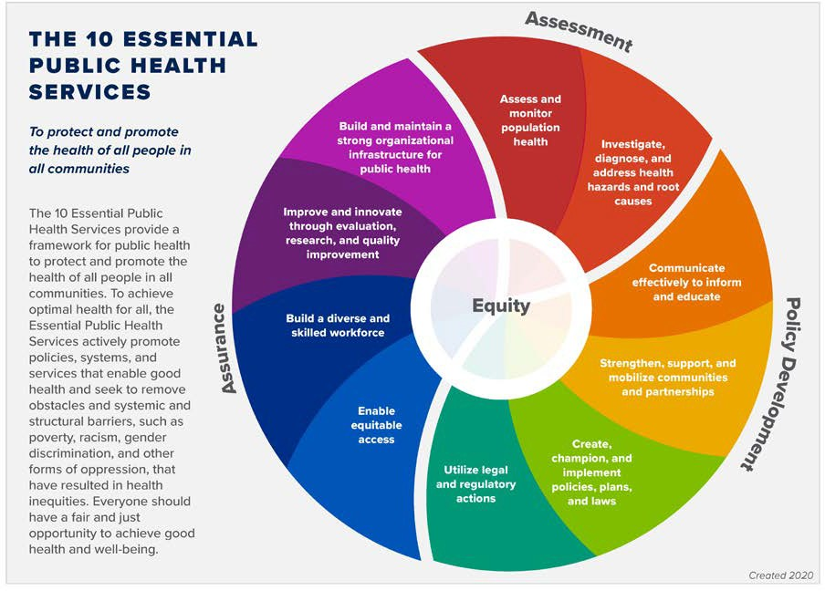
This "essential services" framework, now taught and implemented by public health authorities worldwide (see Figure 1), is embedded in the CDC Healthy Brain Initiative Road Map series. The Road Map for Indian Country (2019) explicitly focuses on four of the ten essential services.

Figure 1 The 10 Essential Public Health Services

Against this backdrop, it is not surprising that Alzheimer's disease and related dementias (ADRD) and dementia caregiving issues are commonly addressed through law and policy in mainstream communities. Over time we have seen the creation or championing of:
- policies and laws shaping the amount and types of long-term services and supports,
- funding for public health surveillance on dementia and the burden of caregiving,
- mandates for awareness-raising activities or risk reduction messaging campaigns,
- workforce development initiatives, and
- funding for biomedical and care research.
Plans for addressing dementia by national and subnational governments have become ubiquitous as a starting point for addressing ADRD. Most plans include target implementation dates and built-in renewal processes to stay current with new and expanded knowledge. The United States (U.S.) National Alzheimer's Project Act (Public Law. 111-375), passed in 2011, called for a National Plan for ADRD that would include input from an Advisory Council (also established by law). The Council also advises the U.S. Department of Health and Human Services (HHS) on priorities for program changes. The first National Plan has been updated annually since its creation in 2012 (Assistant Secretary for Planning and Evaluation, 2020).
The BOLD Infrastructure for Alzheimer’s Act, passed into law on December 31, 2018 (P.L. 115-406), amends the Public Health Service Act (Section 398A; 42 U.S.C. 280c-3-4). The activities outlined in BOLD are designed to create a uniform national public health infrastructure focusing on issues such as increasing early detection and diagnosis, risk reduction, prevention of avoidable hospitalizations, and supporting dementia caregiving.

Road Map for Indian Country
The Healthy Brain Initiative's Road Map for Indian Country, published in 2019, is the first-ever public health guide focused on dementia in American Indian and Alaska Native (AI/AN) communities (Centers for Disease Control and Prevention (CDC)). The Road Map for Indian Country identified eight specific public health strategies for tribal communities (Figure 2). It is intended as a tool for leaders of the nation's 574 federal and state-recognized tribes to engage their communities in addressing this vital issue. Strategy four explicitly acknowledges the importance of the engagement of tribal leaders. These leaders include tribal officials, tribal health and aging services professionals, and regional tribal health organizational leaders. A scan of U.S. tribal policies, laws, and plans regarding ADRD issues is a natural extension of previous U.S.-based efforts and a starting point for identifying critical information resources for tribal leaders.
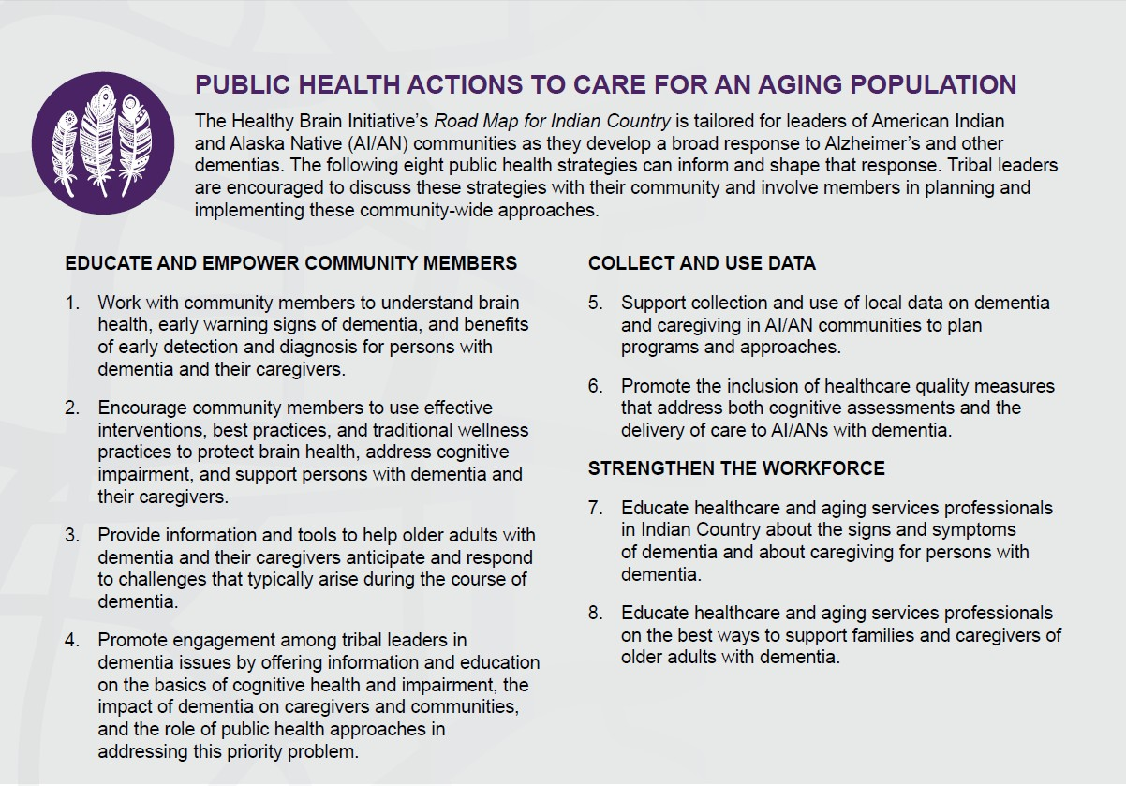
Figure 2 Healthy Brain Initiative's Road Map for Indian Country Public Health Strategies

Tribal Sovereignty
The U.S. Constitution acknowledges federally recognized Indian tribes as distinct governments. They have, with few exceptions, the same powers as state governments to regulate their internal affairs. Sovereignty for tribes includes the right to establish their own form of government, determine membership requirements, enact legislation, and establish law enforcement and court systems.
Federally recognized tribal nations and their leadership have the power, duty, and obligation to promote the health and well-being of their citizens (Gostin, 2000). Based upon powers of sovereignty, they are the de facto public health entities for their citizens. According to the National Indian Health Board (NIHB, n.d.), tribal public health is underrepresented or overlooked within the current U.S. health system. Tribal communities are rebuilding and defining their public health systems, having developed them at a different pace than other public health systems in the U.S. Current tribal systems often differ in structure, infrastructure, scale, and scope from state and local public health entities, if they exist at all. The current state of tribal public health systems is the result of chronic underfunding, federal and state policy, epidemics, and a long-standing history of colonialism, according to NIHB.
American Indian and Alaska Native people are U.S. Citizens and generally subject to federal, state, and local law. However, on federal Indian reservations, only federal and tribal laws apply to members of the tribe unless Congress specifically provides otherwise (U.S. Bureau of Indian Affairs). With this in mind, we sought to identify existing tribal laws, policies, and plans regarding dementia and then look at state actions that impact tribes.
As sovereign nations, tribes are uniquely situated to use law as a public health tool to promote the health and well-being of their communities. Additionally, federal law creates a framework that governs the relationships among tribes, states, and the federal government that can affect tribal public health.
Centers for Disease Control and Prevention (2017)

Process

Primary Sources
Primary sources of tribal law, such as the National Indian Law Library (NILL), were identified and searched for the keywords "Alzheimer's disease," "dementia," and "caregiving." More than 240 tribal codes and 400+ constitutions were queried. This included a custom search of the full text of all codes and constitutions that NILL has available online and the table of contents of materials available in print or on the tribe’s website. In this collection, we did not include tribal resolutions authorizing applications for ADRD-related federal grants, memorials supporting research or awareness activities, or the Wisconsin budget language directing the establishment of two dementia care specialist positions for tribes in its 2016 budget.
In addition, we reviewed two significant sources of tribal public health law: the CDC tribal law portal and the online resources of the Alaska Bar Association, including its Alaska Native Law Section.
In addition to the search of the NILL, we searched for examples of relevant tribal law in the following collections.

Organization | Website
Great Lakes Indigenous Law Center | https://law.wisc.edu/glilc/tribal-resources.html
National Congress of American Indians  (NCAI) Policy Law Center | https://www.ncai.org/
Native Bar Association | https://www.nativeamericanbar.org/
Tribal Law Policy Institute | https://www.home.tlpi.org/
University of Arizona law library, tribal  section | https://libguides.library.arizona.edu/c.php?g=705243&p=5067081
University of Washington law collection | https://guides.lib.uw.edu/research/pnw
Wisconsin Law Library, tribal section | http://wilawlibrary.gov/topics/triballaw.php

Secondary Sources

Road Map Development and Subsequent Activities
The Road Map for Indian Country was researched in 2018 and written in 2019. Subsequently, during dissemination, stakeholders and interested parties have been actively looking for tribal programs or public health initiatives concerning dementia in tribal communities, including policy activity. In 2020 the Northwest Portland Area Indian Health Board received CDC BOLD Act (Building Our Largest Dementia Infrastructure for Alzheimer's Act) funding that includes an expectation of exploring the creation of a dementia action plan. This is thought to be the first attempt at developing a formal dementia plan for American Indian and Alaska Native communities.

Uniform Law Commission
The Uniform Law Commission (ULC), also known as the National Conference of Commissioners on Uniform State Laws), established in 1892, provides states with non-partisan, well-conceived, and well-drafted legislation that brings clarity and stability to critical areas of state statutory law. The ULC has an American Indian and Tribes Committee working on a probate code to create greater interoperability between state probate codes and tribal law.

National Conference State Legislatures (National Caucus of Native American State Legislators)
This Caucus works to promote a better understanding of state-tribal issues among policymakers. Their staff note there is no current work or portfolio regarding dementia. However, there is interest in disseminating the current findings.

Results
The NILL search returned a few references. Most results included language embedded in elder abuse statutes and done in a tribal welfare statute.
Keyword | References
Alzheimer's | Ho-Chunk Nation legislature, Employment Relations ACT,  p-49 reference in the Family and Medical Leave statute as a trigger for eligibility
Dementia | NULL search
Caregiver | Puyallup Chapter 7.28 Vulnerable Tribal Adult Protection Code https://www.codepublishing.com/WA/PuyallupTribe/#!/html/PuyallupTribe07/PuyallupTribe07 28.html  Tohono O'odham Code, Title 17, Adult Protection Ordinance  https://narf.org/nill/codes/tohono/Title17Ch1.pdf  Lummi Nation Code of Laws, Title 5C, Harassment Prevention Code  https://narf.org/nill/codes/lummi/5C_Harassment_Prevention.pdf  Ho-Chunk Nation Code (HCC) Title 4 – Children, Family, and Adult-at-Risk Welfare Code  https://narf.org/nill/codes/hochunkcode/4HCC12_Adult_at_Risk.pdf Grand Traverse Band Criminal Code Title 9 https://www.narf.org/nill/codes/grand_traverse/

CDC Tribal Law Portal
Nothing dementia-specific is available in the CDC's Tribal Public Health Resources. However, guidance on public health legal preparedness, emergency preparedness, and the Affordable Care Act have a loose connection to dementia and caregiving issues. See: https://www.cdc.gov/phlp/publications/topic/tribal.html

Alaska Native Law and Policy on ADRD
The online resources of the Alaska Bar Association and its Alaska Native Law Section were reviewed to identify additional searchable Alaska tribal codes. None were found other than those cataloged in NILL's database. A phone interview with a section leader confirmed no other sources of information, noting that some Alaska codes may not be readily available in a searchable format.

Related Policy Issues Collections
As the authors have a deep familiarity with dementia and related policy issues, we note there are policy issues that frequently impact those living with dementia. Although not dementia-specific, there are substantial, relevant collections for these issues. These collections include the following:

National Indigenous Elder Justice Initiative (NIEJI)
While elder abuse and exploitation issues are not exclusive to persons with Alzheimer's and related disorders, such persons are at higher risk because of the resulting cognitive impairment. The National Indigenous Elder Justice Initiative includes an extensive collection of model tribal elder abuse statutes and programs. See: https://www.nieji.org/codes

Other Long-Term Services and Supports (LTSS) Policies
Under contract with the U.S. Administration for Community Living (ACL), the National Indian Council on Aging (NICOA) is developing a website-based collection of resources, including policy background material for tribal leaders. See: https://nicoaltsscompass.org/tribal-leader-resources/

Medicaid Home and Community Based Services Waivers
In recent years private contractors and government agencies have encouraged tribes to apply for home and community-based services waivers to support tribal members with long-term care needs. Although these may have some accompanying tribal enabling legislation, these waivers are often included in state waivers. Tribes are not authorized to work directly with the Centers for Medicare and Medicaid Services (CMS), the federal entity that runs Medicare and Medicaid. Developing a collection of waivers was beyond the scope of this report. However, this example from the Oneida tribe may be of interest. See: https://www.cms.gov/Outreach-and-Education/American-Indian-Alaska-Native/AIAN/LTSS-TA-Center/program-examples/oneida-nation-wisconsin

State Alzheimer Plans
As mentioned in the introduction, members of federally- recognized tribes are also citizens of their states. Starting in 2007, advocacy organizations (and later government agencies) have promoted comprehensive state government Alzheimer plans. Though not tribal law, the Alzheimer plans in the fourteen states with the highest AI/AN population percentage and Hawaii were reviewed for policy, public health, or program recommendations that included tribes (See table below). It is important to note that most older plans did not have specific sections devoted to AI/AN populations, reflecting that dementia and caregiving issues in Indian country and for Alaska Native people have only recently received attention. State planning processes usually start 12-24 months before their publication date, which means the older plans are even more likely not to have included AI/AN populations. With many plans in the process of updates, AI/AN population issues and tribal engagement may grow. Our chart notes that North Dakota has published a new plan since the initial research for this paper was completed with much more robust engagement and addressing of American Indian community issues and has withdrawn its previous plan from circulation. Idaho will soon release an updated plan, which has included input from the state’s American Indian communities; the chart is based on the 2013 plan and a 2020 evaluation of that plan.

In cataloging these plans, it is hoped that they may inspire consideration by tribal leaders, either within the tribe or through a partnership with state government entities. In some cases, these policy recommendations are based on direct consultation or engagement with tribal leaders and communities. In two states (WA and OK), ongoing implementation workgroups exist. Although not one of the fifteen states with the highest percentage of AI/AN people, Minnesota's 2013 plan featured significant American Indian input and policy recommendations.

 | Plan year | Significant inputs | Culturally tailored awareness | Research participation | Special tribal-based support programs | Ongoing workgroup
Alaska | 2014 | x | x | x
Oklahoma | 2018 - 2022 |  |  | x |  | x  clinical trial participation
New Mexico | 2017 | x | x | x | x
South Dakota | 2018 |  | x |  |  | X  survey for needs
Montana | 2016 | x | x |  | x
North Dakota | 2022 | x | x |  | x | x
Arizona | 2015
Wyoming | 2018
Oregon | 2012 Update Pending
Washington | 2014, 2019 | x | x |  | x | x
Hawaii | 2020 |  | x | x
Idaho | 2013
Kansas | 2020 |  | x
Nevada | 2021-2022 |  | x
Colorado | 2010

National Plan to Address Alzheimer's Disease
For several decades, the U.S. has attempted to address ADRD. The U.S. National Alzheimer's Plan, which originated in 2012, establishes five ambitious goals to prevent future cases of ADRD and better meet the needs of the millions of American families facing these conditions (Assistant Secretary for Planning and Evaluation, 2020). It is updated annually to include discoveries and understanding in the community.
The 2017 Plan Update was the first to mention AI/AN communities, citing a National Institute on Aging (NIA) and Indian Health Service (IHS) jointly funded collaboration to bring evidence-based caregiver programs to a small number of Native communities (Martindale et al., 2017).
The 2018 National Plan Update cited ongoing action to connect AI/AN people to ADRD resources, and an action (1.B.4) related to increasing racial diversity in clinical trial research. It announced the preparation of the Road Map for Indian Country, including the first-ever related brain health materials produced by the Association for State and Territorial Health Officials (ASTHO) and the International Association for Indigenous Aging (IA²).
In the 2020 Plan Update, the publication of the Road Map for Indian Country and several related infographics based on Behavioral Risk Factor Surveillance Survey (BRFSS) data on ADRD caregiving and cognitive decline in AI/AN populations were noted. Action 3.B.3 of the National Plan was updated to include a joint website and other collaborative actions by IHS, ACL, and CMS to share information and support for long-term care services and supports needs of AI/AN people with ADRD. Also noted, was the ACL grant program "ADPI: Dementia Capability in Indian Country," for which four tribal entities received grants in 2020.

Other National Plans
The U.S. is just one country worldwide that has developed a national dementia plan. Of note, Canada (2019), New Zealand (2020), and Australia (2015) all included the participation and engagement of their Indigenous peoples in their national dementia plans. It was noted in these three countries’ national plans that Indigenous populations face barriers to equitable care, access to research, and a significantly higher risk of dementia.
Initial policy recommendations in all three countries’ plans have been acted upon. All three nations have funded initiatives to work collaboratively with their Indigenous communities to devise standardized cognitive testing that is more accurate, culturally safe, and appropriate. Another priority is establishing health promotion activities to promote awareness about dementia and risk reduction for brain health.
Each country has its version of American Indian reservations and treaty obligations for Indigenous health that have been less than adequately fulfilled. Thus, making access to diagnostic services more complex--a problem that each country has set action steps to correct. Investments in dementia caregiver and community care were recommended but, in all cases, have been stalled by the COVID-19 crisis.

Conclusion
This environmental scan has found few direct references in AI/AN tribal codes addressing dementia or caregiving issues. More prosperous policy actions were identified in U.S. states’ Alzheimer plans and in the four national plans. Approaches and tactics identified in those plans may form the basis of a tribal public health law or policy initiative, such as a dementia plan for a single tribe or a tribal consortium.

Citations
Alzheimer's Association & Centers for Disease Control and Prevention. (2019). Healthy Brain Initiative, Road Map for Indian Country. Chicago, IL: Alzheimer's Association. Retrieved May 18, 2021, from https://www.cdc.gov/aging/healthybrain/pdf/HBI-Road-Map-for-Indian-Country-508.pdf
Assistant Secretary for Planning and Evaluation. (2020). National Plans to address Alzheimer's disease. Retrieved May 18, 2021, from https://aspe.hhs.gov/napa-national-plans
Centers for Disease Control and Prevention. (2014). Ten essential public health services. Retrieved May 18, 2021, from https://.cdc.gov/publichealthgateway/publichealthservices/pdf/essential-phs.pdf
Centers for Disease Control and Prevention. (2017, March 2). Tribal public health. Retrieved May 18, 2021, from https://www.cdc.gov/phlp/publications/topic/tribal.html
Gostin, L.O. (2008). Public health law: Power, duty, restraint. 2nd Ed. University of California Press.
Martindale-Adams, J., Tah, T., Finke, B., LaCounte, C., Higgins, B. J., & Nichols, L. O. (2017). Implementation of the REACH model of dementia caregiver support in American Indian and Alaska Native communities. Translational behavioral medicine, 7(3), 427–434. https://doi.org/10.1007/s13142-017-0505-1
Mensah, G. A., Goodman, R. A., Zaza, S., Moulton, A. D., Kocher, P. L., Dietz, W. H., Pechacek, T. F., & Marks, J. S. (2004). Law as a tool for preventing chronic diseases: Expanding the range of effective public health strategies. Preventing chronic disease, 1(1), A13.
National Indian Health Board. (n.d.). Strengthening tribal public health systems. Retrieved May 18, 2021, from http://www.nihb.org/tribalasi/
https://worldpopulationreview.com/state-rankings/native-american-population

