Plan.CR Web Site

Menu
- Home / Inicio
- Soluciones / Soluciones
  - Display extended menu. View Example
- Prices / Planes
  - Redirect to Planes
- Contact Us / Contacto
  - Redirect to Planes
- Sign-In / Ingresar
  - Redirect to Sing-In

Applications Option Menu Example:
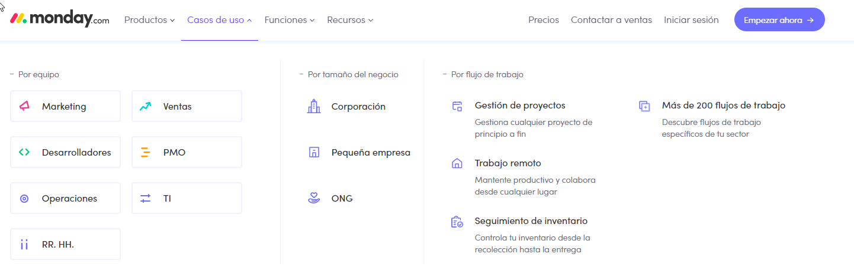
Use this content
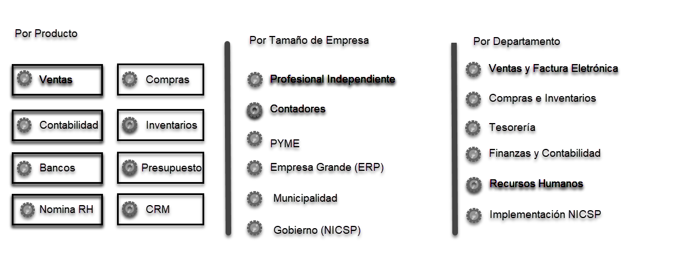

Pages

- Home
- Product Landing Page of each applications
- Product Detailed Page of each application
- Planes
Home
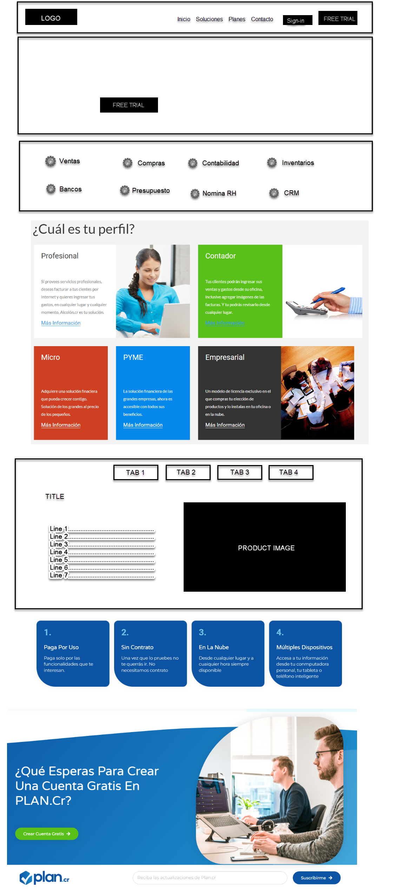

Product Landing Page
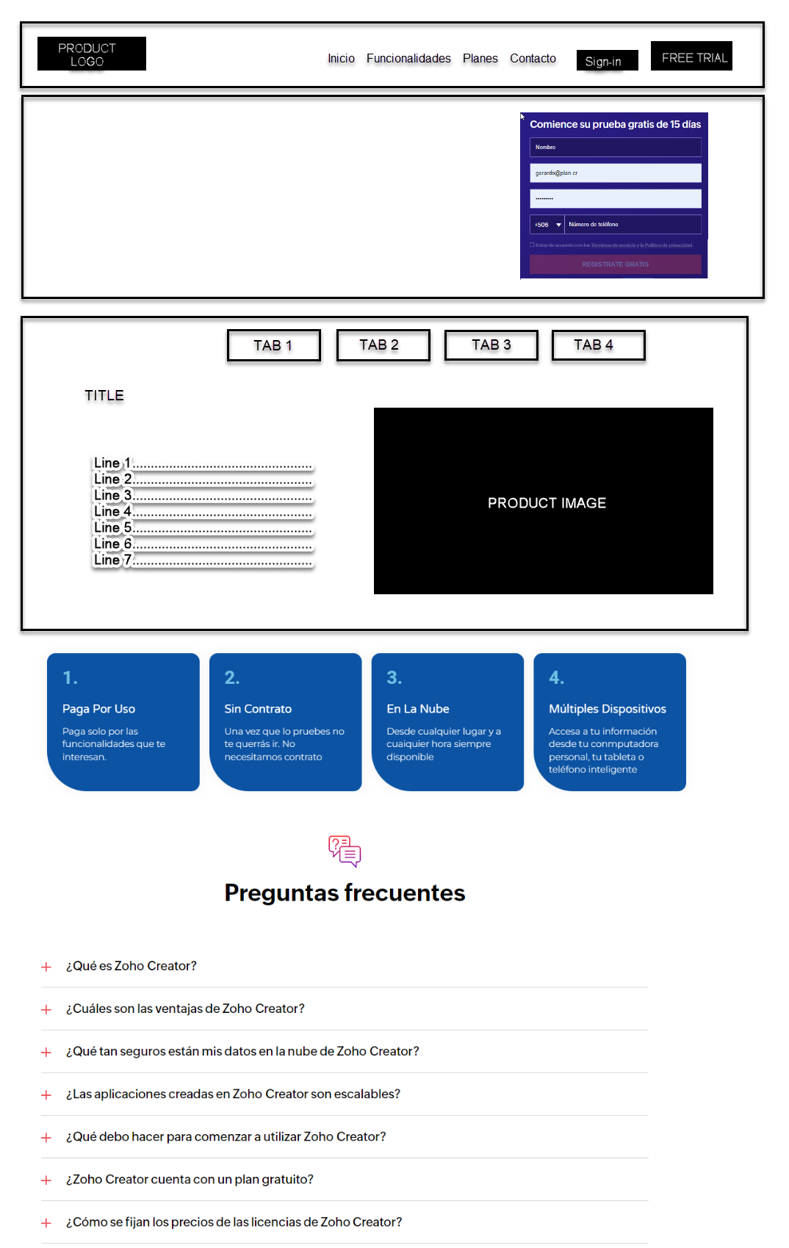

Product Detailed Page
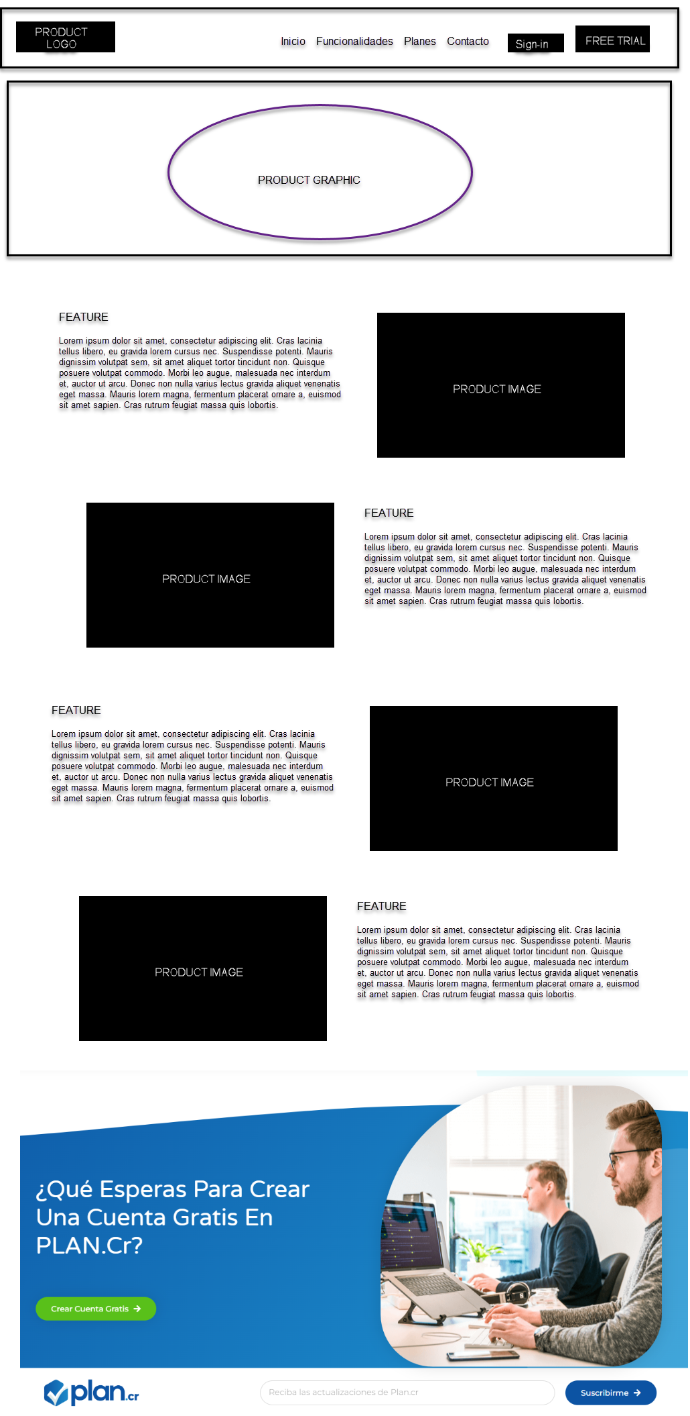
Planes
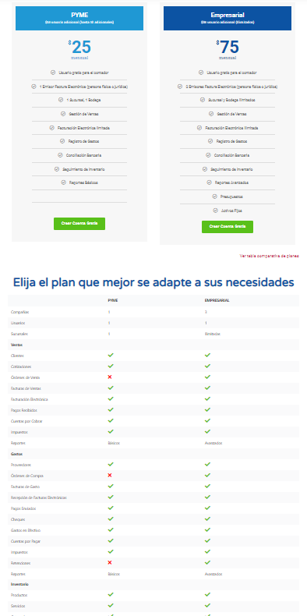

Navigation

