The Mini Branch

Layout and Design

Layout

The Mini Branch’s layout will be open concept. We will require a few walls to be added to create a storage room, office and staff room, and a bathroom for staff and customers.

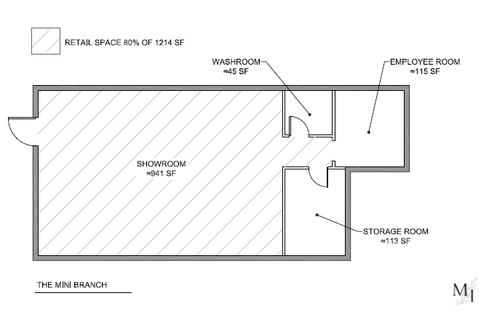

Fixtures and Merchandising furniture
Ideally, we would like to see a shop-in-shop partnership with Oeuf Canada. Using their furniture as our displays, as well as show pieces for drop-ship sales. The other displays will be handmade by Scott, who is an avid woodworker, as well as upcycling pieces purchased from local suppliers.

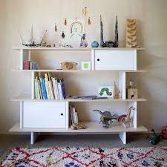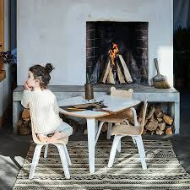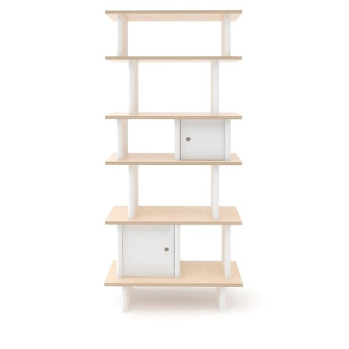

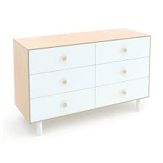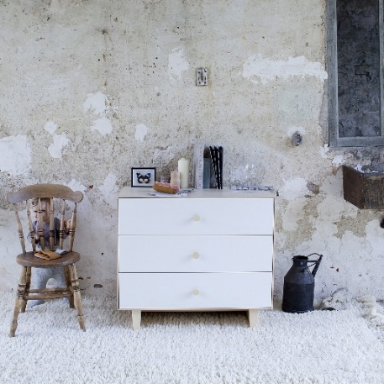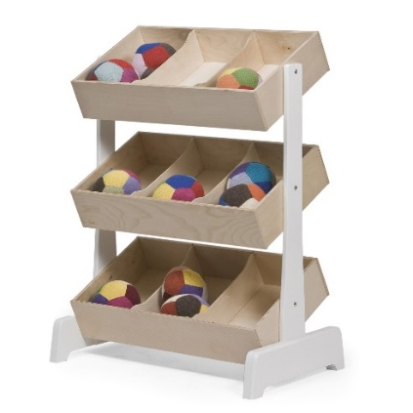
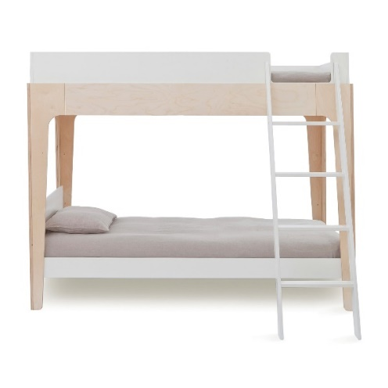

Retail Decor
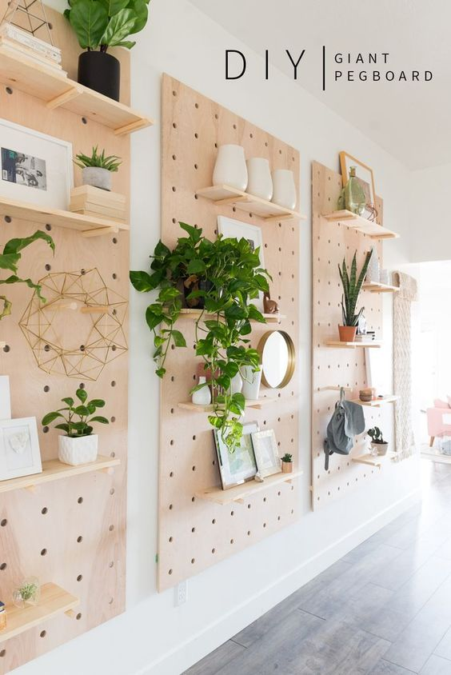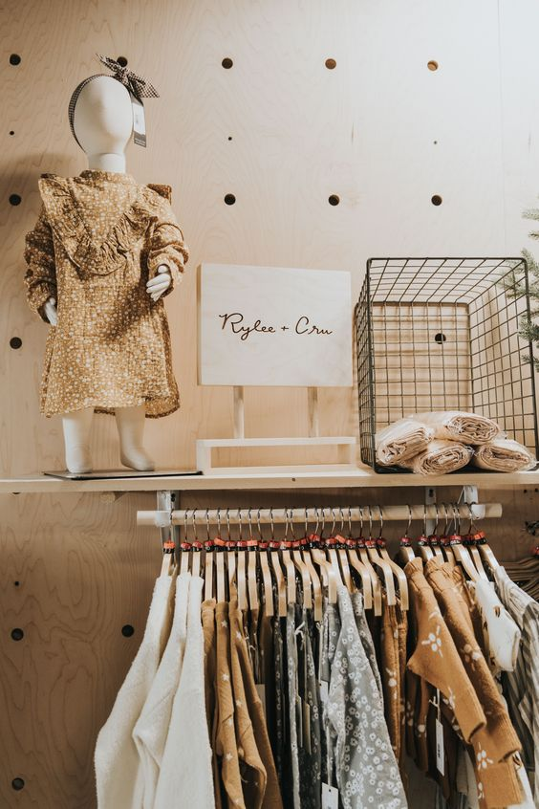
http://thedesignfiles.net/2017/07/foley-street-creative-spaces-the-tribe/

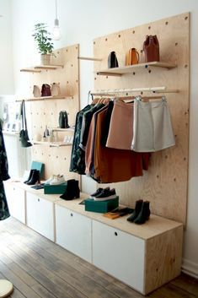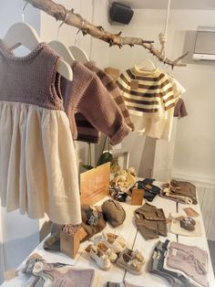
http://www.thomasdellys.fr/portfolio/amenagement-interieur-stories-rennes/

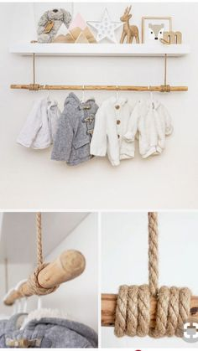
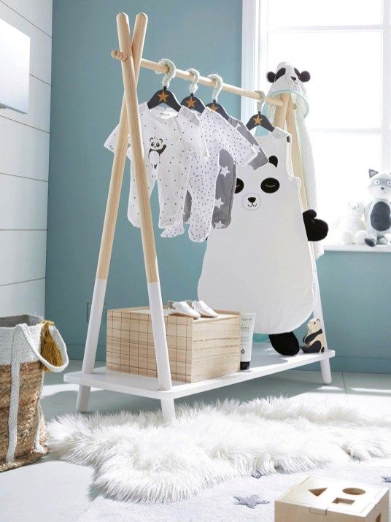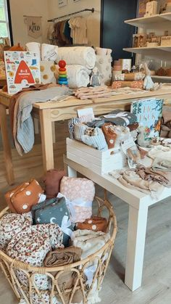

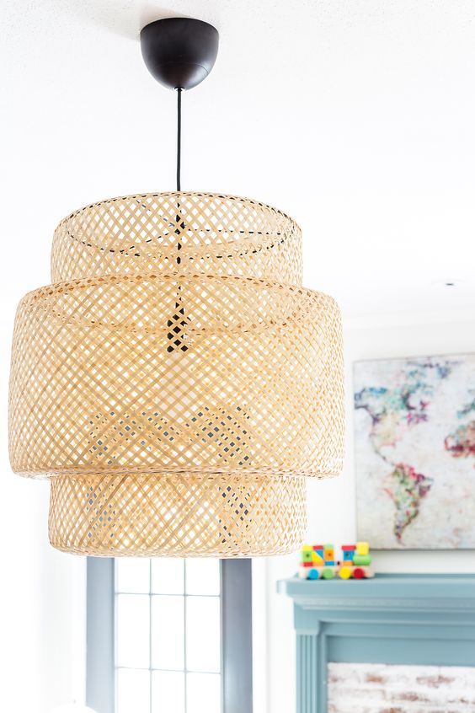

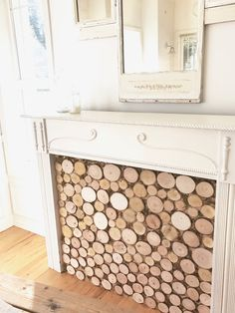

Bathroom

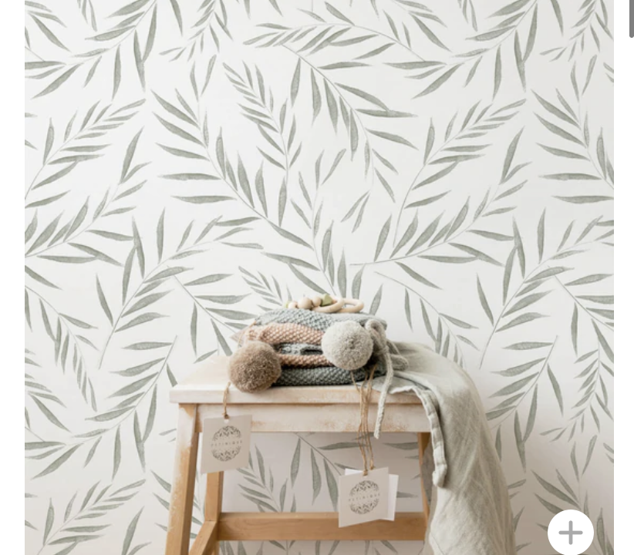
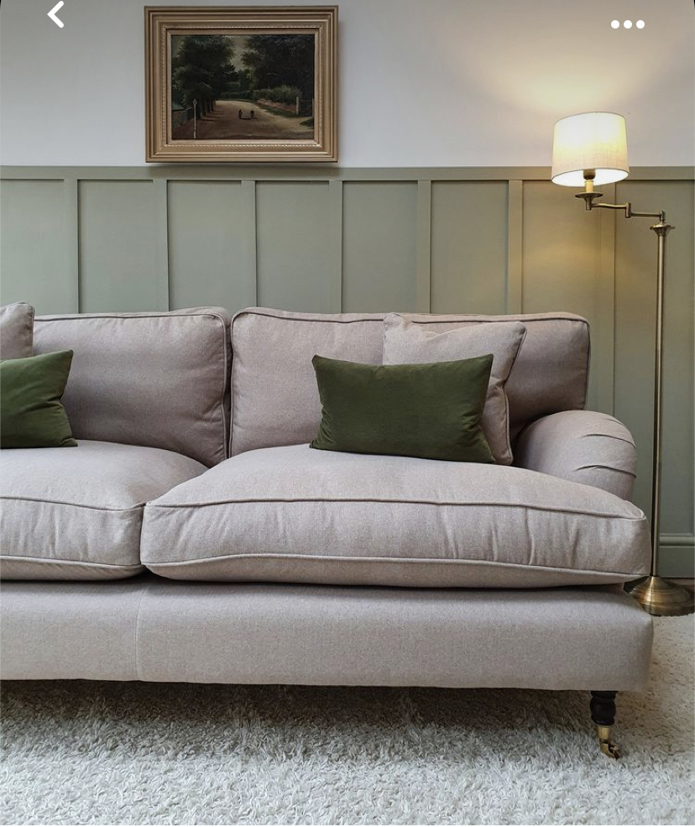
https://livetteswallpaper.com/collections/kids-wallpaper/products/minimal-design-foliage-
wallpaper?variant=22962039554106
Evergreen fog SW130 (colour of the year 2022)
https://www.homedepot.ca/product/murdesign-mirage-32-inch-x-48-inch-wainscott-panel/1001052235

Flooring
https://twelveoaks.ca/products/luxury-vinyl/tetris-suede-delight/ 