Design:

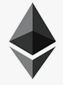

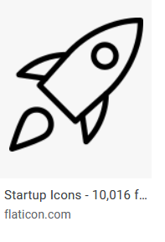
or something similar to demonstrate a crypto coin

Name oft he Company:

Startup Finance

Font:

Something like that:

Website layout:
