https://alpaca-ranunculus-j2hr.squarespace.com/config/pages/62907a80f828e575fa8dc987/categories/62907a80f828e575fa8dc98e

Hi there,
We are cannabis farmers in Northern California. It is a small, organic sustainable family farm. We decided to create our own products. We are trying to launch a line of flower/buds packaged as well as distillate and pre rolls.
- Our Idea is package bud in a mylar pouch, clear, about 10-11cm wide to 17-18cm long.
The front will hold the design,and the California warning sign, the back will be clear and have the prop 64 printed on.
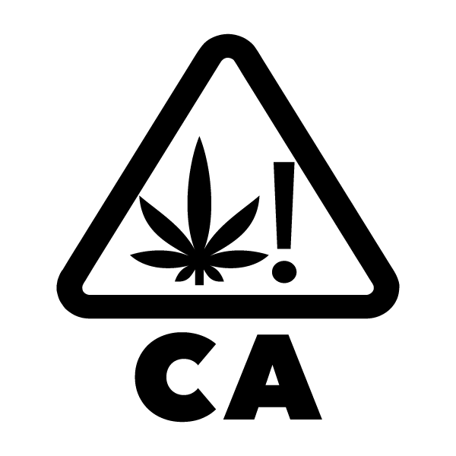
California cannabis warning sign
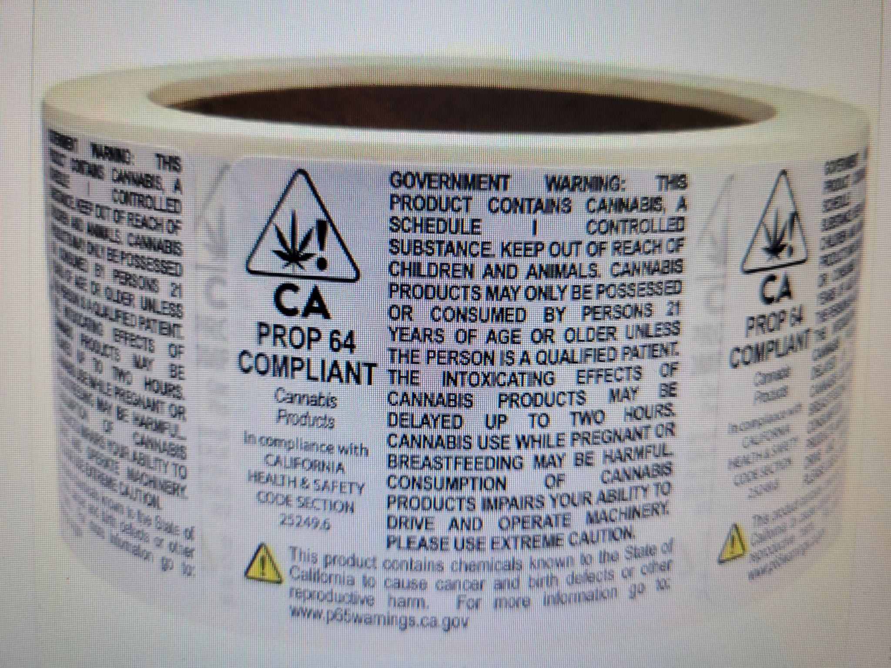
Proposition 65

The front:
Simplify 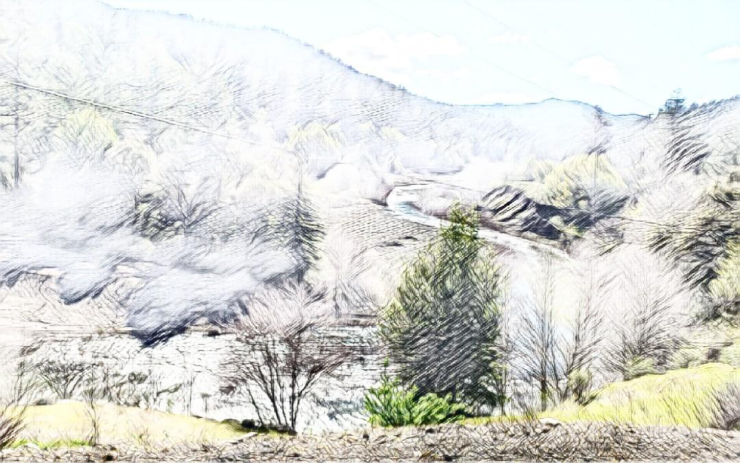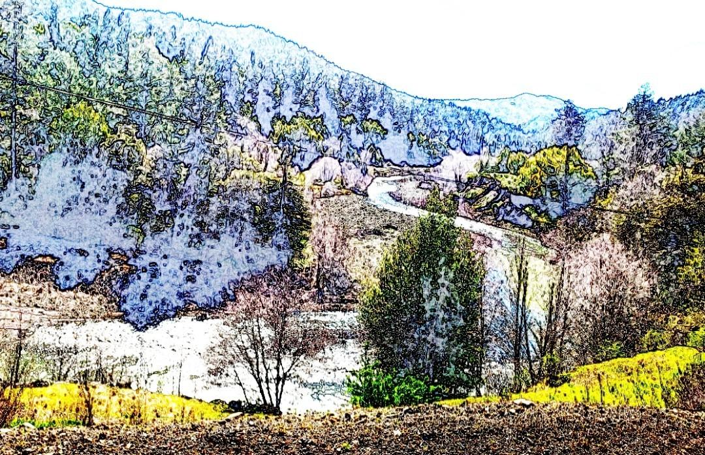
View of Salmon Creek

Redwood forest in mist
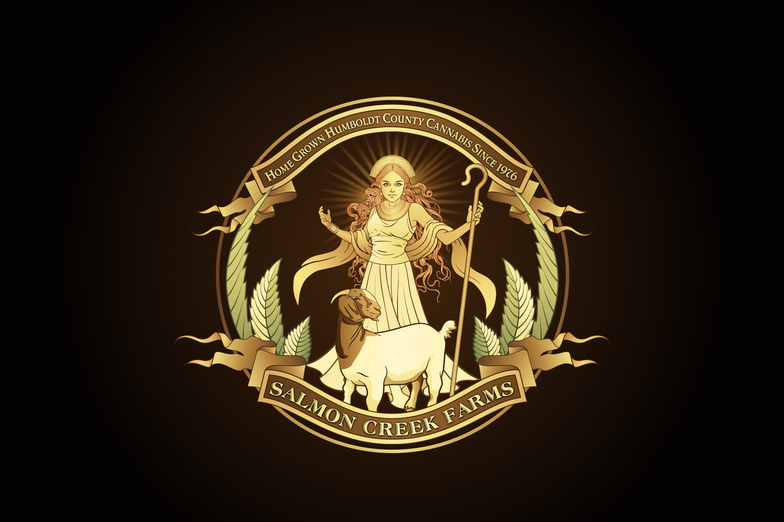
Our logo
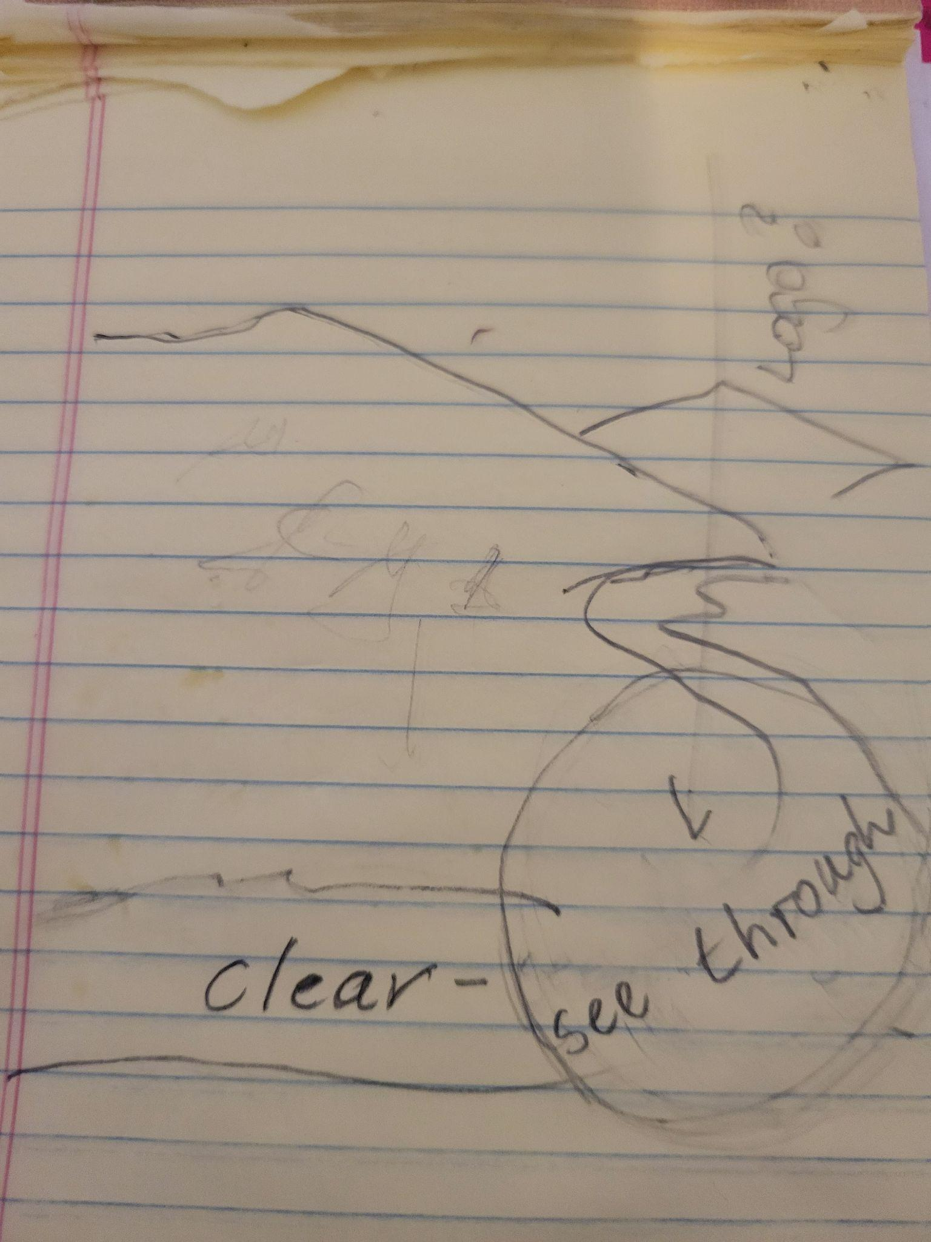

Most of our customers will be in their 25 till 45 year bracket. More men are buying cannabis, but women are catching up. Distillates and high THC products are purchased mostly by young, white males. I would like to reach the female community, being a woman farmer myself.
- We also looking into using Kraft paper pouches 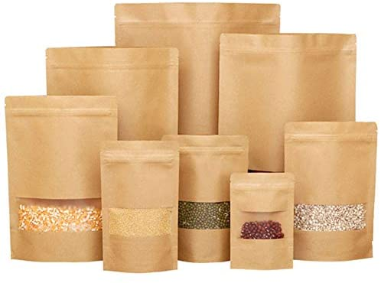

- Paper Boxes for glass jars (for distillate and high quality bud) 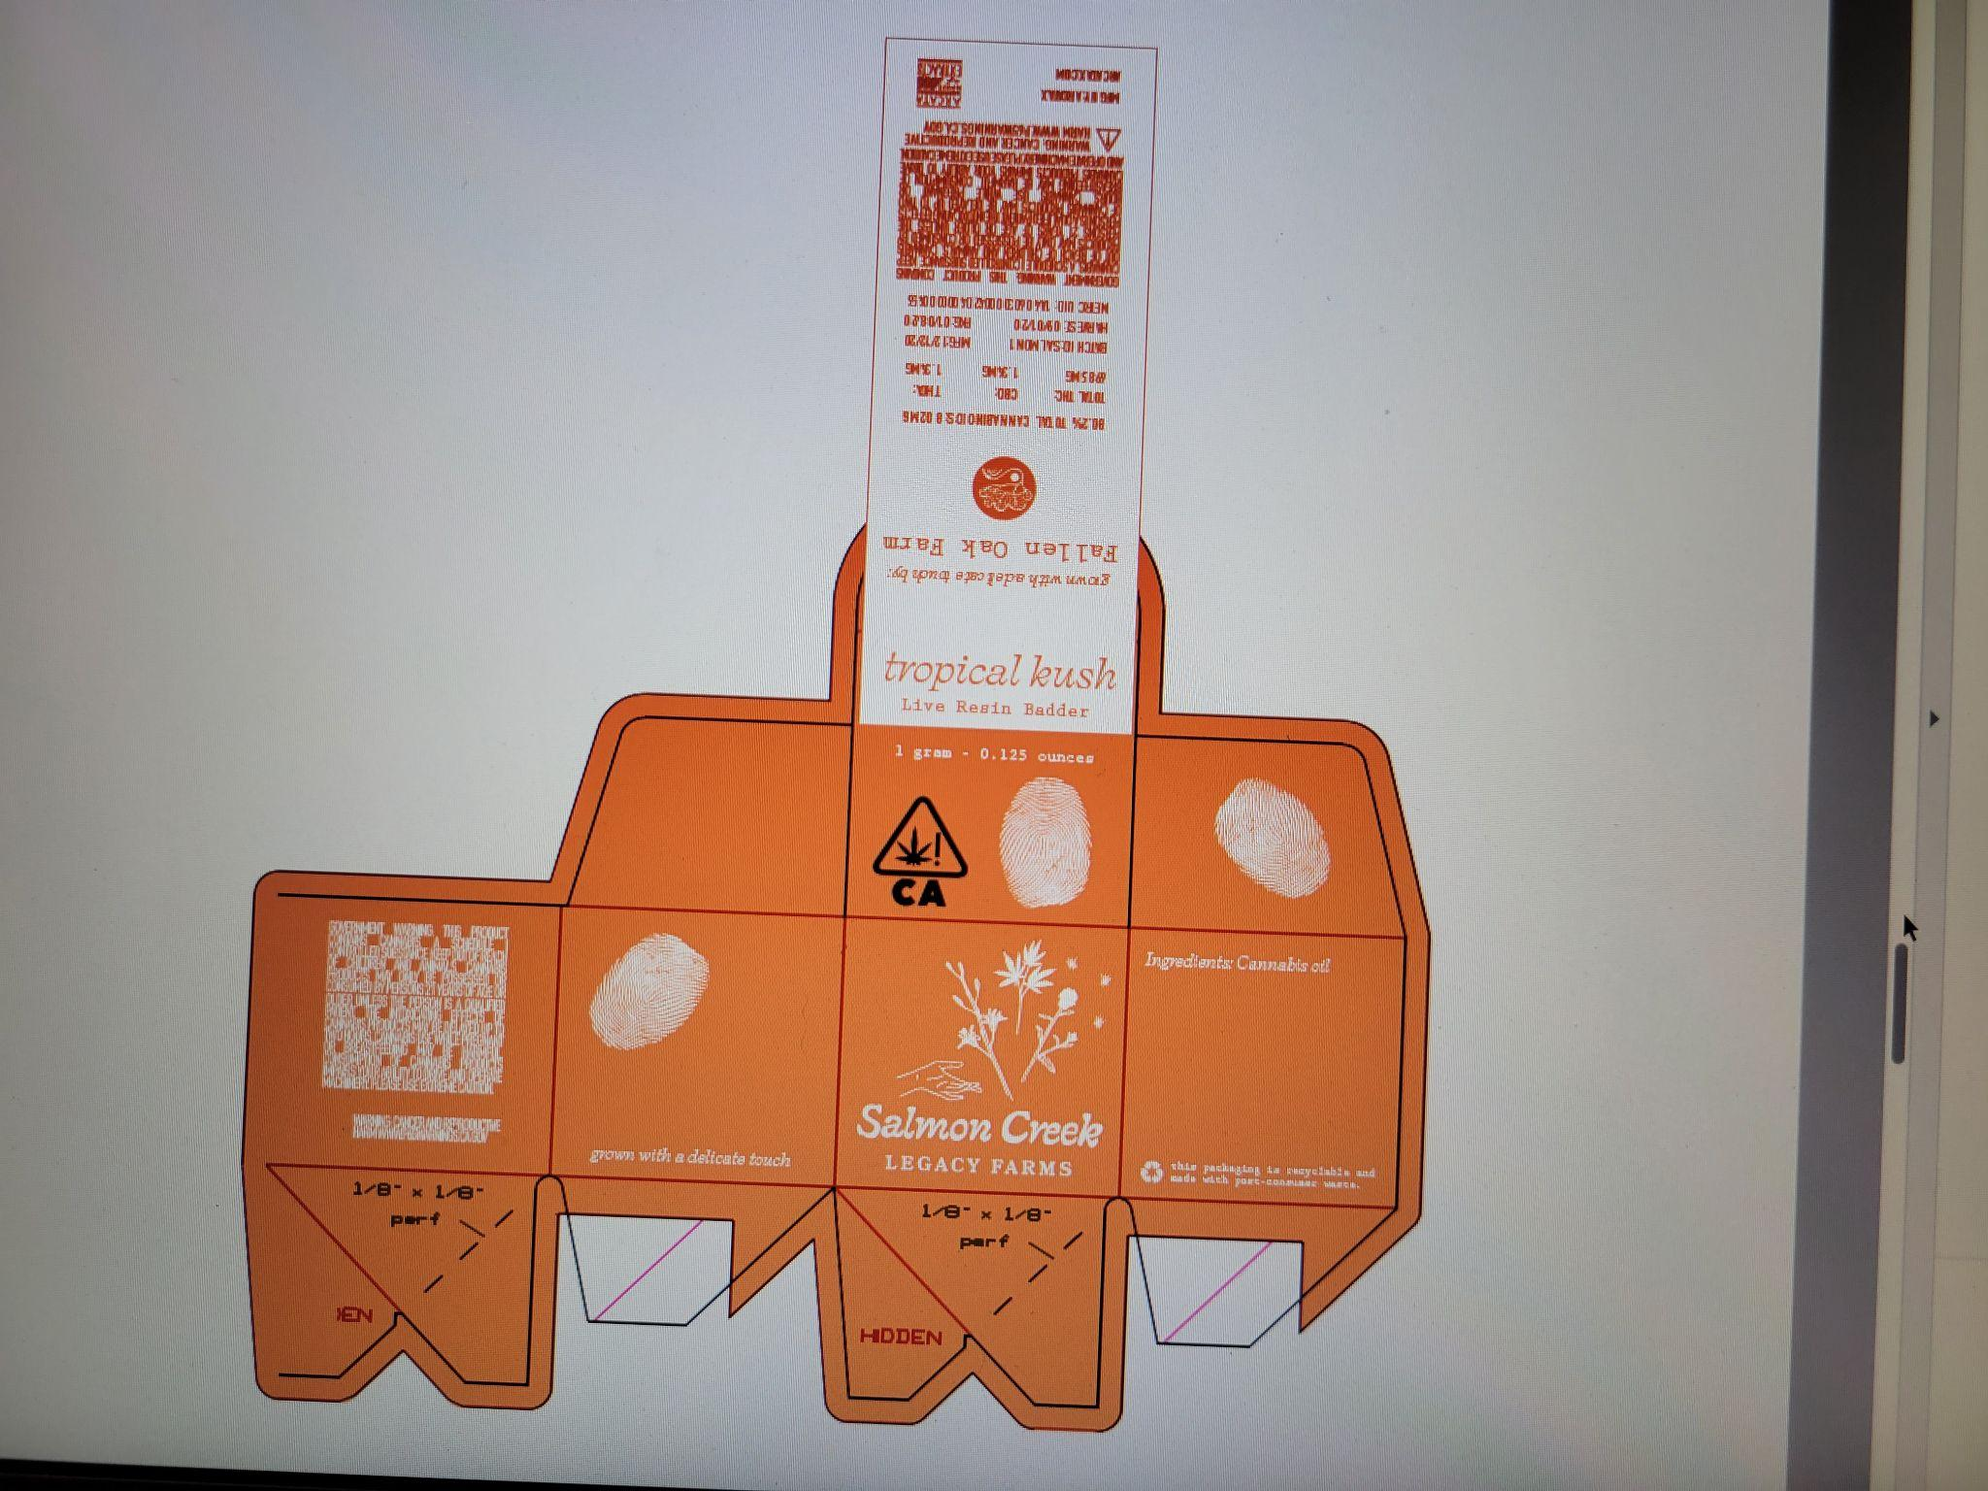 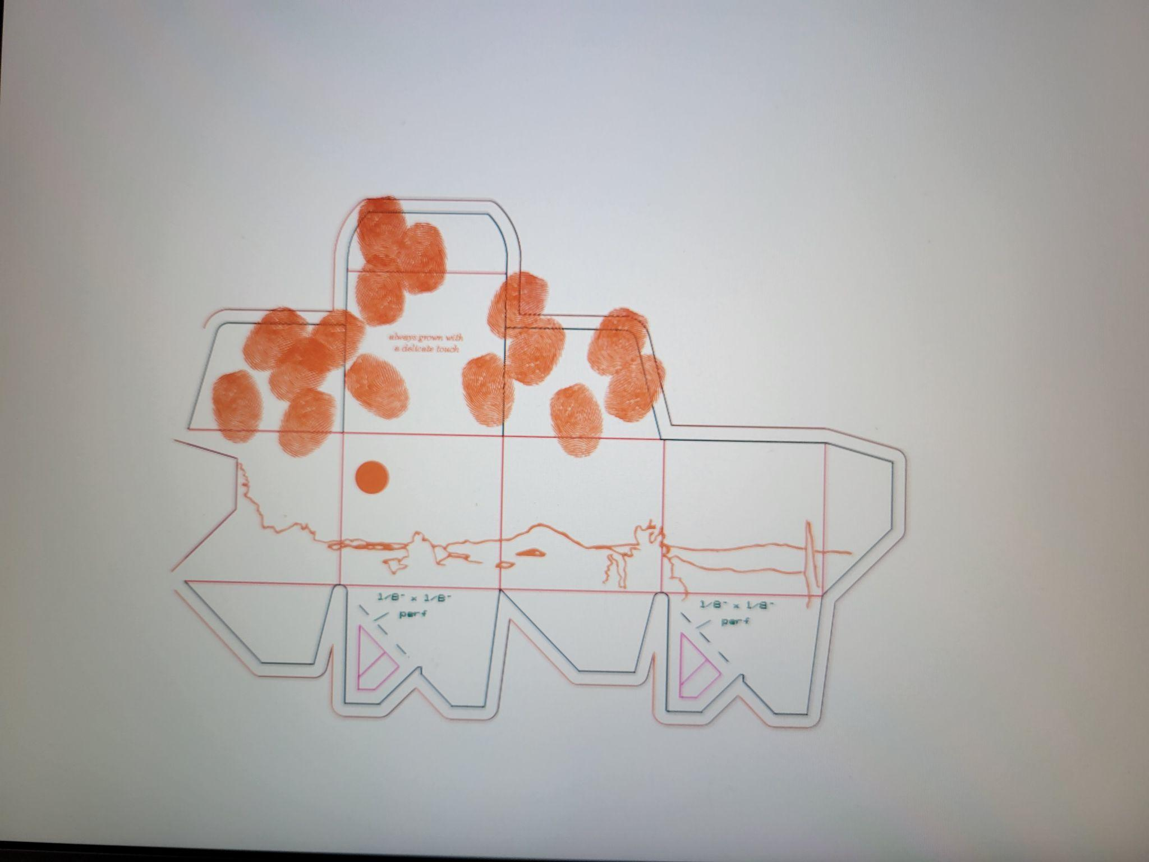
This boxes are pictures for an example of the template for boxes we will be using. I don't really like the design. Note: the box can be printed on the . as well the inside

4.Tin boxes for pre rolls 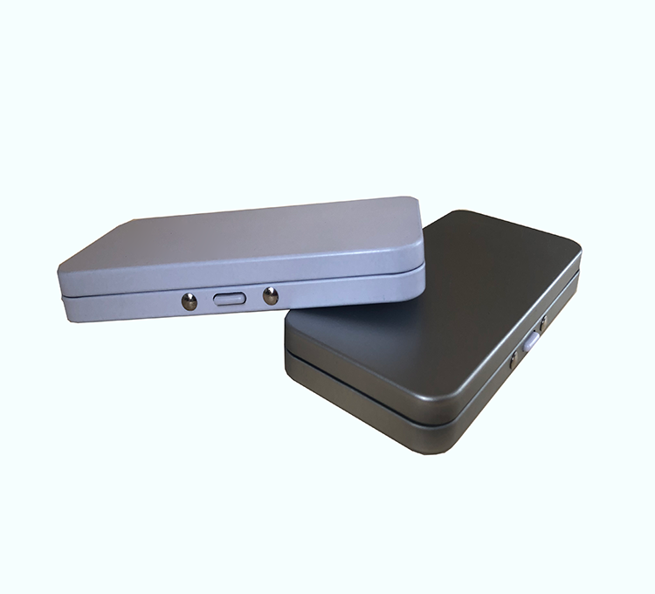

I would like to convey with your design that our farm is producing small batches of organic and sustainable high quality cannabis.

