SI Pharma Pte Ltd

About Us

One-Stop Direct-to-Market Food & Pharmaceutical Product Manufacturing.

SI Pharma Pte Ltd is Singapore-based OEM & ODM manufacturer specialising in the active development and production of food products and pharmaceuticals. Our manufacturing processes are performed in full compliance with industry standards for safety and quality, with products ranging from powder, sachet, softgel, capsule, and gummies—technology processes we have developed extensively for the production of our Sacha Inchi Oil products.

With extensive production capabilities in Malaysia, we are positioned to capitalise on our financial, global business, and production resources to deliver world-class food & pharmaceutical technology solutions.

Supported by a strong R&D, SI Pharma is focused on developing new or improved products, combining comprehensive safety and long-term health studies and product stability testing under a range of realistic environmental conditions.
Led by a dedicated team with years of experience in the industry supported by the essential production resources to deliver one-stop solutions—from product conceptualisation, formulation, packaging design, product registration and legal compliance, and logistics/delivery to deliver ready products direct to market under the brand name of our customers.
As an ISO, GMP, HACCP, and Halal certified manufacturer, SI Pharma is capable of scaling up production while ensuring food safety standards and legal compliance for the benefit of customers and the businesses that serve them.

Vision
Harnessing nature’s gifts to serve the community with exceptional products, service quality, and commitment to bettering lives.

Mission
At SI Pharma, our policies reflect our priority for safety and value for end-users to improve the community’s quality of life while providing businesses access to the resources they need to grow and thrive.

Our Services

Research & Development
Innovation, insights, and entirely novel solutions represent the hallmarks of progress to create products that better serve our customers and business partners.

At SI Pharma, we are committed to strong R&D to formulate new products and improve their safety, stability, and cost-effectiveness with a specific food ingredient, supplement, or pharmaceutical product—including long-term health studies, scientific chemical analysis, and manufacturing process design.

OEM/ODM Manufacturing
SI Pharma offers comprehensive OEM/ODM manufacturing services following our extensive R&D process.

From product formulation, manufacturing process development, and branding and marketing planning, SI Pharma is ready to help customers take their plans from conceptualisation to market-ready products.

We can also adapt & customise our OEM/ODM process to formulations provided by customers after evaluating its safety, stability and business viability.

Step-by-Step Manufacturing Process
- Product development (qualitative and quantitative)
- Laboratory testing, technology evaluation, stability verification
- Production preparation (raw materials purchases and packaging)
- Manufacturing
- Registration and export documentation
- Product Packaging and Quality Control
- Logistics and supply chain
- Delivery

Product Processing
We provide product processing services to prepare a range of finished and partially finished products with no minimum order quantity:

- Liquid to powder processing.
- Safety & hygiene processing of raw materials into ready products.
- Additive manufacturing & processing (e.g. collagen additives, stabilisers).

Equipped with advanced automated production facilities, SI Pharma has the capacity to produce 500,000 softgels per week, with our newer facilities capable of producing 1,000,000 softgels per week.

Products
SI Pharma manufactures products in a range of types based on the end-product:

Powder
We provide bulk powder processing with measured solubility, uniform particle size, free-flowing powder, and taste.

Our powder products are ideal for all common types of storage, including bags, bottles, jars, and canisters

Sachet
Holding precisely measured doses, sachets are ideal for holding liquid and powder fills. Sachets are also affordable, eco-friendly, customisable, and excellent at preserving contents.

At SI Pharma, our automated machines ensure high consistency and reproducibility to meet the strictest standards of quality and safety.

Softgel
Hermetically-sealed, stable, and providing full bioavailability, softgels are ideal for encapsulating liquid foods and pharmaceuticals safely and reliably.

Our softgel products are formulated to provide the best absorption rates and protection for specific foods and pharmaceuticals, including vitamin supplements, honey, oils, beauty line skincare, and more.

Plant-based Vegetarian Softgels

At SI Pharma, we specialise in plant-based vegetarian softgels developed at our R&D laboratories to provide customers with non-animal alternatives.

Made using proprietary technologies, our vegetarian softgels comprise mainly from starches derived from potatoes grown on our organic farms in Johor Bahru, Malaysia, to replace the conventional bovine (beef) protein.

In addition to addressing the specific challenges of enhancing the bioavailability presented by different product fill, our vegetarian softgels offer several other advantages over gelatine-based products :

- Low Hygroscopic properties (moisture resistance/non-absorbing).
- Ethical alternative to animal-based products (can be packed with animal-based product fills, such as fish oil).
- Highly stable - fill products are less likely to migrate to the capsule shell or react with the shell material.

Capsule

SI Pharma specialises in plant-based hard shell cellulose capsules for holding powder and solid product fills. Comprising a precisely-fitting dry body and cap, hard shell capsules are ideal for moisture-sensitive contents.

With fewer design restrictions, hard shell capsules also are comparatively easier to formulate and manufacture compared to softgels, which also open up more options for different formulations.

Gummy
We produce a wide range of gummy products using a precise starch and non-starch moulding process that are combinable with various additives such as vitamins, collagen, calcium, and melatonin.

From chewable vitamins, jelly candy, and calcium-enriched snacks, our R&D is constantly working to add new and improved gummy product types to our lineup.

Product Showcase
We produce a wide range of high-quality pharmaceuticals and supplements for various brands. Below is a selection of SI Pharma’s finished products under the ZEMVELOⓇ brand:

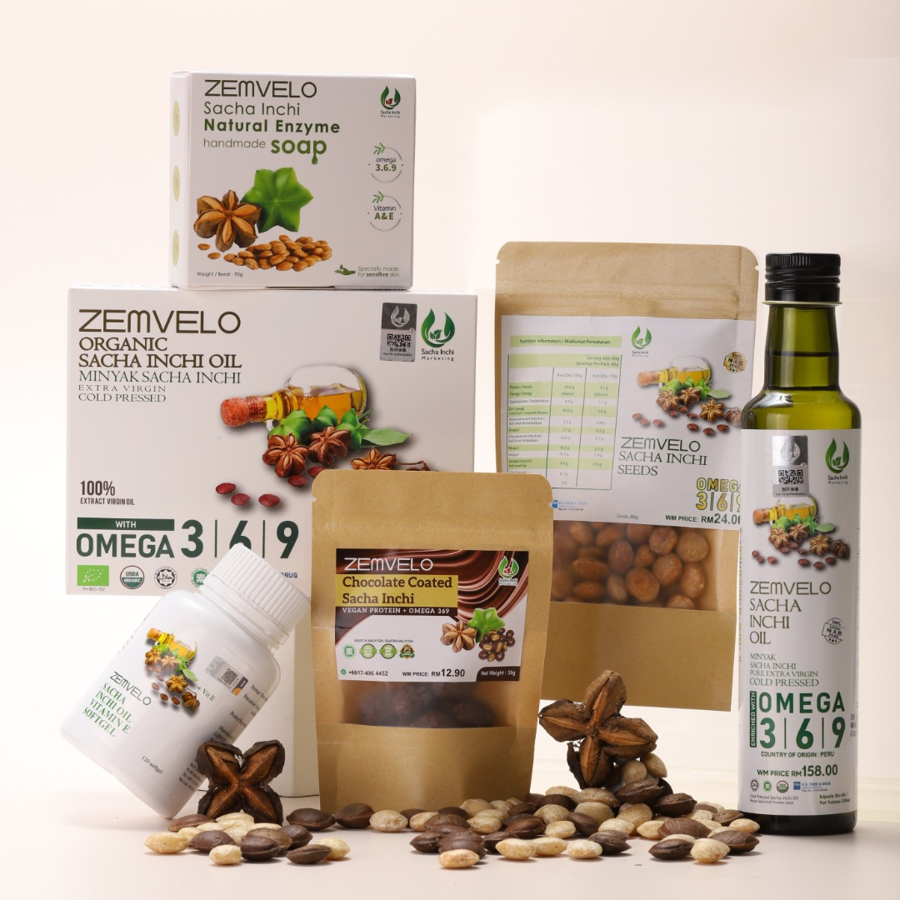
ZEMVELOⓇ is a range of Sacha Inchi Oil products available in softgel, liquid sachet, bottle, chocolate and seed form. Made using state-of-the-art manufacturing and supported by active R&D that identifies the functional components of Sacha Inchi oil and precisely extracts, improves and preserves its contents, we are proud of our ZEMVELOⓇ Sacha Inchi products which capture the essence of the Amazonian fruit in all its goodness.

Certifications
SI Pharma maintains full compliance with international standards of quality and safety with certifications in:

- ISO
- HACCP
- GMP
- Halal
- Etc

Why Choose Us?

Own Plantations
SI Pharma owns and manages its own plantation in Johor Bahru, Malaysia, ensuring a steady supply of quality raw materials to maintain consistent high volume production.

Fair Trade Practice With Farmers

SI Pharma operates on a fair trade practice with the farmers we work with and guarantees to purchase their harvests at agreed prices. In addition, farmers are free to sell their produce elsewhere for their benefit, with SI Pharma willing to purchase any surpluses.

No MOQ
We accept business from anyone regardless of the size of their orders for many of our products. This gives small companies greater access to our services to grow their business and overcome the challenges small businesses face at this critical stage in their development.

//about us summary for website//

One-Stop Direct-to-Market Food & Pharmaceutical Product Manufacturing.

SI Pharma Pte Ltd is a Singapore-based OEM & ODM manufacturer specialising in the active development and production of food products and pharmaceuticals.

Our manufacturing processes are performed in full compliance with industry standards for safety and quality, with products ranging from powder, sachet, softgel, capsule, and gummies—technology processes we have developed extensively for the production of our Sacha Inchi Oil products.

Supported by a strong R&D, SI Pharma is focused on developing new or improved products, combining comprehensive safety and long-term health studies and product stability testing under a range of realistic environmental conditions.
From product conceptualisation, formulation, packaging design, product registration and legal compliance, and logistics/delivery to deliver ready products direct to market under the brand name of our customers.
As an ISO, GMP, HACCP, and Halal certified manufacturer, SI Pharma is capable of scaling up production while ensuring food safety standards and legal compliance for the benefit of customers and the businesses that serve them.

