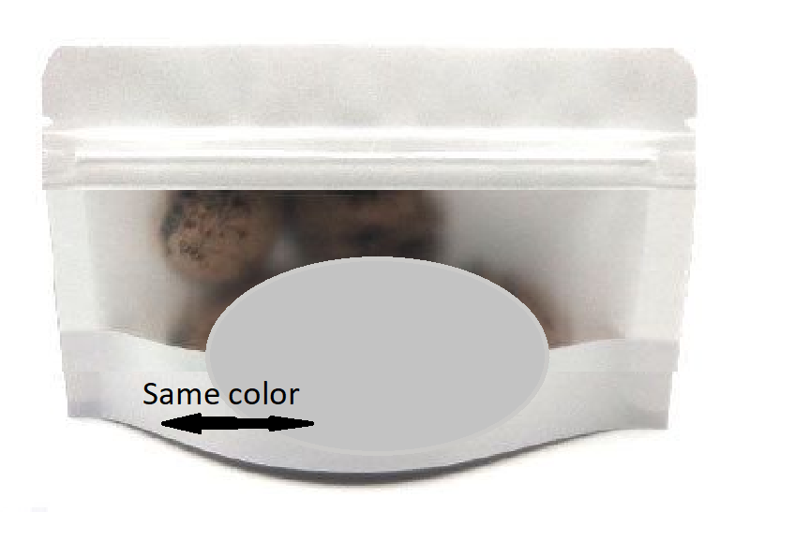
Front
Back

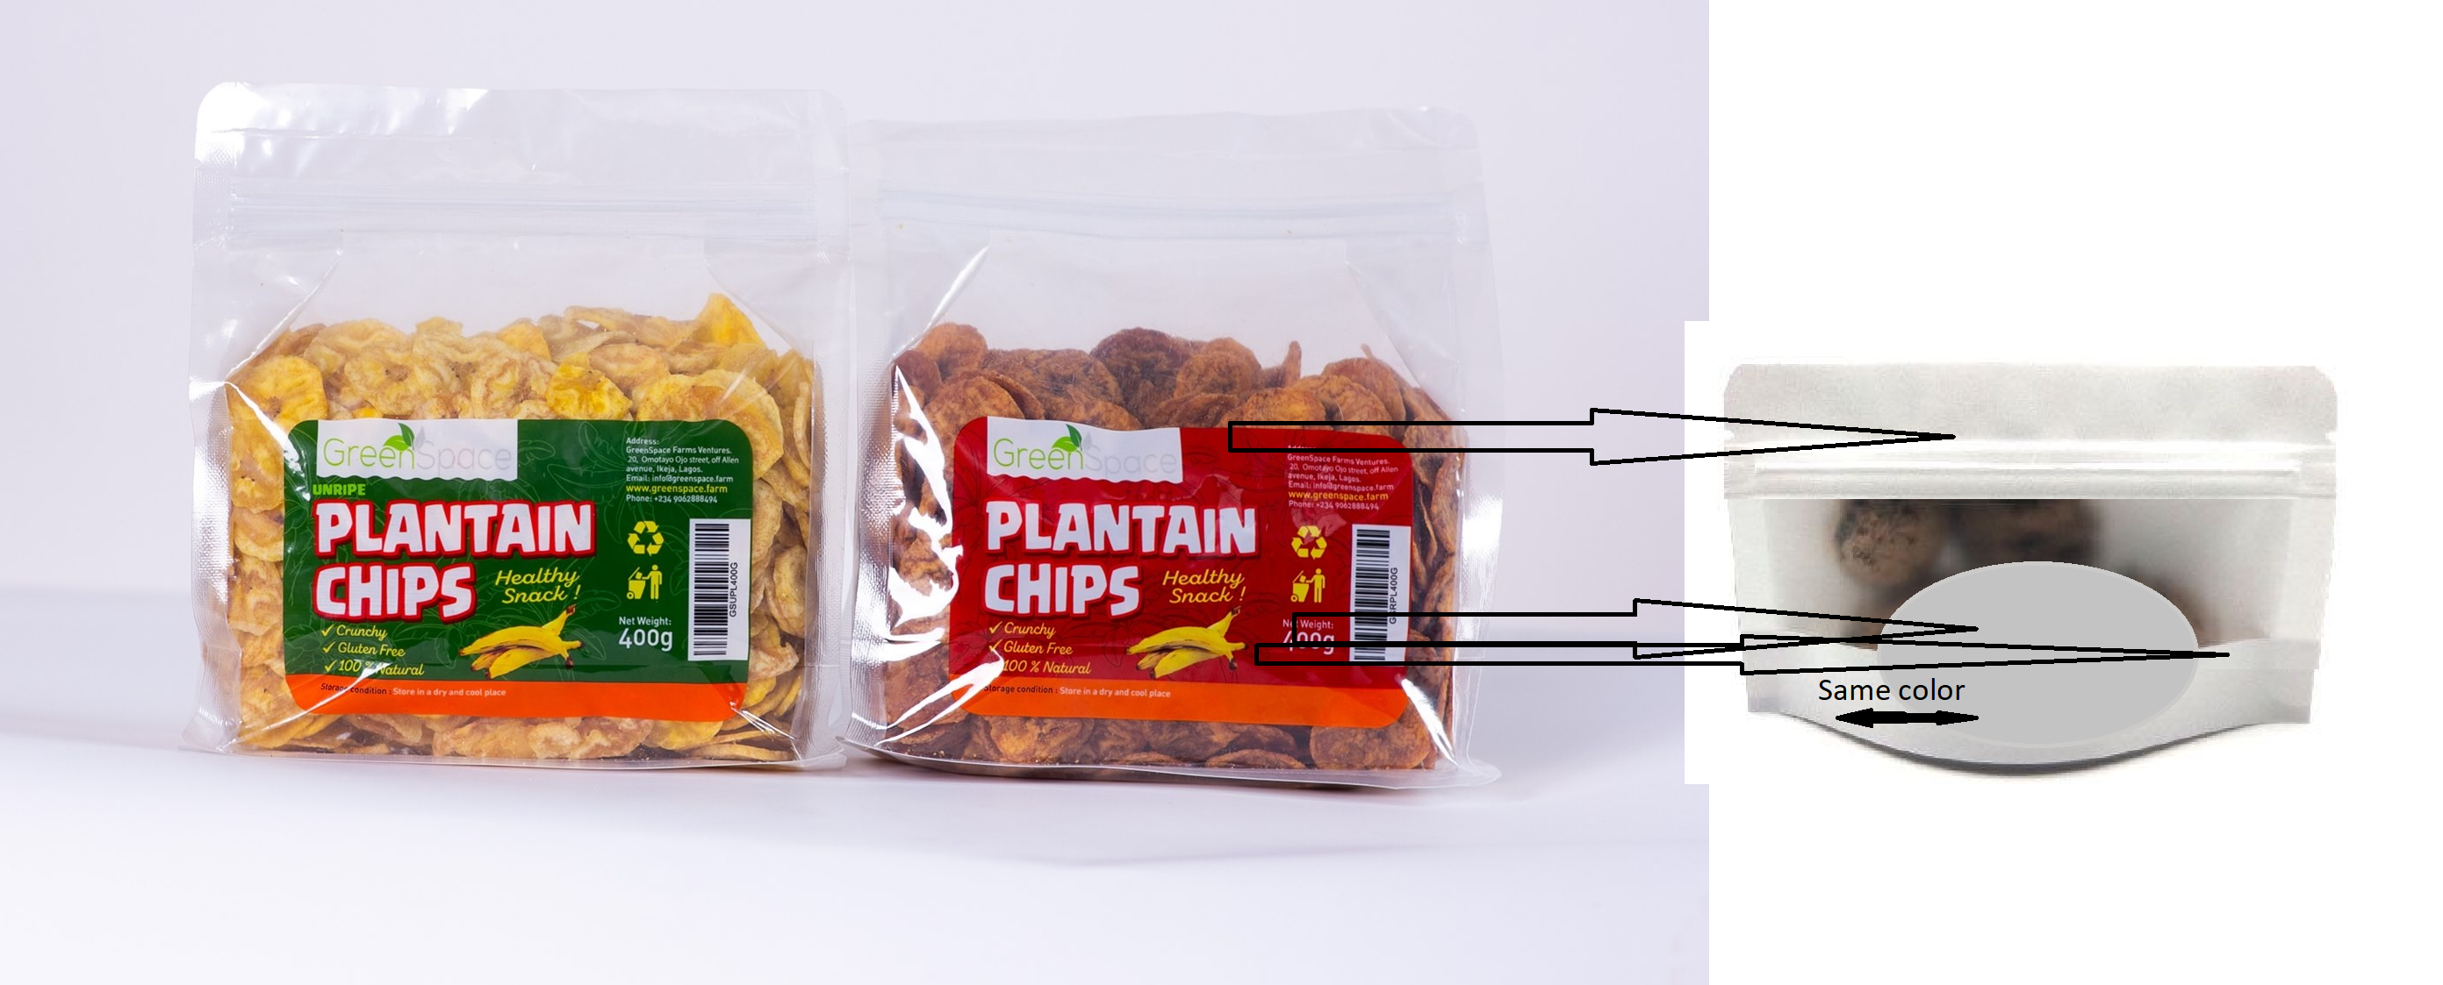
Contents:
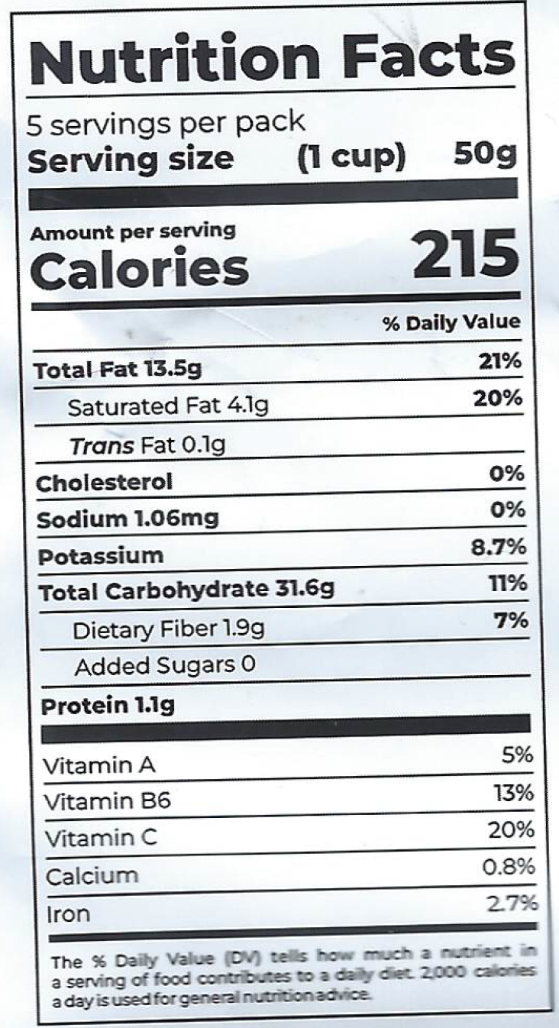  * Approximate values * | Made in Nigeria by GreenSpace Farms Limited  Ingredient : Plantain , Vegetable Oil, Salt  Contact Information:  www. greenspace.farm  +234 9062888494  info@greenspace.farm  Weight 270g  Desired image : ripe plantain chips  Logo:  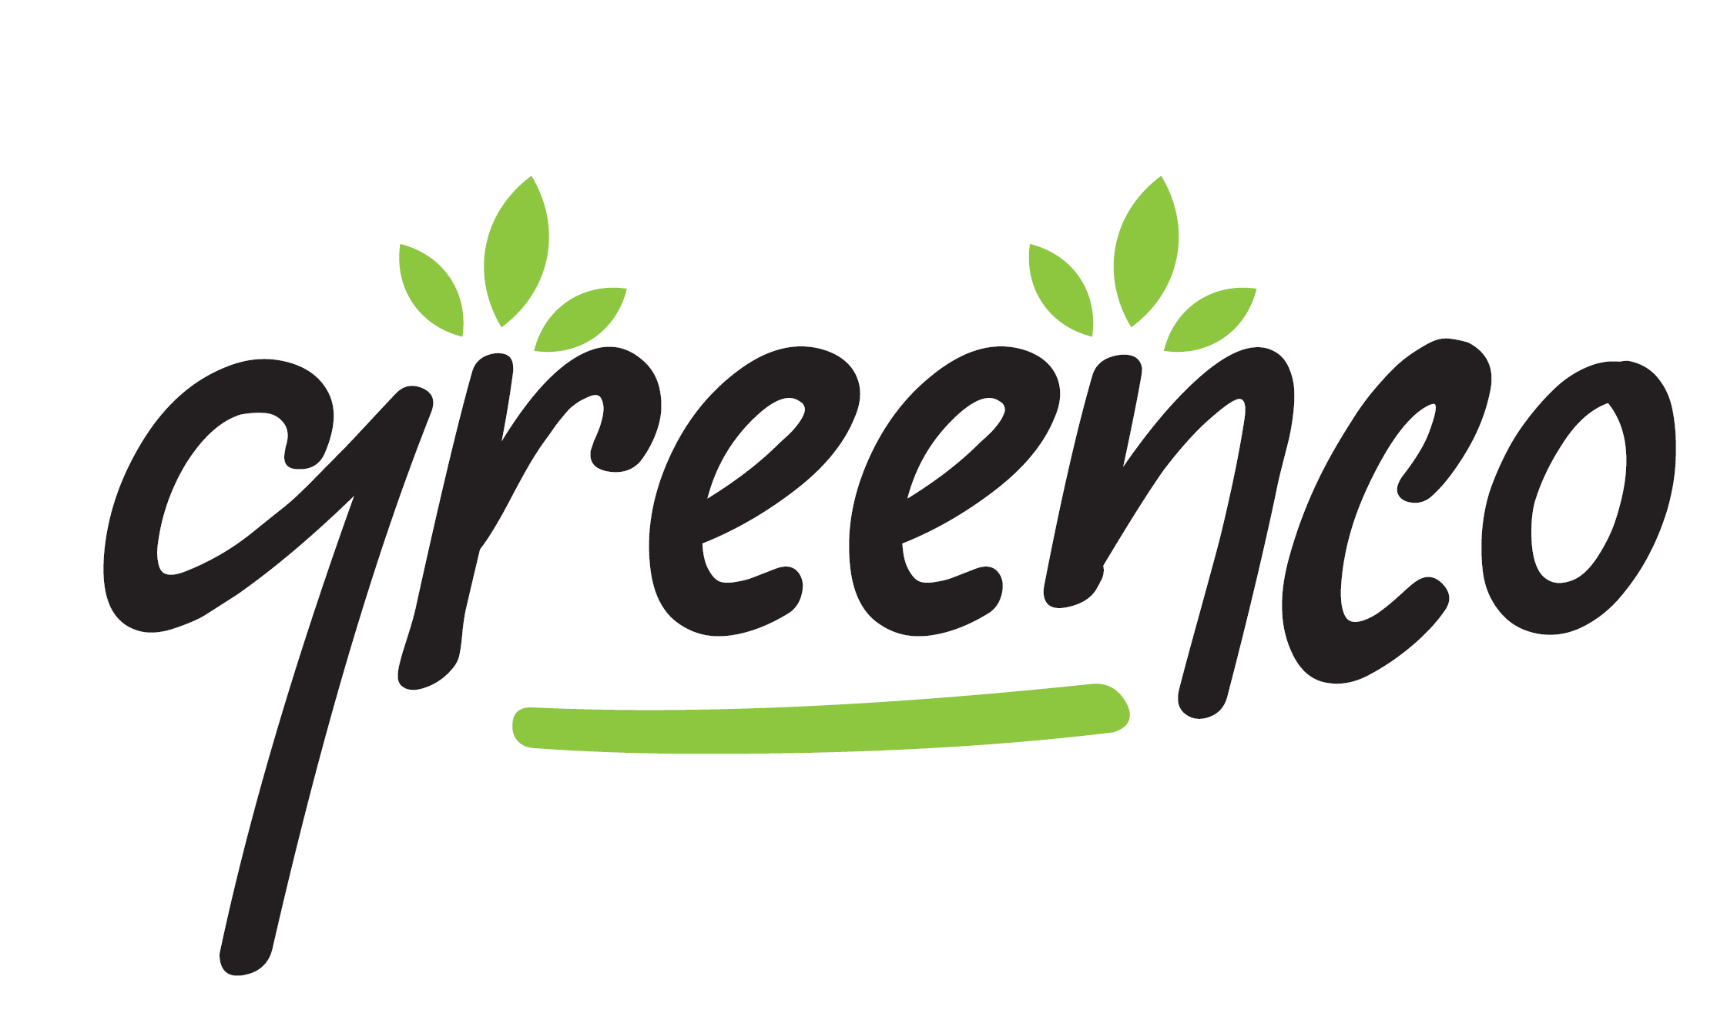  Barcode:  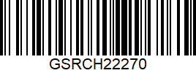  - Crispy  - Gluten free  - 100% Natural

I like these :
