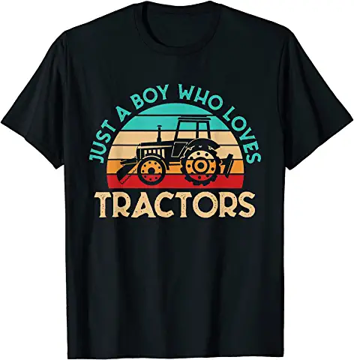Children’s shirt: Maybe more regional like Hood River, Oregon
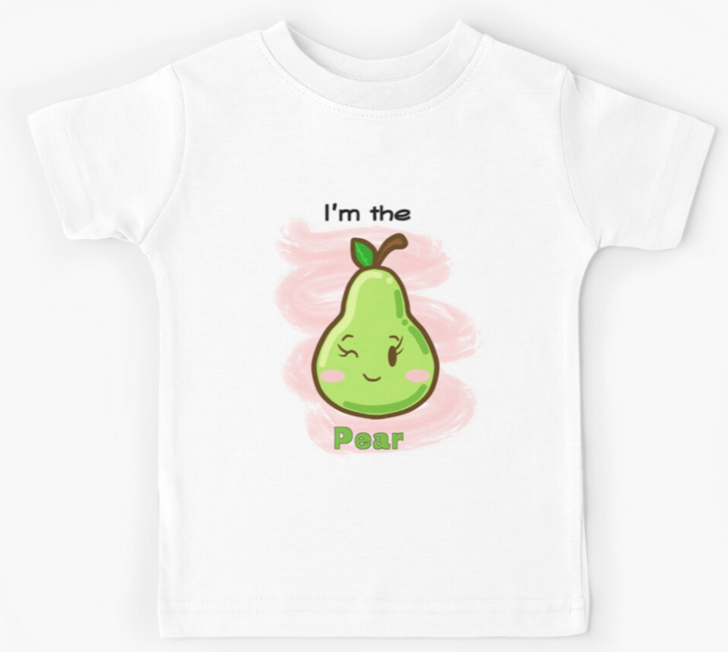
Cute anime style could be great for girls or boys
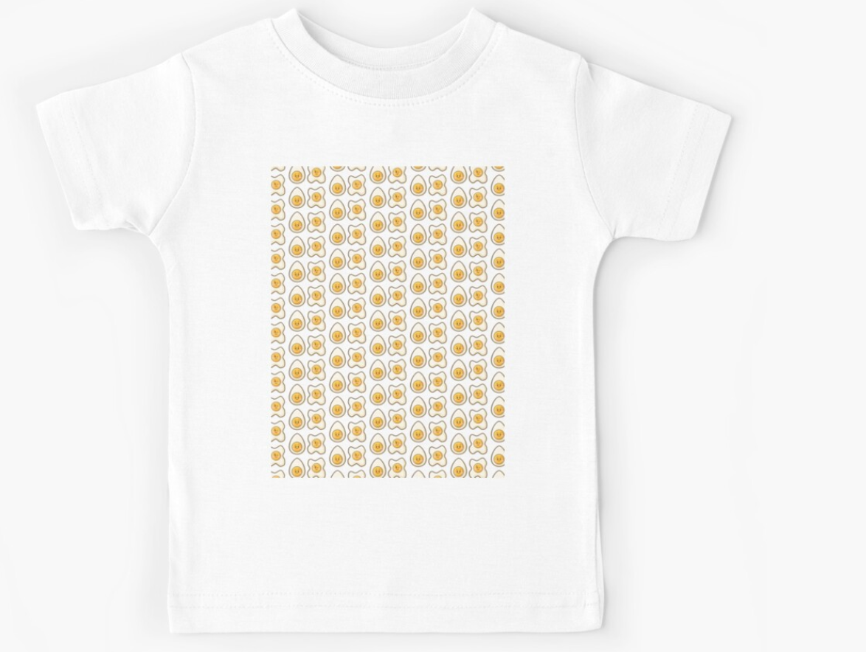
Same concept with anime style
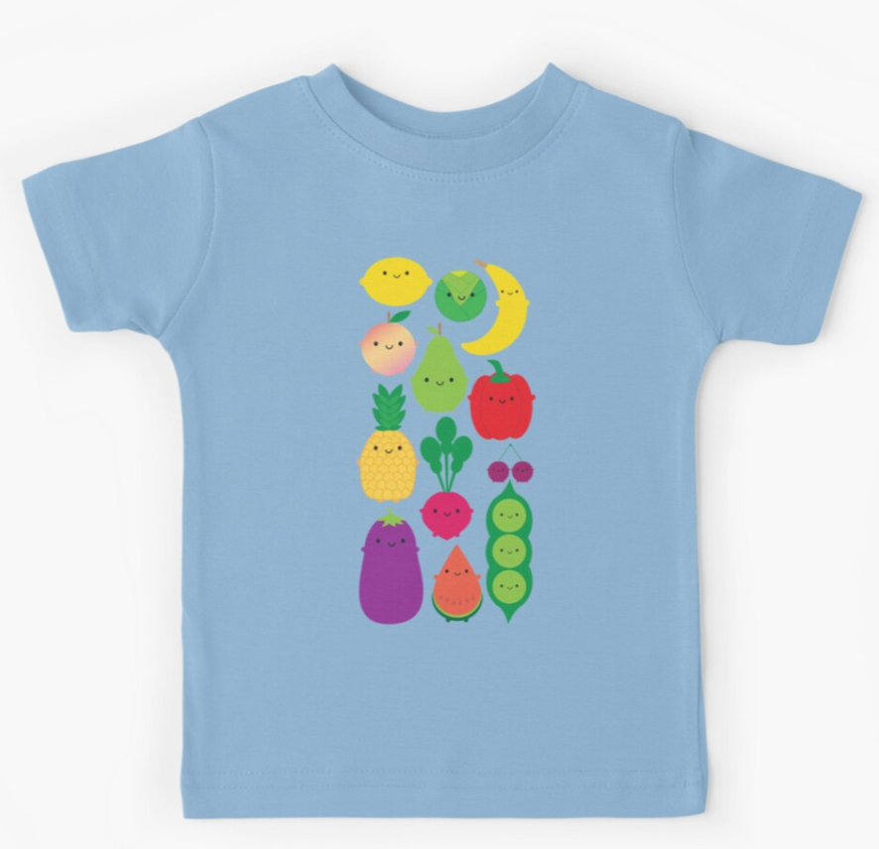
Great boys or girls tea and maybe at the back it says The Fruit Company is a whimsical font?
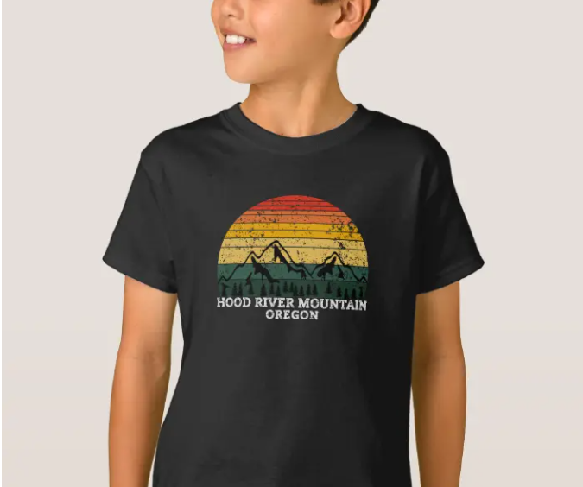
Regional Shirt, but instead it says THE FRUIT COMPANY
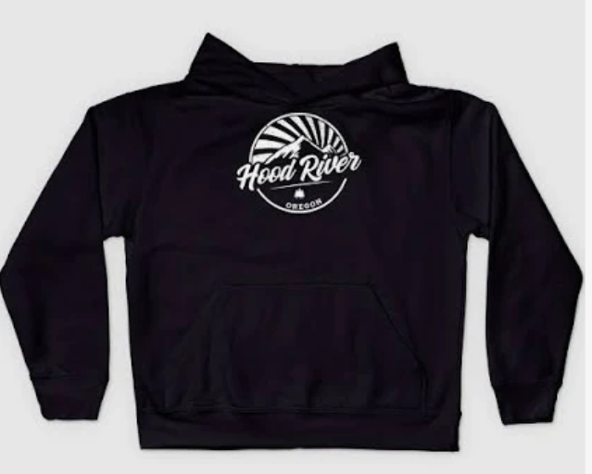
Loved the simplicity of the graphic great for hats but in the same font it’s The Fruit Company?
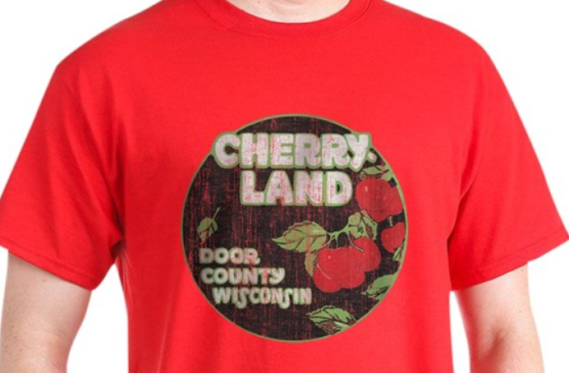

Love the 70’s vibe and font…. Except it would be The Fruit Company – Hood River, Oregon
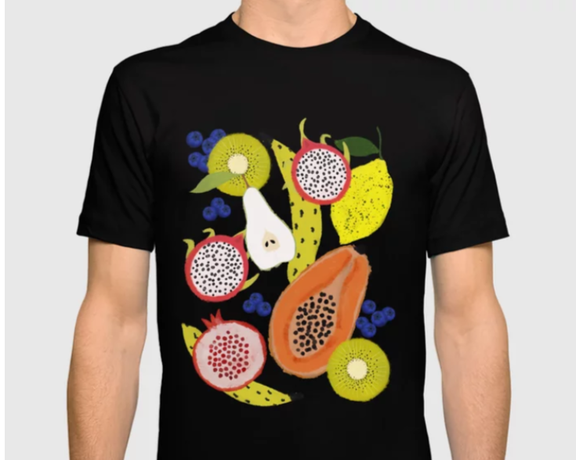
Love this design for shirts and bags

