Word template Content
Creative brief for Word template document for a book summary with images and text. Must be editable document in MS Word.
Instructions:
- Ideally all fits on 2 pages sized 8.5x11 letter US
- Use font Garamond, Veranda or Calibri.
  - Also see font of zebra pattern that can be used minimally or understated
- Photo of author and book cover to be provided
- Add a Zebra pattern print somewhere subtly if fonts not used
- Colors to match brand at website below along with black and white- prefer white background
  - Plum (see colors below) and contrast or accent in yellow (#F0D06E)
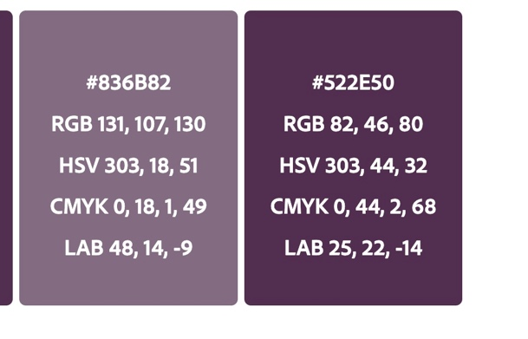
Copy:
- Author - Christie Cox
- Book Title: “Holding It All Together When You’re Hypermobile”
Headline: #1 Ways to Deal – and Heal – for those with Rare Chronic Illness
Copy:
Tired of being told there’s no name or treatment for your illness? That it’s all in your head or that your pain can’t be real because you’re too young/old/pretty/bright/healthy/normal to have a chronic disorder? What if instead there was someone who knew what you were going through and could teach you strategies for coping with rare chronic illness?
This is not a false hope – you can live a full life. You can turn pain into possibility with this life-changing book that can help everyone with elusive hypermobile Ehlers Danlos Syndrome (hEDS) – from those newly diagnosed to those who have suffered in silence for decades. Wherever you are on your journey navigating the complexities of chronic illness, you're not alone.
In Holding It All Together When You’re Hypermobile, Christie Cox explores not only the physical effects of hEDS but its emotional impact as well. As a fellow patient and medical rarity, known to doctors as zebras, she’s experienced her body’s betrayal and suffered through the myriad complications stemming from this disease. But she’s also found a way out from the depths of this life-altering disorder with wisdom you can turn into hope.
As a self-advocacy guide, she offers practical, no-nonsense advice about living with chronic illness and the concrete steps you can take to achieve a new normal. In her book, you’ll discover…
- A healing prescription for the miracle of the modern mindset
- A look at the latest scientific research on the edge of answers
- Q&A interviews with expert doctors and advocacy groups
- Guidance for how to help loved ones better understand hEDS
- Christie’s own inspiring story of how she came to live her best life
- Lessons, questions and quotes to inspire your search for answers

Holding It All Together gives you the tools and resources you need to get back to living the life you want. Reading it will not only boost your confidence but empower you to change your life for the better.

To learn more about Christie’s book, visit www.holdingitalltogether.com.

If you want to learn more about Christie’s advocacy work, visit www.journey2joyous.com.

- Author bio, photo

Christie Cox
Author, advisor and advocate​
​
Christie Cox was always bendy and sometimes witty. It wasn’t until she was properly diagnosed with Ehlers Danlos Syndrome at 48 years old that she understood her quirkiness. Following decades of unrecognizable and untreatable health issues, since learning of her condition she has gone from being disbelieved to determined. Mrs. Cox now devotes her focus, energy, and passion to supporting others facing a similar fate.

- Quote:
“Prior to my diagnosis, my life used to be unmanageable, and there have been times since that I’ve still felt alone, confused, frustrated, and even hopeless. I understand the chronic pain and fatigue and feelings of being dismissed by medical professionals and loved ones alike. It is like pushing a boulder uphill sometimes when your body gives out just as you think you are getting stronger again. But slowly I’ve worked my way back to health and happiness and discovered on the way that the process I took to find my way back could help others. There are techniques that can help you self-manage the flares and hope to live well with hEDS.”

Additional space for the elements below to make room for not yet ready:
- Book cover image TBD (prominent ton top/front page 1)
- Target audience: leave space for text bottom page 2
- Comparative title analysis: leave space for text bottom page 2
- ISBN number/barcode bottom page 2 (see image below)
- CTA: Amazon icon and link to purchase TBD bottom page 1
- Metadata and keywords to embed: Holding It All Together When You’re Hypermobile, Christie Cox, hypermobile, Ehlers Danlos Syndrome, hEDS, rare chronic illness, double jointed, bendy, zebra, inspiration,



