==================================================================================LOGO MESSAGE
==================================================================================The logo is for a company engaged in Trader Training in Financial markets.
The logo message is about 3 things;
1. Letters "A" & "S" - Initials of my name
2. Letter "A" - Shaped as a Pyramid, symbol of Stages of Trader progress (peak performance)
3. Letter "S" - Shaped as a RoadMap, symbol that there is path to reach the top ==================================================================================
==================================================================================LOGO SHAPE 1
==================================================================================
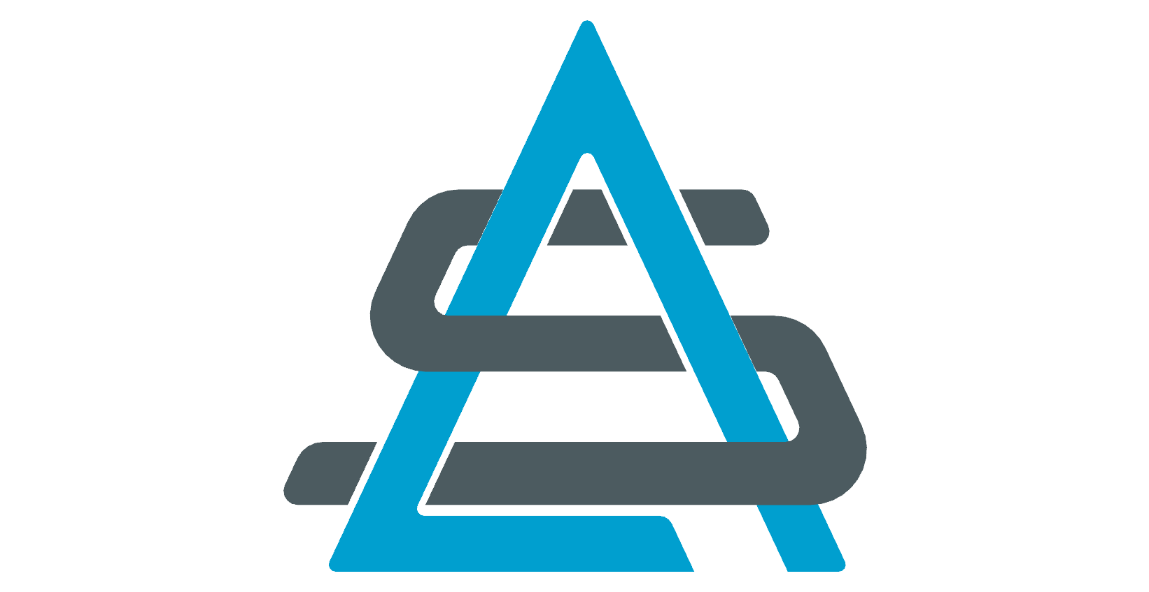
==================================================================================

==================================================================================LOGO SHAPE 2
==================================================================================
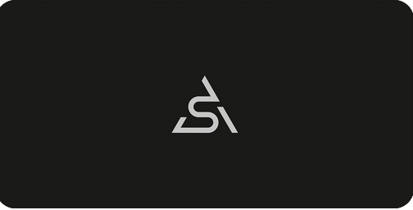
==================================================================================

==================================================================================LOGO TEXT
==================================================================================
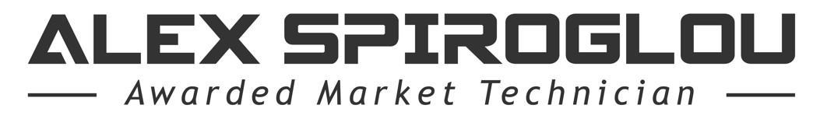
1. The fonts can be found here: https://www.fontsc.com/font/spy-agency
2. You have to create the “A” (in “Alex”) so it looks like a Pyramid
3. Possibly place the logo text under the logo shape
==================================================================================

==================================================================================LOGO SHAPE CLOURS
==================================================================================
In general I like corporate colours - blue, black, white, grey (silver)
Below I have some ideas of what I like -
- Blue, black, white on grey background
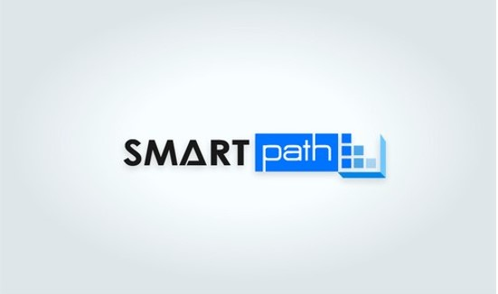
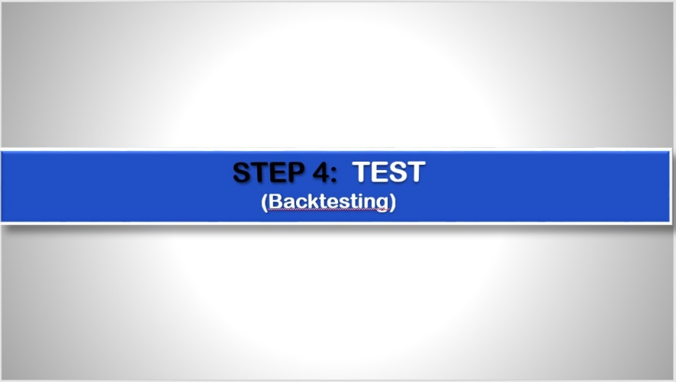
2. Blue, grey, white on black background
https://www.keyshot.com/viewer/
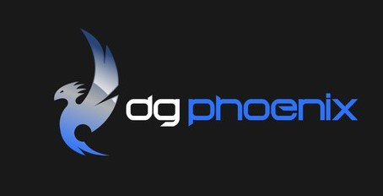
==================================================================================
==================================================================================
FINAL NOTE
==================================================================================
1. I would appreciate if you could create logos based on Logo Shape 1, and then some based on Logo Shape 2.
2. I would not mind slight modifications of the logo shapes (I am open to suggestions), but if you do not change them, I am OK.
3. Feel free to use the colours described and your creativity.
4. I believe this is a simple project as you do not have to waste time guessing what I would like,
so the more versions of these you create the more chances you will have to win !!!!
==================================================================================

