Logo Design for Certainli

NAME - Option 1: Certainli Realty Inc.
NAME - Option 2: Certainli - with the words “Realty Inc, Brokerage” written underneath Certainli on second line. See below for examples. Many other examples on Google.

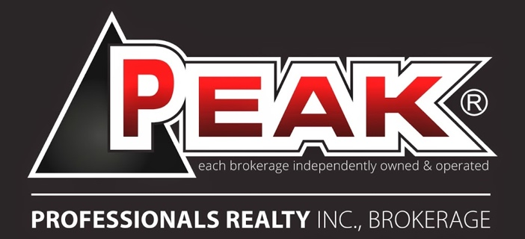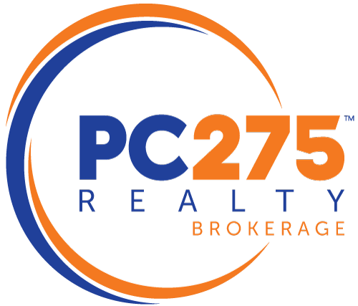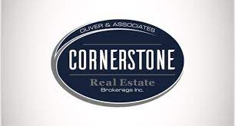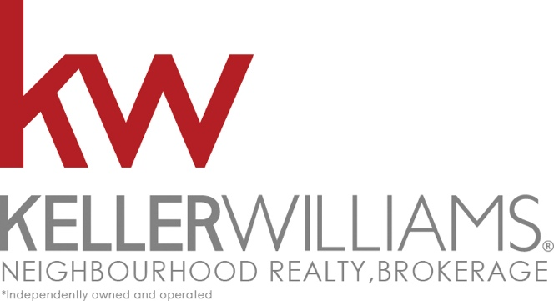

Note: We would like to see both options

Context:
Our current core business operates as a real estate investment company that buys and sells homes privately without using real estate agents. The name of that company is DCI Properties, based in London ON.

We are now going to be launching a second revenue stream under a new name (Certainli) that will operate as an independent real estate brokerage. The logo we are looking to have designed is for this new real estate brokerage.

We operate predominately in Southwestern Ontario and Alberta, and are looking for a logo that will stand out and be unique from other brokerages operating in the same area(s). that being said we are planning on expanding across Canada over the next 2-5 years. Some examples of existing brokerages and their colour schemes are outlined below:

- Red & White = Sutton & Fair Square
- Red/Blue/White = Remax & Fair Square
- Green/White = CBRE/Justo
- Yellow/Black = Century 21
- Blue/White = The Agency/Coldwell
- Red/Black/White = Keller Williams
- Blue + Orange = EXP / Oliver & Associates
- Red/Grey/Black = Peak Professionals/Rockstar Real Estate
- Blue & White – Sotherby’s/Davenport
- Yellow + Green = homelife realty
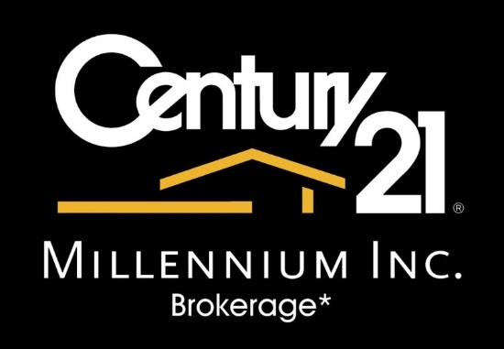

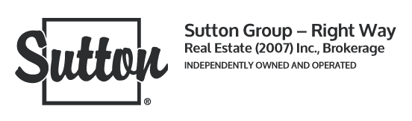
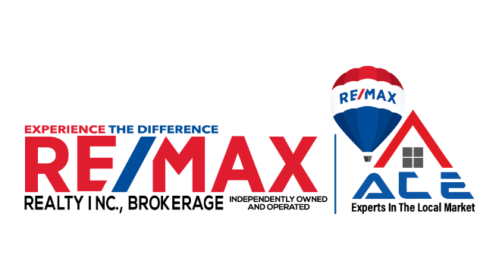
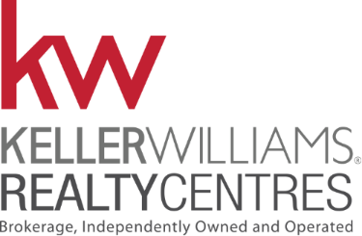
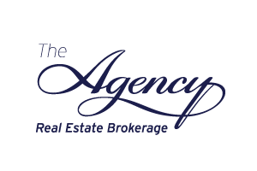

AVOID using the following colours:
- Purple
- Brown
- Green
- Black
- Brown

PROPOSED colour scheme:
- Orange / Yellow / Gold
+ (with)
- Grey / Light Grey/Blue / Light Grey / Teel
+ (with)
White? (optional)

We're called Certainli because we are CERTAIN that we will find the best option for our customers whether that means selling their home privately through our existing company (DCI Properties) or publicly through our new real estate brokerage Certainli.

We are leaning towards having a graphic incorporated into the logo.
We want Certanli to be associated with a positive experience.
Below are words we thought are associationed with “Certainli” but we are open to any and all interpretations of the word and logo design:
- Assurance
- Confidence
- Options
- Ease
- Less Stress
- Happy
- Excitement

HAPPY DESIGNING! LOOKING FORWARD TO SEEING WHAT YOU COME UP WITH!

