Our background:
Since its inception in 1998, Road Rules Driving School has strived to help drivers maintain their driving independence while leading safe and productive lives. Our motto “making drivers safe for life” drives our vision of helping drivers across industries and at all stages of our driving careers.
Road Rules started out working with school boards to deliver driver training to beginner drivers. Thousands of students have graduated from our ministry-approved curriculum. We are also ministry-approved to instruct defensive driving (DDC) and driver improvement courses (DIC), for drivers with speeding tickets, demerit points and at fault crashes.
Road Rules has also evolved to provide comprehensive driver rehabilitation to those who have lost, or are at risk of losing their license for medical reasons. This includes mobility issues requiring adaptive equipment, as well as traumatic crashes resulting in cognitive impairments and PTSD. We work with clients before the courts charged with impaired driving (alcohol, cannabis, opioids), road rage and stunt driving.
Founder Matthew Rivers started driving at an early age on his parent’s farm. Driving professionally and doing so safely is in his DNA. Matthew has a degree in Business and Psychology from Bishop’s University and is a certified in-car and in-class driving instructor

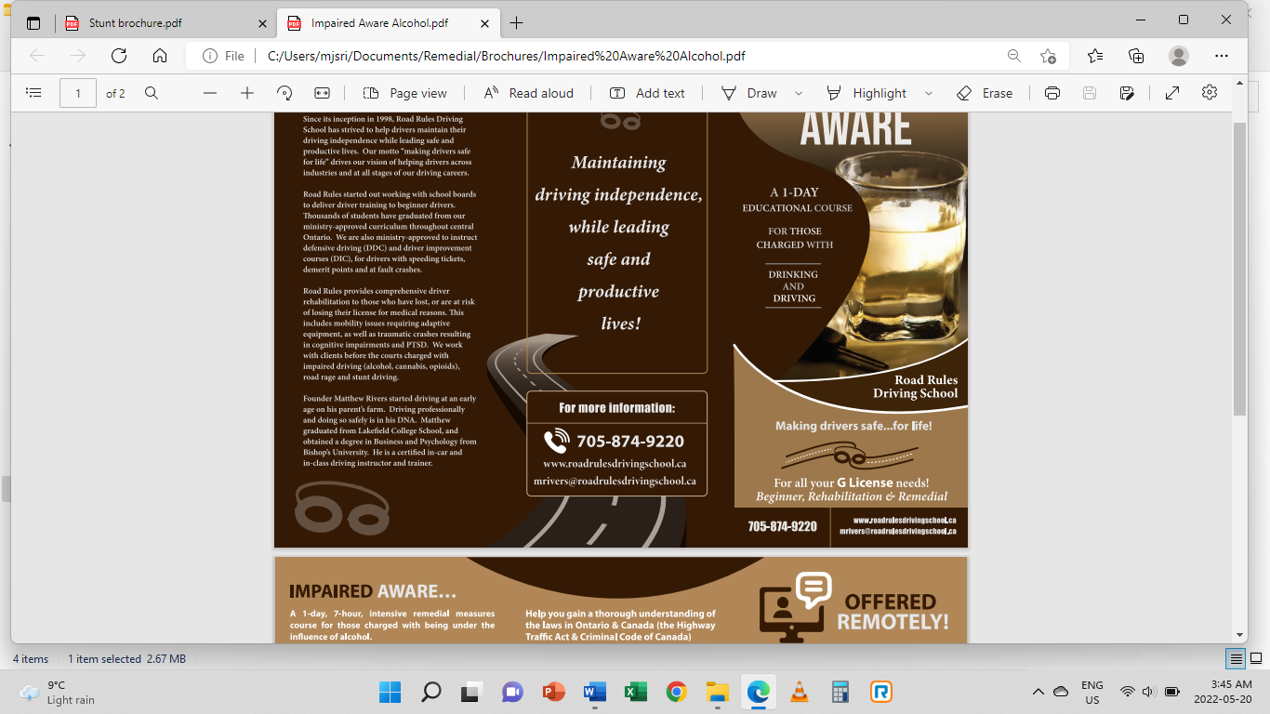

CHANGING GEARS
A 1-DAY EDUCATIONAL COURSE FOR THOSE CHARGED WITH
DRIVING ON A SUSPENDED LICENCE



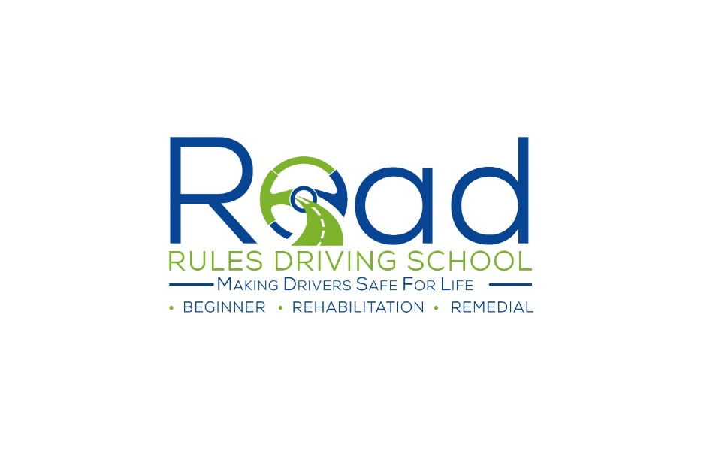
SUSPENDED LICENCE-CHANGING GEARS

During the course we will:
Defensive Driving module (The Big 4):
- Lane position (better to drop 2 wheels on the shoulder than hit an oncoming vehicle)
- Following distance (varies depending on speed and conditions); space cushion driving (always have an out)
- Defensive stopping (what should we do every time we apply brakes?)
- Strategic driving / what we do with our eyes:

Law:
- Highway Traffic Act (privilege vs right); Federal & Provincial; ways we can lose our license
- Implications of a criminal record (relationships, work, financial)

Road Rage:
- Defining the continuum of road rage and escalation of anger
- Triggers
- Personality types (Type A); Holmes & Rahe stress scale
- Aggressive driving (overlap between aggressors and victims); reframing our views
- Psychiatric issues/PTSD: Not uncommon to have professional drivers come through the course due to over-exposure to stress from driving (both on the job and/or the commute to their driving job)

Physiology of aggressive driving and how it affects the body:
- Window of tolerance (hyper-arousal vs hypo-arousal)
- Fight or flight response: how it works
- Stress hormones (Adrenaline, Cortisol, Norepinephrine)
- Chronic levels of exposure/Immune system suppression
- Hypertension
- Sympathetic nervous system
- Substances - will do an overview of alcohol/drinking and driving if relevant; individual and general factors that contribute to B.A.C

Personal context (risk vs protective factors); incumbent upon us to consider:
- Genetics (chemical predispositions)
- Socialization (role models)
- Environment

Strategies to manage:
- Stages of change theory; habit formation and how to reprogram (many of our decisions on any day are subconscious i.e., no decision-making process)
- Neuroplasticity and habit formation
- Supernormal stimuli: how our bodies have not kept up to the complexities of today’s society and its stresses
- Ensure cerebral part of brain is making decisions and not “lizard” part of brain (amygdala vs cerebrum and their roles in the body); triggers & stressors

COURSES ARE
ONE-ON-ONE

