
Your single-source solution for the

ENTIRE EMPLOYEE LIFECYCLE

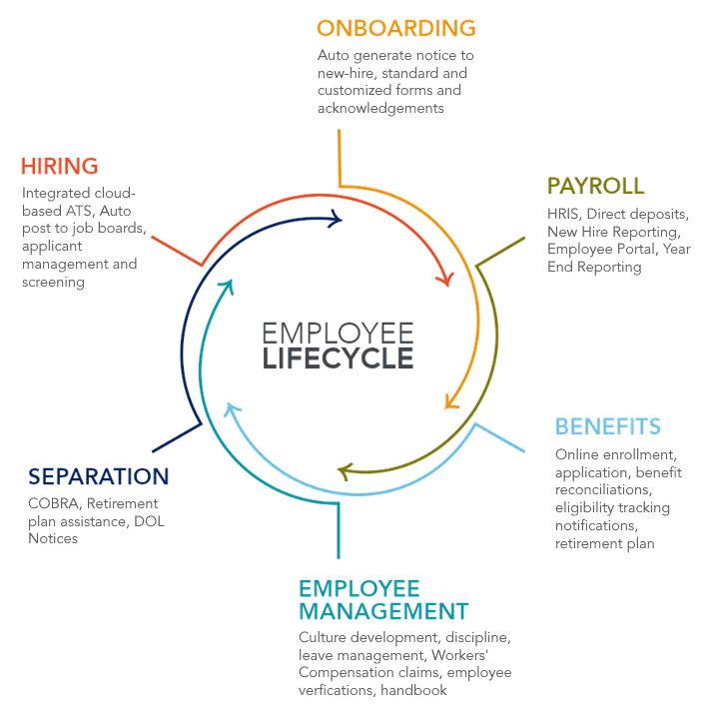
From hire to retire, we’ve got you covered

Employer Support Services has been delivering quality HR and Payroll services for over 25 years. Our dedicated team of professionals is focused on being the best service provider in the industry. Our goal is to relieve business executives of the challenges of managing a dynamic and growing workforce in today’s regulatory environment and give them the freedom to focus on what drives their business.

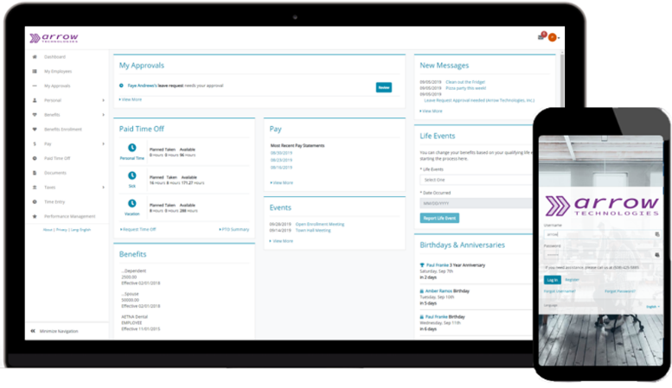

What sets us apart?


Our dedicated team of experts is always just a call or email away! You get direct phone numbers to the professionals you need!
Our advanced software is used to process payroll for over 88,000 companies and 2.2 million employees nation-wide. It makes even the most complex payrolls easy.

Our client branded, cloud-based Employee and Manager portals allow your employees to access their payroll information quicker and more securely than ever before!

Access your employee information how you need it when you need it with our quick-access reports and intuitive report writer. We even provide custom reports!
We are equipped with education, experience, certifications, and motivation. Our staff executes at the highest level in payroll and HR every day.




Employee information is automatically integrated across all modules, eliminating duplicate data entry and significantly reducing errors.

8530 Anselmo Lane • Baton Rouge, LA • 70810
225-364-3000 • info@employersupport.com • www.employersupport.com

 | Payroll  - Fast, efficient, accurate  - Paper checks or direct deposit  - Easy time file uploads or integrated time clock options  - New hire reporting  - Custom G/L file  - Comprehensive reporting options  - Certified payroll option |  | Human Resource Administration  - Wage and hour compliance  - Employee handbooks  - Employee discipline and termination consulting  - Performance management  - Workers’ comp claims administration  - Unemployment administration  - Manager training
 | Benefits Management  - Customized benefits packet  - Track new hire eligibility  - Open enrollment assistance  - Electronic enrollment  - Track and submit enrollments  - Provide 401k census report  - Remit retirement plan reports and funds  - ACA compliance |  | Time and Attendance  - Integrated with payroll (no double entry)  - Mobile and geofencing options  - Overtime notices  - Online time-off requests  - Swipe and proximity card clocks  - Biometric clocks  - PTO tracking
 | Employee Onboarding  - Simple, accurate, paperless  - Custom forms and acknowledgements  - Standard forms (W-4, I-9, State withholding, etc)  - Paperless, electronic signatures  - Employee handbook and policy acknowledgements  - Custom welcome videos |  | Talent Acquisition  - Custom careers page  - Standard or custom job applications  - Easy conversion of applicant data to employee data  - Review, rate, and contact applicants  - Mobile-friendly access  - Easy posting to top job boards  - Candidate screening
   | COBRA Administration  - Initial notices  - Open enrollment notices  - Easy 24/7 online reporting  - Qualified beneficiary election notices  - Premium collection  - Access to professional advice |  | Cafeteria/FSA/HRA Administration  - Plan documents/materials  - Debit cards  - Easy 24/7 online reporting  - Claims processing  - Plan testing
 | Compliance  - Certified experts ensure compliance with all labor laws and regulations  - OSHA Reporting  - Affirmative Action (EEOC)  - Affordable Care Act (ACA)  - Family Medical Leave Act (FMLA)  - Workers’ Comp audits | Save time and stay focused on running your business | 

8530 Anselmo Lane • Baton Rouge, LA • 70810
225-364-3000 • info@employersupport.com • www.employersupport.com

Our services

