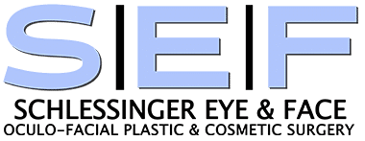
Cover:

Schlessinger Eye & Face
Oculo-Facial Plastic & Cosmetic Surgery
The eyelid experts.
David A. Schlessinger, MD
Medical Director

Page 1 image

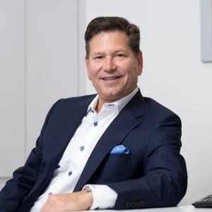
Page 2 About/bio

David Schlessinger, M.D., F.A.A.C.S.

Specializing in eyelid and facial rejuvenation, Dr. David Schlessinger is called upon to consult and treat the most challenging surgical and diagnostic eyelid cases. His state-of-the-art, fully accredited surgical suite along with his carefully selected and highly trained staff - make his practice a one-stop-shop for aesthetic eyelid and facial rejuvenation.
Board certified by the American Academy of Ophthalmology and received his Medical Degree from the University of Pittsburgh School of Medicine in 1988. With over 30 years of experience, his experience, knowledge, talent and warm personality make him an excellent choice for your care.
In 1992, Dr. Schlessinger completed his Fellowship training at the University of Minnesota in Eyelid Plastic Surgery and Neuro-Ophthalmology. As a Fellow of the Academy of Cosmetic Surgery, Dr. Schlessinger is a renowned surgeon in his field and listed among New York’s Top Physicians for Oculoplastic Surgery in Castle Connolly’s prestigious Castle Connolly’s “Top Doctors” and has been named a New York Times “NY Super Doctor” for several consecutive years.
As an Ophthalmic Plastic Surgeon, Dr. Schlessinger is uniquely qualified to treat the delicate skin of the eyelid and face. Numerous respected local physicians entrust the care of their own patients to Dr. Schlessinger and also refer their family members and friends. Many of these same physicians count themselves among Dr. Schlessinger’s patients as well.
Frequently called upon to see the most difficult and challenging eyelid surgery cases, Dr. Schlessinger performs reconstructive surgery for both trauma and cancer patients and lectures extensively to other professionals in the area.
The mission of all of our medical staff is to consistently provide superior care in a safe and friendly environment.

Page-3 & 4-Our Services

Cosmetic Surgery & Treatments
- Blepharoplasty
- Browlift
- Nonsurgical facelifts
- FaceTite
- Morpheus
- CO2 Laser Resurfacing
- Intense Pulsed Light (IPL)
- Thread Lifts
- Subnovii
- Botox
- Dermal Fillers
- Kybella
- PRP Injections

Oculoplastic Surgery
- Blepharoplasty
- Ptosis Repair
- Skin Cancer Reconstruction
- Trauma Reconstruction
- Orbital Tumors
- Ectropion/Entropion
- Tear Duct Drainage Surgery
- Tearing Disorders
- Chalazion
- Dry Eye

Medspa
- RF Microneedling
- Ultherapy
- SculpSure
- Aqua Gold Facial
- Clear and Brilliant Laser
- Laser Hair Removal
- Skinwave Hydrafacial
- Medical Grade Skin Care Products

Pages 5 & 6 Before and After

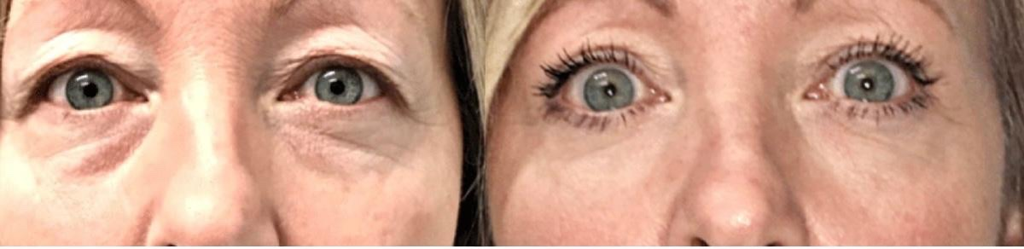
Upper and lower blepharoplasty

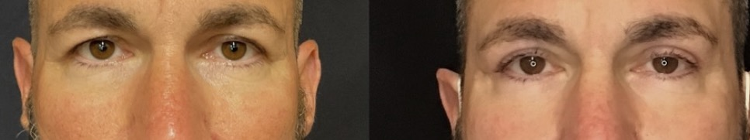
Upper blepharoplasty with browlift

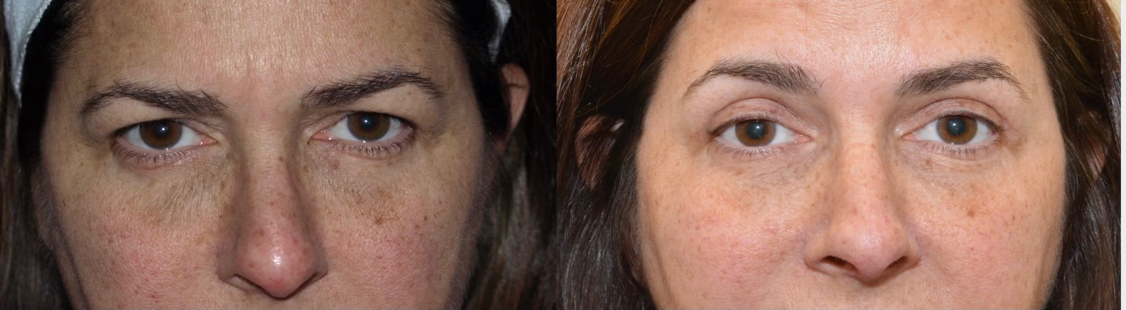
Upper blepharoplasty

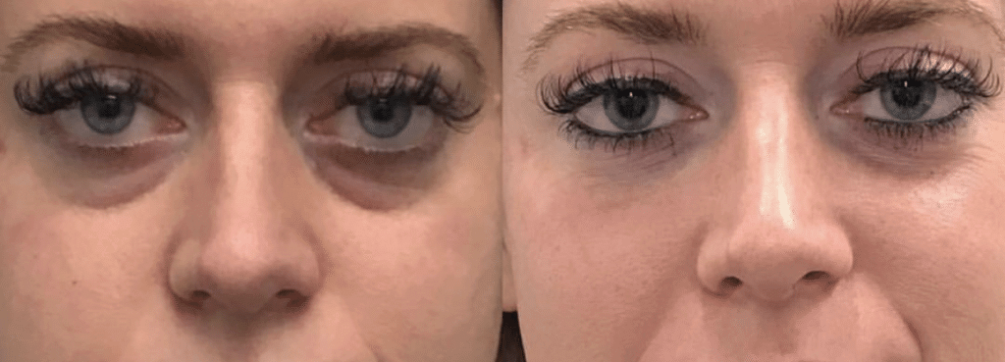
Under eye filler

Page 7 & 8- Reviews

“Dr. Schlessinger truly cares that his patients get results”
“Dr. Schlessinger and staff are exceptional in their kindness and care! Being comfortable through my laser treatment and attention to detail was stellar! Dr. Schlessinger truly cares that his patients get excellent results and takes his time to assure that outcome. All the staff and nurses were so kind and pleasant! I highly recommend Dr.Schlessinger!”
Brenda Silva
“The office is gorgeous”
“My experience was amazing! Doctor Schlessinger was very professional & understanding. He really listened and understand what I wanted done. He’s easy to speak to & the office is so beautiful! The staff was amazing and very helpful. The office is gorgeous with all state of the Art new technology!! He is a master injector & would highly recommend him!
Nicole Rizzuto
“He is truly a master at his craft.”
“My experience with Dr. Schlessinger and his staff was nothing short of amazing. He is truly a master at his craft. My husband and I were welcomed into the practice where we received a thoughtful and thorough consultation. Each of our concerns were thoughtfully addressed and we never felt rushed, as I have experienced with other practices. Dr. Schlessinger’s patient care extends far beyond the office with a friendly follow up call or email. I would never consider another doctor for my Botox and injectables.”
Tara Delisi

Back Cover-Accolades

SuperDoctors, New York
Top Doctor New Beauty
New York Best Doctors
Verified Expert Injectors
American Academy of Cosmetic Surgery
American Academy of Ophthalmology
Castle Connolly Top Doctors

515.496.2122
Schlessingereyeandface.com
75 Froehlich Farm Blvd.
Woodbury, NY 11797
Facebook
Instagram

