Cheesehall B.V. Trading Co
Website Content
First page intro. Some sentences used there in big letters.
- “Quality is our responsibility. Quality is who we are.”
A phrase to be used in the first page above a photo or else.
- “Quality cannot be defined, but you will understand exactly what it means after tasting our dairy products.”
About:
In bigger letters: We supply, sell, and distribute the best quality dairy products.
Cheesehall B.V. is a Dairy Trading Company based in the Netherlands. Cheesehall’s team consists of motivated professionals from all over the world, with experience in the dairy industry, sharing their passion for dairy products. Cheesehall B.V. outlines the importance of high quality in products along with integrity and consistency in the services provided. Thus, Cheesehall stands out for authenticity, integrity, and loyalty.
Our Mission:
Since the very first years of our childhood, dairy products are present in our life and constitute the main source of our nutrition.
Cheesehall deeply understands and appreciates the vital role of dairy products in daily life, and therefore our team constantly searches for the highest quality dairy products. It is very important for us to meet in person and support local producers who take care of their pharms and respect the common (hygienic, etc.) procedures.
Cheesehall emphasizes on the quality of raw materials. Nowadays, when all processes are carried out automatically through advanced technology, Cheesehall focuses on the importance of human involvement in the production of any dairy product. Cheesehall’s team always meets in person with producers and visits their facilities to assure the origins and guarantee the high quality of the dairy products.
Cheesehall focuses on providing our clients with premium quality & competitive products. We achieve that through constant research, our reliable network and our team’s experience in the dairy industry and their love for dairy products.
Our Vision:
Our main goal is to build strong and solid cooperation with our clients, based on mutual trust and understanding to deliver the best possible result. Cheesehall aims to affiliate its company name with “high quality” and “consistency”. Our partners and clients should always feel confident about the outcome of our collaboration. Cheesehall’s team is working hard to assure availability and variety of high-quality dairy products.
Our Values/Strengths:
- Integrity: In Cheesehall, integrity refers to whole-ness, reliability, and consistency. We treat people with respect and honesty. We back-up our promises and honor our commitments.
- Authenticity: Cheesehall remains true and loyal to its mission. We always search for and support local producers who provide us with high quality dairy products. It is important for us to know where the dairy products we trade come from and guarantee for their specifications and quality.
- Loyalty: Cheesehall is committed to fairness in the pursuit of its objectives. We aim for strong, durable, and long-lasting cooperation with our clients. Therefore, we avoid situations that could cause a conflict of interest, we protect and support our clients by being honest and solid to our agreements.
Our Products:
In bigger letters: Our solutions in dairy for your needs
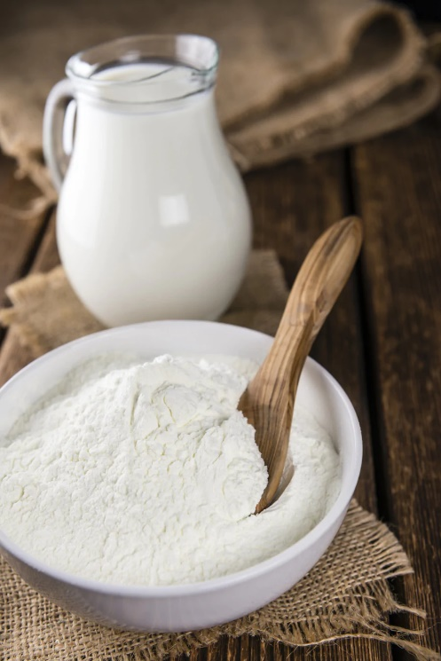
- Milk Powders

  - Skimmed Milk Powder:
Skimmed milk powder is obtained by removing water from pasteurised skim milk by spray-drying. Skimmed milk powder is classified according to the heat treatment used in its manufacture (high heat, medium heat, and low heat).
Skimmed milk powder is used in a wide variety of applications. It can be used in recombined dairies such as UHT milk, yoghurts, or cheeses, but also as non-fat milk solids in chocolate or in bakery. An important use of Skimmed milk powder is also in sport and infant nutrition foods.
  - Whole Milk Powder:
Whole milk powders are obtained by removing water from pasteurised milk through spray-drying. The powder can contain between 26% and 40% milk fat (by weight) on an “as is” basis and offers all the nutritional qualities of milk in its dry form.
Whole milk powder plays an important role in the manufacture of a wide range of food products. It can be used in reconstituted dairy products such as yoghurt and milk drinks, but also as a source of fat and non-fat milk solids in confectionery and baked goods. The powder can be fortified with vitamins, in order to be repacked for direct consumer use in milk beverages, homemade yoghurt, coffee and tea whitener.
- Butter
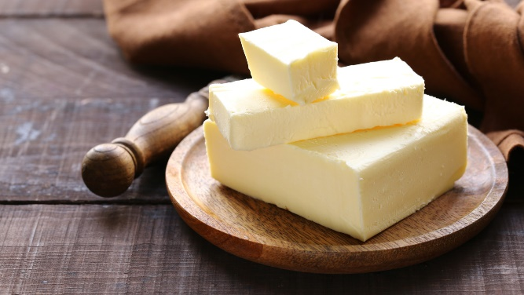
  - Lactic butter
Lactic Butter (also called cultured butter) is made from pasteurized cow’s milk that has been fermented with lactic acid, in a continuous churning and kneading process. Lactic butter has lower levels of water than regular butter and a characteristic fresh lactic flavor. Lactic butter has a uniform light creamy to yellow color and a sweet, slightly acidic flavor, which is a result of adding from 1 to 3% of a milk culture. The product has a cohesive, unitary texture and a smooth, dry surface.
Lactic butter is primarily used in the baking industry, confectionery industry, as well as an ingredient of many dishes. It is also widely used in the production of chocolate, cookies, biscuits, spreads, sauces, ice cream, and puff pastry products.
  - Sweet cream butter
Sweet cream butter is made from pasteurized fresh cream and, often, salt. To make sweet cream butter, cream gets sterilized with heat until the fats break away from the liquid, otherwise known as butterfat and buttermilk. Once the two have separated, the thick fat on top gets churned or agitated in a different container until it forms a solid mass. Butter makers wash the solids, and press until all liquid has been extracted, creating the end product consumers know as butter.
Sweet cream utter has a great texture and rich taste that are very useful for the baking and confectionery industry. It is perfect for the laminated process and high-pressure conditions during production. Thus, it can be a great ingredient in the production of pastries, biscuits, croissants, and other baked products. Butter is also homogeneous and cohesive, making it a great addition to soups, meats, and ready-cooked meals.
- Cheese
  - Gouda 48%
Gouda, semisoft cow’s-milk cheese named for the town of its origin in the Netherlands. Gouda can be found in flat wheels each with a thin natural rind coated in yellow paraffin, rectangular or loaves. Gouda has a smooth-textured interior of pale ivory color. Flavors are bland and creamy, except for aged Gouda, which is darker gold in color, stronger and saltier in flavor, and harder in texture. Gouda is mainly destinated for direct consumption as snacks and as an ingredient of sandwiches, salads, toasts, burgers, and tortillas. Gouda cheese is also suitable for shredding, grating, and slicing. Other applications include pizza toppings, cheese-based sauces and dips, soup premixes, flavored crackers, and chips. Gouda cheese also finds many applications in the confectionery and bakery segment.
  - Edam 40%
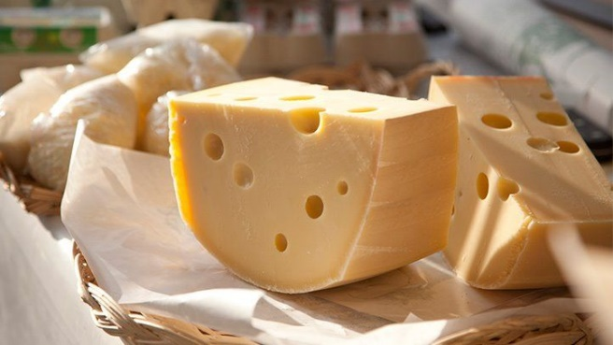
With a smooth texture and a mild, nutty, salty flavor that gets sharper as it ages, Edam is made from skimmed and part-skimmed cow's milk, giving it a lower fat content than its compatriot, gouda, and other semi-hard cheeses. Traditionally, it is manufactured in a spherical shape and is coated in a red/yellow wax, or plastic coating. Edam cheese is suitable for direct consumption as a table snack or on-the-go product. It is also widely used for cooking and as an ingredient in pizza toppings. It is also suitable for grating, shredding, and slicing. Edam is usually used in cheese products with high protein and low-fat content.
  - Mozzarella 40%
Mozzarella cheese is a sliceable curd cheese. Most of the Mozzarella cheeses available now are made from cow's milk. Mozzarella is a plastic or stretched-curd cheese; the curd is mixed with heated whey and stretched and kneaded until it attains a smooth, pliable consistency. It is then molded into forms to shape. Mozzarella has a mild, fresh lactic flavor. Mozzarella’s features make it ideal for melting and shredding. Thus, Mozzarella is a perfectly suitable ingredient for pizza, salads, ready-cooked dishes, lasagna, pasta, soups, and sauces.
  - Cheddar
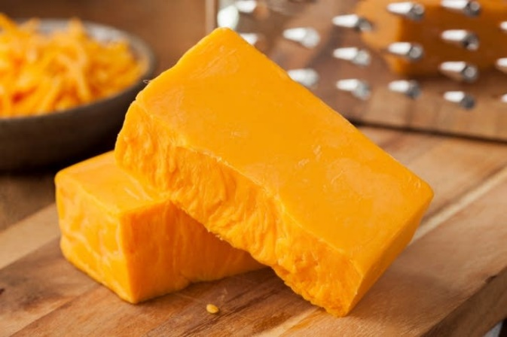
Cheddar cheese, the most widely purchased and eaten cheese globally, is always made from cow's milk. It is a hard cheese with a slightly crumbly texture if properly cured, and if it is too young, the texture is smooth. It gets a sharper taste as it matures, over a period of time between 9 to 24 months. It is shaped like a drum, and its color generally ranges from white to pale yellow. However, some cheddars are orange if coloring such as beta carotene is added. The Cheddar we supply has various industrial applications; it can be shredded, grated, or melted, which can be useful in the bakery and confectionery industry. Other main applications for Cheddar cheese include cheese-based sauces and dips, soup premixes, flavored crackers, and chips. Cheddar is also destined for direct consumption in snacks and as an ingredient of sandwiches, toasts, burgers, and tortillas.
  - Emmentaller 48%
Emmentaller is a semihard cow's milk cheese. Traditionally It has a firm, dense body and a hard, inedible rind, but it can be found in loaves and rectangular blocks as well for industrial users. It is distinguished by large walnut-sized holes or "eyes" formed during the fermentation process. It ranges from mild and buttery to fruity and full-flavored, depending on its maturity. It has good melting properties and is a traditional ingredient in cheese fondue. Emmentaler is an excellent cheese for direct consumption as well as an ingredient of sandwiches, paninis, and bagels or as a table snack. It is also suitable for grating, shredding, and slicing. It is often used as an ingredient in bakery goods, pre-made dishes, dips, cheese sauces, and soups.
- Cream
Cream is a dairy product composed of the higher-fat layer skimmed from the top of milk before homogenization. In un-homogenized milk, the fat, which is less dense, eventually rises to the top. In the industrial production of cream, this process is accelerated by using centrifuges called "separators".
Cream skimmed from milk may be called "sweet cream" to distinguish it from cream skimmed from whey, a by-product of cheese-making.
Cream is categorized according to its milk fat content and comes in two forms – pure and treated. Both must contain no less than 35% milk fat. There are different types of cream:
Whole cream contains a minimum of 40% fat.
Medium cream contains a minimum of 30% fat.
Light cream contains between 12 and 29% fat.
Our Cream is suitable for various applications, from chocolate manufacturing, bakery, frozen desserts & ice-cream to ready-cooked dishes or soups.

Contact Details:
Flight Forum 40
5657 DB Eindhoven, the Netherlands
+31639420678
info@cheesehall.nl

